Kordeus Core
Author: Ana Marija Ćirić

Important notes

- Sections marked with yellow “marker” are under construction.
Explanations in this document override what is visible in the mockups, because mockups tool has limitations such as: I cannot align one table column to the right and others to the left.This is something which is often needed in billing, because all columns and fields which display money should be aligned to the right and have 2 decimal points, whereas fother fields and columns are usually aligned left. This is something I explain in the text and therefore override what is in the mockups. Also, take translations from the text, not from mockups.
- I try to cover everything in this document, from examples from the real world to each and every label in both languages. BUT I must have forgotten something. If you see something that doesn’t make sense, like: I always write that deletion should prompt for confirmation, and in one place I don’t, please ask me if I forgot or skipped in on purpose.
- Generally, whenever you have a question or a comment, or think something could be done better,don’t hesitate to contact me. I will reply within an hour or schedule a discussion with you. Email:ana.marija.ciric@m-pioneers.com / Phone: +381606158156 / Skype: anamarijaciric
- Standard formats
  - date is mm/dd/yyy for english and dd.mm.yyyy for German
  - time is either hh:mm or hh:mm:ss, depending on the requirement for details, but it is the same for both languages
  - decimal delimiter is “.” for english and “,” for German

Versions
Version | Date | Author | Change log
0.1 | 13.11.2017 | AMCiric (ana.marija.ciric@m-pioneers.com) | Initial specification of all aspects of the billing phase, minus e-billing details
0.2 | 13.11.2017 | AMCiric (ana.marija.ciric@m-pioneers.com) | Added details about diagnoses catalog;  Added Tariff to all billable positions;  Added possibility of multiple rule values in tarmed catalog XML;  Added missing values to the report placeholders;  Added more explanation to billable positions / bill positions in Medical Services section;  Added e-billing details;  Added KoGu date and number at the bill
0.3 | 13.11.2017 | AMCiric (ana.marija.ciric@m-pioneers.com) | Corrected UnitFactor and ScaleFactor terminology in Catalogs, Bill printing, Medical Service Billable positions;  Added an option for multiple geografical locations in catalog XML;  Fixed multiple typos in Administration section;  Added explanation about default product variant in Administration / Goods section;  Fixed multiple typos in the Implications section and added some clarifications;  Added more clarifications to the billing blocks in Medical Services section;  Fixed typos and added more clarifications to Bill groups and bills; Reordered some subsections for clarity and better flow;  Added more clarifications to e-billing;  Added specific placeholders for payment instructions;
0.4 | 15.11.2017 | AMCiric (ana.marija.ciric@m-pioneers.com) | Added examples for XML creation for e-billing;  ESR code generation explanation;  Added "has variants" switch to the product form;  Changed the logic of immediate billing;  Introduced info buttons to statistics;
0.5 | 17.11.2014 | AMCiric (ana.marija.ciric@m-pioneers.com) | Added clarifications about medication catalog;  Added context menu concept in patients and changed a few labels;  Changed a couple of labels in the bills section;  Removed the button for making bill groups (they should be implicit);  Changed the way a bill group is created;  Adjusted the info text for capacity statistic.
0.6 | 21.11.2017 | AMCiric (ana.marija.ciric@m-pioneers.com) | Added layout for dunning;  Added more details about bill (group) actions and their availabilities;  Merged e-billing and reports;  Added more e-billing details;  Added patient document archive section;  Added "make a copy" feature to bills section;  Added adding and deleting of participants on the encounter page;
0.7 | 22.11.2017 | AMCiric (ana.marija.ciric@m-pioneers.com) | Added LASIK Pre-OP documentation mask specification;
0.8 | 23.11.2017 | AMCiric (ana.marija.ciric@m-pioneers.com) | Adding diagnosis to bill;  Classification of ICD10 diagnoses using Tessinercode;  Facility added to the encounter and bill;  Bills are now grouped only until the group is signed off (changes to the overview page as well as bill view page);  Adjusted document category names;  Milestone plan outline;  Medical services date;
0.8.1 | 24.11.2017 | AMCiric (ana.marija.ciric@m-pioneers.com) | Added mockup screenshots;
0.9 | 24.11.2017 | AMCiric (ana.marija.ciric@m-pioneers.com) | Added write-off positions (uncollectables) for patient financial account;  Added mockups for patient billing account;  Added reports for Lasik Pre-OP;
1.0 | 03.01.2018 | AMCiric (ana.marija.ciric@m-pioneers.com) | Added dunning steps administration;  Added payment receipt printing and template;  Added ÄrzteKasse interface draft;  Added Bank account administration draft;  Added more details about the medications and disposables catalog;  Added employer as bill recipient;  Added unconfirmed patient deletion;  Added dunning to patient booking account;  Added dunning documents to numberrange assignmnts;  Added dunning specification;  Added bill filter by status;  Adjusted naming of bills / bill groups;  Added functionality to open bill PDF on bill number click;  Added medical services to appointment variant steps (Administration section);  Changed geographical location in TARMED catalog metadata;  Added office to bills report in Reports section;
1.1 | 15.01.2018 | AMCiric (ana.marija.ciric@m-pioneers.com) | Changed bill view and added installment plan view in Bills section;  Updated dunning level change and added mass manipulation in Dunning section;  Added dunning mass manipulation;  Updated medical service to appointment variant steps (Administration section);  Updated performed services in Encounters section;  Added Refractive surgery, early post op and post op documentation masks in Encounters section;
1.2 | 16.01.2018 | AMCiric (ana.marija.ciric@m-pioneers.com) | Removed billing data from facilities and added hierarchy structure in the facility overview, in Administration section;  Updated staff billing settings in Administration section;  Added office administration in Administration section;  Added bank account administration in Administration section;  Added dunning level deletion;  Added billing office and specialization to bill creation in Bills section;
1.3 | 05.02.2018 | AMCiric (ana.marija.ciric@m-pioneers.com) | Updated staff extensions in Administration section;  Updated office billing data in Administration section;  Split patient billing account into two tabs: Bills and Payments, in Billing implications section;  Updated add / edit payment in Billing implications section;  Added info for privileged account sign off in Bills section;  Added diagnoses dropdown (first release solution, to avoid making HIP catalogs) in Bills section;  Removed the payment instructions report, as it will be a part of bill PDF always;  Added mass bill actions in Bills section;  Added open bills validations in the Bills section;  Added payments report in Reports section; (this will be further changed)  Added bills report in Reports section; (this will be further changed)  Removed assigned catalogs and standard catalogs from HIPs section;  Updated bank account administration to Account administration in Administration section;  Added Booking types to Administration section;  Added Cost centers to Administration section;  Added Bill position types catalog in Catalogs section;  Added explanation of cost center booking in Sign off section in Bills and bill groups section;
1.4 | 14.02.2018 | AMCiric (ana.marija.ciric@m-pioneers.com) | Updated reports in E-billing and reports section;  Updateed accounts in Administration section;  Updateed patient payments in Billing implication section;  Added payments page in Bills and Bill groups section;  Moved payment upload from E-billing section to Bills and bill groups section and added more information;
1.5 | 21.02.2018 | AMCiric (ana.marija.ciric@m-pioneers.com) | Updated Cost Centers in Administration section to include standard dunning numberrange;  Updated Offices and Cost Centers in Administration to include tree structure selection instead of dropdown with three structure;  Removed facilities assignment from Offices;  Specified bill position catalog entries in Catalogs section;
1.6 | 23.02.2018 | AMCiric (ana.marija.ciric@m-pioneers.com) | Removed billing data from Cost Centers in Administration;  Updated Offices and in Administration to include ZSR and numberranges;  Added standard billing cost center to Staff in Administration section;  Updated cost centers bookings in bill sign off process in Bills section;
1.7 | 26.02.2018 | AMCiric (ana.marija.ciric@m-pioneers.com) | Added validations for Number Ranges in Administration section;  Added Cost Center assignment catalog entry in Catalog section;  Added simple solution for hierarchy selection in Cost centers and Offices in Administration section;  Added bill position details in Bills section;  Removed unneeded details from billable positions;  Updated TARMED catalog to not deal with scaling, tariffs and reimbursement groups;  Added billing modifiers catalog to Catalogs section;
1.8 | 28.02.2018 | AMCiric (ana.marija.ciric@m-pioneers.com) | Adjusted Number Ranges validations in Administration section;  Copied entire document to Google Drive and introduced document outline;  Renamed some fields in Billing and Billing modifier catalogs in Catalogs section;  Added country iso code to Billing catalog in Catalogs section;
1.9 | 02.03.2018 | AMCiric (ana.marija.ciric@m-pioneers.com) | Adjusted labels for Number ranges in Administration section;  Added a nicer Billed services mockup in the Encounters section;  Updated Billable positions mokckup in Medical services section;
2.0 | 05.03.2018 | AMCiric (ana.marija.ciric@m-pioneers.com) | Updated delivered medical services in Encounters section and on bill creation in Bills section;  Updated DS and TS labels (doctor services -> doctoral services) in Medical services and Bills section;  Added appointment variant to documentation form assignment;
2.1 | 07.03.2018 | AMCiric (ana.marija.ciric@m-pioneers.com) | Added office filter to bills and payments report in Reports section;  Added instructions on how to start billing for patients in Billing implications section;
2.2 | 09.03.2018 | AMCiric (ana.marija.ciric@m-pioneers.com) | Added target bank account to bill header in Bills section;  Added tariff catalog in Catalogs section;  Updated block positions in Medical services section and bill positions in Bills section to select one of the predefined tariffs and remove editable Reimbursement filed;  Renamed treatment type to treatment reason in Bills section;  Renamed billable positions to block positions;  Added option to connect bill positions to booking types in Bills section and to connect billable block positions to booking types in Medical services section;  Added cost center booking types catalog in Catalogs section;  Added delivered service statuses in Catalogs section;  Added status change information to the delivered services in Encounter section;  Added information about facility role types in Administration section;
2.3 | 13.03.2018 | AMCiric (ana.marija.ciric@m-pioneers.com) | Add scale factor to bill positions in Bills section and block positions in Medical services section.
2.4 | 18.03.2018 | AMCiric (ana.marija.ciric@m-pioneers.com) | Added more info about adding medical services to a bill in Bills section;  Added option to add more encounters in Bills section ;  Added scale factor to bill positions in Bills section and block positions in Medical services section.  Added Documentation API requirements to Documentation API section;  Added patient balance shortcut to Patient billing account section;
2.5 | 22.03.2018 | AMCiric (ana.marija.ciric@m-pioneers.com) | Added localization for bill positions in Bills section;  Added placeholders table to Reports section;  Added info about payment import for bills without bill reference in Upload payments section;  Added deposit document draft in Reports section;  Added a code example for checksum calculation in Print Bill section;
2.6 | 23.03.2018 | AMCiric (ana.marija.ciric@m-pioneers.com) | Added main participant and localization specification to Doc API requirements;  Adjusted the recipient address to be separate fields in Bills section;  Refractive masks specification draft;
2.7 | 23.03.2018 | AMCiric (ana.marija.ciric@m-pioneers.com) | Removed main participant and localization specification from Doc API requirements;  Removed locality detection based on the encounters in Bills section;  Removed the requirement for mandatory user and comment capturing on payment edit and delete in Payments section;  Redefined deposit request printing in Reports section;
2.8 | 28.03.2018 | AMCiric (ana.marija.ciric@m-pioneers.com) | Specified main components needed for documentation forms in Encounters section;  Specified Screening, Pre-OP, Surgery and Re-Surgery forms in Encounters section;  Harmonized payment overview tables in Patient Payments section and Payments section;  Added info on patient debitor account debiting in Bills section;  Added info on patient debitor account crediting in Patient Payments section and Payments section;  Updated Doc API extension specs;  Moved delivered service detection to Encounters section;  Added more info to payment receipt printing in Reports section;
2.9 | 29.03.2018 | AMCiric (ana.marija.ciric@m-pioneers.com) | Updated the masks container app info in Encounters section;  Specified Early Followup, Early Re-Treatment and Followup forms in Encounters section;  Updated Screening, Pre-OP, Surgery and Re-Surgery forms in Encounters section by extracting repeated components;  Added more components in Encounters section;
3.0 | 30.04.2018 | AMCiric (ana.marija.ciric@m-pioneers.com) | Added delivered medical services rules to all forms;  Introduced amount, reference number and bank data in deposit request;  Added localization settings to block positions in Medical services section;  Specified patient data catalog entries for all forms;  Changed limits for mask validations;  Changed Number & Comment Box to Number & Comment box;  Updated adding encounters to bill;  Added Optical biometry to pre-op and follwup;
3.1 | 10.05.2018 | AMCiric (ana.marija.ciric@m-pioneers.com) | Added patient account balance in patient overview in Billing implications section;  Added human requirement role to appointment variant design in Encounters section;  Added device types to masks;  Change mask titles in Encounters section;  Added more patient data in anamnesis and pentacam;  Explained starting finishing and editing encounters;  Added more patient data to monovision (Catalog-1.8);  Added changes for screening “where did patient find out about us” (Catalog-1.11);
3.2 | 17.05.2018 | AMCiric (ana.marija.ciric@m-pioneers.com) | Added HARK599 integration draft;  Added FLASIK procedure to Surgery form;  Added Doc API requirement to re-open an encounter;  Updated Upload payment specification in Bills section;  Added missing diagnosis and required person roles;  Added encounter history to Documentation API section;  Added more patient data in PreOP and Surgery sections (Catalog-1.12);  Added comment field requirement in Documentation API section;
3.3 | 22.05.2018 | AMCiric (ana.marija.ciric@m-pioneers.com) | Added re-treatment procedures to Encounters section (Catalog-1.13);  Added case upload to encounters section;  Added objective refraction import in Device integration section;  Updated starting an encounter in the Administration section;  Added patient history in Patient extensions section;  Added full encounter history to Encounters section;  Added active encounter to Encounters section;  Added more info to payment receipt;  Added encounter billing comment to DocAPI section;
3.4 | 12.06.2018 | AMCiric (ana.marija.ciric@m-pioneers.com) | Updated e-billing specifications in e-billing section;  Added missing patient data types;  Added more patient data to pre-op (Catalog-1.17);  Added more refraction values (Catalog-1.17);  Updated patient document archive in Patient extensions section;  Updated add payment to enable negative values in Bills section;  Updated payment and bills report t display deleted items;  Added Pentcam integration to Device integration section;  Added meta services to Medical service section;  Updated service rules;  Case upload changes added to DocAPI section (Catalog-1.18);
3.5 | 02.07.2018 | AMCiric (ana.marija.ciric@m-pioneers.com) | Added more biometry data;  Updated Dunning section (simplified);  Added “new bill” button in the Bills section;  Updated Pentacam import;  Added AR-1s autoref import specification in Device integration section;  New patient data (Catalog-1.21);  Updated re-open encounter specification in Encounters section;  Updated device import for both localizations in Device import section;  Added “other” medication to Encounters section;
3.6 | 15.08.2018 | AMCiric (ana.marija.ciric@m-pioneers.com) | Added referenced technical info files to Device Integration section;  Updated rules in Medical Services section;  Updated Oculyzer data K1 and K2 parsing instructions in Device Integration section;  Added Oculus Pentacam details in Device Integration Section;  Added Tasks section;  Updated excel reports in Reports section;  Updated e-billing with main XML elements in E-billing section;  Updated billing  s in the Reports section;  Updated patient archive in the Patient extensions section;
3.7 | 27.08.2018 | AMCiric (ana.marija.ciric@m-pioneers.com) | Updated dunning mass actionas and levels in Dunning section;
3.8 | 05.09.2018 | AMCiric (ana.marija.ciric@m-pioneers.com) | Added IROC specific masks;  Updated filters for dunning in Dunning section;  Updated filters for bills and payments in Bills section;  Updated filters for patient archive in Patient section;
3.9 | 21.09.2018 | AMCiric (ana.marija.ciric@m-pioneers.com) | Updated Anterior segment observations in IROC General mask;  Added more patient data to YSZ pre-op;  Added appointment document printing in Administration section and Reports section;  Updated patient sidebar options;  Updated pentacam component with image upload;
4.0 | 26.09.2018 | AMCiric (ana.marija.ciric@m-pioneers.com) | Added email templates to Administration section;  Added email reminder tasks to Tasks section;
4.1 | 09.10.2018 | AMCiric (ana.marija.ciric@m-pioneers.com) | Updated Oculus Pentacam integration with images in Device integration section;  Added document templates to Administration section;  Updated Appointment extension with document templates instead of printing templates in the Administration section;  Removed Consent from Reports section;  Added K readings in Device integration section;  Separated e-billing into a separate section;  Restructured and regrouped sections for better overview;  Added printing of document templates;  Added patient and appointment printouts;  Added yearly interest rate for dunning in Administration section and Dunning section;  Added more specification for printing dunning documents in Reports and printing section;  Added Prescription, Glasses prescription, Work excuse, Surgery report to Reports and printing section;
4.2 | 21.10.2018 | AMCiric (ana.marija.ciric@m-pioneers.com) | Added neuroophthalmology tab to General examination in Encouters section (Catalog-1.35);  Updated cataract surgery masks to Encounters section (Catalog-1.36);  Updated YSZ masks (pre-op, early follow up and follow up) in Encounter section with mediactions and work excuses tabs (Catalog-1.37);  Added Price lists to Administration section;  Updated Products in the Administration section;  Added VitoData measurements import into VitoData import section;
4.3 | 01.11.2018 | AMCiric (ana.marija.ciric@m-pioneers.com) | Updated medications tab in all documentation forms in Encounters section;  Added missing data types in VD encounter import;  Updated work excuses printout;  Updated document templates placeholders in Administration section;  Added Lasik mapping in VD Lasik import;  Updated medical service administration with billing data tab, in Administration section;  Added happening validations in Administration section;  Updated duplicate handing in VD encounter import;  Updated image upload component in Encounters section;  Removed standard dunning number range for staff in Administration section;  Updated title component to dict text box in document templates in Administration section;
4.4 | 02.11.2018 | AMCiric (ana.marija.ciric@m-pioneers.com) | YSZ feedback on 31.10.2018 (catalog 1.44)  Added Drivers licence confirmation to Reports and printing section;  Added automatic bill creation on encounter finish to Encounter section;  Added link to patient history in Billing, Payments and Dunning section;  Added to Encounters section:  All masks:  2. Take refraction components from IROC to YSZ masks, with comments and everything  3. Highlight the tabs which have some data filled out (we will ignore the fields which are pre-filled)  4. Add 100 option for FT (flap thickness)  5. Make picture detail popup zoomable  6. Doctor who finished an appointment should be able to unfinish it (ignore bills and anything else connected to the encounter, just re-open)  7. Add new decision panels in Early follow up and other masks  Screening  1. add Job and Hobbies in screening and copy them over to the Pre-OP [Andreas]  Pre-OP  1. Add Fundusphoto and OCT  2. Take Pentacam images and values from screening to pre-op  3. Take values for spectacle refraction from Screening to Pre-op if anything is entered  4. Tränenmeniskus should not be under Lens, not under any category, just a number value (check if = Schirmer)  5. CD ratio should not be under Lens, not under any category, just a number value  6. Kick Comment out of Sonstiges and import historical values into the Operation plan comment  7. Add Monovision to Operation plan  Early follow up  1. Add driving licensee and medication prescription  2. Add binocular VA in Early follow- up [Prof.Seiler] between refraction and Findings  Follow up  1. Add driving licensee and medication prescription urgently  2. In Followup, before refraction, add Target refraction from the OP, to check if it was successful [Andreas]  3. Kick subjective feeling, and  4. Add section “Visus”  1. Visus Bino Ferne: OK / not OK + comment  2. Visus Bin Nahe: OK / not OK + comment  3. Computer screen: OK / not OK + comment  4. Sehen im Dunkeln: OK / not OK + comment  5. Sehen im Tageslicht: OK / not OK + comment  6. Monovision: OK / not OK + comment  5. Add section “Augensymptome”  1. Trockenheit: OK / not OK: leicht, mittel, stark  2. Fremdkörpergefühl : OK / not OK: leicht, mittel, stark  6. Add section Augengewebe postoperativ (cornea after the surgery)  1. Flapkante: OK (geschlossen) / pat. Befund + comment  2. Interface : OK (klar) / pat. Befund + comment  3. Endothel: OK / pat. Befund + comment  4. Bindehaut: OK (rosa) / pat. Befund + comment
4.5 | 19.11.2018 | AMCiric (ana.marija.ciric@m-pioneers.com) | Added general surgery mapping in VD import section;  Replaced tables with sheet links for all VD imports in VD import section;  Extreacted customer specific documentation forms to a separate document.  Added VitoPict document mapping in VD import section;  Added VitoData report documents mapping in VD import section;  Added document editing to Patient extensions section;  Updated email template definition and usage, to support rich text and attachments, in Administration section;
4.6 | 23.11.2018 | AMCiric (ana.marija.ciric@m-pioneers.com) | YSZ feedback 13.11.2018.  Added saving settings on document upload in Patient extensions section [BIsler and AMCiric];  Added time and date and patient filter in Device integration section [TSeilerJr and AMCiric];  Added encounter date to printouts in Reports and printing section [TSeilerJr];
4.7 | 08.01.2019 | AMCiric (ana.marija.ciric@m-pioneers.com) | Updated Products catalog and TARMED catalog structure in Catalogs section;  Updated Surgery report in Reports and printing section [TSeiler];  Added IOL values to VD import;  Added Miscellaneous small features in Patient section [BIsler];  Added IOL Master device integration;  Added Lensmeter Tomey2000a device integration;
4.8 | 30.01.2019 | AMCiric (ana.marija.ciric@m-pioneers.com) | Color the mask group so that the panel with mask name bares that color and the tabs are subtly highlighted in that color [DHassen];  Add patient gender to right tab on masks and on patient history/archive/edit. This is needed because of patients which come from different countries and doctors sometimes cannot deduce from the name if the patient is male or female. This would be helpful info for preparing for the patient [TSeiler];  Rename patient history and general encounter history to "Appointment history" / "Terminhistorie"; make sure that all tooltips are updated too. Change the checkbox in encounter history to "Include future appointments" / "Zukünftige Termine einschließen" [TSeiler];  Archive measurements after 24 hours [TSeiler];  Display an icon if there are images available for a Pentacam measurement in the pentacam import popup [BIsler];  Tarmed diagnosis should be somehow preselected for the bill. Maybe we can just take it from the patient's last bill, because it's unlikely that the diagnosis will change [BIsler];  Sign all bills without errors [BIsler];  Added placeholders for encounter document templates in Administration section;  Transformed surgery report WRB to document templates in Reports and printing section;  Added open amount in e-billing;  Updated product billing in Bills section;  Added Billing block rules;  Moved Biometry import to General examination in VD import;
4.9 | 12.02.2019 | AMCiric (ana.marija.ciric@m-pioneers.com) | Added Patient base data section with new requirements from CKindler [FB2401.8][FB2401.9][FB2401.10];  Added new printing requirements from VWittwer [FB2401.1];  Adding new printing requirements from MFiechter [FB2401.11] [FB2401.12];  Added Appointment plan report from CKindler and TBittner [FB2401.13];  Added bill position rounding specification and default booking types to Bills section;  Added marking dunning as done in Dunning section [dunning-done];
5.0 | 08.03.2019 | AMCiric (ana.marija.ciric@m-pioneers.com) | Minor adjustments to appointment plan report in Excel reports;  Added BIsler requirement for total in bill [FB0702.01] and service description in provided medical services [FB0702.02];  Added CKindler requirement for appointment type comment template to Administration section [FB0702.08];  Added requirement of TSeiler to take the user to draft bill after finishing an encounter [FB0702.15];  Added next appointment task [NAT];  Removed immediate billing from Bills section;  Added BIsler requirements [FB0702.04], [FB1302.21];  Added team requirements [FB1302.01], [FB0702.19], [FB0702.020];  Added CKindler requirement [FB1302.15];  Added SSeiler requirements [FB1302.04], [FB1302.05], [FB1302.07];  Added TKoller requirement [FB1302.14];  Added emergency option to general examination [FB0702.10];make a copy  Added reminder for finishing open encounters [FB0702.14] to Administration and Encounters sections;  Added TSeilers rPDF upload requirements [FB1302.27];  Added check if there is an open encounter for a patient on the same day [FB1302.02];  Added automatic payment distribution [FB1302.20] to Billing section;  Added responsible person and office to bill group [FB1302.18] in Billing section;
5.1 | 04.04.2019 | AMCiric (ana.marija.ciric@m-pioneers.com) | Aded billing and e-billing details by BIsler [QA1103.01, QA1103.02, QA1103.03, QA1103.04, QA1103.05, QA1103.06];  Added emergency appointment data [FB0702.10];  Updated additional measurements [RAM];  Added different recipients on automatic bill creation on encounter finish [CBHIP];
5.2 | 06.05.2019 | AMCiric (ana.marija.ciric@m-pioneers.com) | Added basic calendar and slot calculation documentation to Calendar and appointments section;  Added refractive values report to Excel reports section;
5.3 | 01.08.2019. | AMCiric (ana.marija.ciric@m-pioneers.com) | Updated glasses prescription to Reports section [GLPR];  Added [CLPRE] Contact lenses prescription document to Reports section;  [NOTIF] Display a visible notification for when a patient is in the waiting room to Agenda section;  Added [FB2304.02] Patient referral origins to Patient section;  Added [FB2304.11] to Billing section;  Added [FB2304.9] to Reports section;  Updated responsible person feature in Encounters section;  Added [FB2304.04] and [FB2304.05] to Catalog section;  Added [FB2304.12] to the Agenda section;  Added [C2URG.01] refund to Payments section;  Added [CME] to Encounters section;  Adjusted the task alarm definition in Task section;  Added Patient statistics, appointment statistic and appointment chains to Reports section;  Changed invested time per delivered service in Encounters section;  Added catalog integration with in Zugseil section;  Added bill position sorting [FB2305.04];  Added open tasks to encounter history [FB2305.11];  Updated email tasks in Tasks section [FB2305.12];  Added deletion details in Payments section [FB1206.18];  Added various UI changes [DH2506.xx];  Added e-billing error codes translations;
5.4 | 14.11.2019 | AMCiric (ana.marija.ciric@m-pioneers.com) | Added default bill instruction template choice on staff page [BITEMP];  Corrected Tomey2000a file parsing in Device integration section;  Added print patient information label in Reports section;  Added Speed Optimizations section ([ENCOPT.01][ENCOPT.02][ENCOPT.03][ENCOPT.04][ENCOPT.05]);  Added encounter deletion to encounter history and patient history [FB0409.01.AMC];  Added appointment step changes to Calendar section ([FB2608.03.AM], [FB2308.04.AMC]);  Added confirmation popup for drag & drop in the calendar [FB1609.01.BI];  Added "new patient" badge in Agenda and patient section [FB2509.03.BI];  Added stage 1 of encounter re-opening to Encounters section [FB1610.01.JM];  Adjusted encounter reporting [ENCREP.01] ;  Added indicator of already booked appointments for a patient, when booking appointment [FB2810.03.BI];  Added tenant setting for which masks will be available for starting [DISMA];  Added filtering the agenda in the Calendar section [FB2308.05.JM];  Added changes for appointment booking page in Calendar section [APPO.02];  Added patient's treating doctor to patient section [APPO.03];
5.5 | 14.05.2020 | AMCiric (ana.marija.ciric@m-pioneers.com) | Adjusted Patient's appointments warning in Calendar section;  Added various small changes [FB2908.02.LC] [FB2808.10.BI] [FB2108.01.BI] [FB0611.13.LC] [FB2608.01.JM] [BILPLOC];  Added important patient notes to mask [FB0312.05.MW];  Moved document template placeholders to linked sheets;  Added start encounter without appointment [FB1812.05.AZ];  Added [TSKS.01] Number of private tasks to Tasks section;  Added [TSKS.02] Patient tasks page to Patient extensions;  Added [TSKS.03] Tasks in masks to Encounters section;  Added new error codes to E-billing section;  Added extention of encounter related taskss in Tasks section [FB1812.08.AZ];  Added appointment history to patient history section [FB1812.09.CK];  Added old renamings [DHassen] to documentation;  Added IOL master import sanity check [FB2612.07.SS];  Added queue specification [FB0209.20.SS];  Added [FB1508.19.BI] Displaying only working hours in the agenda to agenda section;  Added [EBILL.NEW] Additional e-Billing tasks to E-billing section;  Extended HIP administration [HIPA];  Added new placeholders for document templates [FB150120.12.a.CK];  Added extensions for indicator groups to Encounters section [IGEXT];  Added view-only behavior when the same user opens one encounter in multiple tabs [BUGCONC];  Added billable products [FB040320.26.BI];
5.6 | 24.09.2020 | AMCiric (ana.marija.ciric@m-pioneers.com) | Added booklet administration;  Added “free of charge” option for creating bills on documentation sign in finish/un-finish encounter, patient history and global history;  Updated un-finish encounter in Encounters section;  Added billing defaults to office and tenant settings section;  Added applicable law transformation in Bills section;  Added bills by patient report in XLS reports section;  Updated patient notes in Patient extensions;  Updated bill preparation in Encounters section;  Added Kordeus File Helper to Patient archive section;  Added bill position rule Main position and reference code required;  Adjusted advance patient filter in Patient extensions section;  Updated report definition pages for all XLS reports (buttons and staff selection);  Added Ref-Code in Medical services and Bills section;  Added Case number and Case date to bill template;  Added Start date and duration to prescription + human readable localizations;  Added choice for downloading Kordeus vs Word file after document generation;  Moved document template placeholders to OneDrive;  Added Patient default recipient;  Adjusted Patient extensions section (re-arranged subhedings);
5.7 | 24.03.2021 | AMCiric (ana.marija.ciric@m-pioneers.com) | Service billing report;  Adjusted Tasks section with document creation and future appointments;  Added Tomey TL6000/7000 Lensmeter specification;  Added TG billing section;  Moved E-billing section bellow Billing;  Updated total medicines, total other and total medical services calculation in bill printout;  Updated slot calculation with time saving limitations;  Added deactivation of appointment types and variants;
5.8 |  | AMCiric (ana.marija.ciric@b-op.com) | Added Real-time Collaboration;  Re-arranged Encounter documentation section;  Added password changing rights to admin users;  Added top bar documentation in Menu and application frame section;  Added optional step definition in Appointment types administration;  Added steps to Add appointment section;  Added booking from appointment reminder task in Add appointment section;  Added appointment steps to Tasks section;  Added mapping for Keratometry values for NIDEK Autoref;  Added Patient Main Health Insurance placeholder to patient details report;
next |  |  | Add Dict for position title in Bills and Block positions;

Administration

HIP (health insurance provider)

A health insurance provider is a company (state owned or private, or mixed) which makes a contract with a citizen, by which it is obliged to cover for health care costs in exchange for monthly, yearly or otherwise specified premium. It differs from country to country.

In Serbia, we don't put in a lot of thought into health insurance providers, because we are all used to the state governed health insurance RZZO (Republicki zavod za zdravstveno osiguranje) which covers for the treatments, as well as most medical prescriptions in state owned hospitals. The "zdravstvena knjizica" is a proof of the contract between the citizen and the insurance and we have one whether or not we are employed. When we are employed, a percentage of our gross salary goes to the health insurance before we even get a chance to see that money. That's because the public health insurance is mandatory and government regulated. In the last couple of years, private health insurances are becoming more and more popular, as the patients prefer private clinics and practices instead of waiting in lines in state owned hospitals. Private insurance, however, can only be acquired in addition to public one.

In Switzerland, the situation is somewhat similar, in the sense that basic health insurance is compulsory (as opposed to the USA where an individual can be without health insurance), but the citizens can chose from one of the 60 approved health insurance providers and can get treatment in private practices. Compulsory health insurance covers a certain number of medical services. The rest can be paid by additional health insurance contract, as well as by the patient themselves (this is an option anywhere, really). You can check out this Wikipedia article for more details on various countries and their health insurance principles.

In our application, HIP administration will be done pretty much the same as all the other administration pages. One useful option which PM supplies is HIP catalog from which a user can "prefill" or add an HIP into the tenant database. Currently we support a list of Swiss health insurance providers, which is imported into realm's elasticsearch via standard b-op Catalog Server, and an HIP catalog plugin developed for these purposes. Currently, a user can assign an HIP to a patient through Patient Form / Heath Insurance Providers tab, by typing a name into an auto-complete box to search through the elastic and select the desired HIP. At this point, the chosen HIP will be saved into the tenant database. In case the user cannot find what they are searching for, currently, there is nothing they can do about it. That (among other things) is why we need to introduce the HIP administration.

HIPs Overview

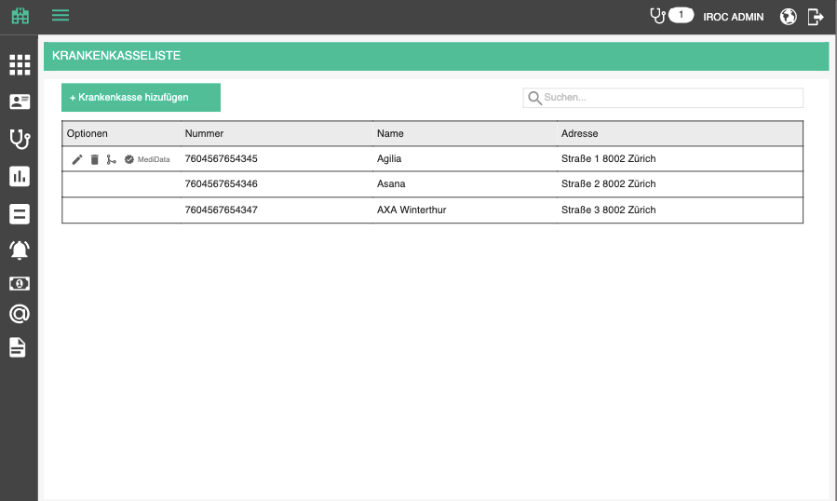

Overview is a table which contains all HIPs which are added to the tenant database. It contains the following columns:
- Options / Optionen (edit, delete, merge, approve by MediData, deactivate)
- GLN, GLN - IK number
- Title / Name - title of the HIP company
- Address / Adresse - Concatenated address <street> <number>, <ZIP> <City>, <Country>

The list should be sortable by all columns (except options, of course). Default sorting is by number.
The list should be search-able by all columns too. Search starts as soon as you type, but with a small debounce. Check the rest of the app for guidance.

When the searched list is empty, display the following text instead of the first row:
- There are no matching HIPs for this search criteria. / Es gibt keine passenden Krankenkassen für diese Suchkriterien.

When the list is empty in general, display the following text instead of the first row:
- There are no HIPs defined. / Es gibt keine definierten Krankenkassen.

Add / edit HIP

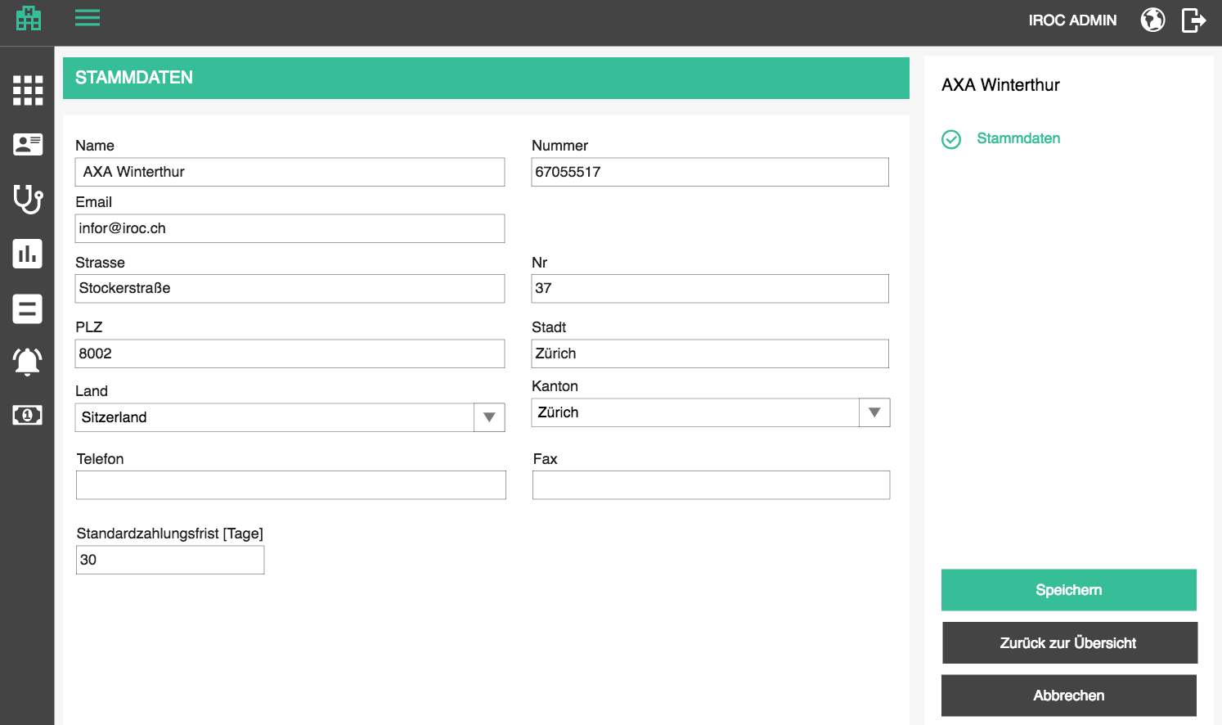

Adding and editing relies on the same form, only in case of editing, the data will be prifilled with existing data. In the top right corner, the title of the currently added / edited HIP is displayed and changes whenever the user changes title.

Adding an HIP is started by clicking on the add button above the table
- Add HIP / Krankenkasse hinzufügen

Editing is started by clicking on the edit button in the corresponding row in the table
- Edit HIP / Krankenkasse bearbeiten

Base data is opened by default and there the user can specify the following attributes
- Base data / Stammdaten - page title
- Title / Name - text, mandatory
- Number / Nummer - text, mandatory, unique
- Email / Email - optional, valid email format
- Street / Strasse - optional
- Nr / Nr - optional
- ZIP / PLZ - optional
- City / Stadt - optional
- Country / Land - optional, catalog entry, see patients edit page
- Canton / Kanton - optional, catalog entry, see patients edit page. Only visible for countries which have defined cantons
- Phone / Telefon - optional, work phone entry
- Fax / Fax - optioanl, fax entry
- Default payment deadline [Days] / Standardzahlungsfrist [Tage] - useful for creating bills, because the user won't have to enter payment deadline if it is defined here; must be a whole positive number

When supplying the address, when ZIP code is selected, city and country should be preselected, at least in Switzerland.

The page offers 3 standard buttons:

- Save / Speichern - executes all the validations and displays errors if necessary, otherwise saves the changes and displays the success message
- (if adding new) HIP has been successfully created. / Krankenkasse wurde erfolgreich erstellt.
- (if editing) HIP has been successfully updated. / Krankenkasse wurde erfolgreich aktualisiert.

- Cancel / Abbrechen - go back to overview without saving changes
- Back to overview / Zurück zur Übersicht - go back to overview without saving changes

If the user tries to leave the page after some changes have been made but not yet saved, the app will warn them with the standard "Are you sure you want to leave this page..." popup. This functionality should be applied to all pages, always.

Delete HIP

If the HIP has been assigned to a patient, the delete icon will be disabled with the following tooltip as explanation:
- It is not possible to delete a HIP which has been assigned to a patient. / Es ist nicht möglich, eine Krankenkasse zu löschen, die einem Patienten zugewiesen wurde.

If the HIP was not assigned to any patients, the user can delete it. Upon clicking on the delete icon, the user will be prompted by a standard confirmation popup.
- Delete HIP / Krankenkasse löschen
- Are you sure you want to delete <Hip name>? / Sind Sie sicher, dass Sie <Hip name> löschen möchten?

Deactivate HIP

Hip deactivation can be used for disabling the users from using a record which is incorrect or redundant. The user can start deactivation manually, by clicking on deactivate icon
- Deactivate / Deaktivieren
- Are you sure you want to deactivate <GLN: hip name>? / Sind Sie sicher, dass Sie <GLN: hip name> deaktivieren möchten?

Deactivated HIPs cannot be chosen anywhere else in the app. They are visible only in HIP administration as grayed out.

Deactivated HIPs can be re-activated by clicking on the icon
- Activate / Aktivieren
- Are you sure you want to activate <GLN: hip name>? / Sind Sie sicher, dass Sie <GLN: hip name> aktivieren möchten?

Merge HIP

If the HIP has been assigned to patients, the user will have an option to merge one HIP into another instead of deleting it. Merging functions the same way as merging patients.

- Merge into another HIP / Mit bestehender Krankenkasse zusammenführen.

A popup is opened where the user can search for existing health insurances based on title and number. By default we will search for the health insurance title as soon as the popup is opened. Title search looks for 80%+ matches. Number only total matches.

When a target health insurance is selected, the merge button is enabled and the operation can be done.
- Merge / Zusammenführen

When an HIP is merged into another one, the connections to patients are replaced with target HIP.
Important: If a bill has an HIP as recipient and the bill is signed, the recipient must not be replaced.

Approve HIP

Various entities offer lists of health insurances which can be used to verify HIP data and make sure that bills are sent to correct recipients.

The first such entity will be MediData.

When a health insurance data are saved, they should be checked against the directory of all available entities, in our case, just MediData. For every entity, if the saved HIP data matches, add the stamp of approval to the saved HIP. Display every stamp of approval for every HIP in the overview.

The approval process is also triggered for every load of the data, in case the directory has changed in the meantime.

If an HIP did not pass the approval, a red icon will be displayed with a tooltip explaining what is wrong.
- Problems: / Probleme:
  - HIP with this GLN is not in the directory / Krankenversicherung mit dieser GLN befindet sich nicht im Verzeichnis
  - Title does not match the directory entry / Name stimmt nicht mit dem Verzeichniseintrag überein
  - City does not match the directory entry / Ort stimmt nicht mit dem Verzeichniseintrag überein
  - Street name does not match the directory entry / Strasse stimmt nicht mit dem Verzeichniseintrag überein
  - ZIP does not match the directory entry / PLZ stimmt nicht mit dem Verzeichniseintrag überein

Price lists
Price lists are used to effectively track product / article prices over time and enable vendors to quickly switch prices of their products based on: season, sale, happy hour, etc. It is important that we keep a history of prices over time in cases we are, e.g. making a bill for a services delivered in the past.

There are two types of price lists:
- sales price lists - in these we define sales prices of the products we offer to our customers
- Procurement price lists - in these we keep the procurement prices of the articles we have on stock, which we order from our suppliers (these are usually provided to us by our suppliers with product catalogs)

Price list overview

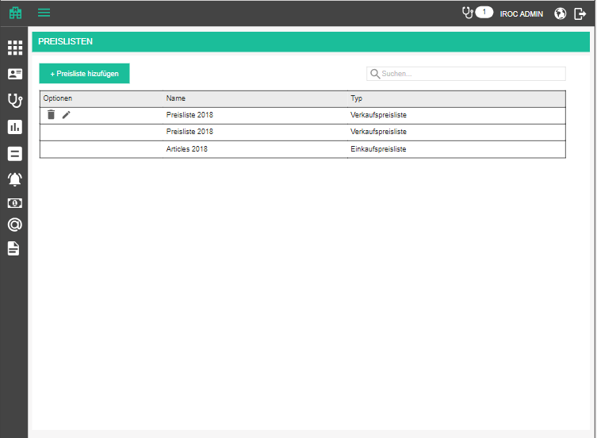

Overview is a table which contains all price lists which are added to the tenant database. It contains the following columns:
- Options / Optionen (edit, delete)
- Title / Name - title of the price list
- Type / Typ -
- Procurement price list / Einkaufspreisliste
- Sales price list / Verkaufspreisliste

The list should be sortable by all columns (except options, of course). Default sorting is by title, alphabetically.
The list should be search-able by all columns too. Search starts as soon as you type, but with a small debounce. Check the rest of the app for guidance.

When the searched list is empty, display the following text instead of the first row:
- There are no matching price lists for this search criteria. / Es gibt keine passenden Preislisten für diese Suchkriterien.

When the list is empty in general, display the following text instead of the first row:
- There are no price lists defined. / Es gibt keine definierten Preislisten.

Add / edit price list

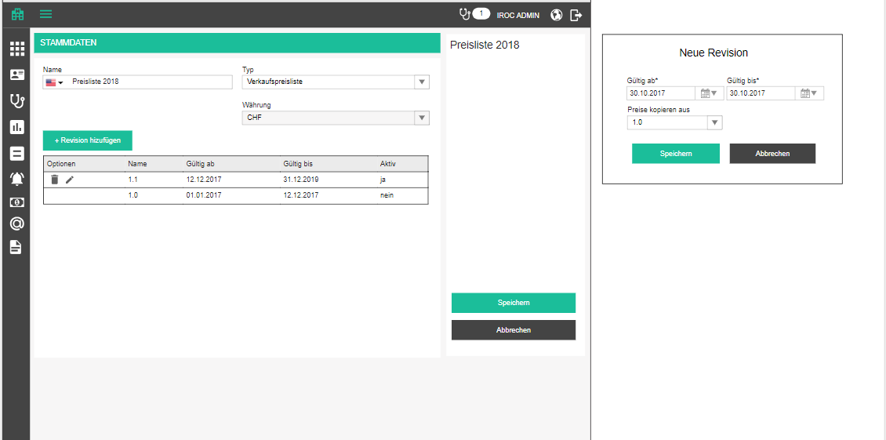

Adding and editing relies on the same form, only in case of editing, the data will be prefilled with existing data. In the top right corner, the title of the currently added / edited price list is displayed and changes whenever the user changes title.

Adding a price list is started by clicking on the add button above the table
- Add price list / Preisliste hinzufügen

Editing is started by clicking on the edit button in the corresponding row in the table
- Edit price list / Preisliste bearbeiten

Base data is opened by default and there the user can specify the following attributes
- Base data / Stammdaten - page title
- Title / Name - dict text box, mandatory
- Type / Typ - dropdown
- Procurement price list / Einkaufspreisliste
- Sales price list / Verkaufspreisliste
- Currency / Währung - CHF is pre selected and disabled

Price list revisions

Each price list must have at least one revision, so it makes sense to create one automatically when a new price list is created. Price list revision is actually the entity which contains product / article prices. This is like a history of a price list.

Note: Since it can happen that a price of a product / article does not change over a long period of time, whereas prices of some products can change rapidly, it will be a common occurrence that one product does not have prices defined in every revision. Basically, we will not copy an unchanged value from one revision to another.

Revision overview

The table contains all price list revisions which are added to the current price list. It contains the following columns:
- Options / Optionen (edit, delete)
- Title / Name - title of the price list
- Valid from / Gültig ab
- Valid to / Gültig bis
- Active / Aktiv
  - yes / ja - if current date falls between valid from i valid to
  - No / nein - otherwise

The list should be sortable by all columns (except options, of course). Default sorting is by title, alphabetically.
The list should be search-able by all columns too. Search starts as soon as you type, but with a small debounce. Check the rest of the app for guidance.

Add / edit revision

Adding a price list revision is started by clicking on the add button above the table
- Add revision / Revision hinzufügen

Editing is started by clicking on the edit button in the corresponding row in the table
- Edit revision / Revision bearbeiten

A popup is opened and there the user can specify the following attributes
- Valid from / Gültig ab - date box, mandatory, inclusive start date
- Valid to / Gültig bis - date box, mandatory, exclusive end date
- Copy prices from / Preise kopieren aus - dropdown with all other revisions, from latest to first
  - Selecting this will copy all prices for all products on save
- Save / Speichern
- Cancel / Abbrechen

Important: Price list revision validity cannot overlap in any situation. There can be a gap in validity between two price list revisions. If start date is smaller than end date of another revision OR end date or larger or equal to start date of another revision, it is not possible to save it and the user gets the following validation tooltip:
- This revision overlaps with <revision name> ( <valid from> - <valid to>). / Diese Revision überlappt sich mit <revision name> ( <valid from> - <valid to>).

Note: Name of a new price list is always a number, increased by one from the latest revision.

Delete revision

If the revision has been assigned to a published catalog, the delete icon will be disabled with the following tooltip as explanation:
- It is not possible to delete a price list revision associated with a published catalog. / Es ist nicht möglich, eine Preislistenrevision zu löschen, die einem veröffentlichten Katalog zugeordnet ist.

If the revision was not assigned to any published catalogs, the user can delete it. Upon clicking on the delete icon, the user will be prompted by a standard confirmation popup.
- Delete price revision list / Preislistenrevision löschen
- Are you sure you want to delete <price list name>? / Sind Sie sicher, dass Sie <price list name> löschen möchten?

The page offers 3 standard buttons:

- Save / Speichern - executes all the validations and displays errors if necessary, otherwise saves the changes and displays the success message
- (if adding new) Price list has been successfully created. / Preisliste wurde erfolgreich erstellt.
- (if editing) Price list has been successfully updated. / Preisliste wurde erfolgreich aktualisiert.

- Cancel / Abbrechen - go back to overview without saving changes
- Back to overview / Zurück zur Übersicht - go back to overview without saving changes

If the user tries to leave the page after some changes have been made but not yet saved, the app will warn them with the standard "Are you sure you want to leave this page..." popup. This functionality should be applied to all pages, always.

Delete price list

If the price list has been assigned to a published catalog, the delete icon will be disabled with the following tooltip as explanation:
- It is not possible to delete a price list associated with a published catalog. / Es ist nicht möglich, eine Preisliste zu löschen, die einem veröffentlichten Katalog zugeordnet ist.

If the price list was not assigned to any published catalogs, the user can delete it. Upon clicking on the delete icon, the user will be prompted by a standard confirmation popup.
- Delete price list / Preisliste löschen
- Are you sure you want to delete <price list name>? / Sind Sie sicher, dass Sie <price list name> löschen möchten?

Products

Since we will need to define product-based billable block positions (more about that later), we will need product administration. Product administration can get very tricky and complex, but for our needs, a few simple pages will be enough. Zugseil product has the most complex product administration and therefore covers all the aspects of product management. Check this section for details on how to make PM and Zugseil cooperate. Everything regarding products must be fully compatible with new Zugseil's API.

When talking about a product, we are actually talking about a pair of entities: product and article. Read all about the differentiation here. Bottom line is: PM will not have an obvious differentiation between products and articles and they will always be edited as one (if editing is possible).

Articles (physical instances of products) are put on stock in warehouses, storage rooms, shelves, etc. For every tenant, we need to create a default storage hierarchy. This means we will have one warehouse group, which has only one warehouse, which has only one warehouse area, which has only one rack, which has only one shelf.
- Default warehouse group / Standard-Lagergruppe
- Default warehouse / Standardlager
- Default warehouse area / Standard-Lagerfläche
- Default rack / Standard-Rack
- Default shelf / Standardregal

Product overview

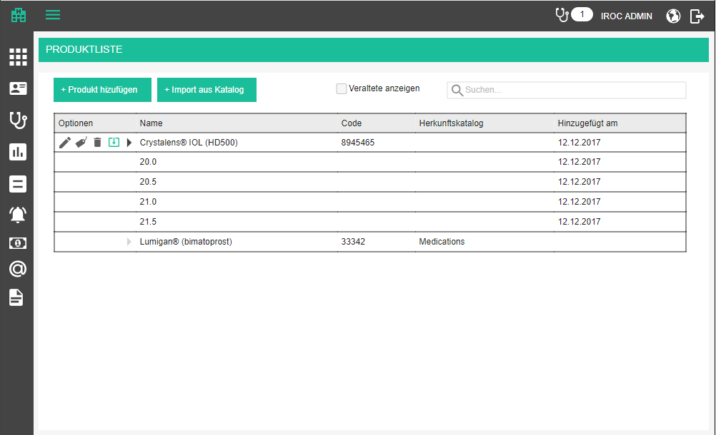

We will need a new administration menu point
- Products / Produkte

Overview is a table which contains all products and their variants which are added to the tenant database. It contains the following columns:
- Options / Optionen (edit, delete, prices, update)
- Title / Name - title of the product
- Code / Code - ID of the product
- Origin catalog / Herkunftskatalog - name of the catalog from which the product stems (if it is from a catalog)
- Added on / Hinzugefügt - date when the product was created (manually or imported from a catalog)

Products which have variants can be expanded and collapsed, like the Appointment types and their variants, except variants do not have a special edit page because they will be administered on a tab of product form, so they don't have controls like edit and delete. Products without variants have have a disabled expand button. Variant names are indented.

The list should be sortable by all columns (except options, of course). Default sorting is by title, alphabetically.
The list should be search-able by name, code and catalog. Search starts as soon as you type, but with a small debounce. Check the rest of the app for guidance. If the search criteria matches a variant and not it's parent product, show the parent in the overview too (no sense in displaying variants without products). When search criteria meats only a product and none of its variants, display just the product in the search results. The product will not be expandable in that case.

When the searched list is empty, display the following text instead of the first row:
- There are no matching products for this search criteria. / Es gibt keine passenden Produkte für diese Suchkriterien.

When the list is empty in general, display the following text instead of the first row:
- There are no products defined. / Es gibt keine definierten Produkte.

Add / edit product

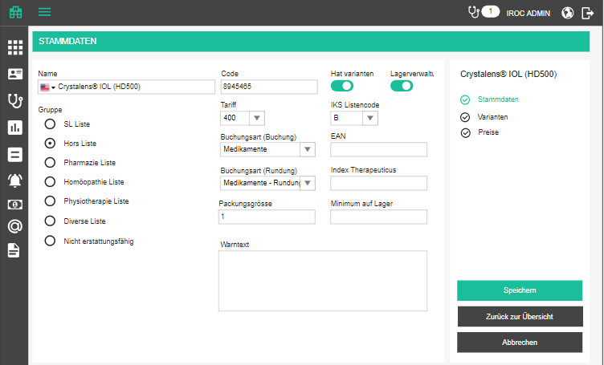

Adding and editing relies on the same form, only in case of editing, the data will be prefilled with existing data. In the top right corner, the title of the currently added / edited product is displayed and changes whenever the user changes title.

Adding a product is started by clicking on the add button above the table
- Add product / Produkt hinzufügen

Editing is started by clicking on the edit button in the corresponding row in the table
- Edit product / Produkt bearbeiten

Note: Products attached to an article coming from a catalog are open in read-only mode. Only prices can be changed.

Base data

Base data / Stammdaten form is opened by default and there the user can specify the following attributes
- Title / Name - dict text box, mandatory
- Code / Code - text, mandatory, unique, human readable ID (pharmacode code for example)
- Has variants / Hat varianten - a checkbox disguised as a switch
- Stock control / Lagerverwaltung - checkbox whether or not a quantity is taken off stock when this product is added to a bill
- Group / Gruppe
  - SL List / SL Liste (always reimbursed by HIP)
  - Hors List / Hors Liste (can be taken over by supplementary health insurance, not mandatorily)
  - Pharmacy List / Pharmazie Liste
  - Homeopathy List / Homöopathie Liste
  - Physiotherapy List / Physiotherapie Liste
  - Miscellaneous List / Diverse Liste
  - Not refundable / Nicht erstattungsfähig (never reimbursed by HIP)
- Tariff / Tariff - needed for TARMED billing; dependant on reimbursement group
- Pharmacode / Pharmacode - swiss specific medication code
- Index Therapeuticus / Index Therapeuticus - another swiss specific medication code
- IKS list code / IKS Listencode - prescription class (A,B,C,D, etc; whether or not the medication can be bought over the counter or only per prescription or other)
- Warning text / Warntext - special warnings
- Package size / Packungsgrösse - how many units come in a package
- Minimum quantity on stock / Minimum auf Lager - for reminder to reorder
- Booking type (booking) / Buchungsart (Buchung) - needed for bookkeeping statistics
- Booking type (rounding) / Buchungsart (Rundung) - needed for bookkeeping statistics; service and medication positions on a bill are rounded to 2 decimal points, and the rest is booked against this booking type

Variants

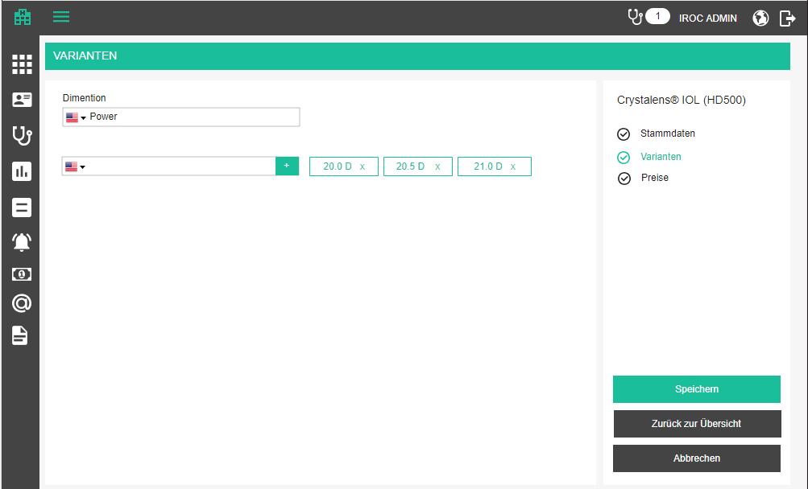

Variants tab can be selected by the user and contains all the variants of this product (if available). If the switch "has variants" is set to NO, than this tab does not even exist.
- Variants / Varianten - title of the page and tab
- Dimension / Dimension - dict text box, mandatory
- Dimension value / Dimensionswert - tag like component with dict text box; at least one must be added; adding is done when the user presses enter or the “+” button
- Add value / Wert hinzufügen

Note: Each product should have a default variant in the background which is active when there are no user-defined variants. It is never visible in the UI, but is used in the background, so a product without variants actually has one invisible default variant.

Deleting a variant

If the product (or any of its variants) has been assigned to a billable block position or bill position, or shipment position, or customer order position (meaning its default variant has been assigned), the delete icon will offer the following explanation:
- It is not possible to delete a variant which has already been used. If you proceed, the product will be marked as obsolete and will not be available for use in the future. / Es ist nicht möglich, ein bereits verwendete Variante zu löschen. Wenn Sie fortfahren, wird die Variante als veraltet gekennzeichnet und steht in Zukunft nicht mehr zur Verfügung.

If the variant was not been used, the user can delete it. Upon clicking on the delete icon, the user will be prompted by a standard confirmation popup.
- Delete variant / Variante löschen
- Are you sure you want to delete <variant title>? / Sind Sie sicher, dass Sie <variant title> löschen möchten?

Note: since product and article behave as one and the same in PM, make sure to delete the corresponding article variant too.

Note: obsolete variants should be marked with critical color, or strikethrough, to make it obvious to the user. These variants will not have any options available.

Prices

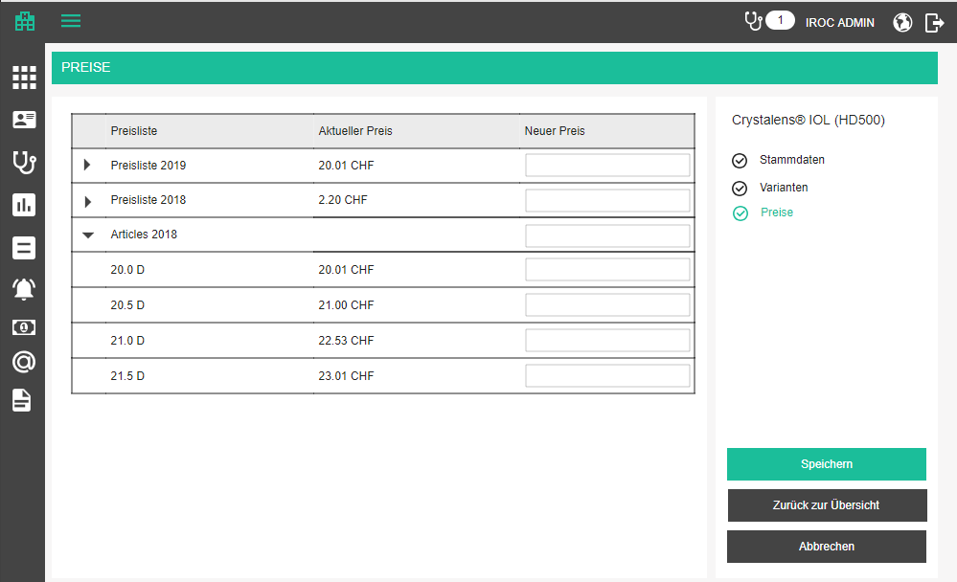

Prices / Preise - title of the tab

The table contain the following columns:
- Price list / Preisliste - name of the price list
- Current price / Aktueller Preis - current price, right aligned, 2 decimal points + currency; this is the last price ever defined for a product, not necessarily in the active revision, because the price for one product may not have changed for years
- New price / Neuer Preis - text box, displayed only if the corresponding price list has an active revision (in which we could enter the new price); Any number is a valid entry. Aligned to the right, with two decimal points

Product prices come from pricelists. We will enable the user to define price for every product (variant) for every sales price list. If a product has variants, every price list is expandable, so that the user can define a price for each variant.

If a price is defined on a product level, and not on a variant level, whenever this variant is used, it will use the product price. Every newly defined price is written into the active price list revision.

The edit page offers 3 standard buttons:

- Save / Speichern - executes all the validations and displays errors if necessary, otherwise saves the changes and displays the success message
- (if adding new) Product has been successfully created. / Produkt wurde erfolgreich erstellt.
- (if editing) Product has been successfully updated. / Produkt wurde erfolgreich aktualisiert.

- Cancel / Abbrechen - go back to overview without saving changes
- Back to overview / Zurück zur Übersicht - go back to overview without saving changes

If the user tries to leave the page after some changes have been made but not yet saved, the app will warn them with the standard "Are you sure you want to leave this page..." popup. This functionality should be applied to all pages, always.

Import from catalog

Whenever a catalog item is used (e.g. put on a bill) an article (variant) has to be instantiated in the tenant database. We have to create both the article and a product (see details about the differences here). After that, if a new version of the origin catalog is available, the product / article is marked as “outdated” in the UI and there is an option available to update it with the new data.
- New version available. Click here to update. / Neue Version verfügbar. Klicken Sie hier, um zu aktualisieren.

Have in mind that updating from new catalog version actually updates the article. The corresponding product is updated based on update rules, e.g. whether a change in article picture updates product picture, whether a change in article name updates the product name, etc. These are not needed for PM purposes. We will always updated all details of a product based on article changes.

Whenever an article (and product) is imported from a catalog, we need to adjust the procurement price. Every product catalog will be published together with a revision of a pricelist and the current price of each article in it. This means that we have to create a procurement price list if the price of an article (variable) has changed, upon importing an article into the tenant database.

When we are updating an article, we also have to update the prices in the active price list revision. Have in mind that the new version of the catalog may have come with a new price list revision. If so, we will need to create a new procurement price list revision to store the prices.

What happens to the sales prices (prices of products)? Since everything we update an the article side reflects on product side, the prices should as well. If there are no sales price lists in the system we will have to create one when creating products and create an active revision for it when importing something from a catalog. That should be the default price list which we always use. When we are importing something from a new version of a catalog, if the pricelist revision has changed, corresponding procurement price list will get a new revision (naturally), but so will the default sales price list. This revision should have the validity start of the catalog revision validity start, and if the article from the catalog has a different “maximum retail price” from the product’s current sales price, we put the new MRT as the new sales price of a product. This way we save the user some time for defining prices.

Manual update / import from catalog

In the product list, the user can start manual import of the products / articles from a catalog by clicking on the button
- Import from catalog / Import aus Katalog

Pressing the button will open a popup where the user can chose a catalog and one of it’s revisions (first catalog and its latest revision are selected automatically) and choose one or more articles to import. There is a filter box for filtering based on code and name. The table below is scrollable (infinite scroll, catalog can have thousands of items) and sortable and displays the following article data
- Code / Code
- Title / Name

When the user checks a couple of articles and presses Import button, the same procedure is applied for every article, as when importing on usage or updating when a new catalog version is available.

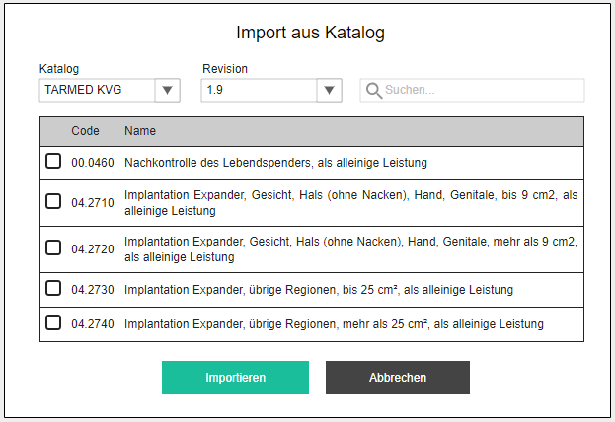

Delete / obsolete product

If the product (or any of its variants) has been assigned to a billable block position or bill position, or shipment position, or customer order position (meaning its default variant has been assigned), the delete icon will offer the following explanation:
- It is not possible to delete a product which has already been used. If you proceed, the product will be marked as obsolete and will not be available for use in the future. / Es ist nicht möglich, ein bereits verwendetes Produkt zu löschen. Wenn Sie fortfahren, wird das Produkt als veraltet gekennzeichnet und steht in Zukunft nicht mehr zur Verfügung.

If the product has not been used, the user can delete it. Upon clicking on the delete icon, the user will be prompted by a standard confirmation popup.
- Delete product / Produkt löschen
- Are you sure you want to delete <product title>? / Sind Sie sicher, dass Sie <product title> löschen möchten?

Note: Deleting or obsoleting a product will delete / obsolete all its variant.

Note: since product and article behave as one and the same in PM, make sure to delete the corresponding article too.

Note: obsolete products should be marked with critical color, or strikethrough, to make it obvious to the user. These products will not have any options available.

Using correct product prices
When adding product (variant) to a bill, we need to select the correct sales price. We will always take the default sales price list, find the revision which was active at the time of shipment and take the sales price from it. If there is no price defined in that revision, we go back in time through the revisions and take the latest supplied price. If none was ever specified, the price to put on the bill is zero.

Product inventory

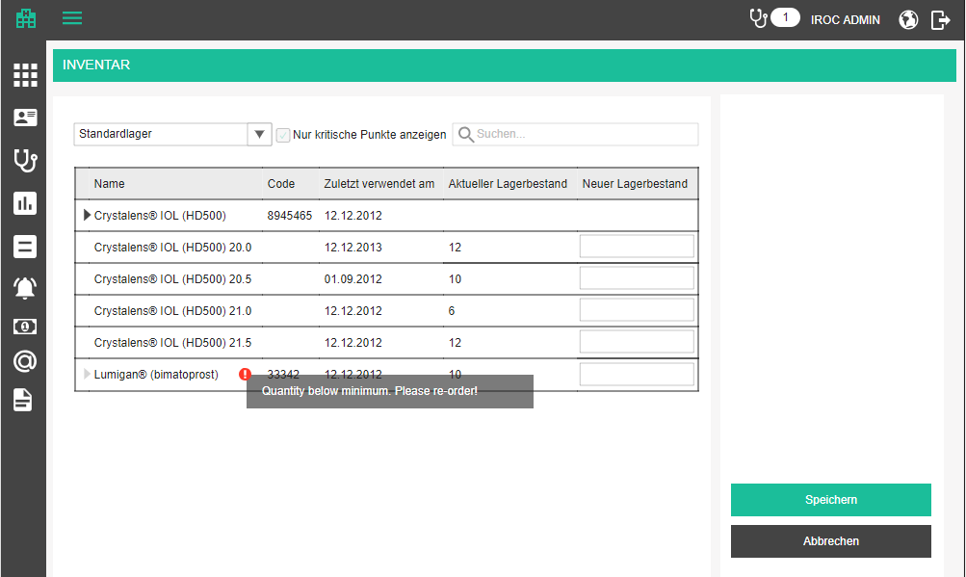

This is a page where the user can adjust the stock quantity for every article and variant in the list. Users will most likely use this for the more expensive articles like intra-ocular lenses, but for cheap eye drops and painkillers they use on regular basis, they will probably just ignore it. Nevertheless, we are hoping that they will get used to this functionality and find it useful, because keeping an up-to-date stock status can later provide input for algorithms for auto-replenishing or at least notifying the users that the stock is running low for some products and that they should be re-ordered.

Table is sortable by all columns.

- Inventory / Inventar - title on the page and menu point in the app
- Lager / Storage - dropdown where the user selects which storage they are doing the inventory for; it’s a tree view where the user actually selects a shelf
- Search / Suchen - same functionality as on the products overview page

The table is also similar to the product overview page, but unlike product overview, this page displays only articles (not products). Articles are expandable if they have variants. Articles without variants have a default variant in the background.
- Title / Name
- Code / Code
- Last used on / Zuletzt verwendet am - date when this article was last taken from stock
- Current stock quantity / Aktueller Lagerbestand - current quantity of the article/variant in the selected warehouse
- New stock quantity / Neuer Lagerbestand - new quantity entered by the user. Must be a positive number. Empty is ignored

We will always display all articles in the system which have been marked for logistic handling, and if they have never before been added to stock, their current quantity will be zero.

- Save / Speichern - executes all the validations and displays errors if necessary, otherwise saves the changes and displays the success message
- Stock quantity has been successfully updated. / Lagerbestand wurde erfolgreich aktualisiert.

Low stock warning

If the current quantity of an article (variant) is lower than the minimum quantity setting (if this is defined at all), that article (variant) will be marked with a warning icon and a tooltip which says:
- Quantity below minimum. Please re-order! / Die Menge liegt unter dem Minimum. Bitte nachbestellen!

Printing (WRB)

Up to now, we only had one printable report - the appointment slip. This report was prepared in an old version of the application which hosted the WRB tool. With billing, we have the need to create a printable report for bill(group) and payment instructions. In order to achieve this, we need an administration section for report templates which will host the WRB tool.

WRB is a web report builder, a javascript application which can be hosted in any other web application. Based on given parameters, it will enable the user to create a jasper template in an WYSIWYG environment. Basically, it enables the users to define their own reports, or adjust the provided ones, without having to hire a developer team. The tool itself is suboptimal at this point, but is still quicker to use than specifying a report for a dev team and contact them for minor adjustments. The created jasper template is merged with data by an application and sent to PCH (a b-op v3 component) which connects with PCA (another b-op v3 component) installed in the customer's local network with access to physical printers, and supplies a print job for a chosen printer.

To create report templates, we will need the following:

Template overview

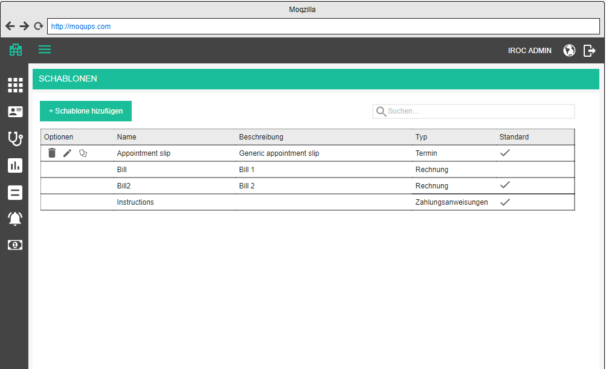

Overview is a table which contains all templates which are added to the tenant database. It contains the following columns:
- Options / Optionen (edit, delete)
- Title / Name - title of the template
- Description / Beschreibung - explanation of the template
- Type / Typ - type of the template
- Default / Standard - whether or not this template is the default one for its type. For example, if we have multiple templates for appointment slip printing, when appointment slip printing is started, if no special template is selected, the default one will be printed

The list should be sortable by all columns (except options, of course). Default sorting is by title, alphabetically.
The list should be search-able by title and description. Search starts as soon as you type, but with a small debounce. Check the rest of the app for guidance.

When the searched list is empty, display the following text instead of the first row:
- There are no matching templates for this search criteria. / Es gibt keine passenden Schablone für diese Suchkriterien.

When the list is empty in general, display the following text instead of the first row:
- There are no templates defined. / Es gibt keine definierten Schablone.

Add / edit template

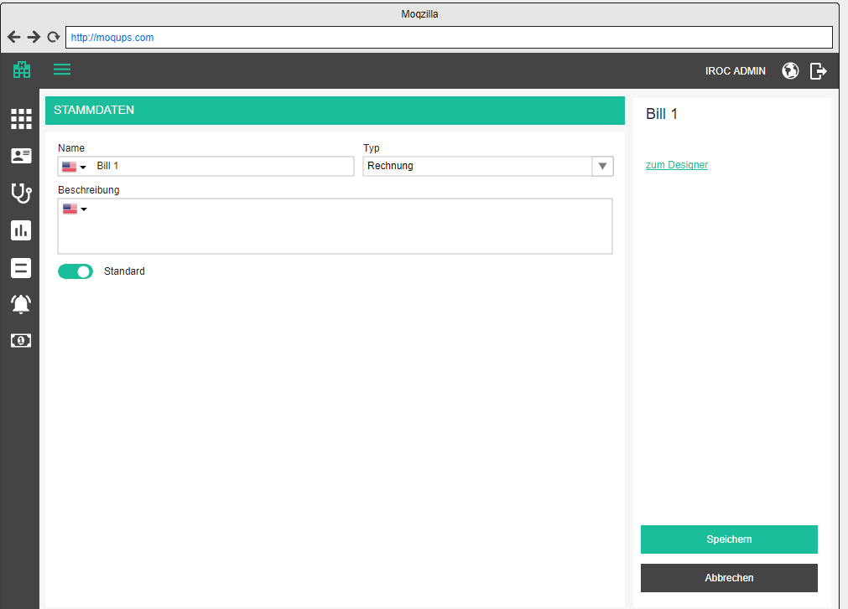
Adding and editing relies on the same form, only in case of editing, the data will be prifilled with existing data. In the top right corner, the title of the currently added / edited template is displayed and changes whenever the user changes title.

Adding a template is started by clicking on the add button above the table
- Add template / Schablone hinzufügen

Editing is started by clicking on the edit button in the corresponding row in the table
- Edit template / Schablone bearbeiten

Base data/ Stammdaten is opened by default and there the user can specify the following attributes
- Title / Name - dict text box, mandatory
- Type / Typ - dropdown, mandatory, filled with predefined values for the tenant
- Description / Deschreibung - dict text area, optional
- Default / Standard - switch button, false by default. Only one template can be default for a type, selecting one will unselect all others

The page offers 3 standard buttons:

- Save / Speichern - executes all the validations and displays errors if necessary, otherwise saves the changes and displays the success message
- (if adding new) Template has been successfully created. / Schablone wurde erfolgreich erstellt.
- (if editing) Template has been successfully updated. / Schablone wurde erfolgreich aktualisiert.

- Cancel / Abbrechen - go back to overview withought saving changes
- Back to overview / Zurück zur Übersicht - go back to overview withought saving changes

If the user tries to leave the page after some changes have been made but not yet saved, the app will warn them with the standard "Are you sure you want to leave this page..." popup. This functionality should be applied to all pages, always.

Delete template

Upon clicking on the delete icon, the user will be prompted by a standard confirmation popup.
- Are you sure you want to delete <template title>? / Sind Sie sicher, dass Sie <template title> löschen möchten?

Design template

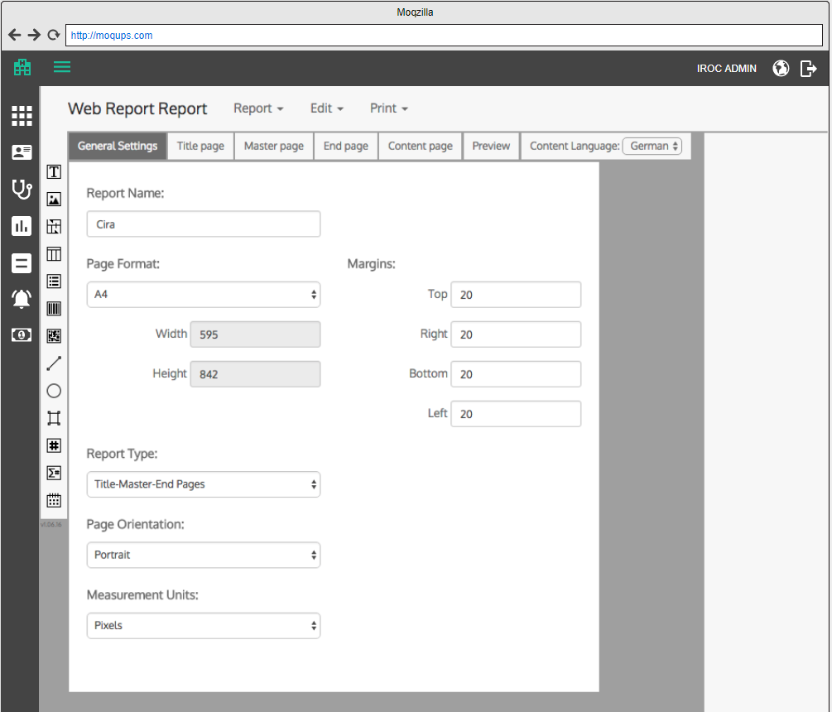

This page hosts the WRB tool. It is reached by clicking on Designer button in the corresponding row in the table or by pressing the Go to designer / Zum Designer link in the base data screen.

Numberranges

Number ranges are essentially a way to generate bill numbers, shipment slip numbers and any other numbers which have to conform to a format like PA000043, meaning they have a prefix, followed by a fixed number of digits which may or may not need padding so they have an uniform length. It may seem that it’s easer to just generate them from the code itself, but that is a very rigid approach because the user cannot change how the numbers are formed.

Consider this example: One customer wants to generate bill numbers as RExxxxxx where the first two digits represent the calendar year and a different one does not need the year number but rather just the incremental number. We would have to implement different number generating methods. What if the third customer wants a totally different schema? And if they all have different schemas for bills, staff, shipping slips, etc. That can easily make a mess in our codebase…

In number ranges, we let the user define the format of the generated numbers and assign them to various entities which we create (e.g. bills), together with the validity time ranges. That way a user can say that they wish to use one number range this year, and another one from next year.

Menu item: Number ranges / Nummernkreise

Number ranges overview

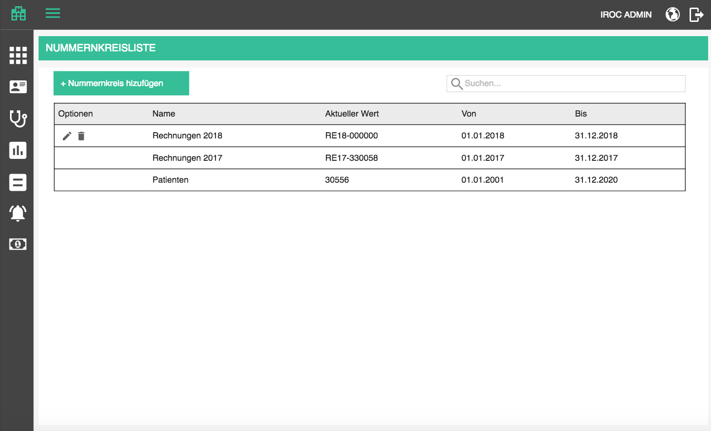

Overview is a table which contains all number ranges which are added to the tenant database. It contains the following columns:
- Options / Optionen (edit, delete)
- Title / Name - title of the number range company
- Current value / Aktueller Wert - the next value which will be used
- Valid from / Gültig ab - date from which the numberrange is valid (inclusive)
- Valid to / Gültig bis - date from which the numberrange is valid (exclusive)

The list should be sortable by all columns (except options, of course). Default sorting is by title, alphabetically.
The list should be search-able by title. Search starts as soon as you type, but with a small debounce. Check the rest of the app for guidance.

When the searched list is empty, display the following text instead of the first row:
- There are no matching number ranges for this search criteria. / Es gibt keine passenden Nummernkreise für diese Suchkriterien.

When the list is empty in general, display the following text instead of the first row:
- There are no number ranges defined. / Es gibt keine definierten Nummernkreise.

Add / edit number range

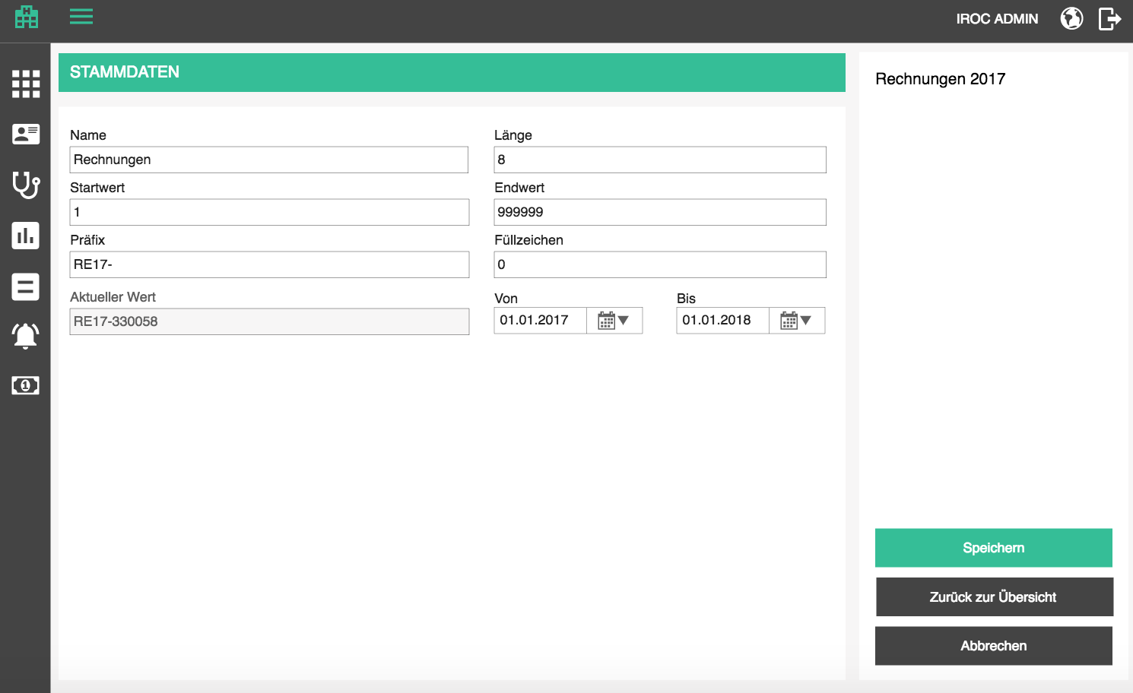

Adding and editing relies on the same form, only in case of editing, the data will be prefilled with existing data. In the top right corner, the title of the currently added / edited number range is displayed and changes whenever the user changes title.

Adding a number range is started by clicking on the add button above the table
- Add number range / Nummernkreis hinzufügen

Editing is started by clicking on the edit button in the corresponding row in the table
- Edit number range / Nummernkreis bearbeiten

Base data / Stammdaten is opened by default and there the user can specify the following attributes
- Title / Name - dict text box, mandatory
- Length / Länge - mandatory, must be positive whole number, 6 by default
- Start value / Startwert - mandatory, must be positive whole number, smaller or equal to maximum number of specified length, 0 by default
- Must be smaller or equal to end value / Muss kleiner oder gleich dem Endwert sein
- End value / Endwert - optional, must be positive whole number, larger or equal to start value, smaller or equal to maximum number of specified length, larger or equal to start value;, 999999 by default
- Must be larger or equal to start value / Muss größer oder gleich dem Startwert sein
- Must be smaller or equal to the maximal number in this number range / Muss kleiner oder gleich der maximalen Anzahl in diesem Nummernbereich sein
- Prefix / Präfix - optional, string, empty by default
- Fill character / Füllzeichen - mandatory, one character or digit, used for padding
- Maximum length: 1 / Maximale Länge: 1
- Current value / Aktueller Wert - read-only field, shows the next value which will be used
- Valid from / Gültig ab - date from which the numberrange is valid (inclusive), must be smaller or equal to to date
- Valid to / Gültig bis - date from which the numberrange is valid (exclusive), , must be larger or equal to from date

Whenever a number range is used for creating a new number for, e.g. bill, the current value is updated so that the next usage just picks up that value.

If we create a number range with these values:

Title: Bills
Length: 8
Start value: 7
End value: 999999
Prefix: RE-17-
Fill: 0

Current value will immediately be: RE-17-0000007

And when we “use” the number range next time, we will take the current value, and update it to RE-17-00000008 and so on...

The page offers 3 standard buttons:

- Save / Speichern - executes all the validations and displays errors if necessary, otherwise saves the changes and displays the success message
- (if adding new) Number range has been successfully created. / Nummernkreis wurde erfolgreich erstellt.
- (if editing) Number range has been successfully updated. / Nummernkreis wurde erfolgreich aktualisiert.

- Cancel / Abbrechen - go back to overview withought saving changes
- Back to overview / Zurück zur Übersicht - go back to overview withought saving changes

If the user tries to leave the page after some changes have been made but not yet saved, the app will warn them with the standard "Are you sure you want to leave this page..." popup. This functionality should be applied to all pages, always.

Delete number range

If a number range is assigned to an entity currently (like cost center), the delete icon will be disabled with the following tooltip as explanation:
- It is not possible to delete a number range which is currently in use. / Es ist nicht möglich, einen Nummernkreis zu löschen, der gerade verwendet wird.

If the number range is not in use, the user can delete it. Upon clicking on the delete icon, the user will be prompted by a standard confirmation popup.
- Delete number range / Nummernkreis löschen
- Are you sure you want to delete <number range name>? / Sind Sie sicher, dass Sie <number range name> löschen möchten?

Using number ranges

The code which generates the bill number will have to look into number range assignment of the cost center which is used for that bill. Based on that assignment, take the current number range value to assign to, e.g. bill and generate the next value.

If the app could not find a valid number range assignment (no assignment is made or the assigned numberrange is not valid any more), display the following error message. The operation cannot be completed.
- There is no valid number range to generate a <bill/shipment slip/something else> number. Please contact the administrator. /
Es gibt keinen gültigen Nummernkreis, um die Nummer der <Rechnung / Sendungsbeleg / etwas anderes> zu estellen. Bitte wenden Sie sich bitte an den Administrator.

If generating a new value after taking the current one is not possible because the end number has been reached, display the following warning message. The operation can be finished successfully, because there already was a valid current number.
- The number range used to generate a the <bill/shipment slip/something else> number has reached the maximum. Please adjust it or create a new one in the Number ranges administration. If you cannot find the administration page, it may be due to your rights - please contact the administrator. /
Der Nummernkreis, mit dem die Nummer der <Rechnung / Sendungsbeleg / etwas anderes> generiert wird, hat das Maximum erreicht. Bitte aktualisieren Sie sie diesen Nummernkreis oder erstellen Sie einen neuen in der Nummernkreisverwaltung. Wenn Sie die Verwaltungsseite nicht finden können, liegt das möglicherweise an Ihren Rechten - wenden Sie sich bitte an den Administrator.

Email templates

Email templates are used to specify emails with placeholders which will be used to send patients email notifications automatically or manually. At first we will have simple, plain text messages, but this may evolve into complex html formatted emails/

Menu item: Email templates / Email Schablonen

Email templates overview

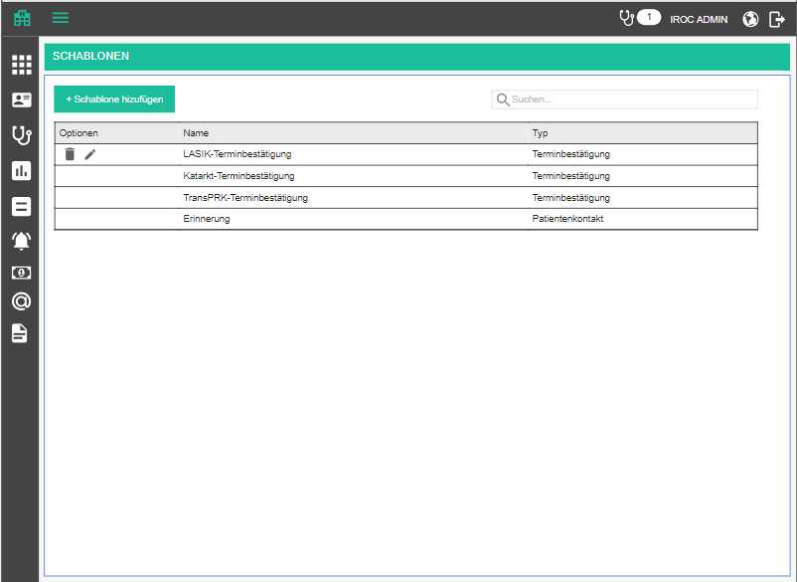

Overview is a table which contains all templates which are added to the tenant database. It contains the following columns:
- Options / Optionen (edit, delete)
- Title / Name an
- Type / Typ

The list should be sortable by all columns (except options, of course). Default sorting is by title and type, alphabetically.
The list should be search-able by title and type. Search starts as soon as you type, but with a small debounce. Check the rest of the app for guidance.

When the searched list is empty, display the following text instead of the first row:
- There are no matching email templates for this search criteria. / Es gibt keine passenden Email Schablonen für diese Suchkriterien.

When the list is empty in general, display the following text instead of the first row:
- There are no email templates defined. / Es gibt keine definierten Email Schablonen.

Add / edit email template

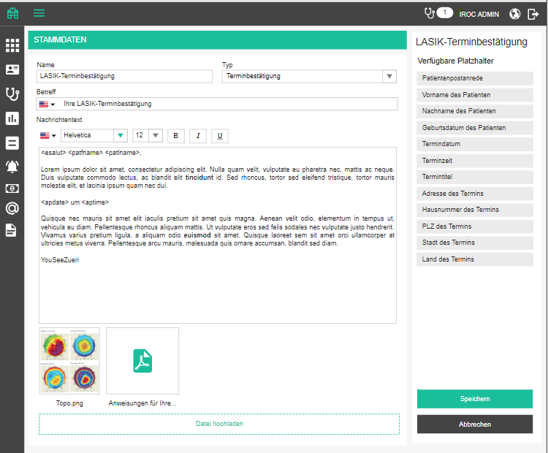

Adding and editing relies on the same form, only in case of editing, the data will be prefilled with existing data. In the top right corner, the subject of the currently added / edited template is displayed and changes whenever the user changes subject.

Adding a template is started by clicking on the add button above the table
- Add email template / Email Schablone hinzufügen

Editing is started by clicking on the edit button in the corresponding row in the table
- Edit email template / Email Schablone bearbeiten

Base data / Stammdaten is opened by default and there the user can specify the following attributes
- Title / Name - text box, mandatory
- Type / Typ - dropdown, mandatory; depending on a type we will offer different placeholders on the right hand side
- Subject / Betreff - dict text box, mandatory
- Body / Nachrichtentext - Rich text area, contains email body with placeholders
  - Language dropdown is needed because template can be define for multiple languages
  - Font face can be chosen for the entire email
  - Font size can be chosen for the entire email
  - Bold, Italic, Underlined can be applied to selected piece of text
- Upload file / Datai hochladen - uploads one or more files as attachment
  - Research the size of files which can be sent and limit the size of files that can be uploaded
  - Ask for confirmation when deleting an attachment
    - Delete attachment / Anhang löschen
    - Are you sure you want to delete this attachment? / Sind Sie sicher, dass Sie diesen Anhang löschen möchten?

Placeholders will be predefined for a type and the user can click on the buttons in the right panel and add them to the text area for email body / subject.

For Patient contact / Patientenkontakt type we will have the following placeholders:

<pat_title> -Patient title / Patiententitel
<pat_fname> - Patient first name / Vorname des Patienten
<pat_lname> - Patient last name / Nachname des Patienten
<pat_dob> - Patient birth date / Geburtsdatum des Patienten

For Appointment confirmation / Terminbestätigung type we will have the following placeholders:

<pat_title> -Patient title / Patiententitel
<pat_fname> - Patient first name / Vorname des Patienten
<pat_lname> - Patient last name / Nachname des Patienten
<pat_dob> - Patient birth date / Geburtsdatum des Patienten
<app_date> - Appointment date / Termindatum
<app_time> - Appointment time / Terminzeit
<app_title> - Appointment title / Termintitel
<app_loc_addr> - Appointment address / Adresse des Termins
<app_loc_nr> - Appointment street number / Hausnummer des Termins
<app_loc_zip> - Appointment ZIP / PLZ des Termins
<app_loc_city> - Appointment city / Stadt des Termins
<app_loc_country> - Appointment country / Land des Termins

The page offers 3 standard buttons:

- Save / Speichern - executes all the validations and displays errors if necessary, otherwise saves the changes and displays the success message
- (if adding new) Email template has been successfully created. / Email Schablone wurde erfolgreich erstellt.
- (if editing) Email template has been successfully updated. / Email Schablone wurde erfolgreich aktualisiert.

- Cancel / Abbrechen - go back to overview withought saving changes
- Back to overview / Zurück zur Übersicht - go back to overview withought saving changes

If the user tries to leave the page after some changes have been made but not yet saved, the app will warn them with the standard "Are you sure you want to leave this page..." popup. This functionality should be applied to all pages, always.

Delete email template

If an email template is assigned to an entity currently (like appointment type), the delete icon will be disabled with the following tooltip as explanation:
- It is not possible to delete an email template which is currently in use. / Es ist nicht möglich, eine Email Schablone zu löschen, der gerade verwendet wird.

If the template is not in use, the user can delete it. Upon clicking on the delete icon, the user will be prompted by a standard confirmation popup.
- Delete email template / Email Schablone löschen
- Are you sure you want to delete <email template name>? / Sind Sie sicher, dass Sie <email template name> löschen möchten?

Using email templates

Email templates will be used from different parts of the application, but the behavior should be encapsulated nicely, since it will always be the same.

Before sending an email, we will give the user a chance to edit it first. This means that the used template will be compiled in the chosen language and placeholders will be populated with actual data (or omitted if no data is present).
This happens whenever the user chooses a different template or language.

If the email body field is not empty, ask the user to confirm their changes, so that they don’t lose any unsent data
- Are you sure you want to proceed? Unsent changes will be lost. / Sind Sie sicher, dass Sie fortfahren wollen? Nicht gesendete Änderungen gehen verloren.
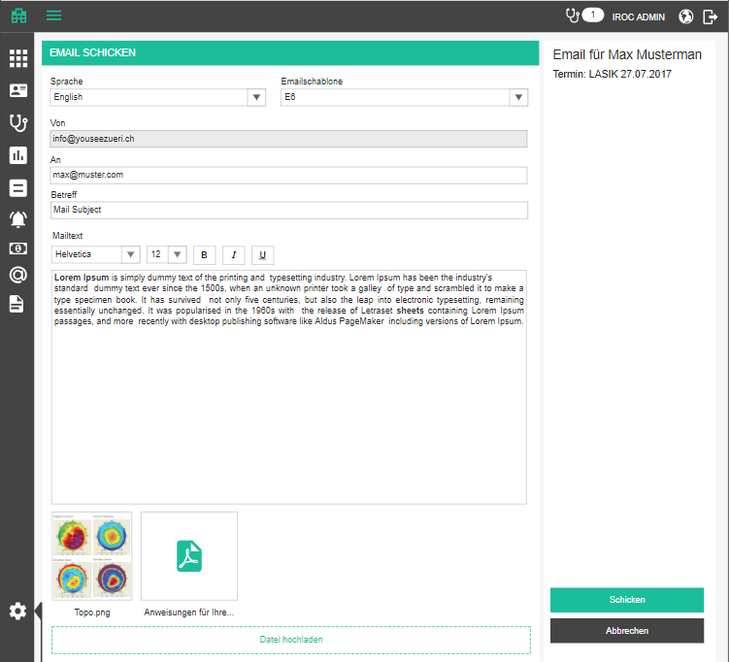

- Send email / Email schicken - page title
- Email for <patient> / Email für <patient> - right panel header
- Appointment: / Termin: <appointment title and date> - if email is sent from appointment context
- Language / Sprache - language of the template and placeholders
- Email template / Emailschablone - template
- From / Von - preselected through tenant settings
- To / An - recipient, mandatory taken from patient data if present
- Subject / Betreff - taken from template
- Body / Nachrichtentext - rich text editor which displays the email as it will look to the user
  - Font face can be chosen for the entire email
  - Font size can be chosen for the entire email
  - Bold, Italic, Underlined can be applied to selected piece of text
- Upload file / Datai hochladen - uploads one or more files as attachment
  - Research the size of files which can be sent and limit the size of files that can be uploaded
- Send / Schicken - sends the email to specified address
  - Email sent / E-Mail verschickt - if successful
  - Error bubble otherwise
- Cancel / Abbrechen - returns the user where they came from

Some examples of sending email templates:
- From email reminder tasks (see Tasks)
- From calendar
  - A new icon “send email / email schicken” which opens the default email client with compiled message
  - If there are more than one email templates associated with the appointment type, we will first open a popup where the user can see all templates one below the other with the “send” icon next to it
- From patient history
  - Same as from calendar
  - Directly for a patient, not related to any appointment - the user can choose any of the “Patient contact” email templates

Document templates
Document templates are used to specify Word documents with placeholders which will be used to send patients and other recipients letters.
Menu item: Document templates / Dokumentschablonen

Document templates overview
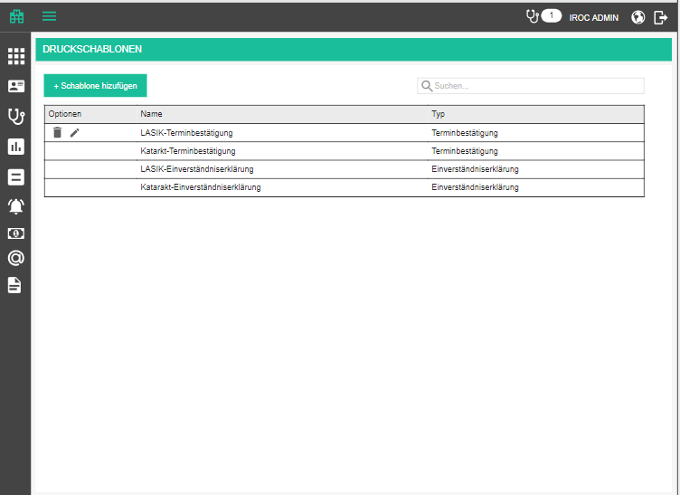
Overview is a table which contains all templates which are added to the tenant database. It contains the following columns:
- Options / Optionen (edit, delete)
- Title / Name
- Type / Typ
The list should be sortable by all columns (except options, of course). Default sorting is by title and type, alphabetically.
The list should be search-able by title and type. Search starts as soon as you type, but with a small debounce. Check the rest of the app for guidance.
When the searched list is empty, display the following text instead of the first row:
- There are no matching document templates for this search criteria. / Es gibt keine passenden Dokumentschablonen für diese Suchkriterien.
When the list is empty in general, display the following text instead of the first row:
- There are no document templates defined. / Es gibt keine definierten Dokumentschablonen.

Add / edit document template
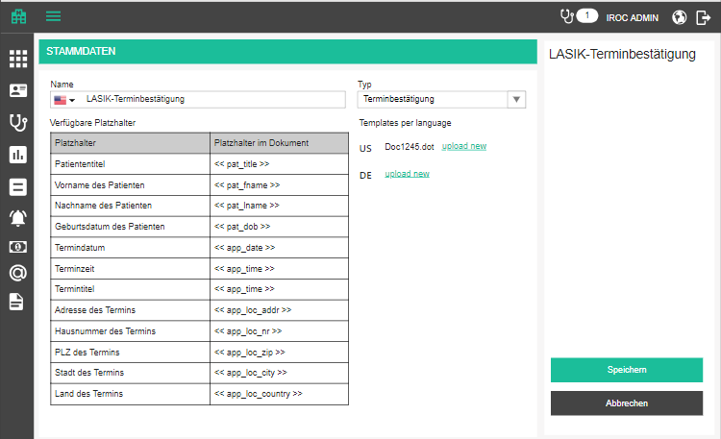
Adding and editing relies on the same form, only in case of editing, the data will be prefilled with existing data. In the top right corner, the title of the currently added / edited template is displayed and changes whenever the user changes subject.
Adding a template is started by clicking on the add button above the table
- Add document template / Dokumentschablone hinzufügen
Editing is started by clicking on the edit button in the corresponding row in the table
- Edit document template / Dokumentschablone bearbeiten
Base data / Stammdaten is opened by default and there the user can specify the following attributes
- Title / Name - dict text box, mandatory
- Type / Typ - dropdown, mandatory; depending on a type we will offer different placeholders in the table below
- If patient is known, upload document to patient archive automatically / Wenn der Patient bekannt ist, läd das Dokument automatisch in das Patientenarchiv hoch - checked by default; the user cannot unselect this in the first version
  - Default category / Standard Kategorie - displayed if the auto-upload is on; lists all categories; preselect the first one
  - Default type / Standardtyp - displayed if the auto-upload is on; lists all types; preselect the first one
- Templates per language / Schablonen pro Sprache
- Language icon + upload new / neu hochladen link
  - When a template document is already uploaded, display the file name
  - Clicking on upload new opens the standard choose file dialog, the user can only choose one file of “.dot” format
  - Uploaded file is put on the document server
  - Uploading a new file replaces the old one
- Available placeholders / Verfügbare Platzhalter
  - Placeholder / Platzhalter - Placeholders available for the selected type of document
  - Placeholder in document / Platzhalter im Dokument - placeholder as the user should use it in the “.dot” document

Appointment related template type
For all appointment related template types we will have the following placeholders:
https://irocag-my.sharepoint.com/:x:/g/personal/ana_marija_ciric_m-pioneers_com/EfwBCz0jgDJFkugbrDX1LlsBUuXmO7QYk0sfk6qnmScmsw?e=eXroou

These types are:
- Appointment confirmation / Terminbestätigung
- Consent / Einverständnis
- Fee agreement / Honorarvereinbarung
- Anesthesia / Anästhesie

Patient related template type
For all patient related template types we will have the following placeholders:
https://irocag-my.sharepoint.com/:x:/g/personal/ana_marija_ciric_m-pioneers_com/EYrVYevpLUpJpUilt-RNLLEBOQnQUlXX5leYoSOg_7hDrA?e=plzPGD

These types are:
- Family physician examination / Hausarzt Untersuchung
- Letter / Brief

Encounter related template type
For all encounter related template types we will have the following placeholders:
https://irocag-my.sharepoint.com/:x:/g/personal/ana_marija_ciric_m-pioneers_com/EfMw2jE9AilHtl40e1EFqWIBDw63aKdv-K7iIXeG6P1i2g?e=kQ1y8W

The page offers 3 standard buttons:
- Save / Speichern - executes all the validations and displays errors if necessary, otherwise saves the changes and displays the success message
- (if adding new) Document template has been successfully created. / Dokumentschablone wurde erfolgreich erstellt.
- (if editing) Document template has been successfully updated. / Dokumentschablone wurde erfolgreich aktualisiert.
- Cancel / Abbrechen - go back to overview without saving changes
- Back to overview / Zurück zur Übersicht - go back to overview without saving changes
If the user tries to leave the page after some changes have been made but not yet saved, the app will warn them with the standard "Are you sure you want to leave this page..." popup. This functionality should be applied to all pages, always.

Delete document template
If a document template is assigned to an entity currently (like appointment type), the delete icon will be disabled with the following tooltip as explanation:
- It is not possible to delete a document template which is currently in use. / Es ist nicht möglich, eine Dokumentschablone zu löschen, der gerade verwendet wird.
If the template is not in use, the user can delete it. Upon clicking on the delete icon, the user will be prompted by a standard confirmation popup.
- Delete document template / Dokumentschablone löschen
- Are you sure you want to delete <template name>? / Sind Sie sicher, dass Sie <template name> löschen möchten?

Using document templates
Document templates will be used from different parts of the application, but the behavior should be encapsulated nicely, since it will always be the same.

See document template generation.

Supported appointment types in availabilities

In IROC's case making a plan for a new year means creating hundreds of "placeholder" appointments for months in advance, according to doctors needs. This is because doctors have certain preferences regarding their schedule, such as: every Moday I want to do General examinations in the morning and Surgery LASIK followups in the afternoon. A person in charge of the appointments will then create a couple of appointments for every Monday morning for general examination and a couple for LASIK followups. These appointments will not have patients. Patient data is filled in only when a patient books the appointment.
Other than being tedious work, this is not very clean when it comes to the calendar, because it's filled up with placeholder data which might not be true. If a doctor wishes to switch something around at some point, there is no automated way to do so, other than repeating the whole process! Yikes!

We, on the other hand, already have half the tools to equip them with a better solution. When we define availabilities for doctors, we can select one or more supported appointment types for each availability. If nothing is supplied, it means there are no boundaries. So what can we do with these information?

Take appointment types into consideration when creating appointment slots

In the AAE, we create slots for each type of appointment, in timeframes where a doctor has an availability. Now we just have to check for each appointment type we are creating slots for, which availabilities include that appointment type, or have no appointment type boundaries. Simple as that.

Show colors according to appointment types

Currently we display the availabilities in the availability calendar pink if in-practice availability and blue if online availability. This should be changed so that an availability is displayed in the color of its available appointment types. If more than one appointment type is specified for an availability, display the color of the first one which was added. If there are no appointment types specified, display the availability as light gray. But how do we differentiate between in-house and online availabilities? Give online availabilities a thick dashed left border, or something similar. This should be applied for all availabilities: staff, devices and facilities.

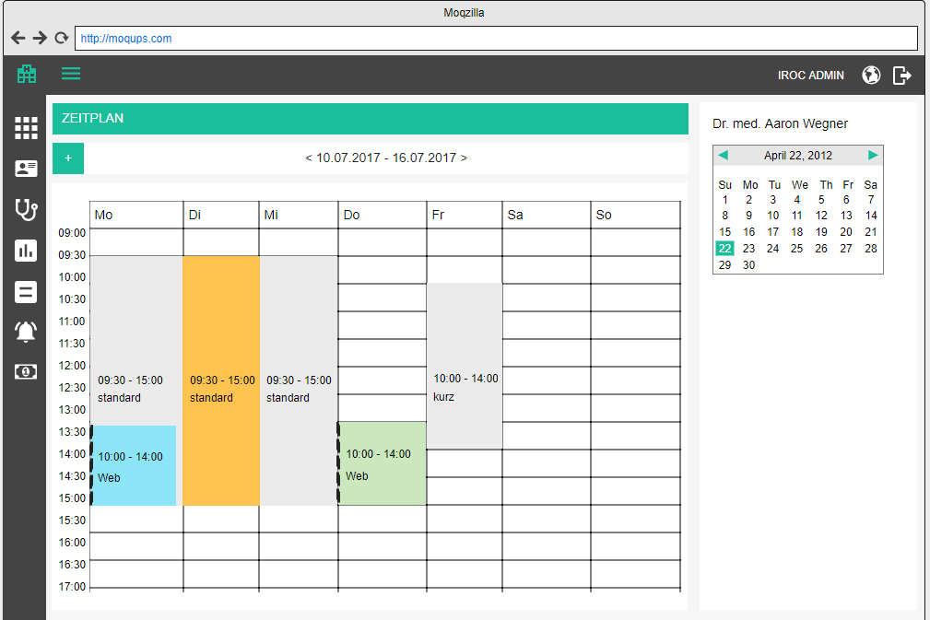

In the appointments calendar, we display the portions of the calendar which have availabilities as white, and the rest gray. Now we are going to change that a little bit: display a background color of portions of the calendar in the color of the specified appointment type for that availability. If the availability covers more appointment types, take the first one which was added. If none were specified, display white as before.

Calendar displays only in-house availabilities of course.

Facility extensions

Since facilities support a hierarchical structure, the facility overview should display them in a tree like structure, much like appointment types and their variants, except we will have multiple levels. Instead of parent facility column, we will display parent-child relationship by indenting children underneath their parent.

Every row which has children is expandable and collapsible, whereas the ones without children have a disabled expand / collapse button.

This new structure will impact the sort and search functionality in a way that:
- sorting sorts highest level facilities alphabetically, and then their children within them, and then children of the children, and so on
- searching will display results from lowest level facilities match the name or type, and then display all the parents too. For example, in the mockup below, searching for "Messungen" will display "Messungen Raum" and its parents; "IROC" will display only the top-most facilities; and "IROC OP" will display just the "IROC OP Zentrum"

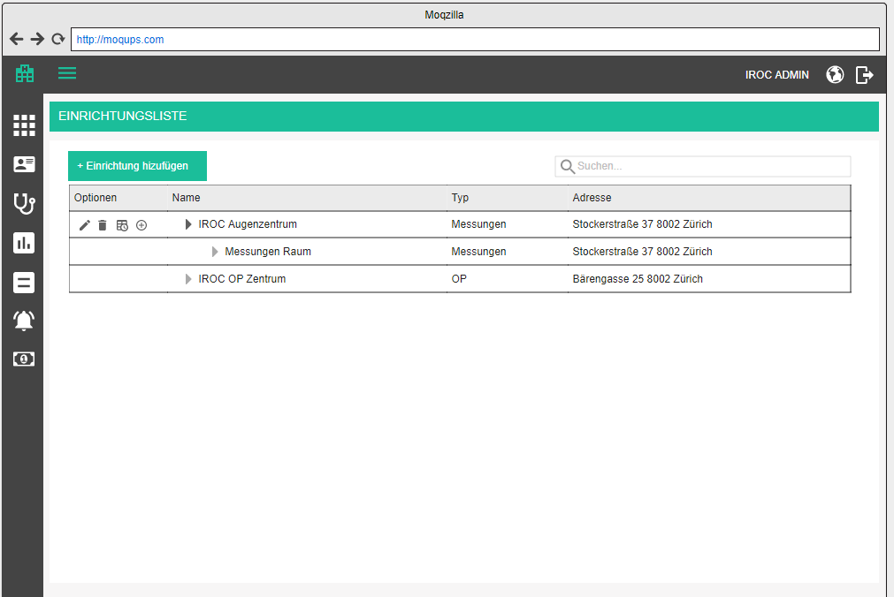

When selecting a parent facility, apply the same approach as we have for cost centers and offices (selection from tree structure).

Facility types and Facility role types
In the current version of PM, facilities have been assigned facility types which are either OR (operation room) or clinic. This was a misuse of the concepts provided by the b-op data model: OR and clinic are not facility types, but facility role types.
Facility type / Einrichtungstyp - indicates the physical type of a facility, e.g. campus, building, room, staircase
Facility role / Einrichtungsrolle - indicates the usage of a facility, e.g. OR or clinic
We need to update the facility type catalog to actually represent the facility role types and to update the facility administration to assign Facilities administration to assign catalog values to facility role type instead of facility type.

Staff

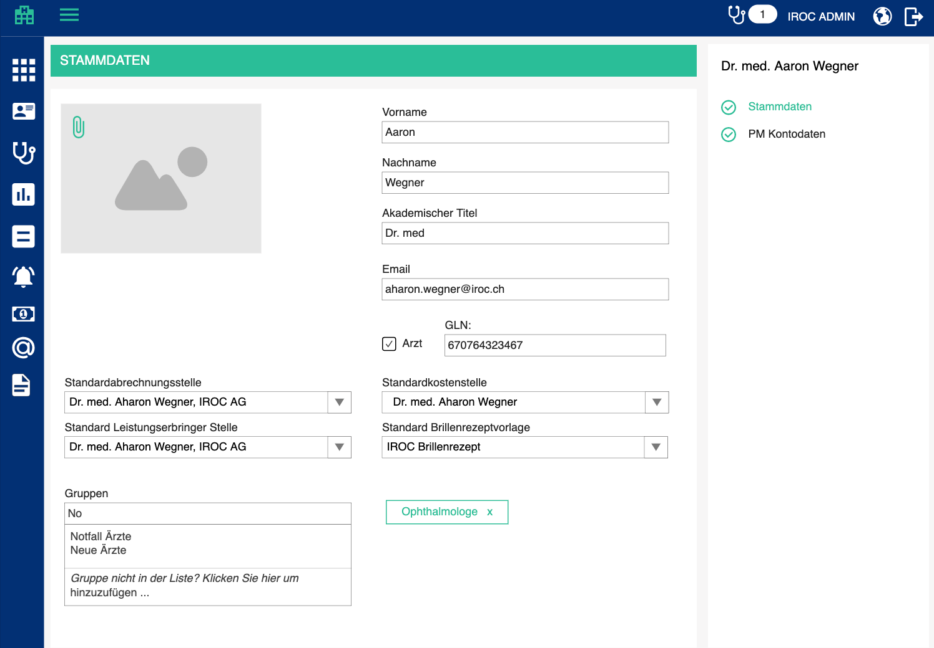

Another piece of data which is needed to write a bill is the default billing office. Billing data will be taken from this office. We would normally put this on a billing data tab, but since it is just one dropdown, we will keep it on the base data tab for now.
- Default billing office / Standardabrechnungsstelle - dropdown with all the offices, where user can select one (this one will be used to prefill the office when creating a bill)
- Default service provider office / Standard Leistungserbringer Stelle - dropdown with all the offices, where user can select one (this one will be used to prefill the provider office when creating a bill)
- Default glasses prescription template / Standard Brillenrezeptvorlage - optional; dropdown with all glasses prescription templates, the tenant default is preselected, but if the user chooses another one, that one will be used for generating glasses prescription for this staff member

(If the number of selectable default templates surpasses four, we will create a separate tab for selecting default templates for each template type of the current tenant.)

Instead of displaying staff first name and last name column in the staff overview, display both in one column to save on space in format <last name>, <first name>.

We need an option to specify exit date for staff, so that the people who no longer work do not appear in any staff dropdowns throughout the app (because we don’t have an option to delete staff, and we need to somehow remove redundant ones)
- Exit date / Austrittsdatum - date picker, optional

User rights
Different users have different rights throughout the app. This will grow over time, but for now we will have:
- Can administer application settings / Kann Anwendungseinstellungen verwalten
  - has access to the administration pages
  - has access to Kordeus Time
  - can change other users’password
- Can sign off encounter documentation / Kann Behandlungsdokumentation signieren (can finish and open encounter)
- Can sign off bill / Kann Rechnung signieren (can sign off on a bill)
- Can cancel bill / Kann Rechnung stornieren
- Can edit payments / Kann Zahlungen bearbeiten
- Can delete payments / Kann Zahlungen löschen
- Can edit refunds / Kann Rückzahlungen bearbeiten
- Can delete refunds / Kann Rückzahlungen löschen

Staff group extensions
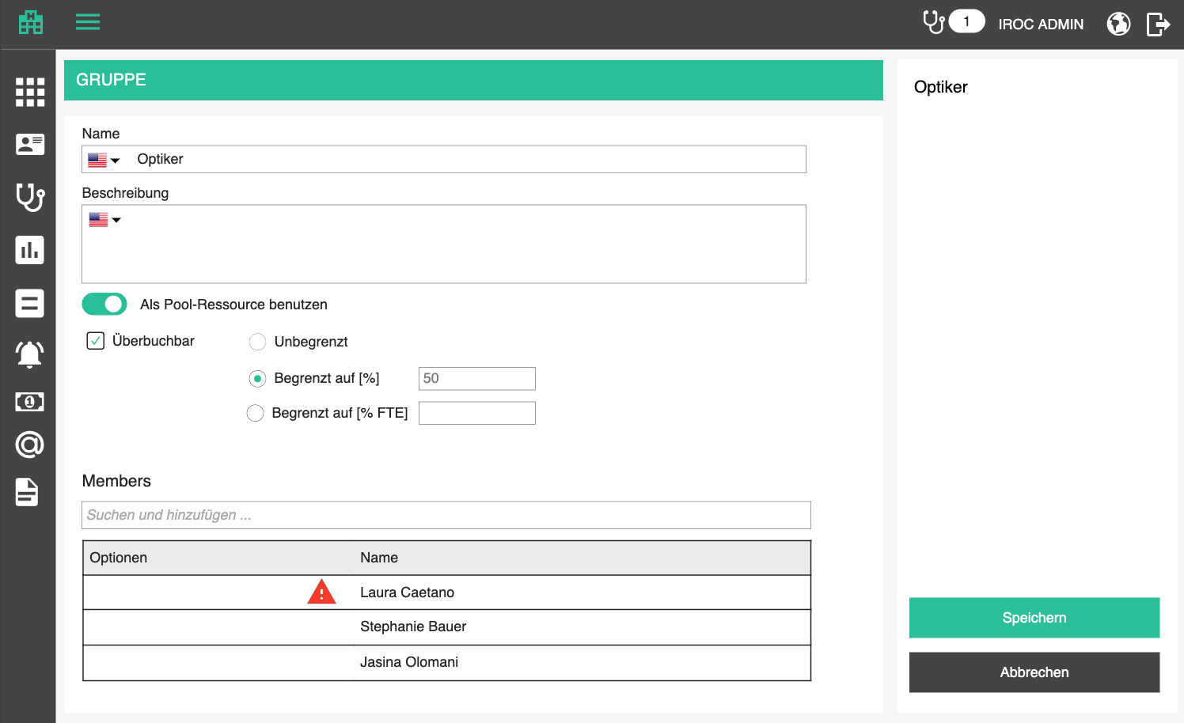

A staff group can be marked as a pool resource, which means that it can be selected as a temporary assignee for an appointment step, until it is clear who will be doing the step. This is normally used for steps performed by opticians in an ophthalmology clinic, where it is not important who will perform the step until it is time to do it - the first available person from the group will take it.

In group details, the user can switch this mode on
- Use as a pool resource / Als Pool-Ressource benutzen

If the group is used as a pool resource, the user can define whether or not this pool resource can be overbookable
- Overbookable / Überbuchbar

Overbookable can be 3 things for availability engine:
- No limit / Unbegrenzt - this group can be used as a pool resource in as many concurrent steps as the user wants
- Limited to [%] / Begrenzt auf [%] - this group can be used as a pool resource in concurrent steps but only until x % of the group members available on that day have been booked at the same time. E.g. 200% means every available resource can be booked twice -> if there are 2 members, the group can be booked as if there were 4 members
- Limited to [% FTE] / Begrenzt auf [% FTE] - this group can be used as a pool resource in concurrent steps but only until every available member has been booked x % . E.g. 500 % FTE means 500% full time employee -> means this group can be booked as if there were 5 members

In addition to the possibility to add group memberships to staff profiles, the user shall be able to add staff to a group, in the group administration page. Adding is performed by searching through the staff list using the autocomplete box above the table.
- Members / Mitglieder
- Search and add... / Suchen und hinzufügen ...

If the staff member is already a member of some other groups, display those groups in an info tooltip:
- This person has been added to <groups> as well. / Diese Person wurde auch zu <groups> hinzugefügt.

Staff member can be removed from a group, with a confirmation.
- Remove / Entfernen
- Are you sure you want to remove <staff name> from <group name>? / Sind Sie sicher, dass Sie <staff name> aus <group name> entfernen möchten?

Consultation hour extensions
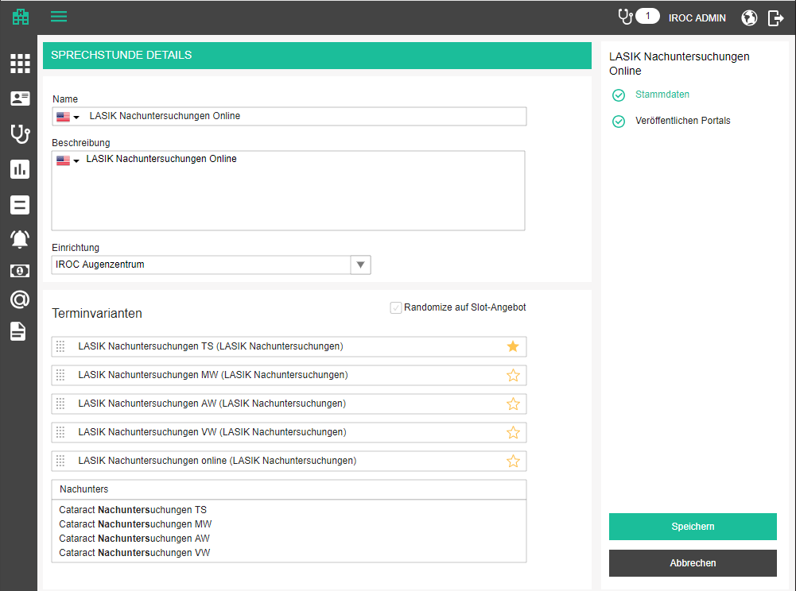

Appointment variants of a consultation hour should be added in a priority sequence with a drag&drop option to reorder them. Priority sequence means the order in which concurrent slots are displayed to the user, if the UI does not support concurrent slot displaying. For example, if a widget can display only consecutive slots, and there are two variants which produce a slot at 2pm, we will display the one with the lower priority sequence number.

Clicking on a star makes a variant default for that consultation hour and it automatically gets the lowest sequence number, and all other numbers are adjusted. Only one can be default.

Randomize checkbox overrides the priority sequence on the spot (when concurrent slots are offered, the first one to be shown will be chosen randomly, not by priority sequence). This feature promotes fairness in practices where each doctor is a free agent and just offers their services through the name of the practice. In that case, every doctor should have the same chances of being offered to the patient first.
- Randomize on slot offering / Randomize auf Slot-Angebot

Appointment type extensions
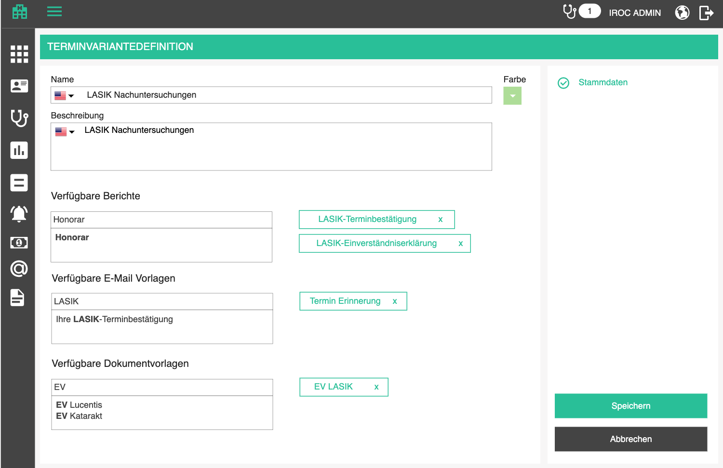

In the appointment type edit screen, we want to enable the user to associate appointment types with document templates, which will mostly be documents like patient consent for a procedure and info for the patient. This is a tag like component in which the user can start typing the name of the template, select it and it will appear on the right side. It can be removed by clicking on the “x” button in the tag itself.
- Document templates / Dokumentschablonen
- Available reports / Verfügbare Berichte

Note: we want to filter the available document templates by type, because not all of them can be used for the same purpose.

In the same manner, using the tag component, we want to enable the user to assign email templates to an appointment type, which will later enable them to send emails with automatically filled patient and appointment data, and save a lot of time.
- Available email templates / Verfügbare E-Mail Vorlagen

In the same manner, using the tag component, we want to enable the user to assign document templates to an appointment type, which will later enable them to download documents with automatically filled patient and appointment data, and save a lot of time. Have in mind that only document templates of type “appointment document” can be chosen for an appointment type. Patient templates are printed from patient history.
- Available document templates / Verfügbare Dokumentvorlagen

Optional steps
The user can mark every step in a variant as optional. This means that this step will be included by the user manually, while booking the appointment.
Steps which are not optional are mandatory, which means that they are included into the appointment by default when booking an appointment.

Dependencies between steps are always dictated by the order of the steps. Every step (other than the first one) is dependent on the previous step, in the sense that it must happen X minutes after the previous step. User can define X.

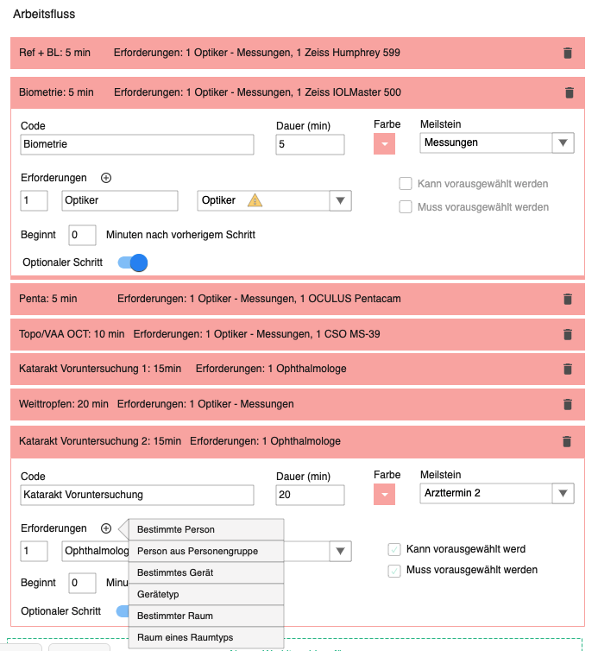

An appointment type variant which contains at least one optional step, automatically gets the InRAM option switched off and disabled with a notification that variants with optional steps cannot be pre-calculated. This is rather common sense because the application cannot foresee which steps the user will want to select while booking.
- InRAM pre-calculation cannot be used for appointment variants with optional steps / InRAM Vorberechnung kann nicht für Terminvarianten mit optionalen Schritten verwendet werden

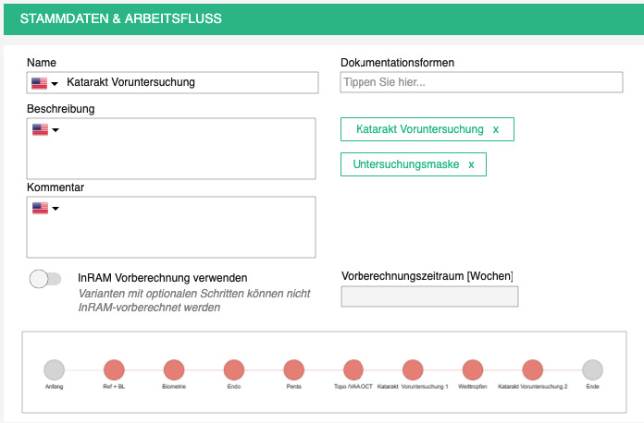

Furthermore, all appointment variants with optional steps will be ignored by AAE while calculating slots for online booking.

Deactivating appointment types and variants
When an appointment type or variant is no longer of use, it cannot simply be deleted if it has been used for past appointments or tasks. It can be deactivated, so that it no longer appears in appointment booking, next appointment screen in masks, appointment task.

- Enabled / Aktiviert – switch; set to true by default

The overview of appointment types and variants gets another column
- Enabled / Aktiviert - check icon if true, x icon if not (or something similar)

Documentation forms for appointment variant
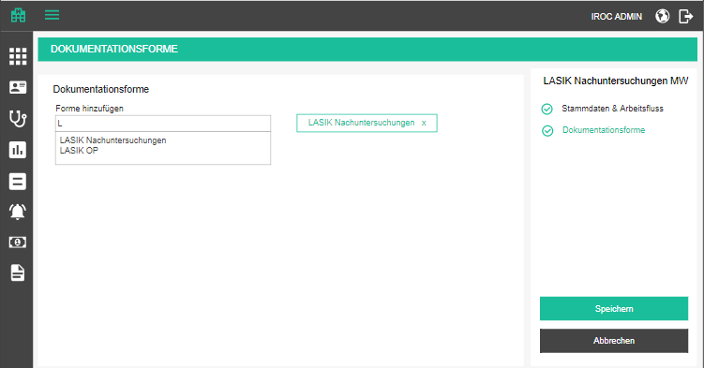

To enable a user to start an encounter documentation from the appointment calendar, we need to connect appointment variants (based on which the appointments are created).

Assigning the documentation forms will function the same way as it is currently implemented in Medical services edit form. Before adding the component for assigning forms, introduce another tab to the Appointment variant form, just for this purpose and rename the existing one to base data and workflow
- Base Data & Workflow / Stammdaten & Arbeitsfluss
- Documentation Forms / Dokumentationsmasken

Opening a suitable documentation form
This process will work as follows:
- The user clicks on the “start encounter” button on the calendar
- If one documentation form was assigned to the appointment variant from which the appointment was made, redirect the user to the documentation app with the suitable plugin opened
- If multiple documentation forms were assigned to the appointment variant from which the appointment was made, open a popup with the list of forms which can be chosen and let the user pick one (the same functionality is implemented for starting an encounter from the list of medical services, just apply the same thing)
- If no documentation forms were assigned to the appointment variant from which the appointment was made OR the appointment is of Ad hoc type (no variant) OR the encounter is starting from history or patient list, without an appointment, forward the user to the page for starting encounter from a medical service (existing functionality)

In addition to that, whenever an encounter is started, the responsible staff needs to be selected. This is a simple dropdown with staff list in the frame of each mask. Staff list consists of persons assigned as possible responsible staff for this mask at the top, and all the rest of the staff which have the “can sign documentation forms“ right at the bottom. The reason why we are listing all the possible staff is that if something was not administered right, the users won’t be able to start an encounter.
- Responsible staff / Verantwortliche Personal

To spare the user from selecting the responsible staff every time:
- Currently logged in user is the only person on the list of responsible staff - select it in the background and don’t show the popup
- The appointment from which we are creating the encounter has a key resource which is on the only person on the list of responsible staff - select it in the background and don’t show the popup
- Possible responsible staff have more that one staff assigned, preselect the key person if existing, or logged in staff, and show the popup
- In all other cases, the user needs to pick a person

After confirming, the encounter is started.

Comment template for appointment type variant

Some information should be supplied with each appointment so that other staff knows the details. In order to remind the front office employees which information they need to inclose, we want to enable the administrator to make a comment template for each appointment type variant, so that appointment comment is prefilled with that text and the front office can just adjust it.
- Comment template / Kommentarvorlage - optional dict text box in appointment type variant base data
- This text is copied to appointment comment whenever an appointment of this variant is booked

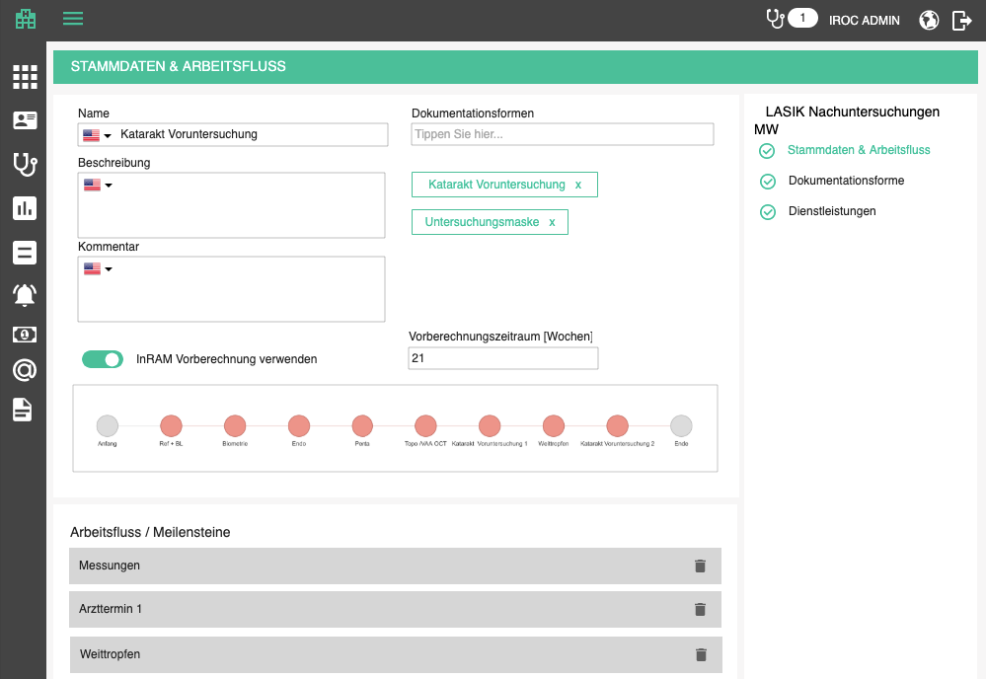

Calculation settings for appointment type variant

The user will have an option to select whether or not an appointment type variant will have possible slots precalculated and put into RAM for quicker access during appointment booking. This is especially important for complex variants with many steps and possible resources, because calculating on the fly can use up server resources.

This introduces new settings to appointment type variant:
- Use InRAM pre-calculation / InRAM Vorberechnung verwenden
- An info button with tooltip explains that enabling this can dramatically increase RAM requirements if this is applied for simple appointment-types, where there is typically enough resources available:
  - This option decreases slot calculation time but increases server RAM requirements. It should be used for complex variants (containing more than 3 steps). / Diese Option verkürzt die Zeit für die Slotberechnung, erhöht aber den Server-RAM-Bedarf. Sie sollte für komplexe Varianten (mit mehr als 3 Schritten) verwendet werden.
- Pre-calculation timeframe [weeks] / Vorberechnungszeitraum [Wochen] - indicates the timeframe for which potential results are pre-calculated into RAM. Enabled only when InRAM is active. Default is 21 weeks.

Appointment type variant steps have new settings as well. Human resource requirements, which are not based on a specific person, but on person group, will have the following new settings:
- Optional pre-selection / Kann vorausgewählt werden - previously known as “Manually selected / Manuell gewählt”) gives the user an option to specify the desired resource before slot calculation starts
- Mandatory pre-selection / Muss vorausgewählt werden - requires the user to preselect the desired resource before slot calculation, thus speeding up the on-the-fly calculation, because the number of options is reduced
- If the group has "use as pool resource" flag enabled, these two checkboxes are disabled and an info icon with tooltip explains why
  - This group is a pool resource. Explicit members are not selectable. / Diese Gruppe ist eine Pool-Ressource. Explizite Mitglieder sind nicht auswählbar.

Medical services of appointment steps

Even at the point of making an appointment for a patient, we are planning services. In simple workflows, a single service will correspond to an appointment step, but technically, a medical service can be delivered through multiple steps, and a single step may contain multiple services. For this reason, we will enable a simple way of connecting appointment variant steps to services, via autocomplete box, which will offer all matching services as the user types, in the appointment variant form.

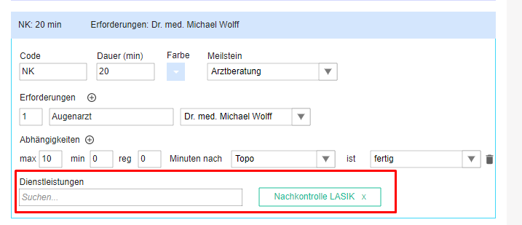

Each service connected to a step will also be connected to a variant itself. Upon creation of an appointment, we will transfer these services into the appointment and connect them to corresponding steps, as specified in the variant. They will be visible in the appointment popover, as a group of tag components
- Planned services / Geplante Dienstleistungen

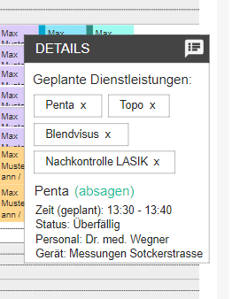

If the user decides to delete a medical service, they can do so by clicking on the "x" button and confirm their action through a confirmation popup
- Are you sure you want to remove <medical service name> from this appointment? / Sind Sie sicher, dass Sie <medical service name> von diesem Termin entfernen möchten?

And in case there are steps which are connected only to this medical service, it does not make sense to keep them. So, for every such step, display a checkbox on the confirmation popup with text

Remove step <step name> also / Entfernen <step name> Schritt auch

After confirmation, all the selected steps will be cancelled.

Happenings extensions
Since we can define how many participants can sign up for a happening, we need to let the user know when they are exceeding that number. When the user clicks on “add participant” button, if the number of allowed participants has been reached, show a popup which asks the user to confirm adding more participants than allowed.
- Warning / Warnung - title of the popup
- You have reached the maximum number of allowed participants. Are you sure you want to add another one? / Sie haben die maximal zulässige Teilnehmerzahl erreicht. Sind Sie sicher, dass Sie eine weitere hinzufügen möchten?
- Yes / Ja - opens the add / edit page
- No / Nein - calls off the action

Billing profiles

Billing profiles are used as a pre-set configuration for Immediate billing (See Immediate billing in the Encounter section). They are important because immediate billing happens within the encounter documentation context and the user does not want to leave that context to specify bill group details. That's why these details can be preset in the user's settings once or rarely.

Billing profiles overview

This page is similar to the calendar filter profiles - these are user specific profiles and are stored in a non-structured DB field. Each user can define one or more of these and mark one as default. The default billing profile is always preselected wherever a billing profile can be applied.

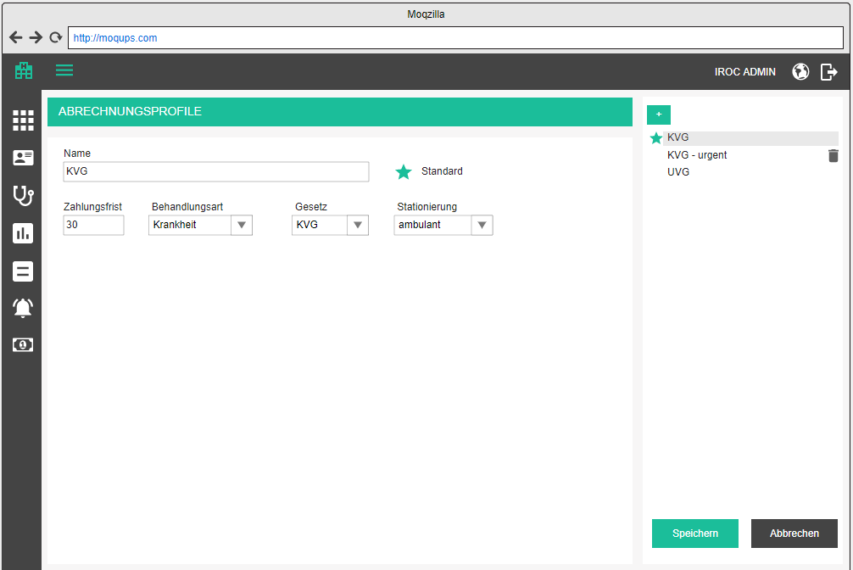

This is a simple page, overview and edit are combined. Overview is available in the sidebar and the selected item is the one which is being edited in the main part of the screen. When the user comes to this page, the default billing profile is preselected. They are sorted alphabetically. The default one is marked with a star. Selected profile should be highlighted.

- Billing profiles / Abrechnungsprofile - title of the menu point and the page

Add / edit billing profile
Adding is done directly from the button above the list of billing profiles. Editing is done by selecting a billing profile from the list.
- Add billing profile / Abrechnungsprofil hinzufügen - button for adding a billing profile
- Title / Name - mandatory
- Default / Standard - a checkbox disguised as a star which is full or outlined depending on the status
- the first or only billing profile is always set as default
- Payment deadline / Zahlungsfrist - number of days for payment, 30 by default, mandatory, must be a whole positive number
- Treatment type / Behandlungsart - dropdown with options which are assigned special GIDs
- Sickness / Krankheit
- Accident / Unfall
- Applicable law / Gesetz - dropdown with options which are assigned special GIDs, these basically correspond to treatment type
- KVG / KVG - for illnesses
- UVG / UVG - for accidents
- VVG / VVG - for additional insurance

Delete billing profile

Deletion is possible by clicking on the delete icon. Upon clicking on the delete icon, the user will be prompted by a standard confirmation popup.
- Delete billing profile / Rechnungsprofil löschen
- Are you sure you want to delete <profile name>? / Sind Sie sicher, dass Sie <profile name> löschen möchten?
- if the user deleted the default billing profile, the first one in the list

All changes take place only after the main save button is clicked.

Dunning levels

Dunning levels are a prerequisite for the dunning process. Basically, we want to define levels of dunning, which will depict the severity of the situation.

Dunning is typically divided into 3 stages:
- warning
- dunning
- inkasso (debt collection)

Each of these stages can have one or more levels within it and these levels will most likely vary in fee. This is what we administer in this section.

Imagine the following scenario: A patient bill becomes overdue. That means it’s time to remind them about the bill. If we don’t receive a payment in the next, e.g. 10 days after the warning, we can warn again. If no payment comes after additional 10 days, we might want to officially send a dunning document along with a dunning fee and give the patient another 20 days to make a payment. If no payment is made, we can hire debt collectors to pursue the patient and make sure the bill and all dunning fees are paid.

So, the levels we allocated here are:
-> warning without a fee, 10 days deadline
-> warning without a fee, 10 days deadline
-> dunning with a fee, 20 days deadline
-> inkasso (debt collection)

The last level usually does not happen because it’s a stressful and complicated situation, plus the debt collecting officials have their fees, which might even be higher than the bill itself! But it is an option.

Dunning levels overview

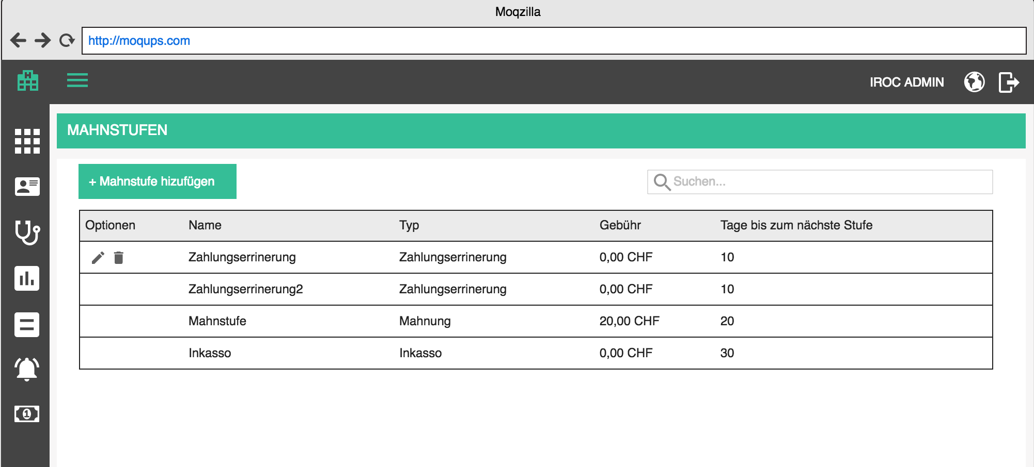

Overview is a table which contains all dunning levels which are added to the tenant database. It contains the following columns:
- Options / Optionen (edit, delete)
- Title / Name
- Type / Type -
- Warning / Zahlungserrinerung
- Dunning / Mahnung
- Inkasso / Inkasso
- Fee / Gebühr - right aligned, 2 decimal points, currency appended
- Days to next dunning level / Tage bis zum nächste Stufe

The list should be sortable by all columns (except options, of course). Default sorting is by title, alphabetically.
The list should be search-able by title and type. Search starts as soon as you type, but with a small debounce. Check the rest of the app for guidance.

When the searched list is empty, display the following text instead of the first row:
- There are no matching dunning levels for this search criteria. / Es gibt keine passenden Mahnstufen für diese Suchkriterien.

When the list is empty in general, display the following text instead of the first row:
- There are no dunning levels defined. / Es gibt keine definierten Mahnstufen.

Order of the levels is important, especially if the dunning process is one day automated, and it is not a person who changes the dunning status, but a program - we will need to know which level comes after which. For that reason, this table (and maybe some other tables in the future) will have to support drag & drop option, so that the user can reorder the rows and specify the order.

Add / edit dunning level

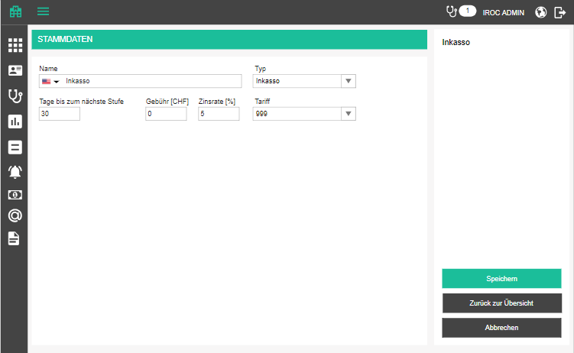

Adding and editing relies on the same form, only in case of editing, the data will be prifilled with existing data. In the top right corner, the title of the currently added / edited dunning level is displayed and changes whenever the user changes title.

Adding a dunning level is started by clicking on the add button above the table
- Add dunning level / Mahnstufe hinzufügen

Editing is started by clicking on the edit button in the corresponding row in the table
- Edit dunning level / Mahnstufe bearbeiten

The add / edit form has 1 tab
- Base data / Stammdaten

Base data is opened by default and there the user can specify the following attributes
- Title / Name - dict text, mandatory
- Type / Typ - dropdown, mandatory, has the following 3 GID entities
- Warning / Zahlungserrinerung
- Dunning / Mahnung
- Inkasso / Inkasso
- Days to next dunning level / Tage bis zum nächste Stufe - mandatory, basically a deadline for that dunning level Must be a whole positive number
- Fee / Gebühr - fee for this dunning level, optional, must be a positive number, right aligned, 2 decimal points, currency appended
- Interest rate / Zinsrate - yearly interest rate, optional, must be a positive number, right aligned, 2 decimal points
- Tariff / Tariff - tariff of the dunning fee position

The page offers 3 standard buttons:

- Save / Speichern - executes all the validations and displays errors if necessary, otherwise saves the changes and displays the success message
- (if adding new) Dunning level has been successfully created. / Mahnstufe wurde erfolgreich erstellt.
- (if editing) Dunning level has been successfully updated. / Mahnstufe wurde erfolgreich aktualisiert.

- Cancel / Abbrechen - go back to overview withought saving changes
- Back to overview / Zurück zur Übersicht - go back to overview withought saving changes

If the user tries to leave the page after some changes have been made but not yet saved, the app will warn them with the standard "Are you sure you want to leave this page..." popup. This functionality should be applied to all pages, always.

Delete dunning level

If a dunning level is assigned to a dunning document, the delete icon will be disabled with the following tooltip as explanation:
- It is not possible to delete a dunning level which is currently in use. / Es ist nicht möglich, eine Mahnstufe zu löschen, die gerade verwendet wird.

If the dunning level is not in use, the user can delete it. Upon clicking on the delete icon, the user will be prompted by a standard confirmation popup.
- Delete dunning level / Mahnstufe löschen
- Are you sure you want to delete <level name>? / Sind Sie sicher, dass Sie <level name> löschen möchten?

Accounts

Because of bookkeeping purposes, bills and payments are associated with different accounts. These accounts can be bank accounts, customer accounts, etc. Depending on the type, they will have different parameters. Since this is a medical software and not a bookkeeping one, we will keep the accounts rather simple on the UI side, but data-model-wise, they need to be compatible with more complex solutions, as bookkeeping really is one of the most complex things we will be dealing with in the future.

Accounts overview

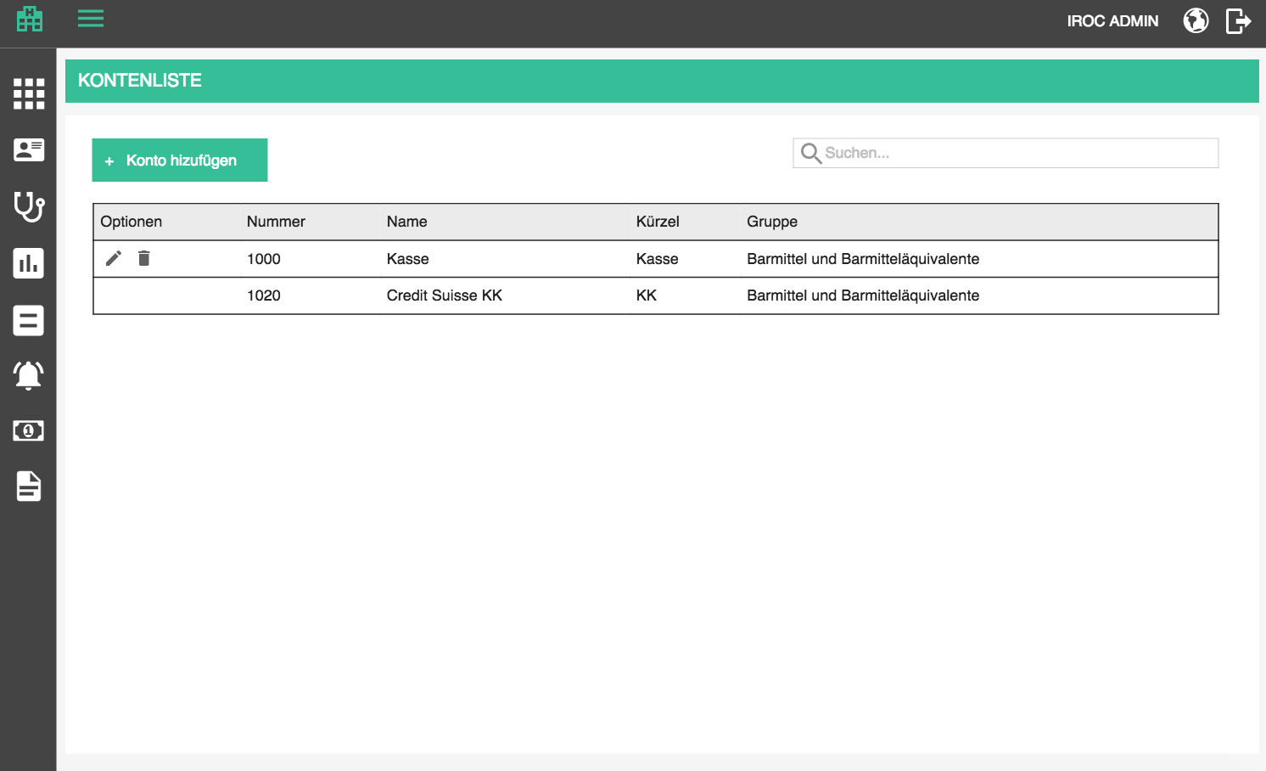

Overview is a table which contains all bank accounts which are added to the tenant database.

Table contains the following columns:
- Options / Optionen (edit, delete)
- Number / Nummer
- Title / Name
- Abbreviation / Kürzel
- Group / Gruppe

The list should be sortable by all columns (except options, of course). Default sorting is by title, alphabetically.
The list should be search-able by all columns. Search starts as soon as you type, but with a small debounce. Check the rest of the app for guidance.

When the searched list is empty, display the following text instead of the first row:
- There are no matching accounts for this search criteria. / Es gibt keine passenden Konten für diese Suchkriterien.

When the list is empty in general, display the following text instead of the first row:
- There are no accounts defined. / Es gibt keine definierten Konten.

Add / Edit account

Adding an account is started by clicking on the add button above the table.
- Add account / Konto hinzufügen

Editing is started by clicking on the edit button in the corresponding row in the table
- Edit account / Konto bearbeiten

Base data / Stammdaten
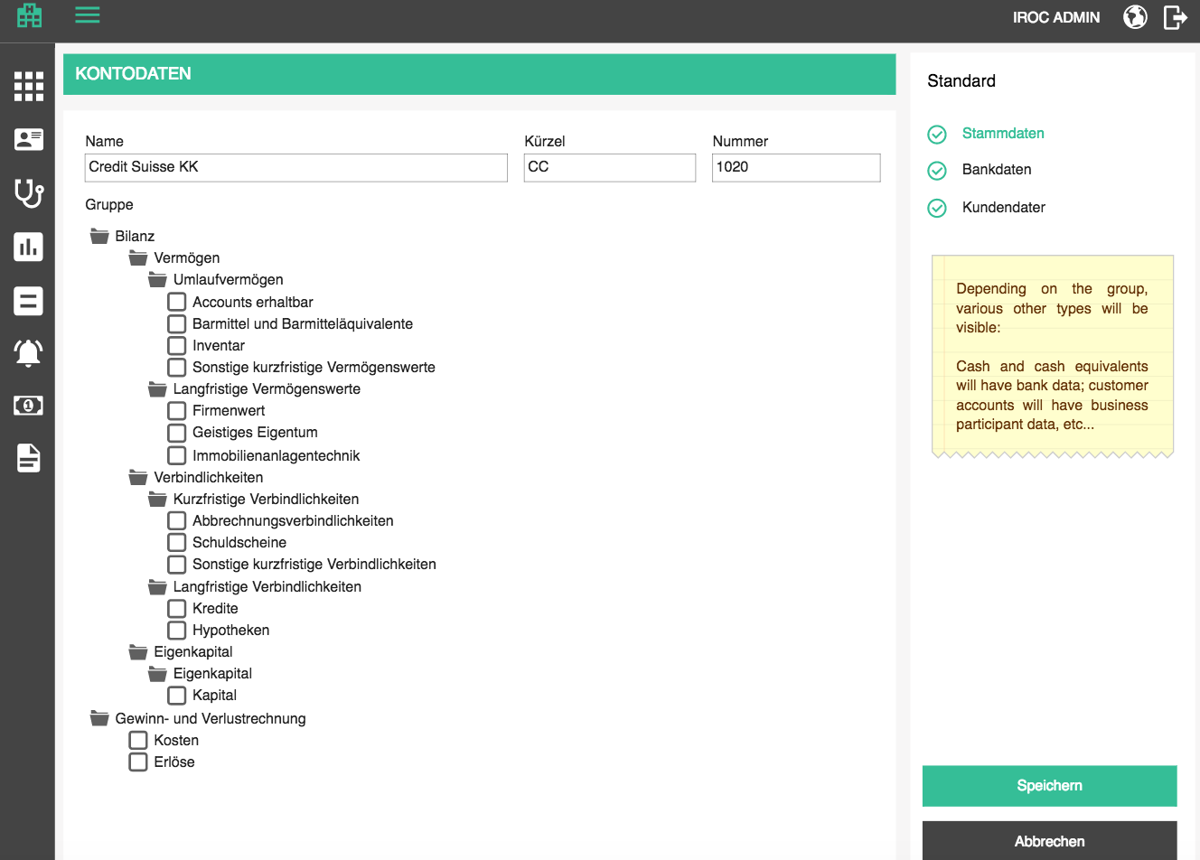

- Number / Nummer - account ID number (human readable ID)
- Title / Name - name of the account
- Abbreviation / Kürzel
- Group / Gruppe - booking account group - based on this group, other tabs with different data will appear

Available groups are displayed in the table below. Selectable groups are the ones marked with ([ ]). The ones marked with (F) are folders.
English | German
F Balance sheet | F Bilanz
F Assets | F Vermögen
F Current assets | F Umlaufvermögen
[ ] Accounts receivable | [ ] Accounts erhaltbar
[ ] Cash and cash equivalent | [ ] Barmittel und Barmitteläquivalente
[ ] Inventory | [ ] Inventar
[ ] Other current assets | [ ] Sonstige kurzfristige Vermögenswerte
F Long term assets | F Langfristige Vermögenswerte
[ ] Goodwill | [ ] Firmenwert
[ ] Intellectual property | [ ] Geistiges Eigentum
[ ] Property, plant, equipment | [ ] Immobilienanlagentechnik
F Liabilities | F Verbindlichkeiten
F Current liabilities | F Kurzfristige Verbindlichkeiten
[ ] Accounts payable | [ ] Abbrechnungsverbindlichkeiten
[ ] Notes payable | [ ] Schuldscheine
[ ] Other current liabilities | [ ] Sonstige kurzfristige Verbindlichkeiten
F Long term liabilities | F Langfristige Verbindlichkeiten
[ ] Loans | [ ] Kredite
[ ] Mortgages | [ ] Hypotheken
F Owners equity | F Eigenkapital
F Equity | F Eigenkapital
[ ] Capital | [ ] Kapital
F Income statement | F Gewinn- und Verlustrechnung
[ ] Expenses | [ ] Kosten
[ ] Revenues | [ ] Erlöse

Bank data / Bankdaten

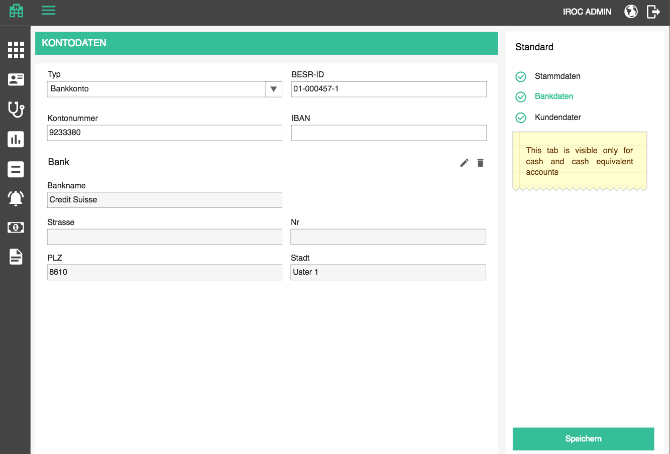

- Type / Typ - GID entry list which will be expanded over time
- Bank account / Bankkonto
- Visa card / Visa-Karte
- Master card / Master-Karte
- Amex card / Amex-Karte
- PayPal / PayPal

- BESR-ID / BESR-ID - id which is assigned to every account in Switzerland, for processing payments

If selected type is bank account:

- Bank account number / Kontonummer
- IBAN / IBAN - account number for international transactions
- Bank / Bank - user can start typing in the bank title filed and select one of the entered banks and all other fields are populated. Clicking on the edit pen opens other fields for editing. This is pretty much the same functionality as healthcare partners in patients page. User can also add a new one if the searched bank does not exist.
- Bank title / Bankname
- Street / Strasse - bank street name
- Nr / Nr - bank number
- ZIP / PLZ - bank ZIP
- City / Stadt - bank city

When supplying the address, when ZIP code is selected, city and country should be preselected, at least in Switzerland.

The page offers 3 standard buttons:

- Save / Speichern - executes all the validations and displays errors if necessary, otherwise saves the changes and displays the success message
- (if adding new) Account has been successfully created. / Konto wurde erfolgreich erstellt.
- (if editing) Account has been successfully updated. / Konto wurde erfolgreich aktualisiert.

- Cancel / Abbrechen - go back to overview withought saving changes
- Back to overview / Zurück zur Übersicht - go back to overview withought saving changes

If the user tries to leave the page after some changes have been made but not yet saved, the app will warn them with the standard "Are you sure you want to leave this page..." popup. This functionality should be applied to all pages, always.

Delete account

If an account is assigned to an office, the delete icon will be disabled with the following tooltip as explanation:
- It is not possible to delete an account assigned to an office. / Es ist nicht möglich, ein Konto zu löschen, das einerZahlung zugewiesen ist.

If the account is not in use, the user can delete it. Upon clicking on the delete icon, the user will be prompted by a standard confirmation popup.
- Delete account / Konto löschen
- Are you sure you want to delete <account name>? / Sind Sie sicher, dass Sie <account name> löschen möchten?

Offices

Offices provide a way to express a company's hierarchy in a not-necessarily-physical way (as opposed to facilities.) An office can be, for example, accounting, or HR. These two offices can physically reside in one physical location (facility), but they don't have to. Staff members belong to different offices (sometimes even multiple).

Since this is a medical software which does not worry that much about company structure, bookkeeping, human resources, etc. we will have a simplified version of office structure. We must, however, have in mind that this may expand in the future, and that it must be compatible with other b-op software which handles these business processes in more detail (Zugseil, for example). PM's primary need for offices comes from billing, because, it's in fact an office that issues a bill.

Offices overview

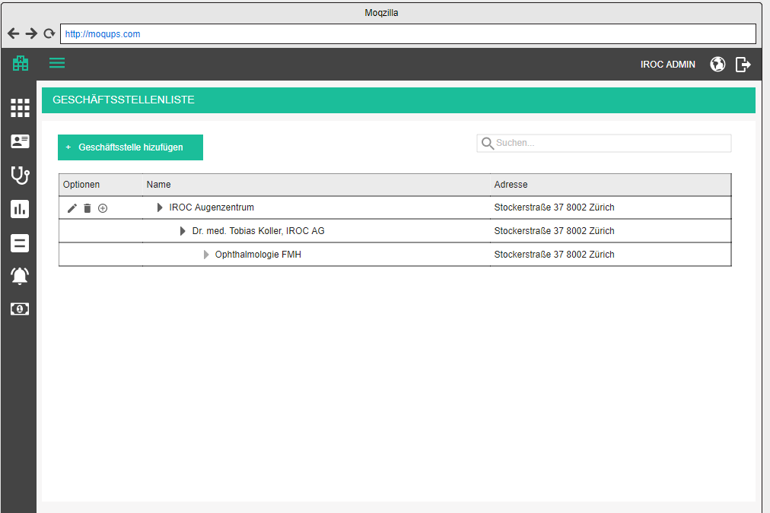

Overview is a table which contains all offices which are added to the tenant database. Since offices support a hierarchical structure, the office overview should display them in a tree like structure, much like appointment types and their variants, except we will have multiple levels. Every row which has children is expandable and collapsible, whereas the ones without children have a disabled expand / collapse button.

Table contains the following columns:
- Options / Optionen (edit, delete, add child office)
- Title / Name
- Address / Adresse (srtreet, number, ZIP, city)

The list should be sortable by all columns (except options, of course). Default sorting is by title, alphabetically.
The list should be search-able by title. Search starts as soon as you type, but with a small debounce. Check the rest of the app for guidance.

When the searched list is empty, display the following text instead of the first row:
- There are no matching offices for this search criteria. / Es gibt keine passenden Geschäftsstellen für diese Suchkriterien.

When the list is empty in general, display the following text instead of the first row:
- There are no offices defined. / Es gibt keine definierten Geschäftsstellen.

This structure will impact standard way of sorting and searching functionality:
- sorting sorts highest level offices alphabetically, and then their children within them, and then children of the children, and so on
- searching will display results from lowest level offices match the name, and then display all the parents too. For example, in the mockup above, searching for "Ophthamologie" will display "Ophthamologie FHM" and its parents; "Koller" will display First two levels; and "IROC " will display just the "IROC Augenzentrum"

Add / edit office

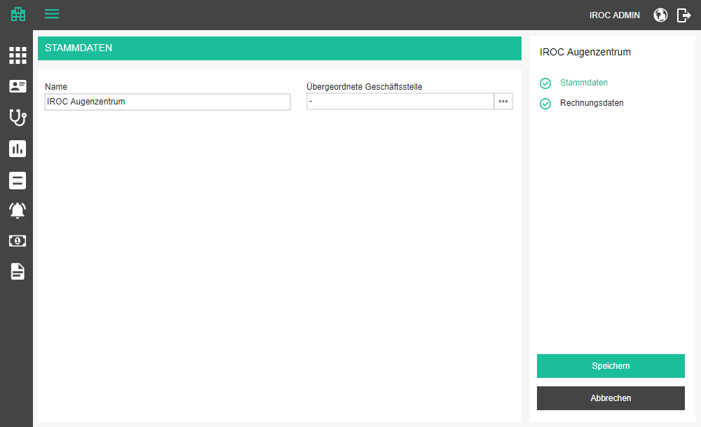

Adding an office is started by clicking on the add button above the table, or in the table, to add a child-office
- Add office / Geschäftsstelle hinzufügen

Editing is started by clicking on the edit button in the corresponding row in the table
- Edit office / Geschäftsstelle bearbeiten

The add/edit form has two tabs:
- Base data / Stammdaten
- Billing data / Rechnungsdaten

On the base data tab, we will administer the following data
- Title / Name - name of the office
- Parent office / Übergeordnete Geschäftsstelle - parent office, user can choose any of the offices which are not children of the current office; if the user got here by clicking the add office button on any of the existing offices, this field is pre-filled with that office;
- Have in mind that offices are a hierarchy, so we need to display the selected office together with the parents, like
office (first parent)
- to select the parent office, a simple dropdown will not be enough, because we need to display the hierarchy. Maybe we can introduce a new component for such purposes, where the field has a button which opens a popup with tree structure where the user can select one of the elements (in some cases only "leaves" will be selectable, but in other we may select "branches", like for cost centers; we must also have an option to disable the user from selecting certain nodes, e.g. when you want to select a parent of the current node, it makes no sense to be able to select one of the children of the current node)

Note: For the first release, we can achieve this with a dropdown which contains the structure by displaying every hierarchy node as:

parent - parent - parent - node

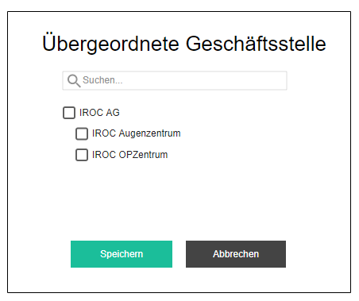

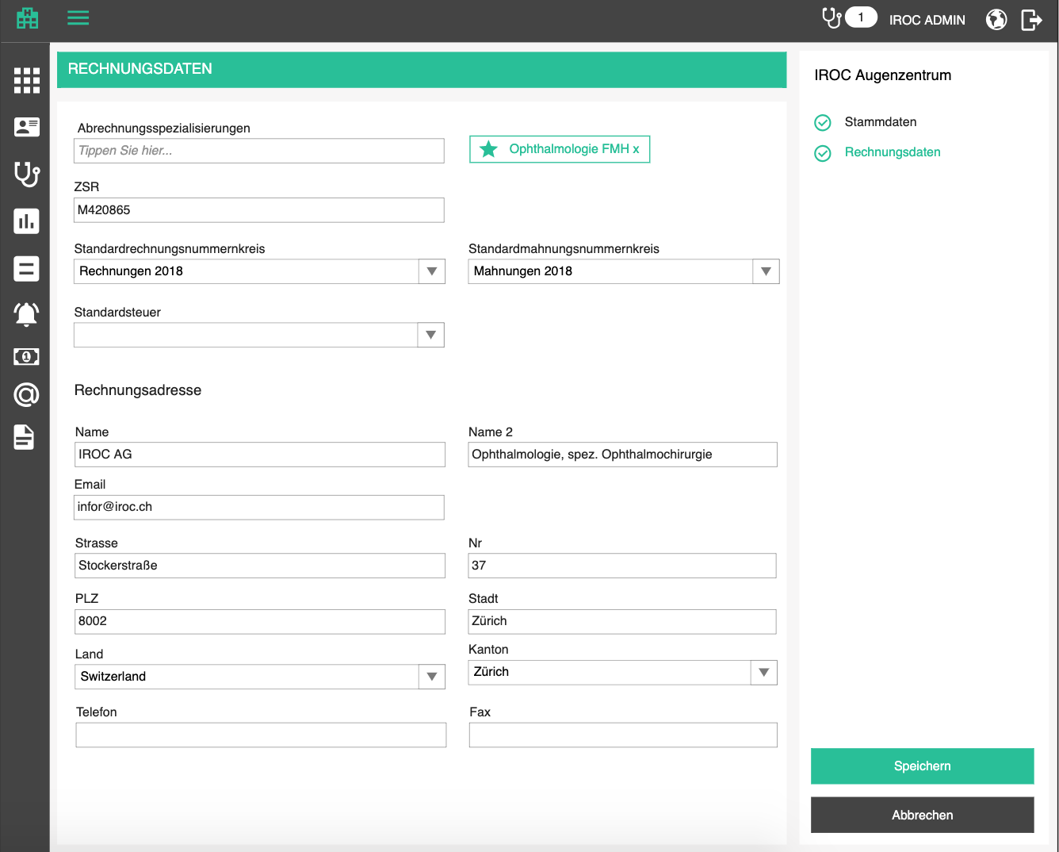

The billing data tab is used to specify the following data:
- Billing specializations / Abrechnungsspezialisierungen - a tag like component which lets the user define and delete the billing specialties in free text form (instead of choosing from existing entities, like usually). This is very swiss-billing-specific data and is used for issuing a bill
- One specialization must be the default one, user can mark the default one by clicking on the star icon on a tag; marking one as default unmarks the others; if there is only one, that is the default one automatically
- ZSR / ZSR - swiss medical billing number, optional
- Default bill number range / Standardrechnungsnummernkreis - a dropdown with valid (date wise) numberranges which will be used when bills are created, mandatory
- Default dunning number range / Standardmahnungsnummernkreis - a dropdown with valid (date wise) numberranges which will be used when dunning documents are created, mandatory
- Default tax / Standard Steuer - optional; dropdown with all the taxes in current tenant; the selected one will be used as a default for creating bills for this billing office
- Default payment deadline in days / Standard-Zahlungsfrist in Tagen – number box; optional;
- Default applicable law / Standard-Gesetz – dropdown with all available applicable laws; optional
- Default payment account / Standard-Zahlungskonto – dropdown with all accounts; optional
- Default facility / Standard-Ort – dropdown with all the facilities; optional
- Default treatment reason / Standard-Behandlungsgrund- dropdown with all treatment reasons; optional
- Default diagnosis / Standard-Diagnose – free text box; optional
- Billing address / Rechnungsadresse
- Name / Name - billing name of the facility
- Name 2 / Name 2 - line 2 of the billing name
- Email / Email - must be syntactically valid
- Street / Strasse
- Nr / Nr
- ZIP / PLZ
- City / Stadt
- Country / Land
- Canton / Kanton - display only if country has cantons
- Phone / Telefon - work number
- Fax/ Fax - fax number

When supplying the address, when ZIP code is selected, city and country should be preselected, at least in Switzerland.

The page offers 3 standard buttons:

- Save / Speichern - executes all the validations and displays errors if necessary, otherwise saves the changes and displays the success message
- (if adding new) Office has been successfully created. / Geschäftsstelle wurde erfolgreich erstellt.
- (if editing) Office has been successfully updated. / Geschäftsstelle wurde erfolgreich aktualisiert.

- Cancel / Abbrechen - go back to overview without saving changes
- Back to overview / Zurück zur Übersicht - go back to overview without saving changes

If the user tries to leave the page after some changes have been made but not yet saved, the app will warn them with the standard "Are you sure you want to leave this page..." popup. This functionality should be applied to all pages, always.

Delete office

If an office is assigned to a bill, or has children, the delete icon will be disabled with the following tooltip as explanation:
- It is not possible to delete an office which was used for billing or has child offices. / Es ist nicht möglich, eine Geschäftsstelle zu löschen, die für die Rechnungsstellung verwendet wurde oder Kind-Geschäftsstellen hat.

If the office is not in use, the user can delete it. Upon clicking on the delete icon, the user will be prompted by a standard confirmation popup.
- Delete office / Geschäftsstelle löschen
- Are you sure you want to delete <office name>? / Sind Sie sicher, dass Sie <office name> löschen möchten?

Booking types

Booking types are used to give semantic to bookings against cost centers. This could be "expense" type, or "income" type, or whatever is significant for the users. For our IROC, they will be used to determine if we put a position on a bill which is a service or a medication or a disposable, etc.

Note: This kind of administration does not belong in a medical software, but rather in a book keeping software. It would be optimal to extract it into a separate module, or at least have in mind that it will eventually be extracted there and to make that switch as easy as possible.

Booking types overview

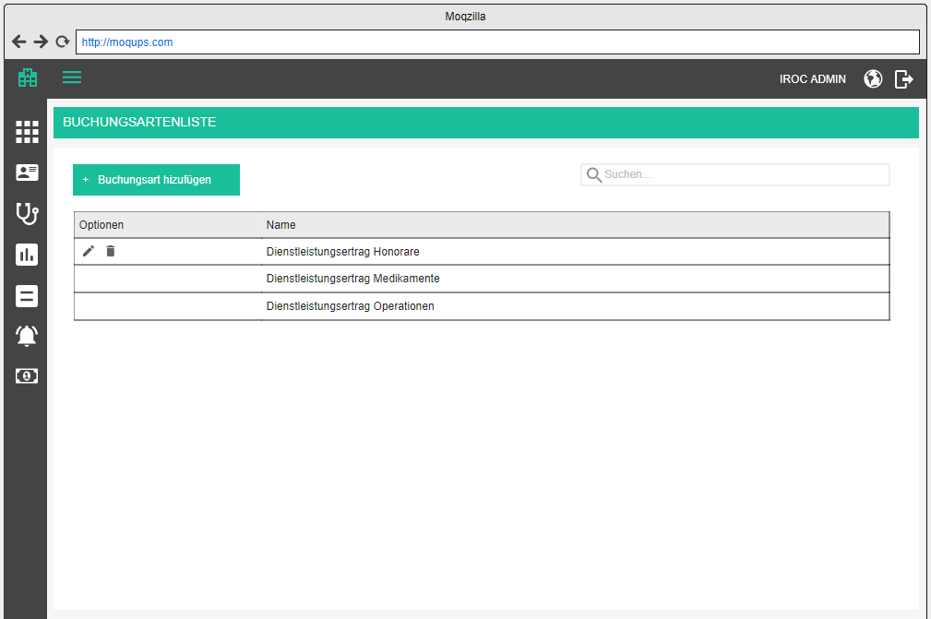

Overview is a table which contains all booking types which are added to the tenant database. It contains the following columns:
- Options / Optionen (edit, delete)
- Title / Name

The list should be sortable by all columns (except options, of course). Default sorting is by title, alphabetically.
The list should be search-able by title. Search starts as soon as you type, but with a small debounce. Check the rest of the app for guidance.

When the searched list is empty, display the following text instead of the first row:
- There are no matching booking types for this search criteria. / Es gibt keine passenden Buchungsarten für diese Suchkriterien.

When the list is empty in general, display the following text instead of the first row:
- There are no booking types defined. / Es gibt keine definierten Buchungsarten.

Add / edit booking type

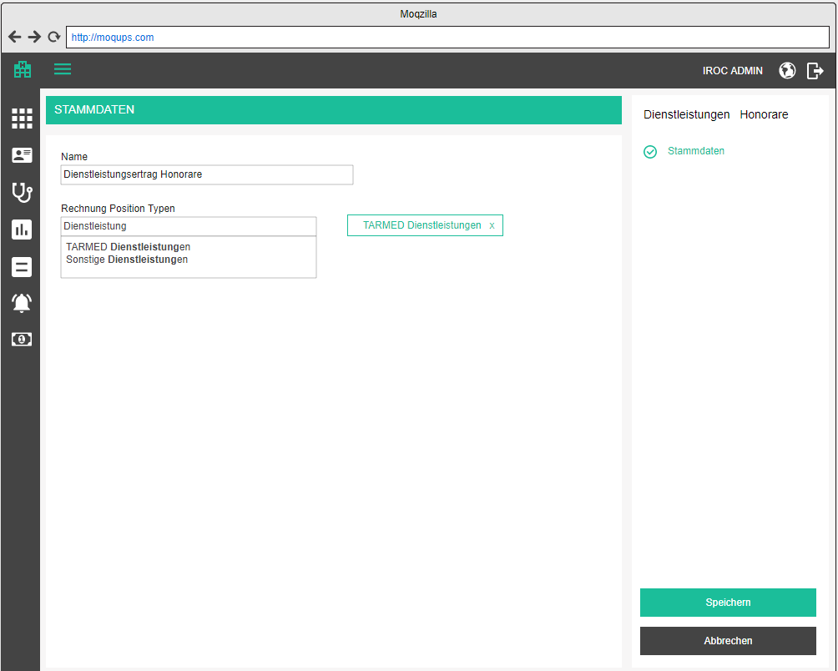

Adding and editing relies on the same form, only in case of editing, the data will be prifilled with existing data. In the top right corner, the title of the currently added / edited booking type is displayed and changes whenever the user changes title.

Adding a booking type is started by clicking on the add button above the table
- Add booking type / Buchungsart hinzufügen

Editing is started by clicking on the edit button in the corresponding row in the table
- Edit booking type / Buchungsarten bearbeiten

The add / edit form has 1 tab
- Base data / Stammdaten

Base data is opened by default and there the user can specify the following attributes
- Title / Name - text box, mandatory
- Bill position types / Rechnung Position Typen - a tag component where the user can add applicable bill position types by searching through a list of predefined types (this should be catalog entries)

The page offers 3 standard buttons:

- Save / Speichern - executes all the validations and displays errors if necessary, otherwise saves the changes and displays the success message
- (if adding new) Booking type has been successfully created. / Buchungsart wurde erfolgreich erstellt.
- (if editing) Booking type has been successfully updated. / Buchungsart wurde erfolgreich aktualisiert.

- Cancel / Abbrechen - go back to overview withought saving changes
- Back to overview / Zurück zur Übersicht - go back to overview withought saving changes

If the user tries to leave the page after some changes have been made but not yet saved, the app will warn them with the standard "Are you sure you want to leave this page..." popup. This functionality should be applied to all pages, always.

Delete booking type

If a booking type is assigned to a cost center booking, the delete icon will be disabled with the following tooltip as explanation:
- It is not possible to delete a booking type which is currently in use. / Es ist nicht möglich, ein Buchungsart zu löschen, die gerade verwendet wird.

If the booking type is not in use, the user can delete it. Upon clicking on the delete icon, the user will be prompted by a standard confirmation popup.
- Delete booking type / Tarif Buchungsart
- Are you sure you want to delete <booking type>? / Sind Sie sicher, dass Sie <booking type> löschen möchten?

Cost centers

A cost center is a department within an organization that does not directly add to profit but still costs the organization money to operate. Cost centers only contribute to a company's profitability indirectly, unlike a profit center, which contributes to profitability directly through its actions.

In our case, cost centers are needed to track cost and revenue across different virtual departments of the organization. Bill positions are booked against cost centers, which will enable us to get detailed reports for bookkeeping.

Note: This kind of administration does not belong in a medical software, but rather in a book keeping software. It would be optimal to extract it into a separate module, or at least have in mind that it will eventually be extracted there and to make that switch as easy as possible.

Cost centers overview

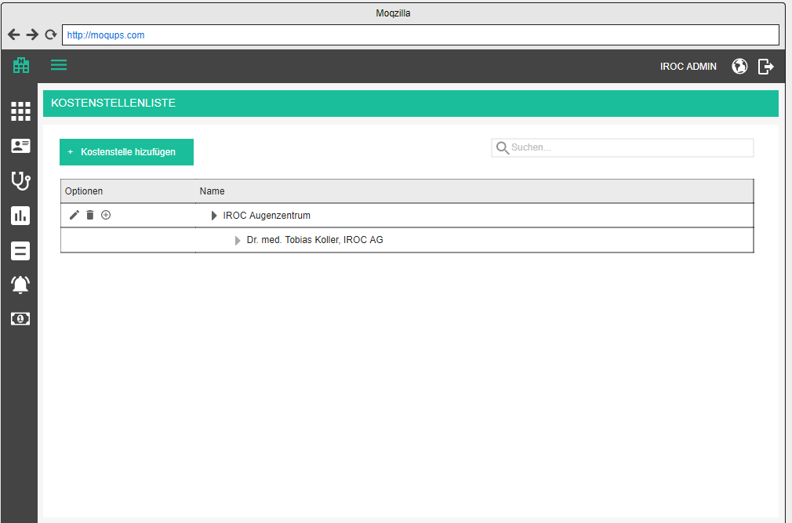

Overview is a table which contains all cost centers which are added to the tenant database. Since cost centers support a hierarchal structure, the cost center overview should display them in a tree like structure, much like appointment types and their variants, except we will have multiple levels. Every row which has children is expandable and collapsible, whereas the ones without children have a disabled expand / collapse button.

Table contains the following columns:
- Options / Optionen (edit, delete, add child center)
- Title / Name

The list should be sortable by all columns (except options, of course). Default sorting is by title, alphabetically.
The list should be search-able by title. Search starts as soon as you type, but with a small debounce. Check the rest of the app for guidance.

When the searched list is empty, display the following text instead of the first row:
- There are no matching cost centers for this search criteria. / Es gibt keine passenden Kostenstellen für diese Suchkriterien.

When the list is empty in general, display the following text instead of the first row:
- There are no cost centers defined. / Es gibt keine definierten Kostenstellen.

This structure will impact standard way of sorting and searching functionality:
- sorting sorts highest level centers alphabetically, and then their children within them, and then children of the children, and so on
- searching will display results from lowest level centers match the name or ZSR, and then display all the parents too

Add / edit cost center

Adding a cost center is started by clicking on the add button above the table, or in the table, to add a child-center.
- Add cost center / Kostenstelle hinzufügen

Editing is started by clicking on the edit button in the corresponding row in the table
- Edit cost center / Kostenstelle bearbeiten

The add/edit form has one tab:
- Base data / Stammdaten

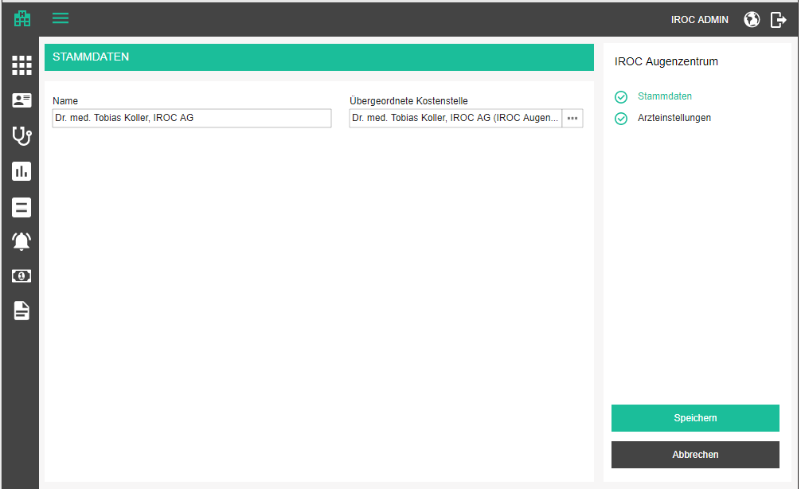
On the base data tab, we will administer the following data
- Title / Name - name of the cost center, mandatory
- Parent cost center / Übergeordnete Kostenstelle - parent center; optional; user can choose any of the cost centers which are not children of the current one; if the user got here by clicking the add cost center button on any of the existing cost centers, this field is pre-filled with that cost center;
- Have in mind that cost centers are a hierarchy, so we need to display the selected cost center together with the parents, like
cost center (first parent)
- to select the parent cost center, a simple dropdown will not be enough, because we need to display the hierarchy. Maybe we can introduce a new component for such purposes, where the field has a button which opens a popup with tree structure where the user can select one of the elements (in some cases only "leaves" will be selectable, but in other we may select "branches", like for cost centers; we must also have an option to disable the user from selecting certain nodes, e.g. when you want to select a parent of the current node, it makes no sense to be able to select one of the children of the current node)

Note: For the first release, we can achieve this with a dropdown which contains the structure by displaying every hierarchy node as:

parent - parent - parent - node

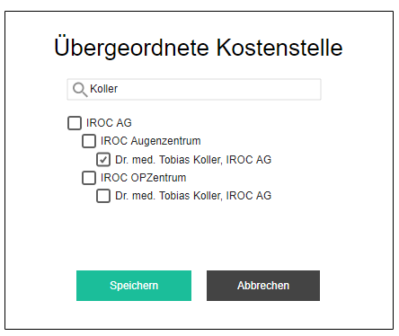

The page offers 3 standard buttons:

- Save / Speichern - executes all the validations and displays errors if necessary, otherwise saves the changes and displays the success message
- (if adding new) Cost center has been successfully created. / Kostenstelle wurde erfolgreich erstellt.
- (if editing) Cost center has been successfully updated. / Kostenstelle wurde erfolgreich aktualisiert.

- Cancel / Abbrechen - go back to overview without saving changes
- Back to overview / Zurück zur Übersicht - go back to overview without saving changes

If the user tries to leave the page after some changes have been made but not yet saved, the app will warn them with the standard "Are you sure you want to leave this page..." popup. This functionality should be applied to all pages, always.

Delete cost center

If a cost center is assigned to a bill position, or has children, the delete icon will be disabled with the following tooltip as explanation:
- It is not possible to delete a cost center which was used for billing or has child cost centers. / Es ist nicht möglich, eine Kostenstelle zu löschen, die für die Rechnungsstellung verwendet wurde oder Kind-Kostenstellen hat.

If the cost center is not in use, the user can delete it. Upon clicking on the delete icon, the user will be prompted by a standard confirmation popup.
- Delete cost center / Kostenstelle löschen
- Are you sure you want to delete <center name>? / Sind Sie sicher, dass Sie <center name> löschen möchten?

Medical Service extensions

Basic functionality regarding medical services has already been implemented, to enable opening encounter documentation masks in the scope of the "Schwind" project. Each medical service (something the practice provides and charges to the patient), can have one or more documentation masks. E.g. for medical service "LASIK operation" we have have one or more masks (forms) in which the staff can document when the operation happened, who was participating, how long they have been working, which anesthetics they have used, what is the thickness of the patient's cornea, which laser was used, etc. There will most likely be one mask for one service, at least in small practices, but technically, we might end up in a scenario where each doctor wants to have their own preferred mask. However, when documenting a provided service, the user must choose one mask even if there are multiple.

Another important aspect of medical services is billing. The practice will want to charge the patient, or their health insurance provider, or both, for the provided medical service. Medical service has been introduced as an entity which comes naturally to the doctors, and to some extent, the patients. The doctor will most likely want to tell their practice's financial officer "Please charge John Smith for the LASIK operation we did last week." The financial officer, however, knows that they have to send the bill to the patient's health insurance, and that the bill needs to come in a certain form, with certain positions, to be accepted. These positions are the billable block positions which are associated with the medical service. This way, the practice can define once (or from time to time) what should be charged when a certain medical service is provided, and the billing can be performed by the financial administrator almost completely without doctor's intervention (which saves doctor's time for actually treating patients) and make financial officer's live less complicated. We will achieve that with billing blocks.

Billing blocks are groups of billable block positions. To better understand why we need to group billable positions of a medical service, let's consider two scenarios...

For example, LASIK operation is a pretty standard procedure which is usually billed the same way. But, if complications arise, the doctor might have to invest extra time or resources, which should be compensated. That way, we can define two billing blocks: LASIK Simple case and LASIK Case with complications. In this scenario, billing blocks can be understood as billing variations of a service. We will either use one or the other.

As another example, a cataract operation is also a routine procedure. A lot of old people need to have it done, due to lens of their eye losing clarity over time and eventually rendering them blind. During this procedure the doctor will replace the patient's lens with an artificial one (read more about amazing ophthalmology stuff explained in simple terms here). This procedure is covered by health insurance, but a patient might opt for a more sophisticated lens, like multi-focal one, which is not covered by the HIP and the patient will have to pay for that one themselves. In this case, we might have two billing blocks, Cataract Standard and Cataract with multi-focal lens. We will either use one or both.

Billing blocks also give us a lot of flexibility for, e.g. billing in Germany where not all HIPs accept the same billing positions, but we would rather have a billing block for each HIP.

Before signing off encounter documentation, a doctor will specify which services should be included in the bill.This feature should be easy to use and done in minutes.

Medical services and catalogs

Since the user can freely add and edit medical services, we have to indicate to the user that before a medical service and its subservices are connected to documentation forms, they will never be marked as delivered automatically based on detection formula.
- This service is not listed as billable service for any documentation forms. Please contact support to connect your service to suitable documentation forms to enable automatic billing. / Diese Dienstleistung wird als abrechenbare Dienstleistung für keine Dokumentationsformulare aufgeführt. Bitte kontaktieren Sie den Support, um Ihre Dienstleistung mit geeigneten Dokumentationsformularen zu verbinden, um eine automatische Rechnungsstellung zu ermöglichen.
- This message only appears if there are any documentation forms for the current tenant, otherwise it will just confuse the user.

Also, if a user defined service is not connected with a GID from an official catalog, it will not be usable for statistics in any ProMed Community. We will indicate this to the user by adding an info
- This service is not connected to an official services catalog and cannot be uploaded to ProMed Communities. Please contact support to connect your service to the catalog. / Diese Dienstleistung ist mit keinem offiziellen Dienstkatalog verbunden und kann nicht in ProMed Communities hochgeladen werden. Bitte kontaktieren Sie den Support, um Ihren Service mit dem Katalog zu verbinden.

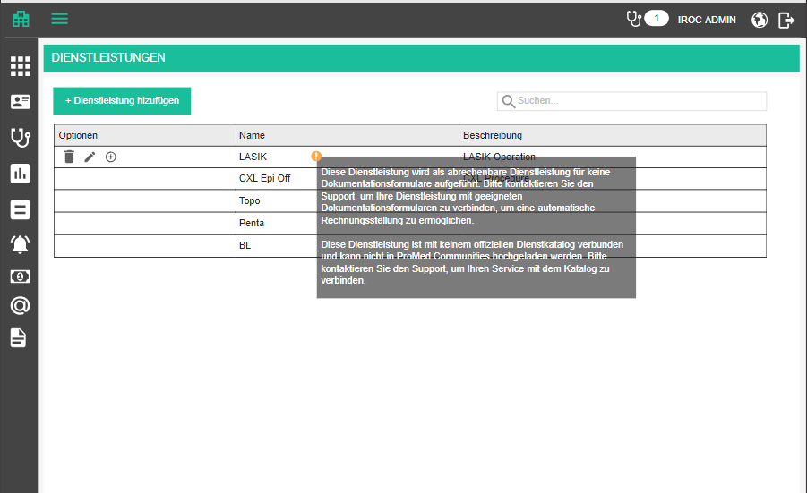

To enable easier detection of services on the PMC side, we will enable the user to select a type of service, a so called meta-service. For example, LASIK, FemtoLASIK, Refractive OP are all Refractive surgeries. We will let the user choose meta-service for each of their services. Meta services come from a catalog and will never be user specified.
- Type / Type - a dropdown with all meta-services from the catalog

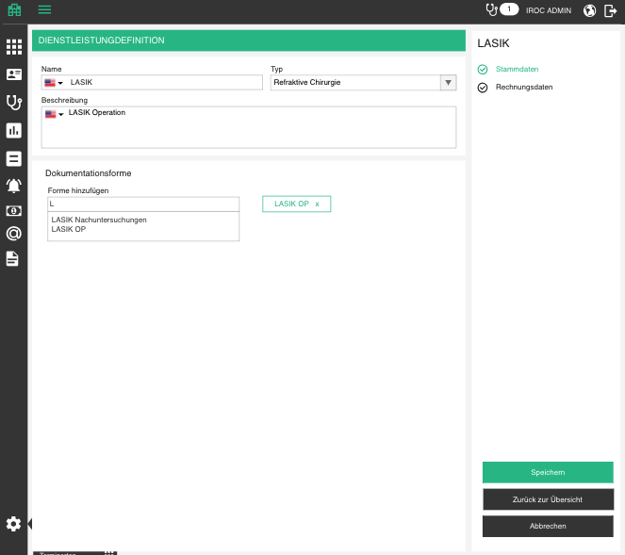

Billing block overview

In the application, we will display billing blocks in a section of medical service add/edit form, billing data tab.
- Billing data / Rechnungsdaten
- Billing blocks / Abrechnungsblöcke

Each block will be presented with an expandable container of billable block positions. All blocks are expanded by default, but the user can also collapse them to save on space. Expand / collapse is achieved by clicking on the billing block header. We will also need a button for expanding/collapsing all blocks at the same time.
- Expand all / Alle erweitern
- Collapse all / Alles schließen

Billing blocks are ordered by their creation timestamp, so that the last added one is at the bottom. The user can reorder them by drag and drop.

Each header contains the name and the name and revision of the assigned billing catalog. In addition to that, display the total value of the billing block (sum of all position total values in the currency specified by the catalog) and the indicator whether this position is the default one.

If there are no billing blocks defined, the user will just see the add new button
- Add billing block / Abrechnungsblock hinzufügen

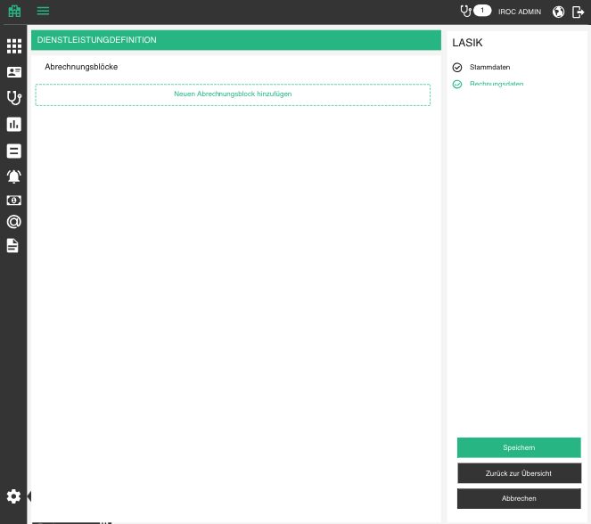

Add / Edit billing block

The user can define name of the billing block and select the associated billing catalog and its revision. Once saved, a billing block cannot change the catalog revision.
- Title / Name - text value, mandatory, unique (apply the same validation as in the rest of the app)
- Default / Standard - checkbox which marks a block as default (the one we choose for billing unless user specifies differently); When one block within a medical service is marked as default, other ones get "unmarked"

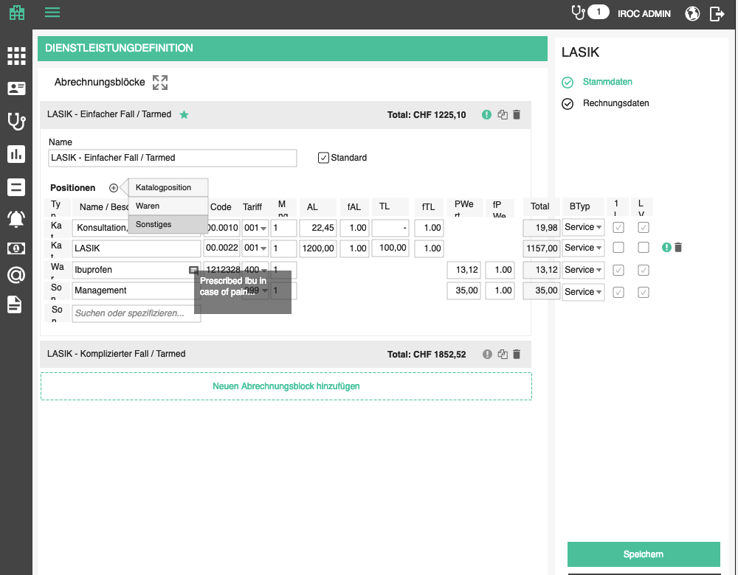

Add / Edit billable block position in a block

Positions of a billing block can be found under the positions subtitle and added by clicking on the add button
- Positions / Positionen
- Add position / Position hinzufügen

Billable positions can be sorted by all columns. Default sorting is by date (ignore time portion as long as time is not displayed); then by type if the date is the same; then by code if the type is the same.

User can add positions of various types to a billing block (see above)

Catalog position / Katalogposition
- Positions imported into the billing catalog. Depending on catalog type, there will be different attributes, e.g. TARMED catalog does not have a unit price, but DS and TS (see details below) and some other catalog in another country might have just a unit price, etc. In this section we will just discuss TARMED and its values.
- Label in the table will say: Cat / Kat
- Title / Name: When the user starts typing the autocomplete offers the most similar positions from all billing catalogs (with catalog name and revision in the brackets, because there might be multiple matches); since TARMED entries have a dot in the code (e.g. 08.0010) enable the user to search by code without the dot too (e.g. 080010)
- Prefill the other attributes from the selected catalog entry; catalog-based entries will not be editable
- Code / Code - mandatory, also works as autocomplete
- Ref-Code / Ref-Code - optional, if the position is a reference position, the code of the main position is written here
- Tariff / Tariff - mandatory, needed for e-billing, dropdown; (value for TARMED = 001, always reimbursable)
- Quantity / Menge - mandatory, must be a number, 4 decimal places (Invalid format. Please specify a number. / Ungültiges Format. Bitte geben Sie eine Nummer an.)
- DS / AL - doctoral services price. This attribute is needed only if the chosen catalog revision dictates it. If yes, it is mandatory, must be a number, aligned right with two decimal points
- fDS / fAL - mandatory; doctoral services price scale factor. Used for scaling the price for discounts or deductions, e.g. -1.00 will make a negative position; default = 1
- TS / TL - technical staff services, similar to doctoral services, available ifSeprateUnitPriceToDoctorAndTechnicalService = 1. Technical services are actually the part which is supposed to cover expenses of non-human resources, the whole practice infrastructure, maintenance and similar (because a practice has more expenses than just the salaries)
- fTS / fTL - mandatory; technical services price scale factor. Used for scaling the price for discounts or deductions, e.g. -1.00 will make a negative position; default = 1
- Total - disabled, calculated automatically as (UP * fUP * Quantity) whenever one of those two values changes, aligned right with two decimal points. If the catalog dictates different prices for doctor and technical (or other) services, this value is calculated as ((DS * fDS) + (TS * fTS)) * Quantity), whenever one of those values changes.
- Booking type / Buchungsart - a dropdown with available cost center booking types, which will be used later for prefilling the same value in bill position (see Bills section for more details why this is important)
- Reimbursment mandatory / Rückerstattung erforderlich - checkbox which will signifies whether or not the position has to be reimbursed
- checked by default
- 1L / 1L (Bill once per encounter / Einmal pro Behandlung abrechnen) - specifies whether or not the position can be billed only once per encounter
- HL / LV (Hide localization / Lokalisation verstecken) - specifies whether the localization string should be hidden on bill

Like mentioned above, these fields depend on the catalog settings. Namely, if the catalog specifies that unit prices is separated into doctor and technical price, then the unit price will not be available for that position. Different catalogs will come with different settings so make sure that the UI can be easily adaptable. For now we just have a situation where instead of unit price we have DS and TS. The DSx and TSx factor come from a catalog setting UseUnitFactor. If yes, every unit price will also get a factor field. Same goes for UseScaleFactor.

Goods / Waren
- User can add positions from the list of goods they keep on stock in the practice
- If there is no stock available for the tenant, this option is also not available for adding
- Label in the table will say: Good / War
- Title / Name: If the stock is set up, the user will add position by typing first letters of the goods and the autocomplete will offer best fit items (the user is actually searching through variants; goods which do not have variants have in fact, one default variant in the background)
- When the user selects a product, we will pick the price defined for the currency of the current billing block, otherwise, take 0
- Prefill the other attributes from the selected catalog entry, but let the user edit them
- Code - mandatory
- Tariff - mandatory dropdown, needed for e-billing; check in product default tariff
- UP / PWert - mandatory, must be a number, aligned right with two decimal points.
- fUP / fPWert - mandatory; unit price scale factor. Used for scaling the price for discounts or deductions, e.g. -1.00 will make a negative position; default = 1
- Total - disabled, calculated automatically as UP*fUP*Quantity whenever one of those two values changes, aligned right with two decimal points
- Reimbursment mandatory / Rückerstattung erforderlich - checkbox which will signifies whether or not a product has to be reimbursed
- if reimbursement group = 1 then this checkbox will be checked by default

Other / Sonstiges
- This option is always available and can be literally anything the user defines
- Label in the table will say: Oth / Son
- Title / Namloe - free text, user can specify anything, but it is mandatory
- Tariff - mandatory dropdown, needed for e-billing; value for other = 406
- Unit price / PWert - mandatory, must be a number, aligned right with two decimal points
- fUP / fPWert - mandatory; unit price scale factor. Used for scaling the price for discounts or deductions, e.g. -1.00 will make a negative position; default = 1
- Total - disabled, calculated automatically as UP*fUP*Quantity whenever one of those two values changes, aligned right with two decimal points
- Reimbursment mandatory / Rückerstattung erforderlich - checkbox which will signifies whether or not the position has to be reimbursed
- unchecked by default
Each position can have a comment which can be lengthy. These comments will later be used to prefill bill position comments. A position with no comment has a small comment icon which is displayed in the right part of the Title field when the user hovers over the position. Clicking on it will open a small popup with text area for specifying comment.
- Comment for <position title> / Kommentar für <position title>
- OK / OK
- Cancel / Abbrechen

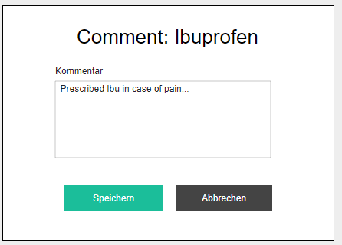

When the comment is specified for a position the comment icon is always visible and highlighted green or something. Hovering on it displays a comment in a tooltip. Clicking on it opens the popup for editing.

Billable block rules

Billable blocks can have billing rules attached to them. These rules define circumstances under which each block will be applied to a bill. They are used at the moment of creation of a bill, based on one or more encounters, and will, in most cases be checked based on various encounter data, like patient age at the time of the encounter, etc.

Since we cannot really tell which types of rules there will exist in the future, this feature must be implemented to be flexible. As types of rules come up, we will have to extend the functionality which applies them. Please have this in mind when developing this feature.

The user defines rules for a billable block by clicking on the rules icon of the corresponding billable block in the medical service administration. If there are no rules defined, the icon will be grayish and will appear only on hover. If there are rules defined, it will be present always and colored with the app theme color, so that it is obvious to the user that rules will be applied.
- Rules / Regeln - tooltip on the icon

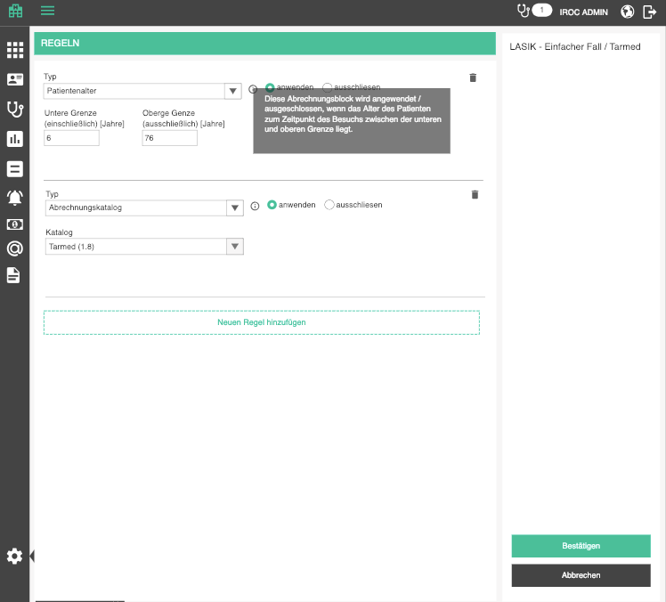

The user is taken to the rules page of the corresponding billable block where they can administer the rules.
- Rules / Regeln - title of the page
- display title of the billable block in the upper right corner so that the user knows on which billable block they are working on
- Save / Bestätigen - saves the rules and leads back to the medical service administration if the validations pass. This does not save to database, user will have to do it from the medical services page
- Cancel / Abbrechen - discards the changes re-applies the initial rules and leads the user back to the medical services page

Adding a new rule is done by clicking on the add new button. After this, a new rule form appears at the bottom with just a dropdown for selecting the rule type. If nothing is selected and the user confirms or adds a new rule, this one will be disregarded and will disappear.
- Add rule / Regel hinzufügen
- Type / Typ - dropdown with possible rule types (details in the rest of the text)

Deleting a rule is done by clicking on the delete icon, and the user is prompted to confirm their action.
- Delete rule / Regel löschen
- Are you sure you want to delete this rule? / Sind Sie sicher, dass Sie diesen Regel löschen möchten?

Type: Flat rate
- Flatrate / Pauschale - type dropdown value
- This billing block will exclude all other services and products from billing on bill preparation. / Dieser Rechnungsblock schließt alle anderen Dienstleistungen und Produkte bei der Rechnungsvorbereitung aus. - info tooltip
- Switch with options
- off: Allows additional positions / Erlaubt zusätzlichen Positionen
- on: Does not allow additional positions / Erlaubt keine zusätzlichen Positionen

Implications on bill preparation:
Whenever this kind of block is selected in a service, all other services and products are unchecked for billing and a warning icon appears next to the block with message:
- This is a flat rate block. It should be billed exclusively, without any additional positions on the bill. / Dies ist ein Pauschalblock. Sie sollte ausschließlich abgerechnet werden, ohne zusätzliche Positionen auf der Rechnung.

Implications on bill:
Whenever this block is selected in a service, a warning icon appears next to it with message:
- This is a flat rate block. It should be billed exclusively, without any additional positions on the bill. / Dies ist ein Pauschalblock. Sie sollte ausschließlich abgerechnet werden, ohne zusätzliche Positionen auf der Rechnung.

Type: Patient age

- Patient age / Patientenalter - type dropdown value
- This billing block will be applied / skipped if the patient age, at the time of encounter is between lower and upper limit. / Diese Abrechnungsblock wird angewendet / ausgeschlossen, wenn das Alter des Patienten zum Zeitpunkt der Behandlung zwischen der unteren und oberen Grenze liegt. - info tooltip
- apply / anwenden - radio button, signifying that the billing block should be applied to the bill if the rule is satisfied
- skip / ausschliessen - radio button, signifying that the billing block should be skipped if the rule is satisfied
- Lower limit (inclusive) [Years] / Untere Grenze (einschließlich) [Jahre] - number text box, mandatory
- Upper limit (exclusive) [Years] / Obere Grenze(ausschließlich) [Jahre] - number text box, mandatory

Application:
When adding positions from this billable block to a bill, check if the patient's age at the time of the encounter was between lower and upper limit. Have in mind that the rule can be "apply" or "skip".

Type: Billing catalog

- Billing catalog / Abrechnungskatalog - type dropdown value
- This billing block will be applied / skipped if the specified billing catalog was used in the encounter. / Diese Abrechnungsblock wird angewendet / ausgeschlossen, wenn der angegebene Abrechnungskatalog in der Behandlung verwendet wurde. - info tooltip
- apply / anwenden - radio button, signifying that the billing block should be applied to the bill if the rule is satisfied
- skip / ausschliessen - radio button, signifying that the billing block should be skipped if the rule is satisfied
- Catalog / Katalog - dropdown with all billing catalogs and their revisions, named like: <billing catalog> (<revision>)

Application:
When adding positions from this billable block to a bill, check if the billing catalog of the encounter is the same as the rule. Have in mind that the rule can be "apply" or "skip".

Billable position rules

Billable block positions can have billing rules attached to them. These rules define circumstances under which each position can or cannot be billed. The Tarmed catalog comes with a set of rules like:
- how old must the patient be
- how many times a position can be billed (in a day, in a month, year, encounter, case, etc)
- with which other position it must be billed together
- with which other position it must not be billed together
- how long must the encounter last

These rules will be applied when creating bill positions out of billable block positions (they are helping the user create a bill with as little effort as possible, by generating the correct quantity based on the quantity formula, for example) and to indicate whether the user has set up the bill correctly if they have made manual adaptations.

Note: Since we cannot really tell which types of rules there will exist in the future, this feature must be implemented to be flexible. As types of rules come up, we will have to extend the functionality which applies them. Please have this in mind when developing this feature.

The user defines rules for a billable block position by clicking on the rules icon of the corresponding billable block position in the medical service administration. If there are no rules defined, the icon will be grayish and will appear only on hover. If there are rules defined, it will be present always and colored with the app theme color, so that it is obvious to the user that rules will be applied.
- Rules / Regeln - tooltip on the icon

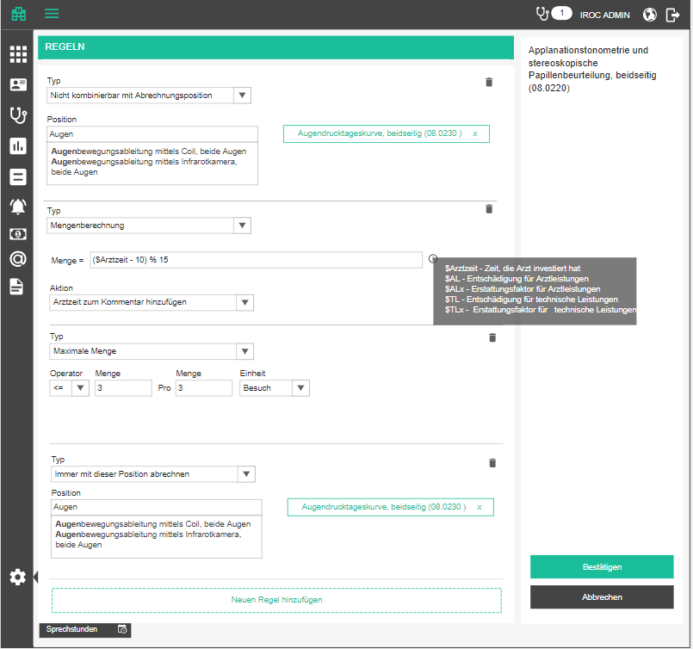

The user is taken to the rules page of the corresponding billable block position where they can administer the rules.
- Rules / Regeln - title of the page
- display title of the billable block position in the upper right corner so that the user knows on which billable block position they are working on
- Save / Bestätigen - saves the rules and leads back to the medical service administration if the validations pass. This does not save to database, user will have to do it from the medical services page
- Cancel / Abbrechen - discards the changes re-applies the initial rules and leads the user back to the medical services page

Adding a new rule is done by clicking on the add new button. After this, a new rule form appears at the bottom with just a dropdown for selecting the rule type. If nothing is selected and the user confirms or adds a new rule, this one will be disregarded and will disappear.
- Add rule / Regel hinzufügen
- Type / Typ - dropdown with possible rule types (details in the rest of the text)

In addition to specific controls for each rule type, we will enable an action to perform for a rule. For now we only offer adding doctor time to the comment, because that's an important variable, but in the future we may want to add something like "attach diagnose to the comment", or something similar.
- Action / Aktion - label for the dropdown
- Append doctor time to the comment / Arztzeit zum Kommentar hinzufügen - value in the drop down; user can either select this or leave it empty
- Doctor time X = / Arztzeit X = - the text to be appended to comment (remember, we can define comments for billable block positions, so that will be copied into the comment first and then the doctor time will be appended)

Deleting a rule is done by clicking on the delete icon, and the user is prompted to confirm their action.
- Delete rule / Regel löschen
- Are you sure you want to delete this rule? / Sind Sie sicher, dass Sie diesen Regel löschen möchten?

Have in mind that some rules will be imported from the billing catalog together will billable block positions.

Type: With which other billable block positions a billable block position cannot be billed together

- Not combinable with billable block position / Nicht kombinierbar mit Abrechnungsposition - type dropdown value
- Position / Position - a tag-like component which adds new entries from an autocomplete box (see Staff groups control on staff page)

The user starts typing in the position autocomplete and the app offers most suitable matches found amongst all existing billable block positions in the database + billable block positions from available billing catalogs. The selected one will be persisted in the database and displayed as a tag. The user can delete that tag by clicking on the "x" field and confirmation is not needed.
It can happen that billable block positions appear multiple times, so display them in the autocomplete as
- <billable block position code>:<billable block position title> (<medical service title>/<billing block title>)

Application:
For every bill position, check if any of the “Cannot be billed together” bill positions appear on the same bill. If yes, the broken rules icon lights up and the following text is added to tooltip:
- This position cannot be billed with: / Diese Position kann mit diesen Positionen nicht abgerechnet werden:
  - <names of the positions>

Type: Which other billable block position is this billable block position a part of

- Must be billed with / Muss abgerechnet werden mit - type dropdown value
- Position / Position - autocomplete for selecting the billable block position with which this one always goes

The user starts typing in the position autocomplete and the app offers most suitable matches found amongst all existing billable block positions in the database + billable block positions from available billing catalogs. The selected one will be persisted in the database.
It can happen that billable block positions appear multiple times, so display them as
- <billable block position code>:<billable block position title> (<medical service title>/<billing block title>)

Application:
For every bill position, check if any of the “Must be billed together” bill positions do not appear on the same bill. If yes, the broken rules icon lights up and the following text is added to tooltip:
- This position must be billed with: / Diese Position muss mit diesen Positionen abgerechnet werden:
  - <names of the positions>

Type: Main position and reference code required

- Main service and reference code required / Hauptleistung und Referenzcode erforderlich - type dropdown value
- This rule should be loaded from TARMED directly for every positions of type R or Z

Application:
For every bill position, check if any of the “Main service and reference code required” bill positions are missing the reference code, or if they have a reference code, is a position with that code present on the bill for the same date. If yes, the broken rules icon lights up and the following text is added to tooltip:
- This position must have a main position specified. / Für diese Position muss eine Hauptposition angegeben werden.

Type: What is the formula for calculating position quantity

- Quantity calculation / Mengenberechnung - type dropdown value
- Quantity = / Menge = - text box in which the user can type up the formula

The formula should support all regular mathematical operations like +, - , *, /, % and grouping with brackets. The user can insert variables with '$' prefix to define a formula which will be applied when the billable block position is translated into a bill position, upon bill creation. For the time being, we will support only times invested by people in different roles.

Add an info icon which displays the list of possible variables:
You can use any of these variables in your formula: / Sie können jede dieser Variablen in Ihrer Formel verwenden:
$<role code> = <role name> time / $<role code> = <role name> Zeit - for every person role, we will enable an invested time variable

Application:
For every bill position, check if it has this rule applied and calculate its quantity based on the formula. For example, ($Optiker-Zeit % 5) + 1 will divide time invested by all opticians on encounter from which the bill position originated without rest, and add one. If opticians invested 22 minutes, quantity will be (22 % 5) + 1 = 4 + 1 = 5

Type: For which localizations can the position be billed

- Localization dependency / Lokalisierungsabhängigkeit
- Rule = / Regel = - text box in which the user can type up the formula

The formula should support all regular boolean operations like OR, AND, NOT and grouping with brackets. The user can insert variables with '$' prefix to define a formula which will determine whether or not the billable block position will be translated into a bill position, upon bill creation.

Add an info icon which displays the list of possible localizations:
You can use any of these localizations in your formula: / Sie können jede dieser Lokalisierungen in Ihrer Formel verwenden:
localization name> - for every localization in the system

Application:
For every bill position, check if it has this rule applied and add it to the bill only if the formula equals TRUE when the variables in the formula are replaced by localizations for which the parent medical service has been detected. For example, "(Links AND Rechts) or Beide" will be TRUE if the service was detected for both OS and OD or for OU.

Type: What is the maximum quantity for a position

- Quantity maximum / Maximale Menge - type dropdown value
- Operator / Operator - ">=", "<=" , "="
- Quantity = / Menge = - text box in which the user can type up the maximum quantity, mandatory, must be a number
- Time frame quantity / Zeitrahmen Menge - amount of units of the timeframe, mandatory, must be a number
- Unit / Einheit - unit of the timeframe (catalog value)
- ENC: Encounter / Behandlung
- PAT: Patient / Patient
- DAY: Day / Tag
- WEEK: Week / Woche
- MON: Month / Monat
- YEAR: Year / Jahr
- LOC: Localization / Localisierung

Application:
For every bill position, check if it has a quantity rule defined, and if yes, check if the quantity conforms to the rule, based on positions from already signed off bills:

X times per Encounter - get all the billed positions of this type which stem from the same encounter as the current position, add their quantity to the quantity of the current position and check if the quantity is ">=", "<=" or "=" X

X times per Patient - get all the billed positions of this type which stem from the encounters of the same patient as the current position, add their quantity to the quantity of the current position and check if the quantity is ">=", "<=" or "=" X

X times per Day - get all the billed positions of this type which stem from the encounters that happened on the same date as the current position, add their quantity to the quantity of the current position and check if the quantity is ">=", "<=" or "=" X

X times per Week - get all the billed positions of this type which stem from the encounters that happened in the 7 days prior to the current position encounter, add their quantity to the quantity of the current position and check if the quantity is ">=", "<=" or "=" X

X times per Month - get all the billed positions of this type which stem from the encounters that happened in the 30 days prior to the current position encounter, add their quantity to the quantity of the current position and check if the quantity is ">=", "<=" or "=" X

X times per Month - get all the billed positions of this type which stem from the encounters that happened in the 360 days prior to the current position encounter, add their quantity to the quantity of the current position and check if the quantity is ">=", "<=" or "=" X

X times per Localization - get all the other positions of this type in the same encounter as the current position, but with same localization, add their quantity to the quantity of the current position and check if the quantity is ">=", "<=" or "=" X

For every broken rule, the following text should be added to the broken rules tooltip:
- This position can be billed only X times per Y <unit>. / Diese Position kann nur X mal pro Y <unit> abgerechnet werden.

Type: Localization

Some services need to have a localization specified. There are no other options to add. E.g. 08.0130

- Mandatory localization / Obligatorische Lokalisierung - type dropdown value

Application:
For every bill position, check if the mandatory localization is on and if yes, is the localization missing. If yes, the broken rules icon lights up and the following text is added to tooltip:
- This position has to have a localization. / Diese Position muss eine Lokalisierung haben.

Type: Patient age

Some services can only be billed if provided to a patient of a certain age frame. E.g. 08.0480.
- Patient age constraint / Patientenalter Grenze - type dropdown value
- Age from / Alter von - text box in which the user can type up the minimum age, mandatory, must be a number
- Age from tolerance / Alter von toleranz - text box in which the user can type up the minimum age tolerance in days, mandatory, must be a number
- Age to / Alter bis - text box in which the user can type up the maximum age, mandatory, must be a number
- Age to tolerance / Alter bis toleranz - text box in which the user can type up the maxmum age tolerance in days, mandatory, must be a number
- Unit / Einheit - unit of the timeframe (catalog value)
- WEEK: Week / Woche
- MON: Month / Monat
- YEAR: Year / Jahr

Application:
For every bill position, check if the age constraint rule is on and if the patient age is <= minimum age + tolerance and <= maximum age + tolerance at the time of encounter. If not, the broken rules icon lights up and the following text is added to tooltip:
- Patient age must be between <min> <unit> + <tolerance> days and <max> <unit> + <tolerance> days. / Patientenalter muss zwischen <min> <unit> + <tolerance> Tage und <max> <unit> + <tolerance> Tage sein.

Delete billable block position from a block

Upon clicking on the delete icon, the user will be prompted by a standard confirmation popup.
- Are you sure you want to delete <position title>? / Sind Sie sicher, dass Sie <position title> löschen möchten?

Delete billing block

Upon clicking on the delete icon, the user will be prompted by a standard confirmation popup.
- Are you sure you want to delete <billing block name>? All positions will be deleted. / Sind Sie sicher, dass Sie <billing block name> löschen möchten? Alle Positionen werden gelöscht.

Copy billing block

For usability reasons, we will implement the copy functionality. The user may want to specify a billing block which differs from another one only in one position. So to not put the user through the trouble of creating all the positions again.
- Create a copy / Kopie erstellen (tooltip for the copy button)

Copy button will create another billing block with all the same positions, same catalog revision, but the name should have " - copy" appended to the original name. This is because we need billing blocks with unique names.

*Assigning medical services to appointment types (deprecated)

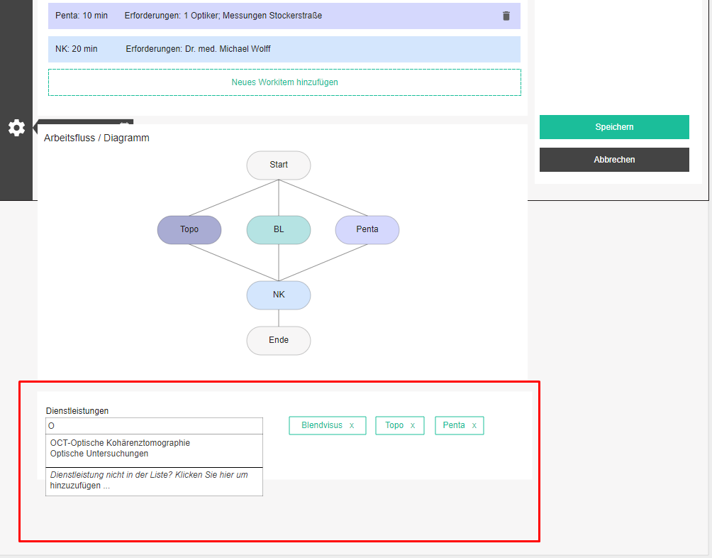

Since billing is all about provided medical services and getting reimbursed for them, we need to know which medical services go with which appointment type. And since different doctors may have a different outlook on these appointment types, we will connect the medical services to the actual appointment variants. The assignment of services to an appointment variant is done via tag-like control at the bottom of the page. As the user types, the best matches appear and clicking on one or pressing enter, adds the service to the list from which it can be removed by clicking on the 'x' button. No confirmation is needed.

Booklets
Booklets are a kind of local catalogs, which are used as bookmarks to items used most frequently in different contexts. For example, a list of medications used regularly in cataract surgery follow ups can be added to a bookle, which can then be configured to appear on suitable documentation forms.

Booklets can have different types, depending on types of items they contain. A booklet can contain products or diagnoses or services, etc. One booklet can contain only items of one type. A booklet can contain manually defined items, as well as links to items from other booklets and catalogs.

Booklet overview
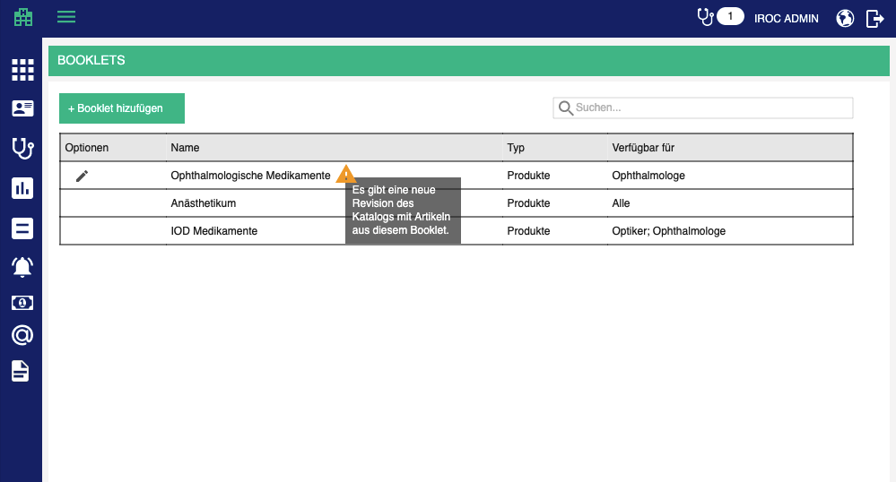

Booklets / Booklets - title

Overview is a table which contains all booklets which are added to the tenant database.

Table contains the following columns:
- Options / Optionen (edit, delete)
- Title / Name + Refresh hint – a warning icon which notifies the user that some of its elements can be refreshed, because there is a new version of the catalog from which they originate
- There is new revision of catalog with elemenys from this booklet. / Es gibt eine neue Revision des Katalogs mit Elementen aus diesem Booklet.
- Type / Typ
- Available for / Verfügbar für

The list should be sortable by all columns (except options, of course). Default sorting is by title, alphabetically.
The list should be search-able by all columns. Search starts as soon as you type, but with a small debounce. Check the rest of the app for guidance.

When the searched list is empty, display the following text instead of the first row:
- There are no matching booklets for this search criteria. / Es gibt keine passenden Booklets für diese Suchkriterien.

When the list is empty in general, display the following text instead of the first row:
- There are no booklets defined. / Es gibt keine definierten Booklets.

Add / Edit booklet
Adding a booklet is started by clicking on the add button above the table.
- Add booklet / Booklet hinzufügen

Editing is started by clicking on the edit button in the corresponding row in the table
- Edit booklet / Booklet bearbeiten

Base data / Stammdaten

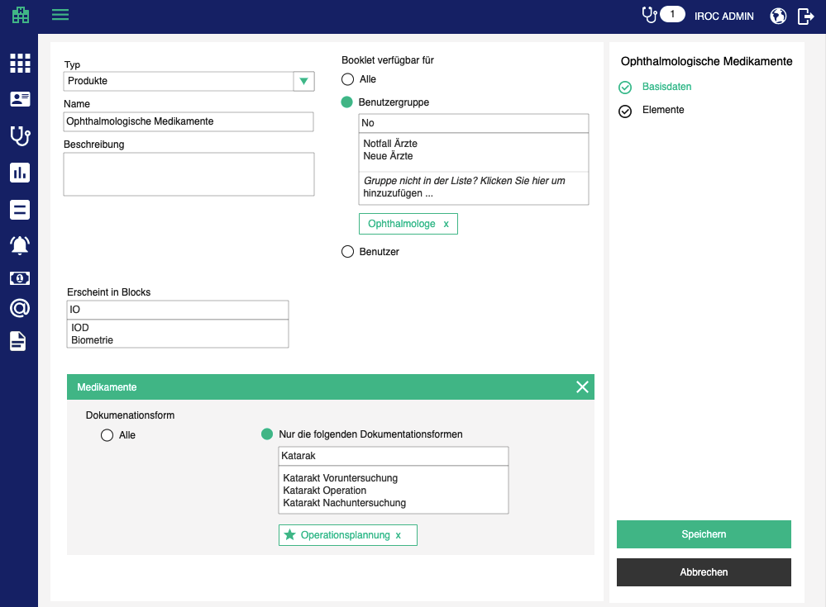

- Type / Typ – type of elements in this booklet; mandatory; disabled when at least one element is added to the booklet
- Title / Name - name of the booklet
- Description / Beschreibung
- Available for / Verfügbar für – list of people or groups who have access (read + write) to this booklet.
- All / Alle – available for every user in the organization
- Groups / Gruppen – one or more person groups; tag-like component
- Staff / Personal – one or more staff members; tag-like component
- Appears in blocks / Erscheint in Blocks - a list of blocks + documentation form combinations in which this booklet can be used (by people who have access to it)
- Block / Block
  - the user searches through available blocks; when they select one, it appears below with an option to select in which documentation forms should that block appear in order to offer this booklet
  - the user can remove the block
    - Remove / Entfernen
    - Are you sure you want to remove this block? / Sind Sie sicher, dass Sie diesen Block entfernen möchten?
  - The user can select all blocks option or specific documentation fotms
    - All / Alle
    - Only the following documentation forms / Nur die folgenden Dokumentationsformen
      - Tag like component for adding specific forms
      - Clicking on a star icon within a form makes this booklet the default option for the selected block + documentation form
      - One booklet can be the default for multiple blocks + forms

Elements / Elemente

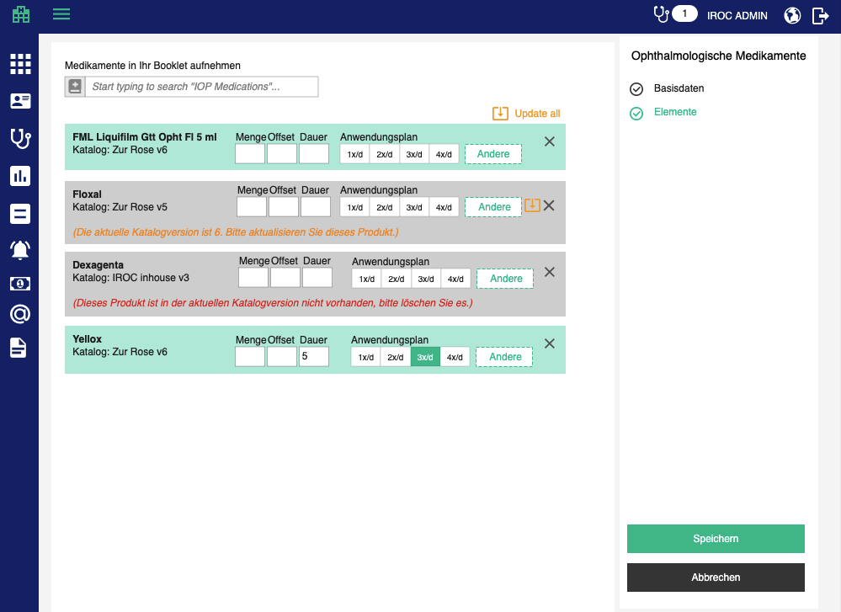

This tab enables the user to add elements to a booklet, depending on the chosen booklet type in base data. Below is the workflow for maintaining elements of a medications booklet.

The user can add medications using the medications box (see Kordeus Documentation Forms documentation / section Components).
- Add products to booklet / Produkte zur Booklet hinzufügen

When a product is added to a booklet, the booklet element must retain a reference to the original catalog item, to enable the user to import updates.

When the origin catalog of any of the elements has updated since the moment when the element has been added, a suitable message and an option to replace the old version of the element with the new one.
- If the element has been updated
  - (Current revision of this catalog is <revision name>. Please update this product.) / (Die aktuelle Katalogversion ist <revision name>. Bitte aktualisieren Sie dieses Produkt.)
  - Update / Aktualisieren – option visible on the booklet element
  - Update all / Alle aktualisieren – option visible above all elements, applied to all eligible elements
  - If the element has been removed from the new source catalog version
  - (This product is not available in the current catalog revision. Please delete it to avoid problems with using an unavailable product in other parts of the application.) / (Dieses Produkt ist in der aktuellen Katalogrevision nicht verfügbar. Bitte löschen Sie es, um Probleme bei der Verwendung eines nicht verfügbaren Produkts in anderen Teilen der Applikation zu vermeiden.)
  - User can remove it manually

The user can remove each element manually by clicking on the remove button
- Remove / Entfernen
- Are you sure you want to remove <element name> from this booklet? / Sind Sie sicher, dass Sie <element name> aus dieser Booklet entfernen möchten?

The user can configure prescription defaults (quantity, duration and application plan) for each product (see Kordeus Documentation Forms documentation / section Active medications). Quantity is applied to active medications (prescriptions), consumed materials and handed out materials.

The page offers 3 standard buttons:

- Save / Speichern - executes all the validations and displays errors if necessary, otherwise saves the changes and displays the success message
- (if adding new) Booklet has been successfully created. / Booklet wurde erfolgreich erstellt.
- (if editing) Booklet has been successfully updated. / Booklet wurde erfolgreich aktualisiert.

- Cancel / Abbrechen - go back to overview withought saving changes
- Back to overview / Zurück zur Übersicht - go back to overview withought saving changes

If the user tries to leave the page after some changes have been made but not yet saved, the app will warn them with the standard "Are you sure you want to leave this page..." popup. This functionality should be applied to all pages, always.

Delete booklet

Upon clicking on the delete icon, the user will be prompted by a standard confirmation popup.
- Delete booklet / Booklet löschen
- Are you sure you want to delete <booklet>? / Sind Sie sicher, dass Sie <booklet> löschen möchten?

Documentation forms
Dynamic documentation forms offer the user an option to customize their documentation processes. The structure is the following:

- Each documentation form has its unique GID and can be used by one or more identities (tenants). In the future, documentation forms will be purchasable from a B-Op marketplace. Currently they are distributed to customers via import scripts.
- Each documentation sub-form (a.k.a tab) has its unique GID and can be added to one or more documentation forms by the user.
- Each documentation block has its unique GID and can appear in one or more tabs. The user can edit if and in which order blocks appear on a tab, within a form, but the choice of blocks is built into a tab.

Documentation forms overview
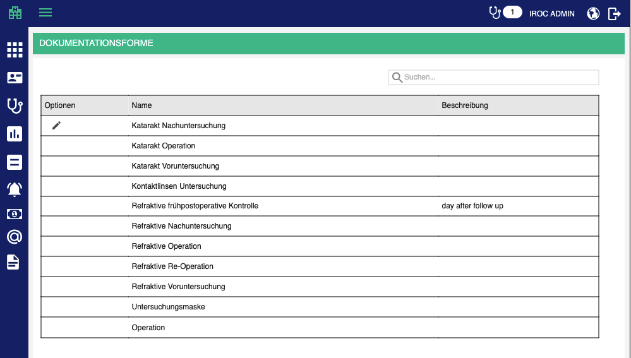

Documentation forms / Dokumentationsformen - title

Overview is a table which contains all documentation forms which are added to the tenant database.

Table contains the following columns:
- Options / Optionen (edit)
- Title / Name
- Description / Beschreibung

The list should be sortable by all columns (except options, of course). Default sorting is by title, alphabetically.
The list should be search-able by all columns. Search starts as soon as you type, but with a small debounce. Check the rest of the app for guidance.

When the searched list is empty, display the following text instead of the first row:
- There are no matching documentation forms for this search criteria. / Es gibt keine passenden Dokumentationsformen für diese Suchkriterien.

When the list is empty in general, display the following text instead of the first row:
- There are no forms imported. / Es sind keine Dokumentationsformen importiert.

Edit documentation form
Editing is started by clicking on the edit button in the corresponding row in the table
- Edit documentation form / Dokumentationsform bearbeiten

Base data
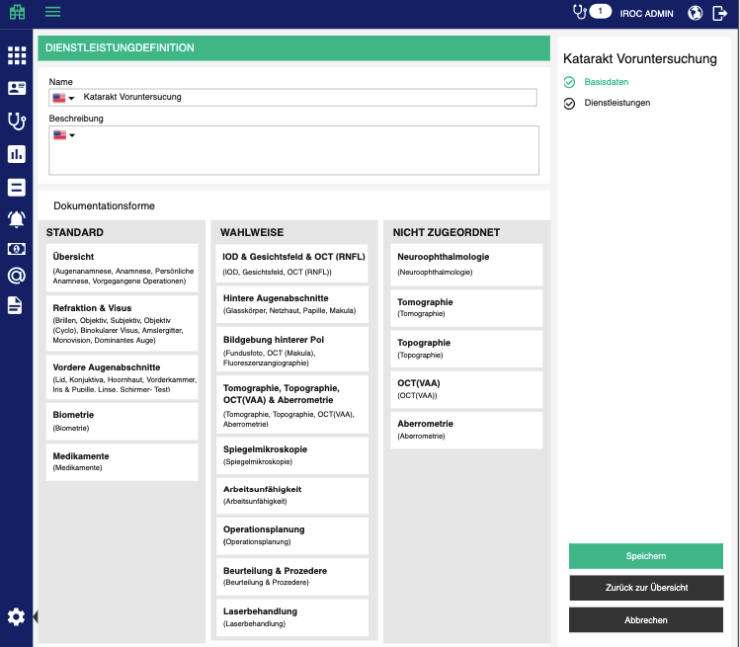

The user can edit Name and Description of documentation form. Likewise, user can distribute all the available tabs into 2 groups: Default (always visible) and Optional (added on demand). This is done via 3 drag & drop columns:
- Unassigned / Nicht zugeordnet
- Default / Standard
  - If added to this column, the tab will appear on each opened documentation form of this type
  - User can re-order the tabs
- Optional / Wahlweise
  - If added to this column, the tab can be added the every form of this kind, on the fly
  - User can re-order the tabs

Medical services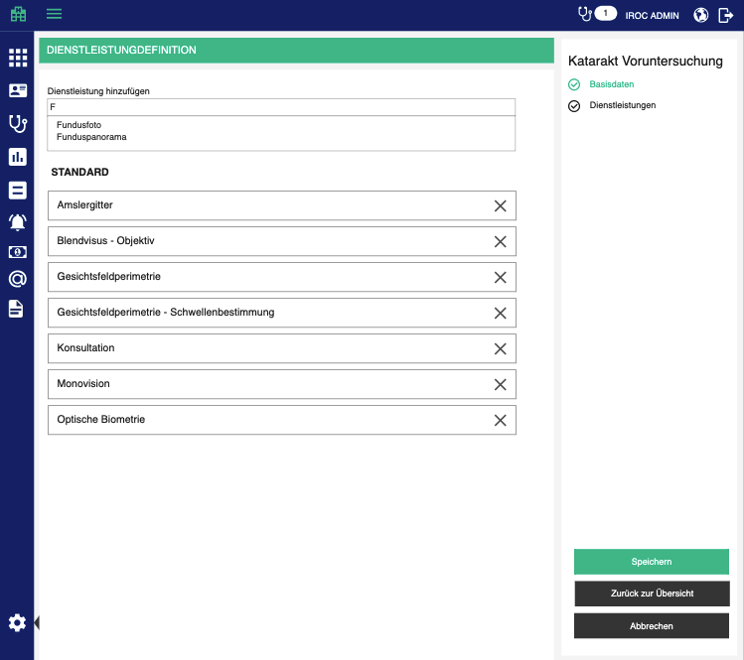

The user can administer medical services which can be documented through a form of this kind. Medical services added to this page are the ones which appear on encounter Bill preparation page and Add / edit bill page, in the order in which the user arranges them here, using drag & drop.

The user can add new services to a documentation form, using the autocomplete box above the table.
- Add medical service / Dienstleistung hinzufügen

The user can remove a medical service from the list by clicking on remove icon.
- Remove / Entfernen
- Are you sure you want to remove <service name>? / Sind Sie sicher, dass Sie <service name> entfernen möchten?
- Remove all / Alle entfernen
- Are you sure you want to remove all medical services? / Sind Sie sicher, dass Sie alle Dienstleistungen entfernen möchten?

The page offers 2 standard buttons:

- Save / Speichern - executes all the validations and displays errors if necessary, otherwise saves the changes and displays the success message
- (if editing) Data have been successfully saved. / Die Daten wurden erfolgreich gespeichert.

- Cancel / Abbrechen - go back to overview without saving changes

If the user tries to leave the page after some changes have been made but not yet saved, the app will warn them with the standard "Are you sure you want to leave this page..." popup. This functionality should be applied to all pages, always.

Edit tab (sub-form)

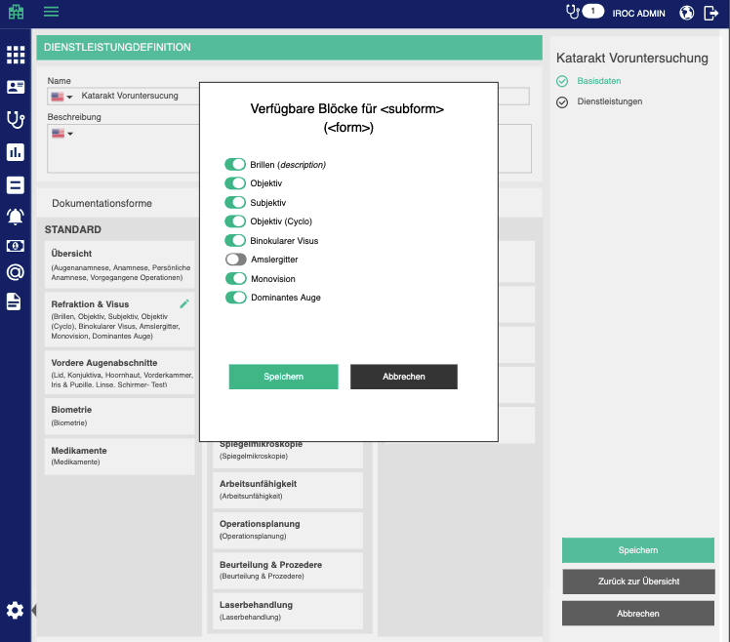

Edit icon on tab car opens a popup with list of available blocks for that tab, and user should be able to switch on/off if they are visible on that tab within that form, and to arrange them in the desired order
- ​Available blocks for <subform> (<form>) / Verfügbare Blöcke für <subform> (<form>)

Tenant settings

Responsible persons for documentation forms

We will enable tenant settings which lists all masks as blocks with title. Under the title, we will show the usual tag-like control, through which we can select one or more possible responsible persons. Offered persons are the ones which have the “can sign documentation forms“ right.
- Possible responsible staff / Mögliche verantwortliche Personale

Documentation forms available in UI

Documentation forms go in and out of fashion, so it must be possible to deactivate the ones which should not be used, i.e. should not be choosable when starting an encounter. These forms, however, will be opened for past encounters - that is why they cannot be deleted.

We will enable tenant setting which is a tag like component through which the user can select one or more forms which should be available in the UI. The user can search through all the masks for the current tenant and all the selected ones are the ones which appear in the mask selection popup, when starting an encounter.
- Available documentation forms / Verfügbare Dokumentationsmasken

Waiting time color code

The user can specify in which color waiting times will be displayed in the queue, based on the value in minutes. Both upper and lower limits are inclusive. If omitted, the limit does not exist.
- From / Von
- To / Bis
- Color / Farbe

E-billing gateway connection
In tenant settings, the administrator can define connection parameters for MediData client. In the future, there will be multiple e-billing gateways or different customers will use different ones. We have to offer a flexible way to show/hide these settings.

MediData Network connection / MediData Netz Verbindung
- Base URI / Base URI
- Client ID / Client ID
- Username / Username
- Password / Password
- Test mode / Test-Modus (checkbox)

Send TG bills electronically
Send TG bills electronically / TG-Rechnungen elektronisch versenden - switch

In E-billing tab, display TG bills in the overview, only if "Send TG bills electronically" is turned on for the tenant.

Un-finish encounter timeframe
Administrator can set up a time frame for re-opening finished encounters. By default it is 24 hours.
- Re-open encounter timeframe / Zeitrahmen für Wiedereröffnung der Untersuchungen

Default billing options
- Default payment deadline in days / Standard-Zahlungsfrist in Tagen – number box; optional;
- Default applicable law / Standard-Gesetz – dropdown with all available applicable laws; optional
- Default payment account / Standard-Zahlungskonto – dropdown with all accounts; optional
- Default facility / Standard-Ort – dropdown with all the facilities; optional
- Default treatment reason / Standard-Behandlungsgrund- dropdown with all treatment reasons; optional
- Default diagnosis / Standard-Diagnose – free text box; optional

Menu and application frame

Menu

Main menu should behave differently, depending on the screen size. Users with wider monitors should see each menupoint name in addition to the icon. However, if the user does not want to have the full menu which takes up space, they should be able to shrink it to icon-only mode. Likewise, when the menu is in icon-only mode, the user should be able to expand it to icon-and-title mode. This is available for small screen users too, they just get the icon-only version by default.

This preference be saved in user's preferences or a cookie, so that if the user has shrunk or expanded the menu, the action is not reverted with every page reload.

Top bar

Top bar contains information about where the user is in the app, i.e. which module.

In the right part it displays open (unfinished) encounters, in case the logged in user has the right to finish encounters. Clicking on the icon, a dropdown with main information about each of the open encounters:
- Last name, first name of the patient
- Encounter date
- Documentation form type
Clicking on an encounter opens it.

User can also change the language of the application in the top bar, by clicking on the globe icon.
Name of the logged in user also serves as a link to the user’s profile page. On the profile page, the user can edit their basic and account data, the same way as an administrator would (See Staff in Administration section), with some limitations. A regular user can edit:
- First name
- Last name
- Academic title
- Contact email
When editing account data, a regular user must enter new password, repeat new password and also supply old (current) password.

Logout icon in the top bar, naturally, enables the user to log out of the application.

Calendar and appointments

Daily agenda
Calendar is the default view in the application. The main part of the screen displays the agenda and the right hand bar displays the monthly calendar for faster navigation and selected appointment details.

Agenda is split into three views:
- Staff / Personal
- Devices / Geräte
- Facilities / Einrichtungen

Each of the views contains people / devices / facilities specified by the current filter profile. Filter profiles can be edited by pressing the edit button in the filter profile dropdown, which is used for selecting the current filter profile.

Above the agenda, the application always displays currently viewed date and the user can go back and forth, through the calendar, by using the navigation buttons.

When an appointment is selected, the right hand bar displays the following data:
- Patient (#<patient number> since <patient entry date>) / Patient (#<patient number> seit <patient entry date>)
- Unconfirmed / Unbestätigt - if patient is unconfirmed, this should be obvious and attract attention
- Location / Lokalität - facility to which the patient should come to start the encounter; main facility (patient might need to change facilities with different steps)
- Type / Typ - appointment type
- Self-payer / Selbstzahler - switch which sets the self-payer badge on the appointment, ON by default for patients who have TG billing profile
- Comment / Kommentar - Comment text with an option to edit it; when in edit mode, offer save and cancel
- Actions (see below)
- Steps
  - Step title
  - Time (planned) / Zeit (geplant) - start and end time of this step
  - Status / Status - icon and title of the current status (see below)
  - Staff / Personal - names of assigned staff of this step
  - Devices / Geräte - names of assigned devices of this step
  - Facilities / Einrichtungen - names of assigned facilities of this step

Agenda window limits

When the user looks at the agenda in the middle of the work day, everything is fine, they see the correct portion of the day. But in case when a user looks at the agenda in the evening, e.g. when they are planning the next day, they see the evening portion of the next day. This is very annoying because the user needs to scroll all the time when switching between agenda and other pages.

To surpass this issue, we will enable the user to set a time frame in their filter profile, from when to when the agenda should “move”. If nothing is specified, the defaults are 7am to 7pm. This means that automatic scrolling of the agenda will not go earlier than displaying 7am and will not go later than 7pm. When the user loads the agenda at 11pm, they will see the screen at latest 7pm. The user can, of course, scroll past that point manually.

In the filter profile settings add a new section with the following options:
- Agenda window / Agenda-Ansichtsfenster
- Min / Min - time box; 07:00 by default
- Max / Max - time box; 19:00 by default

Filtering the agenda
The agenda can get quite crowded and hard to find what one is looking for. To solve this issue we shall add a filtering option. Next to the profile selection, add a filter box
- Filter by / Filtern nach

The user enters a filter criteria, and the agenda removes all the appointments which do not meet the criteria. The criteria should match
- (part of) patient name OR
- patient number

In order to avoid bug reports like "some appointments are suddenly missing", which is very likely to happen, when the filter is active, the filter box shall change color, to make sure the user knows the agenda is filtered. In addition to that, when filter is active, the box shall offer an "x" icon to clear the filter.

Appointment statuses and actions

 | Patient history / Patientengeschichte | Add to queue / Zum Warteraum | Start step /  Untersuchungsschritt anfangen | Mark as finished / Als fertig markieren | Mark as no-show / No-show | Rebook / Umbuchen  OR  Re open / Wieder öffnen | Cancel / Absagen | Add task / Aufgabe hinzufügen | Send email / Email schicken | Document templates / Dokumentschablonen | Print appointment slip / Terminvereinbarung drucken | Print payment request / Anzahlungsanfrage drucken | Print documents / Dokumente drucken | Assign everything to me / Alles mir zuweisen | Re-open / Wieder öffnen
Open / Offen | x | x | x | x | x | x | x | x | x | x | x | x | x | x
Overdue / Überfällig | x | x | x | x | x | x | x | x | x | x | x | x | x | x
In queue / Im Wartenraum | x |  | x | x |  |  | x | x | x | x |  |  | x | x | x
Started / Laufend | x |  |  | x |  |  |  | x | x | x |  |  | x |  | x
Finished / Fertig | x |  |  |  |  | x |  | x | x | x |  |  | x |  | x
Cancelled / Abgesagt |  |  |  |  |  | x |  |  | x | x |  |  | x |  | x
No show / No-show |  |  |  |  |  | x |  |  | x | x

Appointment details
Clicking on an appointment opens up appointment details in the right panel, from which the user can access various appointment actions (depending on the status, see table), patient data, appointment steps and appointment history.

Patient data

Patient / Patient:
- <last name> <first name> (<gender sumbol>) #<patient number>
- Creation date / Aufnahmedatum: <creation date>
- Date of birth / Geburtsdatum: <DOB> (<age in years>)
- Account balance / Kontostand: <colored account balance, like in appointment making>

Appointment steps
TBD

Appointment history
To enable tracking of appointment changes, we will capture the current user whenever an appointment is:
- Created (action: created / erstellt)
- Edited (action: rebooked / umgebucht)
- Cancelled (action: cancelled / abgesagt)
- Marked as no-show (action: marked as no-show / als no-show markiert)
- Changed step status (action: marked <step name> as <status> / <step name> als <status> markiert)
- Cancelled step (action: cancelled <step name> / <step name> abgesagt)
- Moved step ( action: moved <step name> from <original time> to <new time> / <step name> von <original time> nach <new time> verschoben)

This information will be displayed at the bottom of appointment details, on a history panel which expands and collapses when the user clicks on it (make this component look and behave like other expand/collapse containers, so that we remain consistent)
- History / Historie - title
- <date>: <user> (<action>)

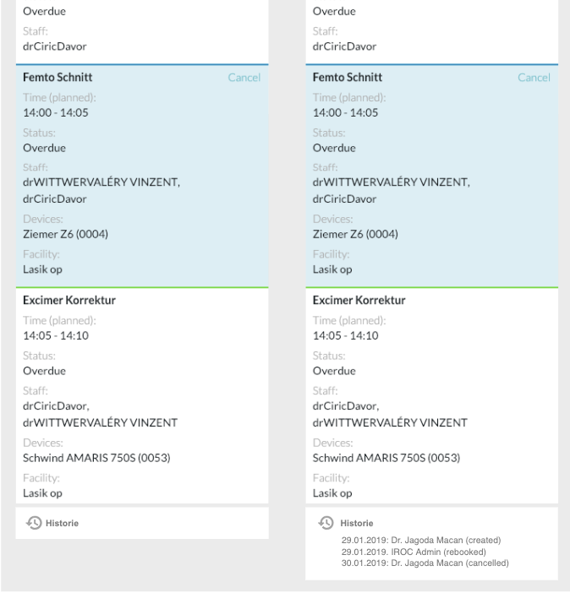

In the appointment details (right hand panel), add the status icon in front of the status text (it’s easier to spot an icon than to read text.) Use the same icons as we use for changing the status
- Nothing for planned,
- couch for waiting room,
- stethoscope for started,
- check for finished (change the icon for putting steps in this status as well)

Appointment actions

Re-Open appointment step (milestone)

Reopening a step is possible when a step is in any other status like: in queue, started, done, cancelled. A button "Re-open / Wieder öffnen" which can be found next to other actions. This button is, naturally, not visible for open steps.

Clicking on the link shows a confirmation popup
- Are you sure you want to re-open <milestone name>? / Sind Sie sicher, dass Sie <milestone name> wieder öffnen möchten?

Start step (milestone)

Starting a step is done by pressing the button "Start appointment step / Untersuchungsschritt anfangen" (have in mind that this will update the corresponding milestone status). This button is only available if the current status is open, overdue or in queue. Started and finished steps cannot be started again.

Open documentation form

Opening documentation form for an appointment is done by pressing the button "Open documentation / Dokumentation öffnen". This button is available no matter what the appointment status is.

It is not possible to open documentation form for appointment which has no patient or has an unconfirmed patient. In these cases the button will be diabled and will display the following message in a tooltip:
- You cannot start documentation for an appointment without specified patient. / Sie können die Dokumentation für einen Termin ohne angegebenen Patienten nicht starten.
- You cannot start documentation for an unconfirmed patient. Please confirm or merge the patient first. / Sie können die Dokumentation für einen unbestätigten Patienten nicht starten. Bitte zuerst bestätigen oder zusammenführen Sie den Patienten.

Appointment step drag & drop function

User can move appointment steps within the same day without rebooking an appointment. They can also re-assign steps to other people by dragging and dropping steps onto different columns on the calendar.

When the user drags an appointment step to another time, a confirmation popup will appear:

Are you sure you want to move <step name> for <patient> from <time> to <time>? / Sind Sie sicher, dass Sie den <step name> für <patient> von <time> nach <time> verschieben möchten?

- Yes and I want all other open steps to be moved with it. / Ja ich möchte, dass alle anderen offenen Schritte damit verschoben werden.
- Yes, but only <step name>. / Ja, aber nur <step name>.
- No / Nein

If the user has chosen the first option, all open and overdue steps which belong to the same appointment will be moved accordingly. This means: if the original step has been pushed 45min later, all open and overdue steps will be pushed for 45min later.

If the second option has been chosen, only the originally touched step will be moved.

If the third option has been chosen, nothing will happen (the user has maybe moved it unintentionally in the first place).

If a user tries to change the duration of a step by dragging and dropping in the calendar, a confirmation popup will appear:

Are you sure you want to change the duration of <step name> from <original duration> to <new duration>? / Sind Sie sicher, dass Sie die Dauer des <step name> von <original duration> auf <new duration> ändern möchten?

- Yes and I want to move all subsequent steps accordingly. / Ja und ich möchte alle nachfolgenden Schritte entsprechend verschieben.
- Yes, but only <step name>. / Ja, aber nur <step name>.
- No / Nein

If the user has chosen the first option, all subsequent steps which belong to the same appointment will be moved accordingly. This means: if the original step has been extended by 15min, all subsequent steps will be pushed for 15min later.

If the second option has been chosen, only the originally touched step will be moved.

If the third option has been chosen, nothing will happen (the user has maybe moved it unintentionally in the first place).

If a user drags an appointment step onto another resource column, a confirmation popup appears:

Are you sure you want to re-assign <step name> from <original resource> to <destination resource>? / Sind Sie sicher, dass Sie <step name> von <original resource> zu <destination resource> zuweisen möchten?

- Yes and I want all other open steps for <original resource> to be re-assigned to <destination resource>. / Ja und ich möchte, dass alle anderen offenen Schritte für <original resource> zu <destination resource> zugeordnet werden.
- Yes, but only <step name>. / Ja, aber nur <step name>.
- No / Nein

Finish step
Finish step / Untersuchungsschritt abschliesen

When the user clicks on finish step, a confirmation popup appears:

Are you sure you want to mark this milestone (<step 1>, <step 2>, <step n>) as finished? / Sind Sie sicher, dass Sie diesen Meilenstein (<step 1>, <step 2>, <step n>) als fertig markieren möchten?

- Yes and I want to put the next milestone (<step 1>, <step 2>, <step n>) into queue. / Ja und ich möchte den nächsten Meilenstein (<step 1>, <step 2>, <step n>) in die Warteschlange stellen.
- Yes, but only finish this milestone. / Ja, aber nur diesen Meilenstein.
- No / Nein

If the appointment has no later milestones, offer just yes / no options.

Daily queue
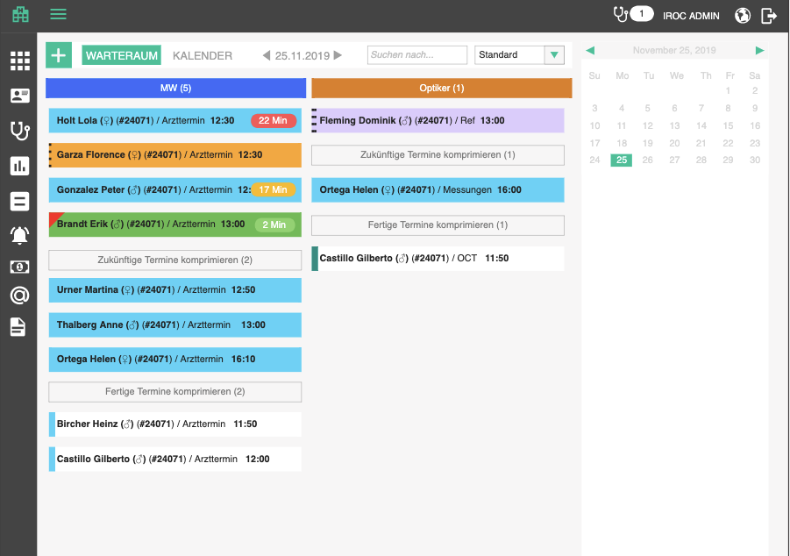

Queue displays milestones for each resource. Resources are taken from the filter profiles, the same as the agenda. The frame of the page is the same as for the agenda. Basically the queue displays the same data as the agenda, except it hides separate steps behind milestones. The goal is to see in which order patients are coming to which resource and if they have been waiting, how long they have been waiting.

Each resource has 3 sections for every date:

Immediate milestones

Milestones with steps with following status:

In queue
- If at least one step is in queue, the whole milestone is considered to be in queue - this is the status of top priority for the queue page.
- Amount of time in queue is the time passed since the earliest in queue step in the milestone was put into queue.

Overdue
- If there are no steps in queue, but there are open ones which were supposed to start in the past, the whole milestone is considered overdue.
- Amount of time overdue is the time passed since the earliest open step in the milestone was supposed to start.

Running
- If there are no steps in queue, and no overdue steps, but at least one step is running, milestone is considered running.

Paused
- Future feature…

The number of immediate milestones is displayed in the resource header. This attracts the users attention to give them a quick feeling of what they have on their plate at the moment.

Future milestones

Milestones where all steps are open and in the future are considered future milestones. They are displayed below the immediate milestones and can be toggled.
- Hide future appointments. / Zukünftige Termine ausblenden. <number of future milestones>
- Show future appointments. / Zukünftige Termine anzeigen. <number of future milestones>

Finished milestones

Appointments where all steps have been finished are considered finished milestones. They are displayed below the future milestones and can be toggled.
- Hide finished appointments. / Fertige Termine ausblenden. <number of finished milestones>
- Show finished appointments. / Fertige Termine anzeigen. <number of finished milestones>

Milestones are visualized as boxes with same look as on the agenda, depending on their status:

In queue: full color, red corner.
Open: full color.
Running: full color with dashed border.
Paused: future feature…
Finished: withe with thick border of corresponding color.

Additionally, each milestone can be presented as collapsed (default) and expanded (toggled on click).

Collapsed box shows:
- Patient last and first name
- Gender icon
- Patient number
- Milestone name
- Planned start time (of the first step)
- Waiting time

Expanded box additionally shows:
- Patient creation date
- Patient birth date and age
- Patient billing account status
- Time of arrival to practice (time when first step was added to queue)
- Selfpayer icon
- Emergency appointment icon
- Appointment type
- Appointment comment
- Collapsable list of steps:
  - status
  - name
- Actions (displayed based on status rules, like in the agenda)
  - Patient info
  - Add to queue
  - Start
  - Pause (future feature…)
  - Finish
  - Open documentation
  - Cancel
  - No-show
  - Assign all to me
  - Add new steps (future feature)
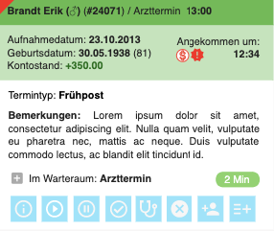

Note: Alternatively, instead of expanded / collapsed boxes, the details can be displayed in the sidebar, the same as on the agenda page.

Waiting time is colored based on tenant settings. The administrator will be able to define the color of waiting time based on the amount of minutes in waiting. If nothing has been configured, defaults are
- 0-5: green
- 6-15: yellow
- 16-undefined: red

Manual ordering

The user can reorder milestones within immediate milestones section section by drag and drop.

When queue page is first loaded, the milestones have no ordinal number. Milestones without an ordinal number are sorted by planned start time, below the ones which have an ordinal number. As soon as the ordinal number of one milestone is changed, all the others are updated, so that they match the current order.

Add appointment

An appointment can be added by dragging through the calendar in any calendar column. This will open a new appointment page with selected date and time frame and person / device / facility preselected, based on the column in which the user started dragging.

Clickin on the “+" button starts the slot calculation. This is a very useful feature, but requires correct setup of:
- Appointment types and variants
- Staff availability
- Device availability
- Facility availability
- Consultation hours

Slot calculation will offer slots (or, more precisely, start times of slots) which satisfy the following requirements: For each step (taking pauses between steps into consideration)
- all required people, devices and facilities have to have inhouse availability set up and no other appointments at those times
- An inhouse consultation hour availability for the selected appointment type has to be defined

Limitation: Since slot calculation is a very expensive from the processing power perspective, the calculation does not offer slots where different resources of the same functions are engaged. This means that, if the appointment type variant requires and Ophthalmologist in 3 different steps, only slots where one person is available to perform in all 3 steps.

Note: when calculating web availabilities for online booking, the same constraints are taken into consideration, only the app is checking for web availabilities of all resources and published consultation hour availabilities.

Resource configuration

Slot calculation can be narrowed down by specifying which resources should be taken into consideration. This is especially useful when the patient is requesting to see a specific doctor and the user wants to get all slots where that doctor is available.

For every distinct function defined in the appointment type variant, the user will see a dropdown were they can choose between resources which fit the requirements. E.g. for function Optometrist which requires any user from group Opticians-Measurements, there will be one dropdown with title Optometrist and all the human resources who belong to that group.

If the patient has a treating doctor, that doctor in is preselected every dropdown where they match the criteria.

Force overbooking
While choosing resources, the user can force overbooking for any human resource by checking the appropriate flag next to the name. If a person has the overbooking flag on, only for this appointment, the slots will be calculated without paying attention to the already booked appointments for this user. In other words, the person has to be working at the time of the appointment, but we don’t care if they are booked at that time already.
- Enable overbooking / Überbuchung ermöglichen

Here is an overview of what settings are available and what are the differences between them:

 | Dragging through calendar | Pressing on + button | Re-booking an appointment | Booking from appointment reminder task
Patient section
Patient / Patient  - autocomplete box  - with "x" button | - focused when page opened | - focused when page opened | - preselected and disabled | - preselected from task and disabled
Placeholder / Platzhalter  - switch  - info tooltip: Blockiert die Kapazität nicht. Wichtig: Ein Patienten-Termin kann nicht in einen Platzhalter umgewandelt werden. | - off by default  - when selected, patient is purged and patient and disabled  - when selected, selfpayer is off and disabled | - off by default  - when selected, patient is purged and patient and disabled  - when selected, selfpayer is off and disabled | - off and disabled | - off and disabled
Selfpayer (issue bill immediately) / Selbstzahler (Rechnung sofort ausstellen)  - switch | - take default from tenant settings  - user can change | - take default from tenant settings  - user can change | - taken from edited appointment  - user can change | - taken from edited appointment  - user can change
Treating doctor / Behandelnder Arzt  - label | - visible only if patient selected and has treating doctor;  - updated when a doctor from resources (below) is picked to be treating doctor | - visible only if patient selected and has treating doctor;  - updated when a doctor from resources (below) is picked to be treating doctor | - visible only if patient selected and has treating doctor;  - updated when a doctor from resources (below) is picked to be treating doctor | - visible only if patient selected and has treating doctor;  - updated when a doctor from resources (below) is picked to be treating doctor
Account balance  - just number without special heading | - visible only if patient selected  - red if negative  - green if positive | - visible only if patient selected  - red if negative  - green if positive | - red if negative  - green if positive | - red if negative  - green if positive
Appointment details
Emergency / Notfall  - switch | - red if on | - red if on | - taken from edited appointment  - red if on | - red if on
Location  - icon and link which opens popup to change location facility | - if the user came here from a facility's column in the agenda, preselect that facility as location  - otherwise, tenant default is selected  - when clicked, a popup appears for picking another one | - tenant default is selected  - when clicked, a popup appears for picking another one | - taken from edited appointment  - when clicked, a popup appears for picking another one | - tenant default is selected  - when clicked, a popup appears for picking another one
Standard appointment / Standard-Termin  - tab-like container for context dependent child components | - default option | - default option | - chosen if appointment based on appointment type | - user can edit
> Appointment type / Terminart  - autocomplete box  - with "x" button | - select first one by default | - select first one by default | - taken from edited appointment | - taken from task
> Appointment type variant  - radio group push buttons | - appears when an appointment type is selected  - if the user came here from a doctor's column in the agenda, preselect the first variant where that doctor fits in any of the human resource criteria  - otherwise, if the selected patient has a treating doctor, preselect the first variant where that doctor fits in any of the human resource criteria  - otherwise, preselect the first one | - if the selected patient has a treating doctor, preselect the first variant where that doctor fits in any of the human resource criteria  - otherwise, preselect the first one | - taken from edited appointment | - taken from task
> Appointment steps  - colored push buttons | - appears when appointment variant is selected | - appears when appointment variant is selected | - taken from edited appointment | - taken from task
Appointment steps can look like a sea of buttons when there are many of them and it can be hard to tell apart what is a variant button and what is a step button. They are separated from the variant with the following instruction text:
- The chosen appointment type variant offers <total steps> steps, <optional steps> of which are optional (no padlock icon). You can toggle optional steps by clicking on them. / Die gewählte Termintyp-Variante bietet <total steps> Schritte, von denen <optional steps> optional sind (kein Sperr-Symbol). Sie können optionale Schritte durch Anklicken ein- und ausschalten.
- mandatory steps are already pushed and visibly marked as mandatory
- optional steps can be selected by the user
- whenever the user changes configuration of the appointment, slots are recalculated and presented
> Resource configuration  - dropdown  - label depends on function name in the variant requirements configuration | - appears only when a variant has been selected  - has "x" button to clear the content and search again  - for every human resource criteria which CAN be selectable by user, display a dropdown  - for every human resource criteria which MUST be selectable by user, display a dropdown which is mandatory  - if the user came here from a human resource's column in the agenda, preselect that human resource in every dropdown where they match the criteria  - otherwise, if the patient has a treating doctor, preselect that doctor in every dropdown where they match the criteria | - appears only when a variant has been selected  - has "x" button to clear the content and search again  - for every human resource criteria which CAN be selectable by user, display a dropdown  - for every human resource criteria which MUST be selectable by user, display a dropdown which is mandatory  - if the patient has a treating doctor, preselect that doctor in every dropdown where they match the criteria | - taken from edited appointment | - has "x" button to clear the content and search again  - for every human resource criteria which CAN be selectable by user, display a dropdown  - for every human resource criteria which MUST be selectable by user, display a dropdown which is mandatory  - if the patient has a treating doctor, preselect that doctor in every dropdown where they match the criteria
Special appointment (Ad Hoc) / Sonder-Termin (Ad Hoc)  - tab-like container for context dependent child components | - user can switch to this option | - user can switch to this option | - chosen if appointment ad hoc | - user can switch to this option
> Description / Beschreibung  - text box | - mandatory for ad hoc | - mandatory for ad hoc | - taken from edited appointment, if ad hoc | - mandatory for ad hoc
> Staff / Personal  - Tag-like component | - if the user came here from a human resource's column in the agenda, preselect that human resource | - mandatory for ad hoc | - taken from edited appointment, if ad hoc | - mandatory for ad hoc
> Devices / Geräte  - Tag-like component | - if the user came here from a device's column in the agenda, preselect that device | - optional for ad hoc | - taken from edited appointment, if ad hoc | - optional for ad hoc
Timeframes
Slots / Slots  - tab-like container for context dependent child components | - disabled for ad hoc appointments  - otherwise, user can pick this option | - default option | - user can pick this option, if edited appointment based on appointment type | - default option
> Slot timeframe  - radio group push buttons  - see "Timeframe" specification for specifics | - user has to pick a timeframe | - user has to pick a timeframe | - specific time frame: start date = current date of the appointment and end date = start date + 7 days | - specific time frame: start date = target appointment date of the task and end date = start date + 7 days
> Calculated slots  - push buttons | - calculated when user selects a timeframe  - if there is an ongoing calculation, for this client, cancel it  - preselect the first slot when available and fill the resources in the section below | - calculated when user selects a timeframe  - if there is an ongoing calculation, for this client, cancel it  - preselect the first slot when available and fill the resources in the section below | - calculated when user selects a timeframe  - if there is an ongoing calculation, for this client, cancel it  - preselect the first slot when available and fill the resources in the section below | - calculated immediately  - calculated when user selects a timeframe  - if there is an ongoing calculation, for this client, cancel it  - preselect the first slot when available and fill the resources in the section below
Manual time settings / Manuelle Zeitangaben  - tab-like container for context dependent child components | - default  - start date and time preselected based on selection in calendar  - end date and time editable only if ad hoc appointment  - end time is the end time of the latest step, if appointment type based | - user can pick this option  - start date and time are: date which was active in the agenda when + button was clicked and current time  - end date and time editable only if ad hoc appointment  - end time is the end time of the latest step, if appointment type based | - default  - date and start time taken from edited appointment  - end date and time editable only if ad hoc appointment | - user can pick this option
Required resources / Benötigte Ressourcen
- not available for ad hoc appointments
Step / Schritt  - text box | - editable, mandatory  - prefilled from variant | - editable, mandatory  - prefilled from variant | - editable, mandatory  - prefilled from edited appointment, unless appointment details changed | - editable, mandatory  - prefilled from variant
Time / Zeit  - text box | - editable, mandatory  - prefilled from variant  - when edited, does not recalculate start and duration for other steps | - editable, mandatory  - prefilled from variant  - when edited, does not recalculate start and duration for other steps | - editable, mandatory  - prefilled from edited appointment, unless appointment details changed  - when edited, does not recalculate start and duration for other steps | - editable, mandatory  - prefilled from variant
Duration [min] / Dauer [Min]  - text box | - editable, mandatory  - prefilled from variant  - when edited, does not recalculate start and duration for other steps | - editable, mandatory  - prefilled from variant  - when edited, does not recalculate start and duration for other steps | - editable, mandatory  - prefilled from edited appointment, unless appointment details changed  - when edited, does not recalculate start and duration for other steps | - editable, mandatory  - prefilled from variant
Resources from appointment type  - dropdown  - label depends on function name in the variant requirements configuration  - see "Choosing resources" section for detailed instructions on what is visible | - editable, mandatory  - prefilled from chosen slot, if applicable  - otherwise, prefilled from variant | - editable, mandatory  - prefilled from chosen slot, if applicable  - otherwise, prefilled from variant | - editable, mandatory  - prefilled from edited appointment, unless appointment details changed  - if appointment details changed, prefilled from chosen slot, if applicable  - otherwise, prefilled from variant | - editable, mandatory  - prefilled from chosen slot, if applicable  - otherwise, prefilled from variant
Manually added resources  - dropdown  - Specific person / Bestimmte Person  - Specific device / Bestimmtes Gerät | - mandatory when added  - deletable | - mandatory when added  - deletable | - mandatory when added  - deletable | - mandatory when added  - deletable
Set as treating doctor / als behandelnder Arzt einstellen  - link | - when selected, patient is updated immediately and treating doctor in patient section at the top is updated | - when selected, patient is updated immediately and treating doctor in patient section at the top is updated | - when selected, patient is updated immediately and treating doctor in patient section at the top is updated | - when selected, patient is updated immediately and treating doctor in patient section at the top is updated
Resource availability | https://docs.google.com/document/d/1qE-iWfn5j0SmkAwA6aApYQteXpVH4B3tOaIqNPeBbds/edit#heading=h.czp7o78lcssb
Comment
Comment / Kommentar  - text box | - user can edit | - user can edit | - taken from edited appointment  - user can edit | - taken from the task comment

Slot calculation timeframe

The app offers a number of time frame shortcuts and an option to specify the time frame manually
- ASAP / ASAP - offers first 10 available slots from current moment
- In 1 month / In 1 Monat - offers slots for start date = current date and time + 1 month and end date = start date + 7 days
- In 1 year / In 1 Jahr - offers slots for start date = current date and time + 1 year and end date = start date + 7 days
- Specific time frame / Spezifisches Zeitraum - lets the user select start date and time and end date and time

The user has to pick a timeframe to start calculation. Display this message to avoid confusion.
- Please select the desired time frame to start slot calculation. / Bitte wählen Sie den gewünschten Zeitrahmen aus, um die Slotberechnung zu starten.

If the appointment type variant has been marked for caching, and there are no slots in the cache for the selected timeframe, display the following message with a prompting warning sign, to let the user know immediately that it's not the same situation as when there truly aren't any slots avaialble
- Unfortunately, there are no available slots in the specified time frame. Try to change the timeframe. If you still get no results, try contacting your administrator to see if the appointment type has been set up correctly. If you would like to make an appointment by manually specifying the required date and resources, click here.
- Leider sind im angegebenen Zeitrahmen keine Slots verfügbar. Versuchen Sie, den Zeitrahmen zu ändern. Wenn Sie immer noch keine Ergebnisse erhalten, wenden Sie sich an Ihren Administrator, um zu überprüfen, ob die Terminart korrekt eingerichtet wurde. Wenn Sie einen Termin vereinbaren möchten, indem Sie den gewünschten Termin und die Ressourcen manuell angeben, klicken Sie hier.

Note: Specific time frame option starts slot calculation as soon as something is chosen, which means the user will have to wait for the slots to be calculated before selecting another time frame. This can be rather annoying, so we should enable changing of the dates and times even while the slots are being calculated. Once the user selects another date or time, a new slot calculation is started immediately.

Manually editing time
When booking an appointment via "+" button all the times will be calculated automatically. When the user is configuring an appointment manually, they need a way to specify whether or not they want the subsequent step times to be automatically adjusted, when one step is changed. In most cases they will want to recalculate all other steps, but in some instances they will want to leave the other steps untouched, like we have on the calendar.

This is done via auto-adjust switch:
- EN: Auto-adjustment (If start time or duration of a step is changed, all other steps will be recalculated and their start times will be adjusted automatically. )
- DE: Auto-Anpassung (Wenn die Startzeit oder die Dauer eines Schrittes geändert wird, werden alle anderen Schritte neu berechnet, und ihre Startzeiten werden automatisch angepasst.)
When the switch is on, changing start time or duration of one step will calculate all surrounding steps' start time. Duration of other steps will not be changed. Toggling the auto-adjustment switch starts the step recalculation.

Notes:
- When booking a new appointment the switch is ON by default. Turning it off will affect only the current appointment booking. For the next one, it will be on again.
- When rebooking an appointment, the switch is OFF by default to avoid wrong calculations.
- However, the switch is turned ON when the user changes appointment type or variant, because it implies that the whole structure of the appointment will be changed.
- When editing a pre-calculated slot, this switch is not visible (because slots do not have information about dependencies at the moment.)

If the auto-adjustment switch is OFF and the user edits step times manually in a way that two or more steps overlap, the overlapping steps become highlighted and the following explanation is displayed:

- Some steps seem to be overlapping. You can distribute them one after the other by switching on the Auto-adjustment. / Einige Schritte scheinen sich zu überschneiden. Sie können sie nacheinander verteilen, indem Sie die Auto-Anpassung einschalten.

Additionally, a hint bubble appears above the auto-adjustment switch to prompt the user to turn it on and adjust the overlapping steps:
- Auto-adjustment is currently switched off. Please switch it on if you want all steps to be adjusted when editing one of them. / Die Auto-Anpassung ist derzeit ausgeschaltet. Bitte schalten Sie sie ein, wenn Sie möchten, dass alle Schritte angepasst werden, wenn Sie einen von ihnen bearbeiten.
The user can dismiss the message and it will not appear again during the ongoing editing session.

Hint bubble appears if:
- appointment start is changed
- a step's start is changed
- a step's duration is changed
- a step is added
- a step is removed
- AND user is currently editing an existing appointment AND auto-adjustment is off.

Manually editing resources

When booking an appointment via "+" button all the resources will be selected automatically. When editing the resources manually, we have to show the user only the resources they need to see, based on the appointment type variant settings:
- Exact person - not changeable
- Person from a group - show only people from specified group in the dropdown
- Exact device - not changeable
- Device of a device type - show only devices of specified type in the dropdown
- Exact facility - not changeable
- Facility of a facility type - show only facilities of specified type in the dropdown

Resource availability legend
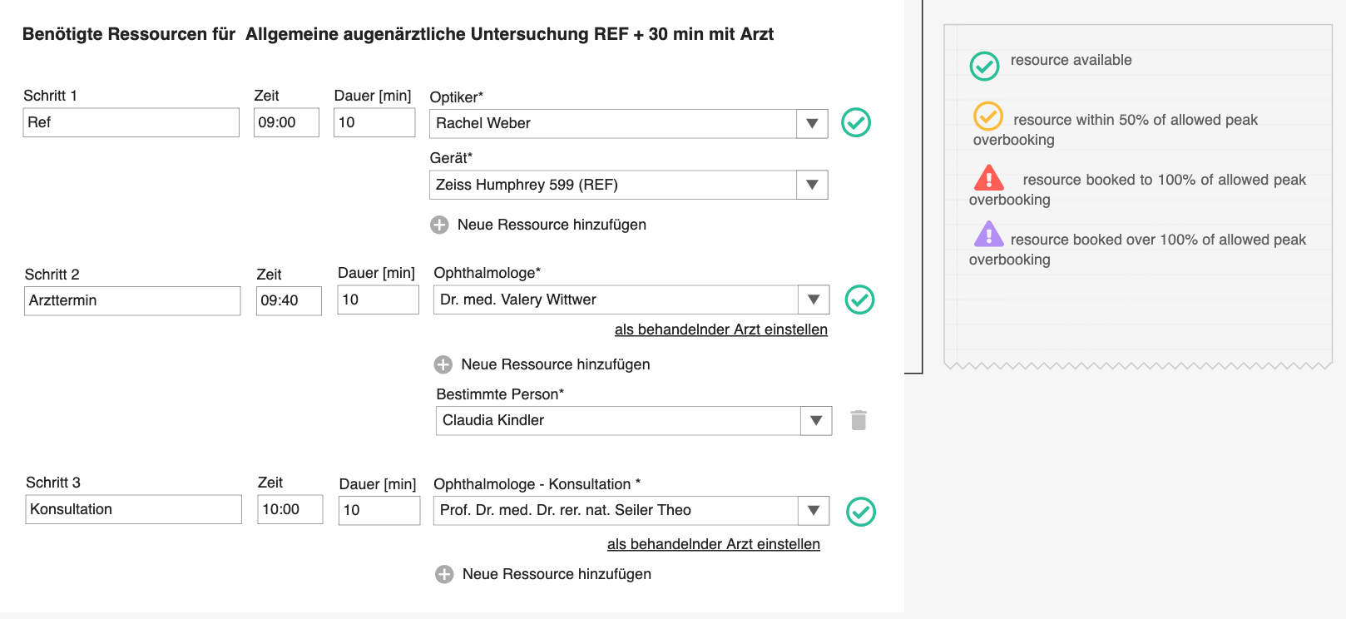

For every resource of the appointment, we will display an info icon with details in tooltip, so that the user gets a feeling of how this appointment is affecting resource availability.

- Available / Verfügbar - resource is completely available for this appointment, either because it has not been overbooked or it is infinitely overbookable (pool resource or regular resource with overbookable flag)
- Within 50% of allowed overbooking / Innerhalb von 50% der zulässigen Überbuchung - Pool resource booked to 50% of allowed overbooking limit
- Booked to 100% of allowed overbooking / Zu 100% der zulässigen Überbuchung gebucht - Pool resource booked to 100% of allowed overbooking limit
- Booked over 100% of allowed overbooking / Über 100% der zulässigen Überbuchung gebucht - Pool resource booked over 100% of allowed overbooking limit OR regular resource which is not overbookable, has already been booked

Manually added resources
TBD

Re-book appointment
Re-booking an appointment is similar functionality to editing. The difference is the fact that original appointment is not changed, but a new version is created, for archive reasons. That is why it's called re-booking instead of editing.

When a user is rebooking an appointment, they will see the same form like when booking the appointment initially. All data will be pre-populated and the user can change it. Patient cannot be changed, because patient is an essential part of the appointment. If that needs to be changed, the user should rather cancel the original appointment and book a new one.

Re-booking offers time slots, like in booking initial appointment, but for specific time frame, which is set to: start date = current date of the appointment and end date = start date + 7 days. The user can change this or pick another timeframe.

Patients in debt

For every appointment step in the calendar, if the patient is in debt, add a red exclamation badge icon with tooltip
- Discuss open bills with patient / Offene Rechnungen mit dem Patienten besprechen

Also add the badge next to the patient name in the appointment details on the right hand panel.

This will remind the doctors to check with the patient why they (or their health insurance) haven't paid open bills and notify them that future appointments will not be booked if the bills are not settled soon.

Patients with incomplete data

When a new patient is created, usually not all data is known and it has to be adjusted later. To make sure this is not forgotten, all patients with incomplete data will get a badge which marks them as "new" in the agenda (each step for that patient) and in the patient list.

A patient has incomplete data if:
- Street, house number and ZIP code are not specified
- No phone numbers (mobile, landline) or email are specified
- Main health insurance is not specified

Hovering over the badge in the patient list shows the following tooltip:
- Patient data is incomplete. Please add mobile or landline phone number or email address AND street, house number and ZIP code. Please make sure that the main health insurance is specified. / Die Patientendaten sind unvollständig. Bitte geben Sie die Mobil- oder Festnetznummer oder E-Mail-Adresse UND Straße, Hausnummer und Postleitzahl an. Achten Sie darauf, dass die gesetzliche Krankenversicherung angegeben ist.

Patient's appointments within a timeframe

To prevent the user from making a redundant appointment for a patient, which happens when multiple people are making the agenda, we will display the already booked appointments for that patient, for a certain time frame. The time frame can be changed in the tenant settings (by specifying the number of days), but the default is 7 days. The user can also disable this feature in the tenant settings.

Once the appointment date has been chosen (user picked a slot or set the appointment date manually) and the patient has been selected, the list of booked (not cancelled, not no-show) appointments for next x days, including the selected date appears in a warning popup.

This happens on new appointment booking and on re-booking. Have in mind that when rebooking, the original appointment should not be among the results.

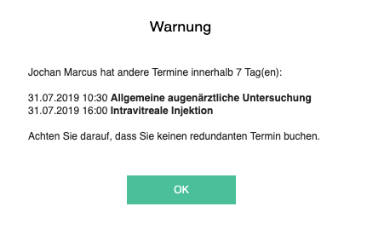

Warning / Warnung

<patient name> has other appointments within <timeframe settting> day(s): / <patient name> hat andere Termine innerhalb <timeframe settting> Tag(en):
<date> <time> <appointment display name>

Please make sure you are not booking a redundant appointment. / Achten Sie darauf, dass Sie keinen redundanten Termin buchen.

Emergency appointments

Any appointment can be marked as emergency. This information is needed for the doctors and the rest of the staff, to know if the patient has to be treated before others. Also, emergency appointments are charged extra.

This indication will look very similar to the self-payer indicator - a switch which can be changed during booking and on overview. It will also be visible as a badge in the calendar.
- Emergency / Notfall

Emergency will be switched on automatically whenever someone makes an appointment for the same date.

New appointment (milestone) in queue
Whenever a milestone of an appointment changes the status from "open" to "in queue", all users who are assigned to any step in that milestone should get a visible notification. This visible notification should pop up even when the browser window with logged in PM is minimized. Actually, this is the main purpose of this feature: the doctor will likely be looking at something else, within or out of PM, but will likely not have the agenda opened at all times. For that reason, a new, small browser window should pop up with the message:
- Patient in queue / Patient in der Warteschlange - title
- <patient name> in queue for <first step in the milestone> (<appointment type>). / <patient name> in der Warteschlange für <first step in the milestone> (<appointment type>). - message

Note: this replaces the blinking step on the agenda.

Milestone icons

Patient who has an appointment on any given day can have multiple steps at multiple stations in the clinic. Step statuses can offer a certain amount of information as to where the patient currently is, but for people who have selective view of the agenda, eg. doctor who is looking only at his agenda, this information may not be sufficient.

For example: The patient came in for a few measurements and a consult with a doctor. The doctor is currently seeing another patient and does not know if the patient in question has already come. To be precise, if the doctor does not follow the opticians agenda, he will not be aware of where the patient is, until the measurements are done and the patient is waiting in front of their door. On a regular day, the doctor might not even need more information, but when there is a delay or the clinic gets crowded, the doctor will want to know where the next couple of patients are, in case they came into the clinic.

A nice way to achieve this is to display a suitable icon of the patient's current milestone (milestone is a group of steps) on all the steps of the day. Current milestone is the milestone with the latest status change.

Milestone statuses should change as follows:

Open (Planned):
- when appointment is created
- when a step status is changed and all the (uncancelled) steps in the milestone are open (this will happen when we introduce putting steps back to open status)

Queue:
- when a step status is changed and all the (uncancelled) steps in the milestone are in queue or open

Finished:
- when a step status is changed and all the (uncancelled) steps in the milestone are finished

In progress:
- when a step status is changed and at least one (uncancelled) step in the milestone is in progress

Cancelled:
- when appointment is cancelled
- when a step is cancelled and all the steps in the milestone are cancelled

A milestone can have an icon defined for queue, in progress and finished. So, when a milestone is finished, all the steps of all the appointments of that patient, on that day will get the finished icon of the milestone.

In our example from above, when a step in Measurements milestone is set to done, the doctor who is looking only at his agenda, will see a "finished measurements" icon on his step, until the opticians put his step in queue. From that point on, all steps will have "queued doctor consult" icon. And so on.

If some steps do not belong to an explicit milestone, or the milestone does not have an icon defined, the icon will simply not be displayed.

Catalogs

Currency catalog

Currencies are a great example of entities which are handled by a catalog. However, since we are now only dealing with Switzerland and Swiss Francs, we do not require a new catalog plugin to handle that one currency. Instead, we can use the same approach we had for, e.g. genders. However, you must first check if any of the other b-op v4 applications have used this currency, because each currency has to have its unique GID, and if it was used before, you need to reuse it. If not, generate a GID (it's a GUID) and notify other teams that CHF is now cataloged under that GID.

Tariff catalog

Tariffs are needed for billing in Switzerland. Every bill position has a tariff which dictates whether or not that position must be reimbursed by the health insurance. All TARMED positions must be reimbursed, but not all medications are reimbursed. Values which we will have in the beginning are:
- 001 (TARMED); always reimbursed
- 400 (medications); always reimbursed
- 406 (other); not always reimbursed

Bill position types catalog

Different users will have different bill position types, such as: medications, services, software products, etc. We need to keep track of there in a catalog where each type will have its GID. For now we have:

- Catalog position / Katalogposition
- Goods / Waren
- Other / Sonstiges

Delivered service statuses catalog

Delivered services of an encounter can be checked and unchecked for billing, up until the point when they are actually billed. These are the values we need:

- Ready for billing / Bereit für Abrechnung
- Not ready for billing / Nicht bereit für Abrechnung
- Billed / Abgerechnet

Cost center booking types catalog

For reporting and controlling purposes, we will need to assign cost center booking type to each bill position which is billed against a cost center. This gives a financial officer a way to see how much revenue was brought in through doctor fees, operations, medications etc. For now we have:
- Fees / Honorare
- Surgeries / Operationen
- Medications / Medikamente

Cost center assignment types catalog

There will be different ways in which a business participant can be associated with a cost center. For now, we will have the following types:

- Default Billing Cost Center / Standardrechnungskostenstelle - an assignment between doctor and cost center to which bill positions are booked, to keep track of revenue streams

Diagnoses catalog

Different practices in different countries will use different diagnose catalog. For example. ICD10 is a world wide recognized diagnose catalog, but it also has variations from country to country, and is not vary convenient for the doctors. In Switzerland, they use a catalog called "Tessinercode" which is basically a classification of ICD10, since all diagnoses related to eye diseases can be mapped to just 6 entries. (see b-op data model documentation)

As a part of billing module, a task will be to develop the catalog plugin for diagnoses with Tessinercode classification. B-Op XML with all the required data and classification will be provided by MPG.

Note:
We have not used classifications up to now, so please check if they are supported by the catalog server.

Healthcare service products catalog

Since the billing capabilities of PM will first be implemented for Swiss market, we can enjoy a fairly simple billing schema called Tarmed. This is a set of instructions for billing medical services, which everyone in Switzerland must abide by.

Each instruction explains which medical service it is good for, how much can be charged to the patient's health insurance for doctor's activities, how much for technical staff activities, if it can be applied with other rules or not, if there are any specific requirements like patient age in order to bill a medical service, etc.

Tarmed database is available in .mdb format, a Microsoft Access database, which can be queried with SQL. The database should be transformed into b-op v4 catalog XML and imported with a special catalog server plugin which is to be developed for this purpose. B-Op XML with all the required data will be provided by MPG.

Structure of the catalog XML will look something like this:
<?xml version='1.0'?>
<CatalogInformation xmlns:xsi="http://www.w3.org/2001/XMLSchema-instance" xmlns:xsd="http://www.w3.org/2001/XMLSchema" xmlns="http://www.bop.org/catalogs/2">
<CatalogType>tariff_positions</CatalogType>
<CatalogType_GID>16d557f0-f019-4295-a39c-50390c5011c6</CatalogType_GID>
<Catalog_GID>721fa84b-6d1c-8340-ba3b-e092690df98c</Catalog_GID>
<CatalogRevision_GID>41978316-47ee-4bc4-be65-fa94b8ad284d</CatalogRevision_GID>
<SupportedLanguages>
<LanguageIso6391>DE</LanguageIso6391>
<LanguageIso6391>FR</LanguageIso6391>
<LanguageIso6391>IT</LanguageIso6391>
</SupportedLanguages>
<CatalogName>
<Dict>
<Iso6391>DE</Iso6391>
<Content>TARMED_KVG</Content>
</Dict>
<Dict>
<Iso6391>FR</Iso6391>
<Content>TARMED_KVG</Content>
</Dict>
<Dict>
<Iso6391>IT</Iso6391>
<Content>TARMED_KVG</Content>
</Dict>
</CatalogName>
<RevisionName>
<Dict>
<Iso6391>DE</Iso6391>
<Content>TARMED_KVG</Content>
</Dict>
<Dict>
<Iso6391>FR</Iso6391>
<Content>TARMED_KVG</Content>
</Dict>
<Dict>
<Iso6391>IT</Iso6391>
<Content>TARMED_KVG</Content>
</Dict>
</RevisionName>
<RevisionNumber>01.09</RevisionNumber>
<ValidFrom>2018-01-01T00:00:00</ValidFrom>
<Metadata>
<UseBaseValue>false</UseBaseValue>
<UseTechnicalServiceBaseValue>true</UseTechnicalServiceBaseValue>
<UseDoctorServiceBaseValue>true</UseDoctorServiceBaseValue>
<UseUnitFactor>true</UseUnitFactor>
<CurrencyIso6391>CHF</CurrencyIso6391>
<CountryIso6391>CH</CountryIso6391>
<ApplicableLaws>
<ApplicableLaw>KVG</ApplicableLaw>
</ApplicableLaws>
<Origin>FMH</Origin>
</Metadata>
</CatalogInformation>

Structure of one catalog entry will look like this:
<?xml version='1.0'?>
<CatalogItems xmlns:xsi="http://www.w3.org/2001/XMLSchema-instance" xmlns:xsd="http://www.w3.org/2001/XMLSchema" xmlns="http://www.bop.org/catalogs/2">
<CatalogItem>
<Code>08.1940</Code>
<GID>869965e5-ed7f-492f-8a2d-ba05f0a495f8</GID>
<Name>
<Dict>
<Iso6391>DE</Iso6391>
<Content>Ptosisoperation durch Levatorverkürzung, jede Methode, einseitig</Content>
</Dict>
<Dict>
<Iso6391>FR</Iso6391>
<Content>Opération unilatérale de ptosis par raccourcissement du lévateur, toute méthode</Content>
</Dict>
<Dict>
<Iso6391>IT</Iso6391>
<Content>Intervento chirurgico per ptosi mediante accorciamento del muscolo elevatore, ogni metodo, unilaterale</Content>
</Dict>
</Name>
<ObjectSpecific>
<UnitPrice>0</UnitPrice>
<DoctorUnitPrice>378.45</DoctorUnitPrice>
<TechnicalUnitPrice>355.06</TechnicalUnitPrice>
<Rules>
<Rule>
<Type>10</Type>
<TypeDescription>Not billable with</TypeDescription>
<BillablePositionCode>08.1930</BillablePositionCode>
<BillablePositionGID>e9627f64-c422-42dd-af58-2f17913087ad</BillablePositionGID>
<Amount>0</Amount>
<UnitAmount>0</UnitAmount>
<UnitGID>00000000-0000-0000-0000-000000000000</UnitGID>
<AgeFromInclusive>0</AgeFromInclusive>
<AgeFromToleranceDays>0</AgeFromToleranceDays>
<AgeToInclusive>0</AgeToInclusive>
<AgeToToleranceDays>0</AgeToToleranceDays>
</Rule>
<Rule>
<Type>10</Type>
<TypeDescription>Not billable with</TypeDescription>
<BillablePositionCode>08.1960</BillablePositionCode>
<BillablePositionGID>a33b385f-5f6e-4917-9a93-09b14d7851f5</BillablePositionGID>
<Amount>0</Amount>
<UnitAmount>0</UnitAmount>
<UnitGID>00000000-0000-0000-0000-000000000000</UnitGID>
<AgeFromInclusive>0</AgeFromInclusive>
<AgeFromToleranceDays>0</AgeFromToleranceDays>
<AgeToInclusive>0</AgeToInclusive>
<AgeToToleranceDays>0</AgeToToleranceDays>
</Rule>
<Rule>
<Type>10</Type>
<TypeDescription>Not billable with</TypeDescription>
<BillablePositionCode>08.1980</BillablePositionCode>
<BillablePositionGID>ff94ca1a-4731-4e51-9b11-8682ef532c16</BillablePositionGID>
<Amount>0</Amount>
<UnitAmount>0</UnitAmount>
<UnitGID>00000000-0000-0000-0000-000000000000</UnitGID>
<AgeFromInclusive>0</AgeFromInclusive>
<AgeFromToleranceDays>0</AgeFromToleranceDays>
<AgeToInclusive>0</AgeToInclusive>
<AgeToToleranceDays>0</AgeToToleranceDays>
</Rule>
<Rule>
<Type>10</Type>
<TypeDescription>Not billable with</TypeDescription>
<BillablePositionCode>28.0210</BillablePositionCode>
<BillablePositionGID>d77e5ba5-d5d0-40a1-b3a6-48ed46406354</BillablePositionGID>
<Amount>0</Amount>
<UnitAmount>0</UnitAmount>
<UnitGID>00000000-0000-0000-0000-000000000000</UnitGID>
<AgeFromInclusive>0</AgeFromInclusive>
<AgeFromToleranceDays>0</AgeFromToleranceDays>
<AgeToInclusive>0</AgeToInclusive>
<AgeToToleranceDays>0</AgeToToleranceDays>
</Rule>
<Rule>
<Type>10</Type>
<TypeDescription>Not billable with</TypeDescription>
<BillablePositionCode>39.2170</BillablePositionCode>
<BillablePositionGID>d479e80a-aea7-4201-b1cd-c85820733335</BillablePositionGID>
<Amount>0</Amount>
<UnitAmount>0</UnitAmount>
<UnitGID>00000000-0000-0000-0000-000000000000</UnitGID>
<AgeFromInclusive>0</AgeFromInclusive>
<AgeFromToleranceDays>0</AgeFromToleranceDays>
<AgeToInclusive>0</AgeToInclusive>
<AgeToToleranceDays>0</AgeToToleranceDays>
</Rule>
<Rule>
<Type>40</Type>
<TypeDescription>Quantity max</TypeDescription>
<BillablePositionGID>00000000-0000-0000-0000-000000000000</BillablePositionGID>
<Operator>&lt;=</Operator>
<Amount>1</Amount>
<UnitAmount>1</UnitAmount>
<UnitCode>ENC</UnitCode>
<UnitGID>00000000-0000-0000-0000-000000000000</UnitGID>
<AgeFromInclusive>0</AgeFromInclusive>
<AgeFromToleranceDays>0</AgeFromToleranceDays>
<AgeToInclusive>0</AgeToInclusive>
<AgeToToleranceDays>0</AgeToToleranceDays>
</Rule>
<Rule>
<Type>50</Type>
<TypeDescription>Localization mandatory</TypeDescription>
<BillablePositionGID>00000000-0000-0000-0000-000000000000</BillablePositionGID>
<Amount>0</Amount>
<UnitAmount>0</UnitAmount>
<UnitGID>00000000-0000-0000-0000-000000000000</UnitGID>
<AgeFromInclusive>0</AgeFromInclusive>
<AgeFromToleranceDays>0</AgeFromToleranceDays>
<AgeToInclusive>0</AgeToInclusive>
<AgeToToleranceDays>0</AgeToToleranceDays>
</Rule>
</Rules>
</ObjectSpecific>
</CatalogItem>

</CatalogItems>

TARMED.zip

Billing modifiers catalog

Billing modifiers regulate the Swiss (and other) markets by adjusting the unit price for reimbursable services across different economic regions. The goal of this is to make sure that doctors in areas where the economic standard is lower, do not profit off of basic health insurance, if they receive the same compensation as doctors in regions with higher standard (they have more expenses for paying their staff and renting office space. etc).

These modifiers change from time to time, so we need to take care of validity period.

<?xml version="1.0" encoding="utf-8" ?>
<CatalogInformation>
<EntityType>billingmodifiers</EntityType>
<Name>BillingModifiers</Name>
<GID>99F23D1B-FAEC-8448-8077-0A08BB237C9D</GID>
<Version>01.00</Version>
<Metadata>
<ValidFrom>2018-01-01T100:00:00.00</ValidFrom>
<ValidTo></ValidTo>
</Metadata>
<AvailableClassifications>
<AvailableClassification>CatalogClassificationHierarchy_1.xml</AvailableClassification>
</AvailableClassifications>
</CatalogInformation>

<?xml version="1.0" encoding="utf-16"?>
<BillingModifiers>
<BillingModifier>
<Code>TPV</Code>
<GID>f987bb78-e1b4-4c98-8370-e2690d415b14</GID>
<Name>
<Dict>
<Iso6391>de</Iso6391>
<Content>Taxpunktwert</Content>
</Dict>
<Dict>
<Iso6391>en</Iso6391>
<Content>Tax Point Value</Content>
</Dict>
<ObjectSpecific>
<RegionSpecificValue>
<RegionGID>296dd6f7-73a1-4ba5-ba54-5aabe15532e5</RegionGID>
<RegionIso6391>ZH</RegionIso6391>
<ModifierValue>0.89</ModifierValue>
</RegionSpecificValue>
<RegionSpecificValue>
<RegionGID>b2c8cc62-35af-4710-85c2-a9bfba9c843a</RegionGID>
<RegionIso6391>BE</RegionIso6391>
<ModifierValue>0.86</ModifierValue>
</RegionSpecificValue>
</ObjectSpecific>
<BillingModifier>
</BillingModifiers>

BillingModifiers.zip

Healthcare products catalog

Medication and disposables are all of the things that can be used during a procedure or prescribed and handed out to the patient. Different customers will have different source of catalog to import (meaning it comes from their suppliers in a different format), but they should all boil down to the same b-op catalog xml.

MPG will create conversion to customer specified format to standard b-op xml.

For each item on this list we will have some basic data, and some additional data which will give us a clue whether or not an item is covered by the basic health insurance, covered by additional health insurance, or not covered by health insurance at all.

Structure of the catalog XML will look something like this:
<?xml version='1.0'?>
<CatalogInformation xmlns:xsi="http://www.w3.org/2001/XMLSchema-instance" xmlns:xsd="http://www.w3.org/2001/XMLSchema" xmlns="http://www.bop.org/catalogs/2">
<CatalogType>products</CatalogType>
<CatalogType_GID>8a4e21ea-a8ed-4fc5-8707-7878c74b7c8d</CatalogType_GID>
<Catalog_GID>a396dc05-118f-452a-b1da-f26a301d5ed6</Catalog_GID>
<CatalogRevision_GID>32c546fb-e08f-473c-92f5-2a6eb24d516e</CatalogRevision_GID>
<SupportedLanguages>
<LanguageIso6391>DE</LanguageIso6391>
</SupportedLanguages>
<CatalogName>
<Dict>
<Iso6391>DE</Iso6391>
<Content>Medikamente und Disposables</Content>
</Dict>
</CatalogName>
<RevisionName>
<Dict>
<Iso6391>DE</Iso6391>
<Content>Medikamente und Disposables 2.3</Content>
</Dict>
</RevisionName>
<RevisionNumber>2.3</RevisionNumber>
<ValidFrom>2018-11-13</ValidFrom>
</CatalogInformation>

Structure of one catalog entry will look like this:
<?xml version='1.0'?>
<CatalogItems xmlns:xsi="http://www.w3.org/2001/XMLSchema-instance" xmlns:xsd="http://www.w3.org/2001/XMLSchema" xmlns="http://www.bop.org/catalogs/2">
<CatalogItem>
<Code>0020209</Code>
<GID>f310a492-de4a-4723-bd04-594d3e1de28c</GID>
<Name>
<Dict>
<Iso6391>DE</Iso6391>
<Content>ERYTHROCIN i.v. Trockensub 1000 mg Amp</Content>
</Dict>
</Name>
<ObjectSpecific>
<IsService>false</IsService>
<PackageSize />
<Pharmacode>0020209</Pharmacode>
<EAN>7680202580475</EAN>
<IndexTherapeuticus>0801600</IndexTherapeuticus>
<IKSListCode>B</IKSListCode>
<Tariff>406</Tariff>
<StandardBookingType></StandardBookingType>
<RoundingBookingType></RoundingBookingType>
<ReimbursmentGroup>3</ReimbursmentGroup>
<Variants>
<Variant>
<UID>fb6cf3ba-cdcc-4c3a-967d-a1683870d8d6</UID>
<OrderSequence>0</OrderSequence>
<IsStandardVariant>true</IsStandardVariant>
<Name>
<Dict>
<Iso6391>DE</Iso6391>
<Content>ERYTHROCIN i.v. Trockensub 1000 mg Amp</Content>
</Dict>
</Name>
<PriceReferences>
<PriceReference>
<RefUID>d7226bbd-a3cc-482f-8191-9484c3b4cde3</RefUID>
</PriceReference>
</PriceReferences>
</Variant>
</Variants>
</ObjectSpecific>
</CatalogItem>
</CatalogItems>

And product prices can be found in the pricelist located in the Dependencies XML:

<?xml version='1.0'?>
<Dependencies xmlns:xsi="http://www.w3.org/2001/XMLSchema-instance" xmlns:xsd="http://www.w3.org/2001/XMLSchema" xmlns="http://www.bop.org/catalogs/2">
<PriceList>
<UID>f2e6de16-a962-4705-985b-790a30b6855b</UID>
<RevisionUID>a0d97437-c97e-45c7-9db7-bbbc32d3a508</RevisionUID>
<CurrencyISO>CHF</CurrencyISO>
<Version>1.2</Version>
<Name>
<Dict>
<Iso6391>DE</Iso6391>
<Content>Standardpreisliste</Content>
</Dict>
</Name>
<Prices>
<Price>
<UID>d7226bbd-a3cc-482f-8191-9484c3b4cde3</UID>
<PurchasePrice>50.53</PurchasePrice>
<MaximumRetailPrice>69.15</MaximumRetailPrice>
</Price>
<Price>
<UID>a59de867-d50c-4337-bfb6-f0067664c50e</UID>
<PurchasePrice>8.96</PurchasePrice>
<MaximumRetailPrice>13.8</MaximumRetailPrice>
</Price>
<Price>
<UID>35a8e9e1-091b-4a20-9b24-5f1faae155fb</UID>
<PurchasePrice>5.01</PurchasePrice>
<MaximumRetailPrice>0</MaximumRetailPrice>
</Price>
</Prices>
</PriceList>
</Dependencies>

Whenever an item from this catalog is used, it should be saved to the database and used from the, from that point on.

Encounter documentation

Creating encounters

With appointments
Let's say we have an appointment which has multiple steps and those steps belong to different milestones:

APP 1
- MS 1
- - STEP 1
- - STEP 2
- MS 2
- - STEP 3
- MS 3
- - STEP 4
- - STEP 5

When the appointment is open and the user clicks on stethoscope icon on STEP 1:
- Check if there is an encounter for APP 1 -> no -> create it and attach to APP 1
- put STEP 1's milestone (MS 1) in status "running" -> STEP 1 and STEP 2 re running
- open the encounter form

User saves the encounter and goes back to calendar, clicks on stethoscope of STEP 2
- Check if there is an encounter for APP 1 -> yes -> don't create another
- don't change statuses because STEP 2 belongs to MS 1 which is already running
- just open the encounter form

User saves the encounter and goes back to calendar, clicks on stethoscope of STEP 3 :
- Check if there is an encounter for APP 1 -> yes -> don't create another
- put STEP 3's milestone (MS 2) in status "running" -> STEP 3 is running
- just open the encounter form

User finishes the entire appointment without even starting STEP 4 and STEP 4:
- put all the milestones and all their steps into "finished" status, no matter which status they were in

Once an encounter is finished, it is opened in view mode, until someone un-finishes it. This action has to be documented so that we can track who finished and unfinished encounters. At first stage, the person who finished and encounter and the administrator can unfinish it. At a later stage, we will have user rights for finishing and unfinishing encounters.

Finished encounter is practically signed off, so only specific users should be able to do so. Those are the users which have finish encounter right switched on.

Choosing a form
When creating or opening an encounter, if multiple documentation forms are available for that appointment type, open a popup with the list of available forms and let the user pick one. This means that every documentation form needs to handle missing data without blowing up, i.e. if it attempts to load some data which was partially entered in another form, it should treat missing data as empty and display whatever data exists.

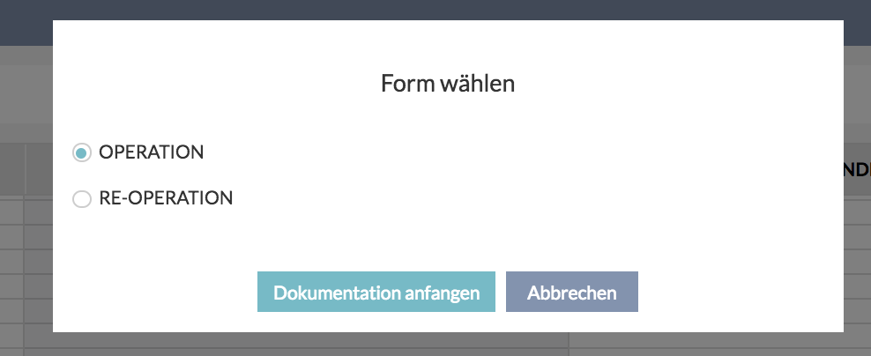

When starting a new encounter on a day where there already is an open encounter, we want to enable the user to open that encounter and continue with documentation. This will most likely happen if someone adds another appointment for a measurement, on the same day, expecting the results to be added to the ongoing encounter.

If this occurs, the user will get a popup:
- An open encounter for <date> already exists. Would you like to continue documenting there, or start a new one? / Eine offene Behandlung für <date> ist bereits vorhanden. Möchten Sie dort weiter dokumentieren oder eine neue beginnen?
- Button: Use existing encounter / Vorhandene Behandlung verwenden
- Button: Start new encounter / Cancel / Abbrechen

Without appointments

From patient list
User can start an encounter even if there is no appointment for the patient, by clicking on Start encounter in the context menu in patient history.

In order to start an encounter without an appointment, the user needs to choose a documentation form. See details here.

From patient history
Same as from patient list, an encounter can be started from the patient history by clicking Start encounter button above the history table.

Documentation forms

Since a lot of aspects of billing rely on performed medical services as a part of encounters, we have to have at least one documentation mask. The plan for documentation masks is to have a plugin concept, which means that an Angular application, which relies on a standardized documentation API, and is simply installed into various realms, without having to change the basic PM application. The plugins should be hosted in the specialized documentation app.

Each plugin can have its theme color, which will be dominant around the title of the plugin and slightly lighter behind the available tabs;

The documentation app, which hosts the plugins has a standard set of controls:
- Patient full name as a link to the patient edit form which opens in a new tab
- Patient date of birth + calculated age + gender
- List of diagnoses (important to be visible at all times so that the doctor knows what they are dealing with)
- Print icon: invokes printing of the encounter report, see Documentation reports section
- Date / Datum - the date of the encounter (default is appointment date (if appointment date is not available, default is today), but the user can change it because they can technically be documenting encounters retroactively)
- Treatment reason / Behandlungsgrund - reason for treatment, same same on bill: illness or accident
  - Accident number / Unfallnummer - text box which appears only when treatment reason is “accident”, this is important for communication with the health insurance
- Time tracking (more details at the end of Encounters section)
- Available documentation forms / Verfügbare Dokumentationsmasken
  - Titles of all subforms of all forms which have been instantiated for the current encounter
  - Eventually, the user will be able forms manually - after adding a form, all its subforms will appear here
  - All tabs which have any values specified will be highlighted
- Bill preparation / Rechnungsvorbereitung (more details later in Encounters section)
  - (<total estimate with 2 decimal places> <currency>) - display estimated total (sum of services estimate and products estimate)
- Save / Speichern - just saves the changes to the encounter
- Cancel / Abbrechen - cancels the last changes

In addition to that, documentation app contains 2 standard pages:
- Next appointment
- Billing preparation

Real-time collaboration
Real-time collaboration is a mechanism which allows multiple users to work on the same documentation form. It works on a premise that although multiple users will work on the same documentation form (e.g. an optician is entering measurements data, while the doctor is entering his comments and observations), no two users will ever have a need to work on the exact same data at the same time (e.g. doctor and optician will not edit the objective refraction at the same time).

Still, in order to ensure that multiple users will never override each other’s work, a portion of the documentation form (block) will get locked by the first user who starts editing it. The other users will see that block in view-only mode, with an indicator who is currently working on it.
- <initials> <full user name with title> is currently editing this block / <initials> <full user name with title> bearbeitet gerade diesen Block
The block is unlocked automatically if there has been no activity in any of its fields for 25 seconds.

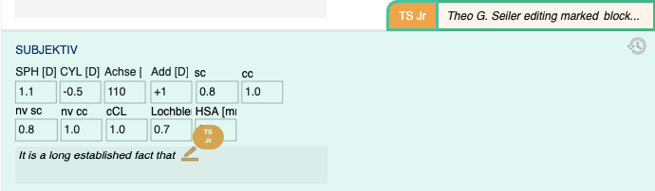

As the users are entering their changes, the application saves the last applied changed automatically, and sends the updates to all the users which have the same documentation form open (subscribers).

Subscribers are visible next to tab names on the navigation page as badges with initials of the users. Active subscribers (editors) are distinguished from passive subscribers (viewers). Subscriber badge disappears as soon as the subscriber leaves the documentation form tab.

- <full user name with title> is currently working on this tab / <full user name with title> arbeitet gerade an diesem Tab

Important: one person looking at the same documentation form in 3 different browser windows/tabs is treated as 3 subscribers.
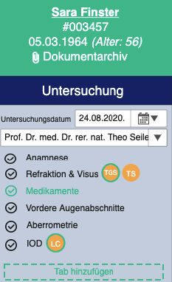

Automatically saved changes build a transaction log document, which is kept until the encounter is finished. In that moment, all changes are applied to the encounter and saved in the database. Until that moment, the changes exist only in the transaction log and are served to each subscriber of the documentation form. The user sees a product of all changes in the transaction log applied to the last persisted version of the encounter.

Since saving is done automatically, 5 seconds after the last entered change, the Save button is replaced by a notification label, which contains a link for the user to force changes if they do not feel like waiting.
Initially, until there have been new changes, the label is grey:
- No changes to save. / Keine Änderungen zu speichern.
When the user adds some changes, the label starts counting down to the next automatic save and offers a link to save manually:
- Changes detected. Saving in x seconds... Save now. / Änderungen registriert. Speichern in x Sekunden... Jetzt speichern.
When the user clicks on save, or automatic saving has been triggered, the label goes grey again:
- Saving changes... / Änderungen werden gespeichert...
When the data is saved, before new changes have been made, the label displays:
- Changes saved. / Änderungen wurden gespeichert.

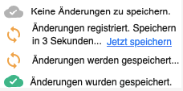

Finish button is somewhat of a dramatic button with an icon, to make it clear to the user that it is different and important.
- Finish encounter / Besuch fertig stellen (red, with a lock icon)
- Re-open encounter / Besuch wieder öffnen (default color, with unlock icon)

An encounter can be finished only if there are no other users working on it, including the current user in other tabs. This is needed in order to avoid changes which will not make it into the bill.
- Warning / Warnung - title
- This encounter cannot be finished at the moment, because X other users are working on it. Please wait until every user is done with their documentation. / Diese Untersuchung kann im Moment nicht als fertig markiert werden, da X andere Benutzer daran arbeiten. Bitte warten Sie, bis jeder Benutzer mit seiner Dokumentation fertig ist. - message
- Please close all other browser windows and tabs in which this encounter is open, in order to finish it. / Bitte schließen Sie alle anderen Browserfenster und Tabs, in denen diese Untersuchung geöffnet ist, um sie als fertig zu markieren. - message if the current user is working on this encounter in other tabs

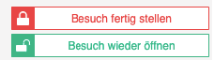

Finishing an encounter asks the user for confirmation and offers an option to create a bill automatically. See Automatic bill creation section.

Finishing and re-opening an encounter have to capture the user which initiated the action. When an encounter is re-opened, it becomes editable again, can be changed and can be finished again. If the encounter is connected to a finished appointment, the appointment remains finished. Editing of the encounter is available only through encounter history.

Re-opening an encounter removes the free-of-charge flag.

Transaction log
Even after the encounter has been finished, the transaction log is available to the users as a history popover, which is available on most of the blocks (exception: history and graph blocks). It appears when the user clicks on the corresponding history icon. The history is sorted by timestamp descending.
Each entry shows:
- Date and time
- User who made the change
- Action
- List of changes to
  - devices (if any)
  - data items (if any)
  - participants (if any)
  - documents (if any)

Action labels, depending on object:
- Patient data item
  - changed / geändert
  - <data type>: <old value> -> <new value>
  - <data type>: (empty / leer) -> <new value>
  - <data type>: <old value> -> (empty / leer)
- Device
  - changed / geändert
  - device / Gerät: <old value> -> <new value>
  - <data type>: (empty / leer) -> <new value>
  - <data type>: <old value> -> (empty / leer)
- Participant
  - changed / geändert
  - <role>: <old value> -> <new value>
  - <data type>: (empty / leer) -> <new value>
  - <data type>: <old value> -> (empty / leer)
- File
- <file name> uploaded / hochgeladen
- <file name> deleted / gelöscht
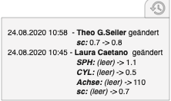

Bill preparation

To be able to know which medical services should actually be billed for an encounter, we will have to rely on the doctors instructions. Appointment types can be configured to have planned medical services, and that is giving us a clue, but as we know, a medical service has different billing groups which apply in different scenarios, and if we try to automate the process of choosing which one has been delivered, we might make more problems than benefits. Based on input provided by doctors, a financial officer can easily create bills in just a couple of clicks.

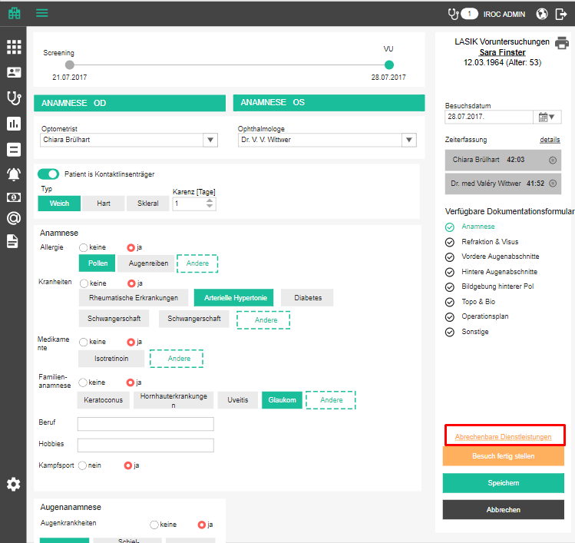

In each encounter documentation section, we will have a link which leads to a special page where the user can specify which medical services that have been delivered, and products that have been used in documentation, should be billed. Below the documentation form tabs we will have a link to this page.
- Bill preparation / Rechnungsvorbereitung
- clicking on it leads to the bill preparation (see below), and automatically saves the encounter before opening the page

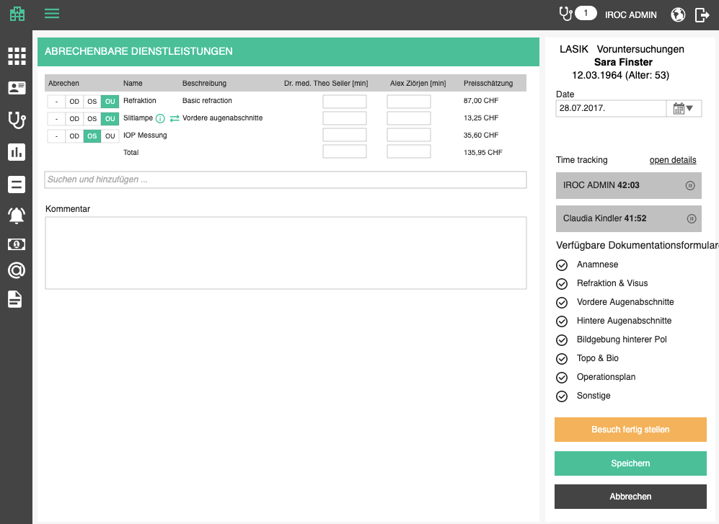

Delivered services detection

Although we will let the user (doctor) check which services they delivered and want to bill, we will also like to make their life easier and pre-select the services which were documented.

We can set up formulas which indicate, based on documented patient data and performed procedures on a certain form, if a medical service has been delivered. E.g. If we have a value for SPH (spherical refraction value) that means that Refraction medical service has been delivered.

These formulas will eventually be administered from a UI, but for now they will be imported into the database.

Documentation API will provide a list of formulas for each potential medical service for each documentation form. From the formula, we can deduce if a service was delivered as a part of an encounter documentation. Namely, a service is delivered if InclusionRule formula resolves into TRUE and ExclusionRule formula resolves into FALSE.

Basically, we will have a formula like F = (Var1 OR Var2) AND NOT Var3. We have to see which patient data or performed procedures correspond to Var1, Var2 and Var3, check if those patient data or performed procedures are a part of the current examination (true / false), replace variables with boolean values, and evaluate the formulas. If all inclusion formulas are TRUE and all exclusion formulas are FALSE for a medical service, we consider that service delivered.

We have to take into consideration that delivered services can be delivered on multiple localizations (e.g. left and right eye). To connect the correct localizations to performed services, we have to check on which localizations performed procedures / patient data have been captured. This means that one delivered service can be attached to zero, one or more localizations.

Variables can be expressed in two ways:
1. Variable is a documented procedure (IsPotentialProcedureIndicator) with specified procedure GID
2. Variable is a documented data type (IsPerformedDataTypeIndicator) with specified data type GID
- If it is important in which data set type the documented data type was documented, set type should be specified (If_PerformedDataTypeIndicator_PatientDataSetType_GID)
- If it is important during which procedure the documented data type was documented, procedure should be specified (If_PerformedDataTypeIndicator_PotentialProcedure_GID)
- If it is important which value the documented data has, value should be specified (If_PerformedDataTypeIndicator_ValueToCheck)

Below are some examples of how formulas look like.

Example A: A service is delivered if a value is entered
VariableName A1 ---> Is true, if Thickness of Cornea was entered
Indication for Medical Service "Pachymetrie" --> Boolean Expression : A1
Example B: A service is delivered in three different ways, depending on a value entered + a type measurement (performed procedure) was selected
VariableName A1 ---> Is true, if Thickness of Cornea was entered
VariableName A2 --> Is true, if measurement was entered by Pentacam
VariableName A3 --> Is true, if measurement was entered by OCT
VariableName A4 --> Is true, if measurement was entered by Ultrasound
Indication for Medical Service "OCT" --> Boolean Expression : (A1 AND A3)

Medical services tab
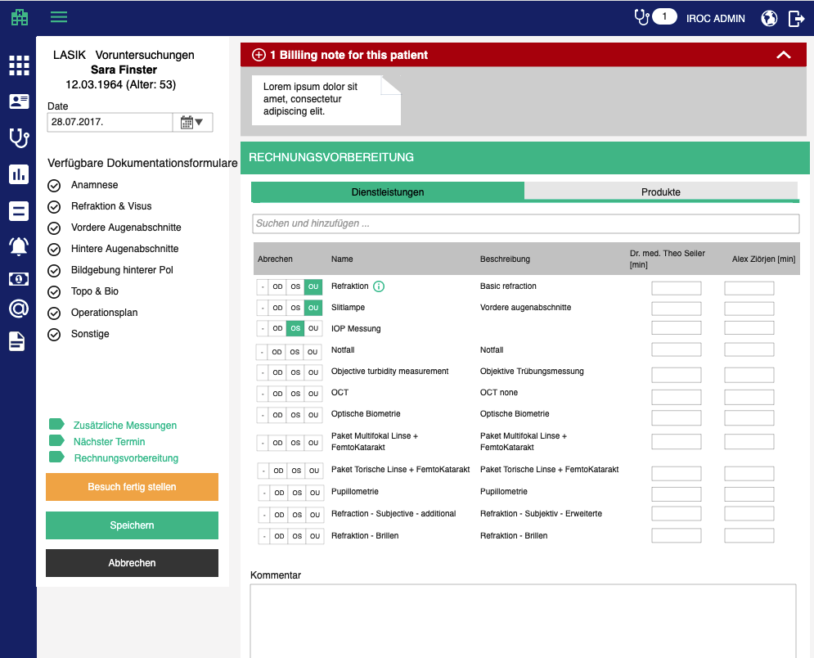

This tab contains billable services. Services are sorted so that the delivered ones are on top (sorted alphabetically), and potential un-detected services are below (also sorted alphabetically). Re-sorting should happen only on page load, to avoid rows changing places when user manually sets some services to delivered. Services which were delivered (see Delivered services detection) should be pre-checked as to-bill.

Table displays the following columns:
- Medical services / Dienstleistungen – tab title
- Bill / Abbrechen - localization, (see below)
- Title / Name - service name
  - If manually changed, show info icon with tooltip for manually changed (see below)
  - If service offers multiple blocks, preselect the default one and display dropdown in which the user can choose one
  - The choice is highlighted until the user changes anything
- Description / Beschreibung - description of the service
- Recipient / Empfänger - a dropdown with all possible bill recipients for that patient
  - if the service has no Reimbursment Mandatory (RE) items -> select the patient as recipient
  - otherwise select default recipient defined in the patient record
  - the user can change selection manually
- <title + name> [min] / <title + name> [min] - number text box, optional; one column per each person encounter participant; changing the time marks the service as manually changed
- Price estimate / Preisschätzung - price estimate based on total for the selected billing block (for catalog positions, apply the region unit factor of the responsible person’s default billing office’s region); aligned right, 2 decimals, including currency
  - Last row displays the total
  - This changes whenever something in "to bill" column is changed or billing block is changed
  - Price estimates are needed so that the doctor can take something off the billing list, even if it is done, if they see the bill will be too high

User can check on which eye (OS, OD) the service was provided, as well as both eyes (OU), or none (-) in cases where localization is not important.

Above the table we will offer an autocomplete box. The user can try to search and select any service which exists in the system. This is needed because doctor may have provided a service which was not planned but was necessary. The user can delete any of these manually added services too.
When a user manually adds or marks an offered service as delivered, we are not certain on which localization (left or right eye, sternum or humerus, etc) the service was delivered. For that reason, we will bill it for both eyes (OU).

Whenever the user adds a service or edits a service, the service should be marked as manually specified, so that the service calculating algorithm doesn’t overwrite it.
- Manually changed / Manuell bearbeitet

If the service offers multiple billing blocks, we will preselect the default one. If no block has been marked as default, the oldest one will be selected. The user should be able to change this, like on bill itself, in case the user does not really want to go into bill section at all. Services with multiple blocks will appear as dropdowns. Services with one billing block will just be a label. And in the off chance there is not a single one billing block defined for the service, it will remain empty.

The comment is optional but if provided, it will be appended to the bill comment, once a bill is created.
- Comment / Kommentar

Every time a delivered services is marked for billing on delivered and billable page, we have to change its status and capture which user changed it. Check Catalogs section for statuses.
- Ready for billing - when the service is checked
- Not ready for billing - when service is unchecked
- Billed - when services has been included in a bill; when in this status, the checkbox in UI is disabled for editing

Products tab
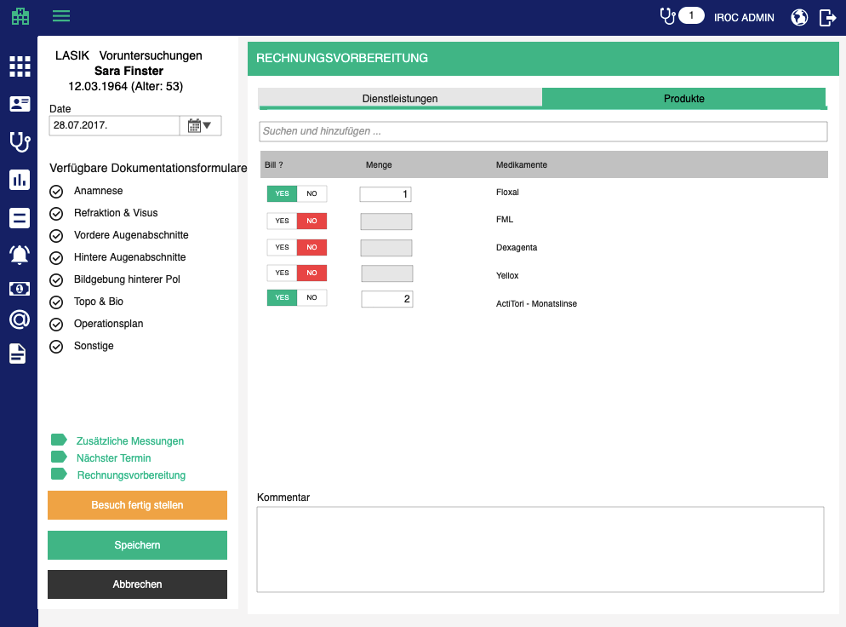
This tab contains documented products (consumed materials, handed out materials, prescribed medications), sorted alphabetically.

Table displays the following columns:
- Products / Produkte – tab title
- Bill / Abbrechen - Checkbox which indicates whether or not consumed, handed out or prescribed product shall be added to bill; active by default, except for prescriptions
- Quantity / Menge - number box where the user can specify the quantity of a product, in case it is selected for billing, 4 decimal places
  - If quantity has been entered during documentation, copy it here
  - When a product is selected to be added to bill, quantity is 1 by default
  - Quantity can be adjusted by up/down arrows
- Title / Name - product name
  - If manually changed, show info icon with tooltip for manually changed (see below)
- Recipient / Empfänger - a dropdown with all possible bill recipients for that patient
  - if Kontaktlinsen form (check GID) -> select the patient as recipient
  - otherwise select default recipient defined in the patient record
  - the user can change selection manually
- Price estimate / Preisschätzung - price of the product; aligned right, 2 decimals, including currency
  - Last row displays the total
  - This changes whenever something in "to bill" column is changed or billing block is changed
  - Price estimates are needed so that the doctor can take something off the billing list, even if it is done, if they see the bill will be too high

Every time a consumed, handed out or prescribed product is marked for billing on this page, we have to change its status and capture which user changed it. Check Catalogs section for statuses.
- Ready for billing - when the product is checked
- Not ready for billing - when the product is unchecked
- Billed - when the product has been included in a bill; when in this status, the checkbox in UI is disabled for editing

Automatic bill creation

The bill preparation page is editable even when the encounter has been finished. The only thing we have to have in mind is: if a service or a products is attached to a signed-off bill, it cannot be deselected nor can a different localization be selected. Basically, the buttons are disabled.

When the user clicks Finish encounter, we can offer them to add billable positions to an existing open bill for that patient, if there are any such bills. This will shorten the bill creation process. So if any open bills are detected, we will display the corresponding popup:
- Add services to a bill / Dienstleistungen zur Rechnung hinzufügen
- Would you like to add services from this encounter to an open bill for this patient, or create a new bill? / Möchten Sie Leistungen aus dieser Behandlung zu einer offenen Rechnung für diesen Patienten hinzufügen oder eine neue Rechnung erstellen?
  - Radio button per open bill for the patient + recipient in the brackets (Recipient / Empfänger: <recipient name>; Issue / Aussteller <issuer name>)
  - Create new bill / Neue Rechnung erstellen
  - Just finish the encounter / Einfach die Behandlung fertig stellen
  - Free of charge / Kostenlos – this option makes the encounter behave as if it were billed (does not show up in lists of non-billed encounters)
- Bill from / Rechnung von - dropdown with doctors, like on bill creation page; mandatory but appears only if “new bill” is selected and the admin is logged in; shows only doctors with billing offices
- Finish / Fertig stellen - confirmation button
- Cancel / Abbrechen - cancel button

Important: If the signing doctor does not have a defined office, automatic bill creation will fail. For that reason, we will disable the “new bill” option, with a tooltip explaining the issue
- Responsible person (<name>) has no billing office defined and thus cannot issue bills. Please contact your administrator. / Verantwortliche Person (<name>) hat keine Rechnungsstelle definiert und kann daher keine Rechnungen ausstellen. Bitte wenden Sie sich an Ihren Administrator.

Important: If the user has picked multiple recipients in the bill preparation, existing bills will be disabled. If the user has picked only one recipient in the bill preparation, only the bills with the same recipient will be enabled.
- This bill cannot be selected because its recipient is either not the same as the recipient from bill preparation, or you have chosen multiple recipients in bill preparation. / Diese Rechnung kann nicht ausgewählt werden, weil ihr Empfänger entweder nicht mit dem Empfänger aus der Rechnungsvorbereitung übereinstimmt oder weil Sie in der Rechnungsvorbereitung mehrere Empfänger ausgewählt haben.

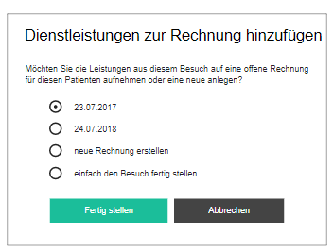

When a new bill is automatically created from finished encounter, these are the values which will be used in the background:
- Bill date is the date of the encounter
- Patient is the one who had the encounter
- Recipient is the last selected recipient for this patient
- Account is loaded from tenant defaults
- Treatment reason is loaded from tenant defaults
  - If accident number is specified for the encounter, treatment reason is Accident
- Applicable law is loaded from tenant defaults
  - If treatment reason is Accident, this should be UVG
- Stationing is loaded from tenant defaults
- Billing office and specialization are taken from defaults of the selected doctor who is issuing the bill
- Payment deadline is taking from tenant defaults deadline (duration in days, naturally, the deadline itself is calculated)
- Localization is taken from tenant defaults
- Diagnosis is taken from the last bill for that patient

Since this action may take some time, we will notify the user so that they know everything is under control:
- We are creating bill positions based on the data you documented. This will take a couple of seconds. / Auf der Grundlage der von Ihnen erfassten Daten erstellen wir jetzt die Rechnungspositionen. Dies dauert einige Sekunden.

After creating a new bill or adding the encounter to an existing bill, the user is taken to the edit page of that bill and the page should be scrolled down to the bill positions table, so that user can check those first.

Customer specific documentation forms
See this document.

Next appointment
To speed up the process of communicating the next required appointment from a doctor to front office staff, we will add a next appointment link to the navigation panel of every documentation form, which opens a popup where the doctor can add basic data about the next appointment. The link opens a page similar to the Performed services page.
- Next appointment / Nächster Termin - link and page title
- Date shortcuts: Next appointment in <number> / Nächster Termin in <number> days / Tage | weeks / Wochen | months / Monaten | years / Jahren
- Target date / Zieldatum - date box, optional
- Appointment type / Terminart - dropdown with all appointment types, mandatory
- Appointment type variant / Terminvariante - dropdown with all variants of the chosen type, mandatory
- Staff / Personal - dropdown with all currently employed doctors and an option “Me / Mich”, optional
- Comment shortcuts - see below
- Comment / Bemerkungen - becomes task description

Comment shortcuts are push buttons which add/remove their content to and from the comment box. They should be highly customizable, because in some cases they should not be visible (depending from where the page is opened). An example is a set of comment shortcuts for required measurements. This is, actually, a list of devices, which have instances in the current tenant, and belong to one of the specified device types.

Requested examinations / Gewünschte Untersuchungen
- Device types: [REF, ABERTOPO, TOP, SCH, OCT, CXL, BIO, FPHO, VFP, SPMIC, SLC, LENS]
- This comment shortcut group is visible in the standard "next appointment" function (from navigation panel), but not needed for, e.g. next operation appointment

The attributes which are set automatically:
- Title -> Schedule appointment for <patient name> / Termin für <patient name> vereinbaren
- Due date -> current date, current time
- Task for: staff who are configured in tenant settings as default appointment recipient (should be anyone in Front Office staff group)

When this is saved and the task is created, everyone assigned will get a notification. This should make sure that the appointment scheduling does not get forgotten.

The added appointment task will be visible in the right panel, as usual. Clicking on the next appointment link again will open the default appointment task for the current encounter, for editing.

Important: On different masks, it will be possible to add multiple appointment reminders, so there must be a way to know which one is the default appointment reminder, even if it was not added first.

If the next appointment is specified the next appointment link is colored.

Next appointment page can have all fields (and background attributes) prefilled, based on data from the calling documentation form.

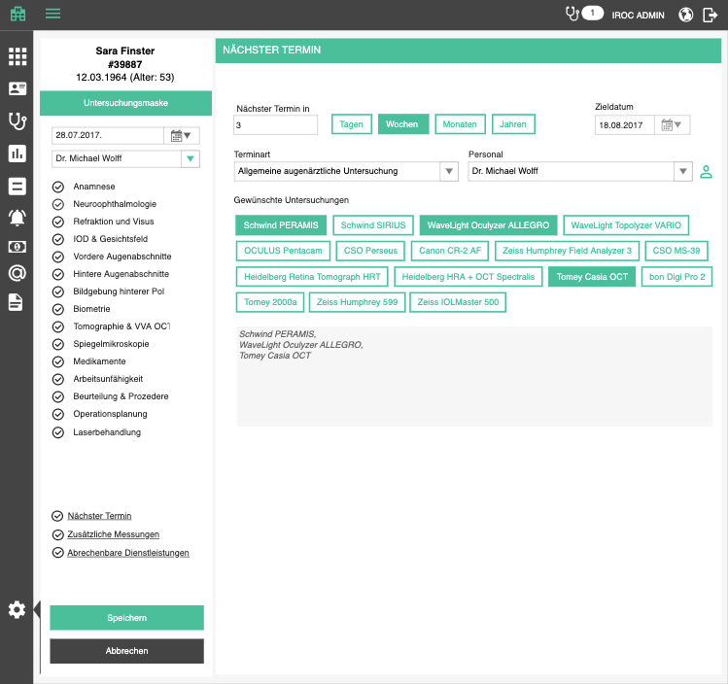

Additional measurements

To speed up the process of communicating the required additional measurements from a doctor to opticians, we will add an additional measurements link to the right panel of every documentation form, which opens a popup where the doctor can add basic data about the additional measurements.
- Additional measurements / Zusätzliche Messungen - link and popup title
- List of predefined measurements "disguised" as push buttons. Each button which is pushed, becomes a checkbox in a checklist task
  - Push button: Autoref / Autoref
  - Push button: Measure glasses / Brille vermessen
  - Push button: Topo / Topo
  - Push button: Penta / Penta
  - Push button: Schwind Sirius / Schwind Sirius
  - Push button: Schwind Peramis (Aberrometry) / Schwind Peramis (Aberrometrie)
  - Push button: OCT Cornea / OCT VAA
  - Push button: OCT Macula / OCK Makula
  - Push button: OCT RNFL / OCT RNFL
  - Push button: HRT / HRT
  - Push button: Fundusphoto / Fundusfoto
  - Push button: Mydriasis before cycloplegia / Mydriase vor Cycloplegie
  - Push button: Mydriasis after cycloplegia / Mydriase nach Cycloplegie
  - Push button: VF Glaucoma / GF Glaukom
  - Push button: VF Kinetic / GF Kinetisch
  - Push button: Other / Andere: adds a new checkbox
- Comment / Bemerkungen - becomes task description

The attributes which are set automatically:
- Title -> Additional measurements for <patient name> / Zusätzliche Messungen für <patient name>
- Due date -> current date, current time
- Show alarm -> yes, 0 minutes before deadline
- Task for: staff who are configured in tenant settings as default measurement recipient (should be anyone in Opticians staff group)

When this is confirmed and the task is created, everyone assigned will get a notification. This should make sure that the opticians know why the patient is coming to them.

The added measurements task will be visible in the right panel, as usual. Clicking on the additional measurement link again will open the first checklist task for the current encounter, for editing.

If the additional measurements are specified the additional measurements link is colored.
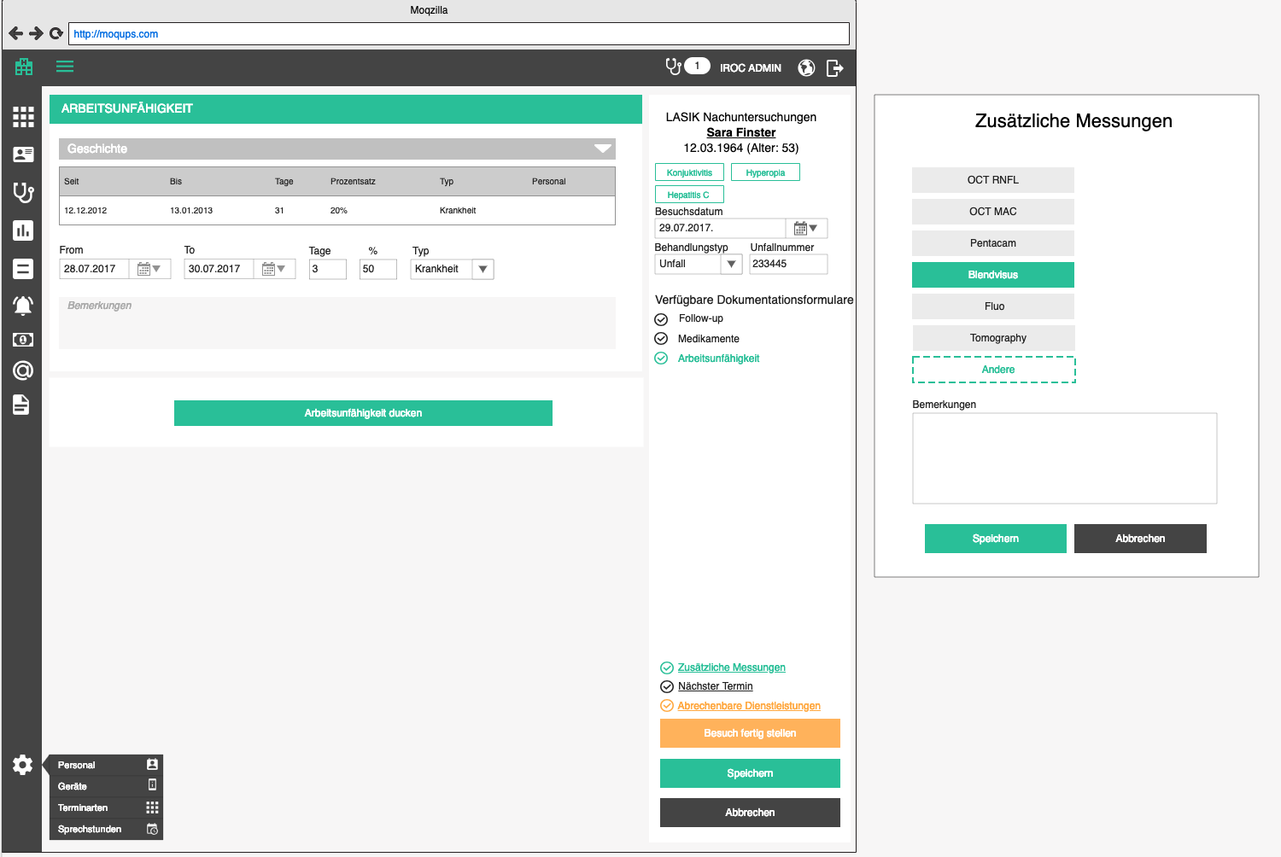

Important: Next appointment task and additional measurements task in masks should always be visible, even if it is assigned to one person who is not the currently logged in one.

In addition to that, a mask will display all tasks connected to the patient of that encounter, except, the ones which are also connected to the current encounter are highlighted differently than the rest.

Encounter history
Encounter history gives the user an easy way to find an encounter without having to go through calendar. It can be reached by pressing the stethoscope button in the main menu. It is basically the same as patient history, with a couple of adaptions
- Appointment history / Terminhistorie - title
- No sidebar present
- Instead of sidebar for patient data, we will have a patient column after date column
  - Patient / Patient
  - Table is searchable by patient
- Table will contain a lot of entries eventually so it should have the infinity scroll option
- Case section is not present

Delete encounter

If an encounter is finished, the delete icon will be disabled with the following tooltip as explanation:
This encounter cannot be deleted because it has been finished. / Diese Untersuchung kann nicht gelöscht werden, da sie abgeschlossen ist.

If the encounter is open, the user can delete it. Upon clicking on the delete icon, the user will be prompted by a standard confirmation popup.
- Please confirm / Bitte bestätigen
- Are you sure you want to delete <encounter name> from <date> for <patient>? / Sind Sie sicher, dass Sie <encounter name> von <date> für <patient> löschen möchten?

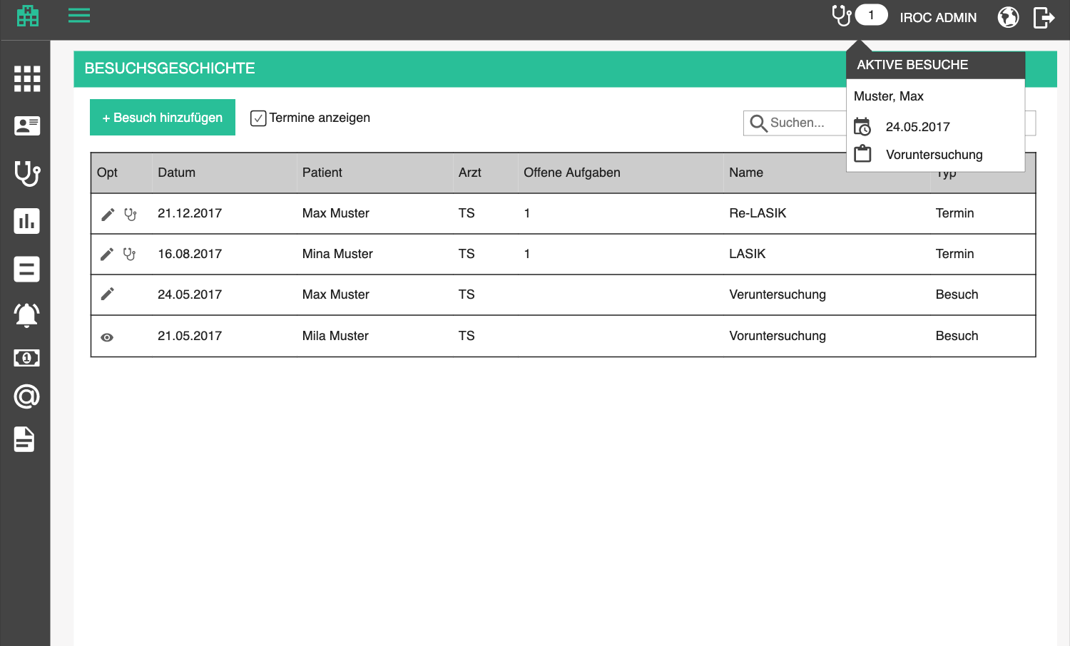

Active encounters
To give the users an option to easily find active (unfinished) encounters, we will introduce an icon in the top bar, which has a bubble with the number of active encounters. For each encounter, display
- Patient full name
- Date
- Title
Clicking on one opens the encounter documentation form, so that the user can easily continue working.

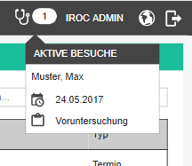

Each user sees the number of open encounters on which they are selected as responsible person. Administrators see all open encounters to be able to monitor the overall progress.

Finish encounters reminder

Whenever a user logs in, we will remind them to finish the encounters they are responsible for (if there are any such unfinished encounters).
- Don’t forget to finish these encounters / Vergiss nicht, diese Behandlungen fertig zu stellen.
- Finish encounters / Behandlungen fertig stellen
- Later / Später

The list will look something like the list of open encounters, except there will be a checkbox next to every patient name. The list will be sorted ascending by date, because we want to make the user finish the oldest ones first. The user can check one or more encounters and click finish. We will need a confirmation just in case:
- Are you sure you want to finish the selected <number of selected encounters> encounters? / Sind Sie sicher, dass Sie die ausgewählte <number of selected encounters> Behandlungen fertig stellen möchten?

Since there can be a lot of encounters to finish, we need to update the user about the stats in a progress popup:

- x / y encounters have been finished. | x / y Behandlungen wurden fertig gestellt.

- Encounters are being processed in the background. Please do not reload this page or close it before the process is done. If you wish to use the application in the meantime, you can use it in another tab or browser window. | Behandlungen werden im Hintergrund bearbeitet. Bitte laden Sie diese Seite nicht neu und schließen Sie sie nicht, bevor der Prozess abgeschlossen ist. Wenn Sie die Programm in der Zwischenzeit nutzen möchten, können Sie es in einem anderen Tab oder Browserfenster verwenden.

After that, the encounters are finished and the user can continue with their normal activities.
- Selected encounters have been finished successfully. / Ausgewählte Behandlungen wurden erfolgreich fertig gestellt.

Billing

Bills and bill groups

This is the core of billing functionality, naturally. In this section, a financial officer can monitor open bills for all patients, filter them and generally administer them.

Bills overview

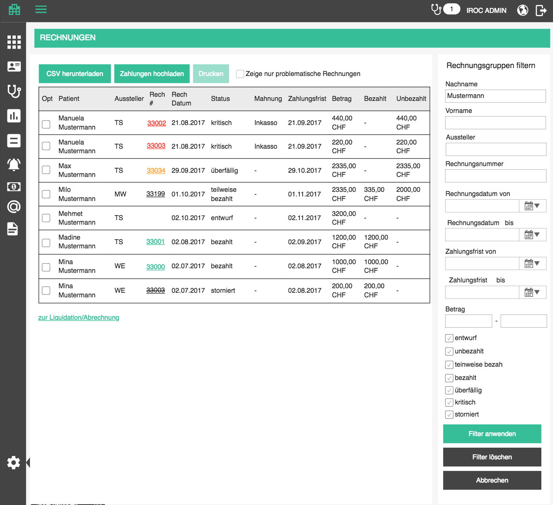

Overview is a table which contains all bills which are added to the tenant database. Open bills are displayed as groups because we want to give the user an option to edit multiple bills simultaneously before signing them off (more details in bill creation).

The overview table contains the following columns:
- Bills / Rechnungen - page and menu point title
- Options / Optionen (edit, delete, etc)
- Patient / Patient - patient name in form <last name>, <first name>, a link to patient history
- Issuer / Aussteller - the person who issued the bill
- Bill number / Rechnungsnummer - only visible for signed off bills; a link that opens bill PDF in a new tab
- Bill date / Rechnungsdatum - date when the bill (group) was made
- Status / Status - see details below
- Dunning / Mahnung - name of the current dunning level, if there is a dunning process for this bill
- Payment deadline [date] / Zahlungsfrist [Datum] - date until when the bill has to be paid (or the latest deadline in bill [group] in case of open bills)
- Amount / Betrag - aligned right, two decimal points, currency appended; In case of open bill [group], the amounts on bills within it will be summed up
- Paid / Bezahlt - paid portion of the total amount (customers might pay in installments, or just pay partially when they have the money), aligned right, two decimal points, currency appended
- Unpaid / Unbezahlt - unpaid portion of the total amount (customers might pay in installments, or just pay partially when they have he money), aligned right, two decimal points, currency appended
- Recipient / Rechnungsempfänger - display name of the recipient; If the bill is a bill group (draft), display all recipients, comma separated, and the warning message if any of the recipients breaks the patient’s billing profile preferences.
- Remuneration Type / Vergütungsart - TP if recipient is a health insurance; TG if recipient is the patient, alternative contact or employer
- Transmission status / Übertragungsstatus - last transmission status and history icon + popup as in e-billing

If bill recipient does not match the patient’s billing profile, there may have been a mistake in creating the bill and we need to notify the user about it. It will just be a warning, will not stop the user from sending the bill, because it may have been a special case where purposefully overrode the settings of the patient.
If bill recipient is an HIP and the patient has billing profile TG (Bill to patient), display the following message
- Patient’s billing preference is <billing profile label, like on the patient administration>, but bill recipient appears to be a health insurance. Please check if this was intentional. / Die Rechnungspräferenz des Patienten ist <billing profile label, like on the patient administration>, aber der Rechnungsempfänger scheint eine Krankenkasse zu sein. Bitte prüfen Sie, ob dies gewünscht ist.
If bill recipient is a person (patient or alternative contact) and the patient has billing profiles TP (Bill to HIP) or TP+copy (Bill to HIP + copy to patient), display the following message
- Patient’s billing preference is <billing profile label, like on the patient administration>, but bill recipient appears to be a person. Please check if this was intentional. / Die Rechnungspräferenz des Patienten ist <billing profile label, like on the patient administration>, aber der Rechnungsempfänger scheint eine Person zu sein. Bitte prüfen Sie, ob dies gewünscht ist.

The list should be sortable by all columns (except options, of course). Default sorting is by bill date, descending.
The list should be search-able by patient and bill number. Search starts as soon as you type, but with a small debounce. Check the rest of the app for guidance.

Advanced filters should appear on the right side of the screen and be visible at all times.

Filters should be applied as AND operation, meaning, only bill [groups] which meet all the criteria are shown.
- Filter bills/ Rechnungen filtern - subtitle
- Last name / Nachname - of the patient
- First name / Vorname - of the patient
- Issuing office / Ausstellende Geschäftsstelle - issuing office, dropdown which represents the tree structure
- Bill number / Rechnungsnummer
- Bill date from / Rechnungsdatum von - including specified date
- Bill date to / Rechnungsdatum bis - including specified date
- Payment deadline from / Zahlungsfrist von - including specified date
- Payment deadline to / Zahlungsfrist bis - including specified date
- Amount / Betrag - two text boxes for lower and higher amount boundary for search
- Bill status: list of all bill statuses; this section is applied as OR operation, because a bill can only be in one status and we might want to filter for multiple
- Remuneration Type / Vergütungsart: switch or radio group
- All / Alle - returns all bills
- TP - returns bills where recipient is a health insurance
- TG - returns bills where recipient is the patient, alternative contact or employer

- Apply filters / Filter anwenden - filter bill [groups] based on specified criteria
- Clear filters / Filter löschen - clear filters and show all bill [groups]

Above the table, offer a quick filter control
- Valid drafts / Gültige Entwürfe - icon for valid drafts, which is another toggle button
- Invalid drafts / Ungültige Entwürfe - icon for invalid drafts, which is another toggle button
- When these buttons are toggled, all draft bills are loaded, without infinite scroll function
- When this option is active, the advanced filters are ignored and hidden; applying advanced filters resets the “only drafts” toggle

When the searched list is empty, display the following text instead of the first row:
- There are no matching bills for this search criteria. / Es gibt keine passenden Rechnungen für diese Suchkriterien.

When the list is empty in general, display the following text instead of the first row:
- There are no bills defined. / Es gibt keine definierten Rechnungen.

Download CSV / CSV herunterladen - download a csv file with all the bill [groups] which are currently displayed in the list.

Bill statuses

A bill can be in any of the following statuses:
- draft / entwurf - not yet signed off
- open / offen - signed off but nothing has been paid
- partially paid / teilweise bezahlt - payments associated with this bill do not amount to the bill total; bill gets in this status whenever the first payment is added but full sum is not reached
- paid / bezahlt - payments associated with this bill amount to the bill total; bill gets in this status whenever a payment is added to this bill which reaches the bill total
- overdue / überfällig - this status is calculated on the fly; any open or partially paid bill which has due date before current date is considered overdue
- critical / kritisch - user can mark overdue bills as critical, which will have an impact on the patient (more details in Billing implications section)
- canceled / storno

Depending on the status and due time, bill numbers will be colored:
- green - paid
- orange - not fully paid + overdue (if a bill has an installment plan, only one overdue and unpaid installment makes the bill overdue)
- red - marked as critical
- regular - not fully paid but also not overdue
- strike through - cancelled

Bill (group) validations

Some data in the bill can remain unspecified or incorrect before a bill is signed off on. The reason for this is that a draft of a bill can remain invalid because the person making it might not know all the details while working on the bill, and it would not be OK not not let them save!

If an open bill (group) has any errors, a warning icon will appear in the corresponding bill’s row. When clicked a popup will appear with a list of errors.
- Errors / Fehler - title
- Please correct all errors listed below, in order to sign off this bill. / Bitte korrigieren Sie alle unten aufgeführten Fehler, um diese Rechnung signieren zu können. - explanation text, above listed errors

If any of the included bills contain an error of a certain type, display the message. Each error is a bullet point. Possible errors are:

- Patient not specified / Patient nicht angegeben
- Patient is underage, but no alternative contact is specified / Der Patient ist minderjährig, aber es wird kein alternativer Kontakt angegeben
- Recipient does not have ZIP and city defined / Der Empfänger hat keinen PLZ und keinen Ort definiert
- HIP (recipient) is not approved / Die Krankenversicherung (Empfänger) ist nicht genehmigt
- Patient does not have ZIP and city defined / Der Patient hat keinen PLZ und keinen Ort definiert
- Guarantor does not have ZIP and city defined / Der Garant hat keinen PLZ und keinen Ort definiert
- Issuer not specified / Aussteller nicht angegeben
- Office not specified / Abrechnungsstelle nicht angegeben
- Bill date not specified / Rechnungsdatum nicht angegeben
- Payment deadline not specified / Zahlungsfrist nicht angegeben
- Recipient address not specified / Empfängeradresse nicht angegeben
- Bill contains 0 positions / Rechnung enthält 0 Positionen
- Bill total is 0 / Rechnungssumme ist 0One or more bill positions are missing a booking type / Eine oder mehrere Rechnungspositionen fehlen eine Buchungsart
- Certain TARMED rules are broken/ Bestimmte TARMED-Regeln gebrochen
- One or more positions are incomplete / Eine oder mehrere Positionen sind unvollständig

To help the user get an overview of which bills are problematic, introduce a checkbox above the bills overview which displays only problematic open bills
- Show only problematic bills / Zeige nur problematische Rechnungen

If a user tries to sign off a bill (group) which has errors, it will be saved but not signed off. The user will be presented with the same popup as described above.

Bill (group) actions

Available actions depend on the status of the bill (group). Performing any of the actions on the bill group level results in performing the action on each bill in the group.
Status | Edit | Delete | View | Cancel | Cancel and copy | Sign off | Print | Print payment instruction | Pritn details | Print details copy | Go to payments | Mark as critical | Make a copy | View installment plan
Draft (bill group) | + | + |  |  |  | + | +* |  |  |  |  |  | + | +
Open |  |  | + | + | + |  | + | + | + | + | + |  | + | +
Overdue |  |  | + | + | + |  | + | + | + | + | + | + | + | +
Paid |  |  | + | + | + |  | + | + | + | + | + |  | + | +
Canceled |  |  | + |  |  |  | + | + | + | + | + |  | + | +
Critical |  |  | + | + | + |  | + | + | + | + | + |  | + | +
Since there will be many available actions for some rows in the table, we need to introduce a new UI concept for this. We will eventually apply this concept to all tables which provide more than 3 actions.

The goal is to display 2 of the most commonly used actions directly in every row, and the rest of them in a context menu which appears after clicking on a "burger" icon (three dots or lines). The actions in the context menu will have appropriate icons and labels. If no more than 3 icons exist, show all 3 of them.

//
- sign off
- go to payments
- print copy
- view installment plan (only available if there is an installment plan)
- edit
- mark as critical
- cancel
- delete
- make a copy

Each action is defined in more detail below.

Add / edit bill (group)

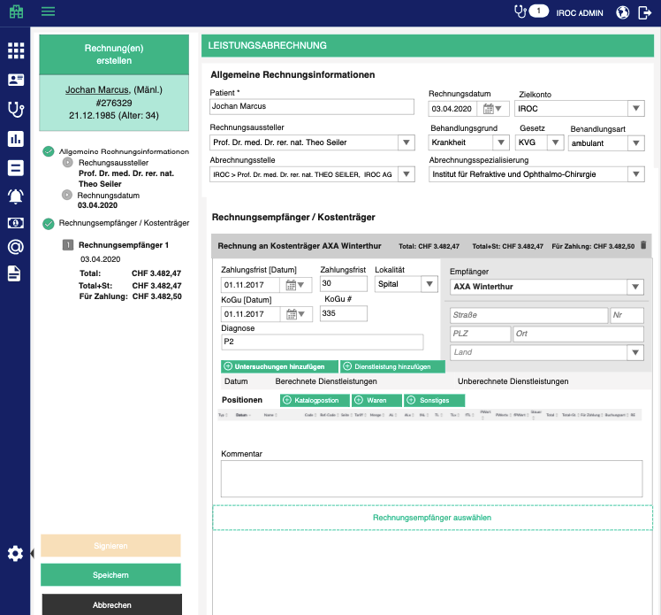

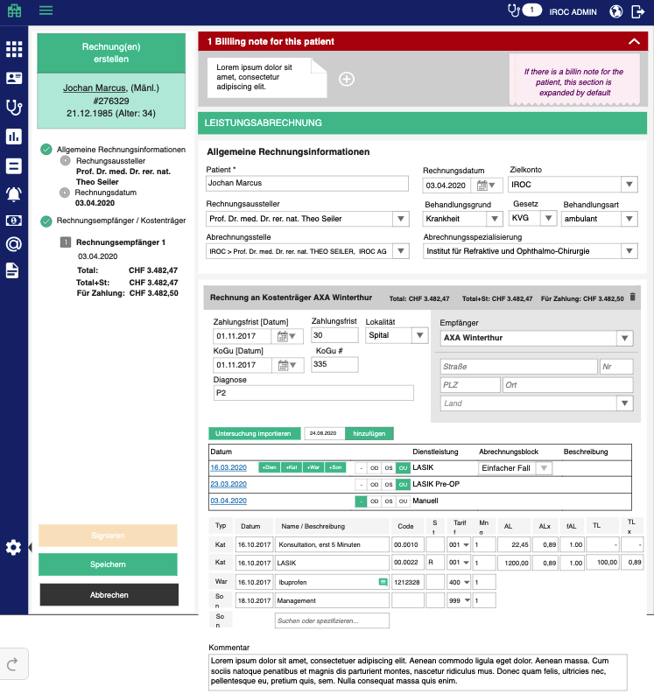

Adding and editing relies on the same form, only in case of editing, the data will be prefilled with existing data. In the top right corner, patient name of the currently added / edited bill group is displayed.
- Bill for <patient name> / Rechnung für <patient name> - disabled if editing an existing bill group

When talking about adding and editing draft bills, we are always dealing with bill groups. Bill groups are basically containers for bills which are created at the same time, for the same patient. Within one group, we can have one or more bills with different recipients. Multiple bills are created for 2 reasons:
- The financial officer does not always bill for each encounter - sometimes, a few encounters which happened over a short period of time are billed at once, therefore we will have a bill group with multiple bills which can be maintained together, on the same page, until they are signed off
- One encounter can be billed to multiple recipients. Remember the story about cataract surgery which is normally billed to an HIP, except when the patient wants sophisticated lenses which are not covered by health insurance? This is exactly the case here: one bill group will contain a bill for HIP and a bill for the patient himself

The bill group as an entity, however, should remain in the background, so we will never call them by that name directly in the UI.

Adding a bill can be started by pressing "Add bill / Rechnung hinzufügen" button above bills. An empty bill (group) page appears and the patient must be selected.
-> open a new bill group form
-> select current date as bill date
-> set the deadline to default deadline
-> set applicable law, treatment type and stationing based on tenant settings
-> open new bill popup where the user can pick which encounters to bill

Adding a bill group can also be started from the patient list. The user will be able to filter for patients with unbilled services and click on a button which starts adding them to a bill group. The bill group overview will have a link to the patients page with pre-filtered patients - only the ones that have unbilled services will be displayed.
- start liquidation/billing / zur Liquidation/Abrechnung

On the patient overview page:
Clicking on the "bill" icon on a patient row is pretty much just a link which leads to the “New Bill (group)” form
-> open a new bill group form
-> select the patient
-> select current date as bill date
-> set the deadline to default deadline which should be defined in tenant settings or for a specific HIP (see HIPs in Administration section for details)
-> set applicable law, treatment type and stationing based on tenant settings
-> open new bill popup where the user can pick which encounters to bill

Editing is started by clicking on the edit button in the corresponding row in the table
- Edit bill / Rechnung bearbeiten

User can specify the following data on the bill group add/edit page
- Liquidation/billing / Liquidation/Abrechnung - title of the page
- Patient / Patient - an autocompletebox which filters patients as the user types, same as on Book appointment page
- Target bank account / Zielkonto - a dropdown with bank accounts; mandatory (needed for payment instruction printing)
- Bill from / Rechnung von - an autocompletebox which filters staff who are doctors with a default cost center, as the user types
- Only doctors with default cost center can issue a bill. / Nur Ärzte mit Standardkostenstelle können eine Rechnung ausstellen. (note under the doctor selection)
- Bill date / Rechnungsdatum - a date box for the date when the bill is issued. Mandatory, must be a valid date. During creation, this box is set to current date as default
- Treatment reason/ Behandlungsgrund - dropdown with options which are assigned special GIDs
- Sickness / Krankheit (default)
- Accident / Unfall (if applicable law is UVG)
- Applicable law / Gesetz - dropdown with options which are assigned special GIDs, these basically correspond to treatment type
- KVG / KVG - for illnesses (select automatically if patient’s default recipient is a normal health insurace)
- UVG / UVG - for accidents (select automatically if patient’s default recipient is an accident health insurance)
- IVG / IVG - for disability (select automatically if patient’s default recipient is an disability health insurance)
- MVG / MVG - for military insurance
- VVG / VVG - for additional insurance (default if patient’s default recipient is not a health insurance)
- special behavior: when UVG is selected manually, all bills within the group, which have patients main or private HIP as recipient will be changed so that the recipient is main accident insurance, or private accident insurance (if those are specified for the patient); additionally, treatment reason changes to Accident / Unfall
- Stationing / Stationierung for billing reason, we need to know if the patient was an out-patient (just came in for a treatment) or an in-patient (stayed at the hospital)
- out-patient / ambulant
- in-patient / stationär
- Billing office / Abrechnungsstelle - dropdown with offices (display them indented to show hierarchy structure); preselect default one from the selected doctor; mandatory
- Billing specialization / Abrechnungsspezialisierung - dropdown with all available specializations for chosen office; preselect the default one for the office; optional;
- Service provider office / Leistungserbringer Stelle - dropdown with offices (display them indented to show hierarchy structure); preselect default one for bill issuer if available, otherwise the same as billing office, until changed; optional;
- Service provider specialisation / Leistungserbringer Spezializierung - dropdown with all available specializations for chosen provider office; preselect the default one for the office; optional;

Note: if service provider and their office and specialization are not specified, the billing doctor and billing office are used in the bill report.

These are defaults which can be used:
- Bill date is the date of the earliest selected encounter
- Patient is the one who had the encounter
- Recipient is the last selected recipient for this patient
- Account is loaded from tenant defaults
- Treatment reason is loaded from tenant defaults
  - If accident number is specified for the encounter, treatment reason is Accident
- Applicable law is loaded from tenant defaults
  - If treatment reason is Accident, this should be UVG
- Stationing is loaded from tenant defaults
- Billing office and specialization are taken from defaults of the selected doctor who is issuing the bill
- Payment deadline is taking from tenant defaults deadline (duration in days, naturally, the deadline itself is calculated)
- Localization is taken from tenant defaults
- Diagnosis is taken from the last bill for that patient

The page offers 3 standard buttons:

- Save / Speichern - executes all the validations and displays errors if necessary, otherwise saves the changes and displays the success message
- (if adding new) Bill has been successfully created. / Rechnung wurde erfolgreich erstellt.
- (if editing) Bill has been successfully updated. / Rechnung wurde erfolgreich aktualisiert.

- Cancel / Abbrechen - go back to overview withought saving changes
- Back to overview / Zurück zur Übersicht - go back to overview withought saving changes

There is an additional button which signs off the bills, but details about it are displayed later in this section.

If the user tries to leave the page after some changes have been made but not yet saved, the app will warn them with the standard "Are you sure you want to leave this page..." popup. This functionality should be applied to all pages, always.

Add / edit bill in bill group

When a new bill group is created, a new, blank recipient section is added.

The user can add more bills to the group by clicking on the button at the bottom
- New payer / Neuer Kostenträger - the reason we are not calling this "new bill" is because we refer to the bill group as a bill, and the bills are different recipients of the bill group

The user specifies the following data for each bill in the group:

- Recipient / Empfänger - display name, street, number, ZIP, city, country; mandatory; taken from the chosen recipient but can be added manually (When supplying the address, when ZIP code is selected, city and country should be preselected, at least in Switzerland.)
- Patient: <patient name> / Patient: <patient name>
- Alternative contacts (1...n), represented by their type (e.g. Emergency, Legal representative)
- Employer: <employer name> / Arbeitgeber: <employer name>
- Main health insurance: <HIP title> / Gesetzliche Krankenversicherung: <HIP title>
- Main accident insurance: <HIP title> / Gesetzliche Unfallversicherung: <HIP title>
- Disability insurance: <HIP title> / Invaliditätsversicherung: <HIP title>
- Other insurance: <HIP title> / Sonstige Krankenversicherung: <HIP title>
- Private health insurance: <HIP title> / Private Krankenversicherung: <HIP title>
- Private accident insurance: <HIP title> / Private Unfallversicherung: <HIP title>
- preselect patient default recipient

- Payment deadline [Days] / Zahlungsfrist [Tage] - number of days in which the bill should be paid in total. Default should be set to the value from tenant settings OR from HIP administration if defined
- Payment deadline [Date] / Zahlungsfrist [Datum] - a date box for the date by which the bill should be paid in total. During creation, this box is set to bill date + payment deadline as default
- Location / Lokalität - dropdown with all billing relevant role facility types;
- Cost credit [Date] / KoGu [Datum] - optional, the date when the HIP confirmed that they would compensate for the expenses
- Cost credit Nr / KoGu Nr - optional, number of the confirmation
- Diagnosis / Diagnose - text field where the user can specify the diagnose manually; loaded from issuer office settings if available; from tenant setting if not; or “P2” if neither setting is available

P1 | Lid/Konjunktiva
P2 (deafult) | Linse/Kornea / Glaskörper
P3 | Iris/Glaukom
P4 | Retina/Sehnerv/Gefässe
P5 | Augenmuskeln/Strabismus
P9 | Andere Augenerkrankungen

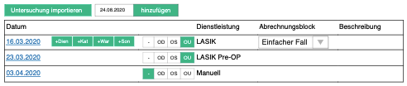

To make it clear to the user which medical services were billed and which were not billed in this bill group, we display the encounters and medical services section (table) above positions table with the following columns:
- Date / Datum - when the encounter took place; it is a link which opens the encounter documentation form (multiple rows with the same name date are grouped)
- Service / Dienstleistung – name of the service + localization for which it is billed (-, OD, OS, OU); if nothing is selected, the service is not billed
- Billing block / Abrechnungsblock – if the service has multiple billing blocks, a dropdown appears so that the user can choose another one; preselected is the one from billing preparation
- Description / Beschreibung

Changing service localization changes the content of the positions table. When the user unselects all localizations, i.e. removes service from the bill, they are prompted with message:
- Are you sure you want to remove <service> and all its positions from the bill? / Sind Sie sicher, dass Sie <service> und alle ihre Positionen aus der Rechnung entfernen möchten?

Add medical services(s) to bill

User can add a service which was never delivered through the encounter by clicking on the add service button next to the encounter date. Clicking on the add medical service button opens a popup in which the user can select one or more medical services and convert their billable block positions into bill positions of the current bill.
The popup will show a table with all the medical services, but since this can be quite large, we will add a filter box which filters the table based on medical service name or description.
- Add medical service / Dienstleistung hinzufügen - title of the popup
- Search / Suchen
- Localization (-, OD, OS, OU)
- Medical service / Dienstleistung
- Billing block / Abrechnungsblock - if the service has multiple billing blocks for the catalog revision of the bill recipient, display a dropdown with all the matching blocks; default one is preselected; if no default - preselect the first one
- Description / Beschreibung

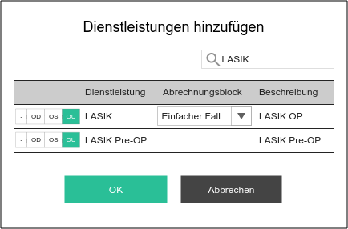

The user can add positions to a bill in any of the following ways:
- Add encounters to bill
- Add medical services to bill
- Add separate positions to bill

Add encounter(s) to bill
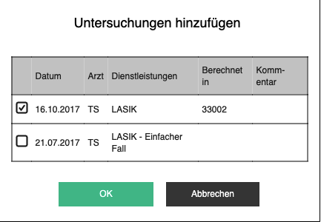

The user can import one or more encounters to the existing bill
- Import encounters / Untersuchungen importieren

Clicking on this button opens a popup where the user can select multiple encounters which they want to bill
- Encounters / Untersuchungen - a table with all finished encounters for the patient, which have non-billed services and are not free of charge. The user can select multiple encounters, but it is important to show which ones have already been billed, because it is not really legal to bill for the same service twice
- Date / Datum - date of the encounter, sort table by this column, descending
- Doctor / Arzt - main participant on the encounter; the participant who finished the encounter
- Medical services / Dienstleistungen - comma separated list of services provided in that encounter, which were not already billed in any non-draft bills
- If some of the delivered services from the encounter have a recipient in bill preparation which is not the same as recipient on the currently edited bill, the user has to be notified with warning icon
- Only <number of services for this recipient> services from this encounter will be added to the bill for <recipient>, based on bill preparation. / Nur <number of services for this recipient> Dienstleistungen aus dieser Untersuchung werden der Rechnung für <recipient> hinzugefügt, basierend auf der Rechnungsvorbereitung.
- Comment / Kommentar - billing comment if the doctor left it when specifying which medical services they want to bill. If there is a comment, a comment icon will be visible and hovering on it will display the comment in a tooltip
- If the encounter table has nothing to show (no encounters for non-billed services), show the following message under the table header
- There are currently no encounters with non-billed services. / Es gibt derzeit keine Behandlungen mit nicht abgerechneten Leistungen.

The generated bill positions are calculated this way:
-> for each of the selected encounters, go through delivered services (which doctor has selected before finishing the encounter) and take the selected (preferred) block; if there is no selected block, take the default billing one; if there is no billing block marked as default, take the oldest one
-> for each of the selected encounters go through products marked for billing in bill preparation, with the specified quantity and add them as goods positions
-> create bill positions based on the billable block positions in the matched billing group
-> If the service was delivered to multiple localizations, create a bill position for each localization (and set the localization abbreviation based on organ structure element’s abbreviation)
-> if the block position has “bill only once per encounter” flag, don’t create additional bill positions for different localizations
-> if the block position has “hide localization on bill” flag, don’t set the localization abbreviation
-> copy all the values including comment
-> apply rules: calculate quantity based on a formula
-> user can later change any of these values
-> Copy the address of the recipient into the billing address (this can also be changed by the user)

The user can create one or more billing-only encounters which do not come from a documentation form, but are created ad hoc for billing purposes. They are flagged in the database to not appear in patient history
- Add / hinzufügen – a button preceded by a date box in which the user specifies the date for which they are creating the encounter; once encounter is created, the date box is emptied so that the user can add a new one

Add separate position

- Add position / Position hinzufügen - like in medical services, adding a position is done by choosing a type of position and then searching through a billing catalog of the current bill or product list via auto complete.

Bill positions can be sorted by all columns. Default sorting is by date (ignore time portion as long as time is not displayed); then by type if the date is the same; then by code if the type is the same.

Bill positions have different fields, based on their type. See details below:

Catalog position / Katalogposition

Only quantity can be changed for catalog entries, other fields are disabled.

- Code / Code – mandatory
- Ref-Code / Ref-Code - optional, if the position is a reference position, the code of the main position is written here
- Side / Seite - optional; Abbreviation for localization, e.g. R (right/rechts) or L (left/links); when a bill position is created from block position of a medical service, this can be deduced from the captured localization of a delivered service; user can change manually
- Tariff / Tariff - mandatory, needed for e-billing, dropdown with catalog values
- Quantity / Menge - mandatory, must be a number (Invalid format. Please specify a number. / Ungültiges Format. Bitte geben Sie eine Nummer an.)
- DS / AL - doctoral services price. This attribute is needed only if the chosen catalog revision dictates it. If yes, it is mandatory, must be a number, aligned right with two decimal points
- DSx / ALx - doctor service unit factor, a factor by which the reimbursed doctor time is multiplied. E.g. 0.89 means that only 89% of the doctoral services will be reimbursed. This value comes from the modifiers catalog, based on the economic region of the office which is issuing the bill and the selected applicable law of the bill; if no billing modifier is found for selected law, default of 1 is used;
- fDS / fAL - mandatory; doctor service scale factor, used for discounting or increasing the value, but usually left as default = 1
- TS / TL - technical staff services, similar to doctoral services. Technical services are actually the part which is supposed to cover expenses of non-human resources, the whole practice infrastructure, maintenance and similar (because a practice has more expenses than just the salaries)
- TSx / TLx - technical service unit factor, a factor by which the reimbursed technical time is multiplied. E.g. 0.89 means that only 89% of the technical services will be reimbursed. This value comes from the modifiers catalog, based on the economic region of the office which is issuing the bill and the selected applicable law of the bill; if no billing modifier is found for selected law, default of 1 is used;
- fTS / fTL - mandatory; technical service scale factor, used for discounting or increasing the value, but usually left as default = 1
- UP / PWert - mandatory if catalog dictates it, must be a number, aligned right with two decimal points.
- UPx / PWertx - unit price unit factor, a factor by which the reimbursed unit value is multiplied. E.g. 0.89 means that only 89% of the unit price will be reimbursed. This value comes from the modifiers catalog, based on the economic region of the office which is issuing the bill
- fUP / fPWert - mandatory UP exists; unit price scale factor, used for discounting or increasing the value, but usually left as default = 1
- Tax / Steuer - dropdown, optional, offers all taxes for the current tenant; if standard tax specified for the billing office, preselect it, to save the user some time (display as name and percentage of the tax, e.g. MwSt 7.7% because some taxes have the same name and different percentage)
- Total - disabled, calculated automatically as (UP * UPx * fUP * Quantity) whenever one of those two values changes, aligned right with two decimal points. If the catalog dictates different prices for doctor and technical (or other) services, this value is calculated as ((DS * DSx * fDS) + (TS * TSx * fTS)) * Quantity), whenever one of those values changes.
- Total + Tax / Total + St. - disabled, calculated automatically as Total + Tax (Total) whenever one of those two values changes, aligned right with two decimal points
- Booking type / Buchungsart - a dropdown with available cost center booking types; this indicates what kind of booking it is (e.g. operation, consult, medication) to enable in depth reporting and controlling later. Default is (TAR - dd32704e-9bd0-4d83-8595-a1ddbdc3b87b)
- Reimbursment mandatory / Rückerstattung erforderlich - checkbox which will signifies whether or not the position has to be reimbursed
- checked by default

Goods / Waren
- User can add positions from the list of goods they keep on stock in the practice
- If there is no stock available for the tenant, this option is also not available for adding
- Label in the table will say: Good / War
- Title / Name: If the stock is set up, the user will add position by typing first letters of the goods and the autocomplete will offer best fit items (the user is actually searching through variants; goods which do not have variants have in fact, one default variant in the background)
- When the user selects a product, we will pick the price defined for the currency of the current billing block, otherwise, take 0
- Prefill the other attributes from the selected catalog entry, but let the user edit them
- Code - mandatory
- Side / Seite - optional; Abbreviation for localization, e.g. R (right/rechts) or L (left/links); when a bill position is created from block position of a medical service, this can be deduced from the captured localization of prescribed medication; user can change manually
- Tariff - mandatory, needed for e-billing; dropdown with catalog entries
- Quantity / Menge - mandatory, must be a number, 4 decimal places (Invalid format. Please specify a number. / Ungültiges Format. Bitte geben Sie eine Nummer an.)
- UP / PWert - mandatory, must be a number, aligned right with two decimal points.
- UPx / PWertx - unit price unit factor, a factor by which the reimbursed unit value is multiplied. E.g. 0.89 means that only 89% of the unit price will be reimbursed. Default for goods is 1
- fUP / fPWert - mandatory; unit price scale factor, used for discounting or increasing the value, but usually left as default = 1
- Tax / Steuer - dropdown, optional, offers all taxes for the current tenant; if standard tax specified for the billing office, preselect it, to save the user some time
- Taxes are something that is usually administered by the financial officers, but since we will have just one VAT, the administration will be implemented at a later stage. What is necessary for the current project stage is to create a 7.70% - MwSt 7.70% / VAT 7.70% tax for every created tenant
- Total - disabled, calculated automatically as UP*UPx*fUP*Quantity whenever one of those two values changes, aligned right with two decimal points
- Total + Tax / Total + St. - disabled, calculated automatically as Total + Tax (Total) whenever one of those two values changes, aligned right with two decimal points
- Booking type / Buchungsart - a dropdown with available cost center booking types; this indicates what kind of booking it is (e.g. operation, consult, medication) to enable in depth reporting and controlling later. Default is taken from product settings, if available.
- Reimbursment mandatory / Rückerstattung erforderlich - checkbox which will signifies whether or not a product has to be reimbursed
- if reimbursement group = 1 then this checkbox will be checked by default

Other / Sonstiges
- This option is always available and can be literally anything the user defines
- Label in the table will say: Oth / Son
- Title / Name - free text, user can specify anything, but it is mandatory
- Side / Seite - optional; Abbreviation for localization, e.g. R (right/rechts) or L (left/links); user can change manually
- Tariff - mandatory, needed for e-billing; dropdown with catalog entries
- Quantity / Menge - mandatory, must be a number (Invalid format. Please specify a number. / Ungültiges Format. Bitte geben Sie eine Nummer an.)
- Unit price / PWert - mandatory, must be a number, aligned right with two decimal points
- UPx / PWertx - unit price unit factor, a factor by which the reimbursed unit value is multiplied. E.g. 0.89 means that only 89% of the unit price will be reimbursed. Default for other is 1
- fUP / fPWert - mandatory; unit price scale factor, used for discounting or increasing the value, but usually left as default = 1
- Tax / Steuer - dropdown, optional, offers all taxes for the current tenant; if standard tax specified for the billing office, preselect it, to save the user some time
- Total - disabled, calculated automatically as UP*UPx*fUP*Quantity whenever one of those two values changes, aligned right with two decimal points
- Total + Tax / Total + St. - disabled, calculated automatically as Total + Tax (Total) whenever one of those two values changes, aligned right with two decimal points
- Booking type / Buchungsart - a dropdown with available cost center booking types; this indicates what kind of booking it is (e.g. operation, consult, medication) to enable in depth reporting and controlling later
- Reimbursment mandatory / Rückerstattung erforderlich - checkbox which will signifies whether or not the position has to be reimbursed
- unchecked by default

Each position can have a comment which can be lengthy. These comments will later be used to prefill bill position comments. A position with no comment has a small comment icon which is displayed in the right part of the Title field when the user hovers over the position. Clicking on it will open a small popup with text area for specifying comment.
- Comment for <position title> / Kommentar für <position title>
- OK / OK
- Cancel / Abbrechen

The user can also delete a position by clicking on the delete icon next to the position
- Delete position / Position löschen
- Are you sure you want to delete <position title>? / Sind Sie sicher, dass Sie <position title> löschen möchten?

Whenever a bill draft is updated (on save on sign off), bill positions must be ordered alphabetically, for the current language.

If the user specifies or edits bill positions manually, check if one of the following rules are satisfied, and if not
1: With which other billable block positions a billable block position cannot be billed together
2: Which other billable block position is this billable block position a part of
3: What is the maximum quantity for a position

If one or more rules are broken, show a warning sign with the text which rule was broken
1: Cannot be billed with <position> / Darf nicht abgerechnet sein mit <position>
2: Must be billed with <position> / Muss abgerechnet sein mit <position>
3: Maximum quantity is <quantity> / Maximale Menge ist <quantity>

Below all bill positions, aligned with bill position total, display bill total and total with tax as a label or disabled text box
- Total / Total
- Total + Tax / Total + St.

If the user starts the process of adding bills again and choses one of the already billed encounters in this bill [group], the bills will be deleted and created again, which means that all manually added positions will be lost. We want to warn the user about this.
- You selected encounters which have already been billed in this bill. All manual changes will be lost. Do you want to proceed? / Sie haben Behandlungen ausgewählt, die bereits in dieser Rechnung abgerechnet wurden. Alle manuellen Änderungen gehen verloren. Möchten Sie fortfahren?

Applicable law transformation

When applicable law is changed from, KVG (source applicable law) -> UVG/MVG/IVG (destination applicable law) TARMED and vice versa, the TARMED positions should be translated into ones from the other catalog.

Process:
- Find a catalog which covers the destination applicable law
- For each TARMED position in the bill, try to find a corresponding one in the destination catalog, i.e. one with the same code
- Prompt the user to confirm the action:
- Changing <source applicable law> to <destination applicable law> / Änderung von <source applicable law> in <destination applicable law>- title of the popup
- The following positions can be transformed into <destination applicable law>: / Die folgenden Positionen können in <destination applicable law> transformiert werden: <list of codes of positions which have a pair in the other catalog>
- The following positions cannot be transformed into <destination applicable law>: / Die folgenden Positionen können nicht in <destination applicable law> transformiert werden: <list of codes of positions which don't have a pair in the other catalog>. They will be deleted. / Sie werden gelöscht.
- Do you wish to continue? / Möchten Sie fortfahren?

If the user confirms, the positions with pairs are replaced by their pairs (with the prices from the destination catalog and the suitable billing modifier). The ones without pairs will be deleted. The bill totals are recalculated recalculated.

Rounding and cost center booking

When calculating the total value of a bill position we have to round the values to 2 significant decimal places, where the last decimal digit is 0 or 5. Due to this rounding, some money might be lost or gained. For example: if a products sales price is 14.56 and we put a third of the unit quantity on the bill (0.33) the total for that bill position would be 14.56 * 0.33 = 4.8048. However, since we have to round to 2 decimal digits, we will put 4.80 on the bill, which means 0.0048 is not paid by anyone, which means we will be 0.0048 short on the books! This has to be accounted for somewhere.

Because of this, we will have to make a cost center booking for the bill position itself (BPV) and a rounding booking (BPR). Later, an administrator will be able to extract how much has been lost / gained on rounding, buy selecting the correct booking type on financial reports.

BPT = bill position total = ((unit price * scale factor * unit factor) + (tech. unit price *tech. scale factor * tech. unit factor)) * quantity (+ tax if applicable)
BPV = BPT rounded to 2 decimals
BPR = BPV - BPT (full precision)

BPV cost center booking type is selected for each bill position, and BPR is either taken from the product, or the default one (RUND - 017edcc4-4e4d-4217-b4a8-2f13ab8afe9d), if the product does not have one specified. TARMED services are also products (which are services).

Validate bill
Validate bill button performs TARMED rule validation and displays any issues in the bill positions table.
- Validate / Validieren

Delete bill from group

This function is only available in bill (group) edit page.

Upon clicking on the delete icon, the user will be prompted by a standard confirmation popup.
- Delete bill / Rechnung löschen
- Are you sure you want to delete bill for <recipient display name>? / Sind Sie sicher, dass Sie die Rechnung für <recipient display name> löschen möchten?

Delete bill group

This function is only available for draft bill groups in the bills overview page.

Upon clicking on the delete icon, the user will be prompted by a standard confirmation popup.
- Delete bill / Rechnung löschen
- Are you sure you want to delete bill for <patient name>? / Sind Sie sicher, dass Sie die Rechnung für <patient name> löschen möchten?

Sign off bill group

This function is only available for draft bill groups on the overview and on edit page. Before the financial officer signs off on a bill group, it is treated as draft and all the bills within it have no bill numbers. This is important to note, because once a bill is issued and gets a bill number, it cannot be modified or deleted since it is against the law.

When the user signs off on a bill group, all the bills within it get their generated bill numbers and the bills go into view-only mode.
- Sing off / Signieren
- this button is not visible for people who do not have the right to sign off on bills
- this button is disabled until at least one bill is added
- this button is disabled if any of the bill positions have a broken or any other mistake billing rule
- Are you sure you want to sign off on the bill group for <patient name>? No further changes will be possible after this action. / Möchten Sie sich wirklich in der Rechnungsgruppe für <patient name> signieren? Nach dieser Aktion sind keine weiteren Änderungen möglich.

Bill number is created using a number range defined for the billing office.

Also, when the bill group is signed off, we need to create bookings against doctor's default cost center. For each bill created from the current bill group, we will go through each position and based on the position type, find the correct booking type and create a booking in the cost center (see Booking types in Administration section). This data will be used for reporting.

In addition to that, we must book a billing transaction against the patient’s debitor account. If the account does not exist at the time of first bill, create it (each patient must have a debitor account).

After signing off a bill group, PDF of all included bills should be added to the corresponding patient document archive, to keep the original bill for future reference.
- Bill PDF / Rechnung PDF - document type, GID entry
- Billing data / Abrechnungsdaten - document category, GID entry

Automatic payment distribution

When the user signs off on a bill, we want to give them an option to assign undistributed payments to it right away, so that they don't have to do this manually.

It is important to check if the patient has undistributed payments in the correct currency. So, sum up all the undistributed payments for this patient which have the same currency as the bill we have just created and if the value is greater than zero, display the following popup:
- Information / Information
- This patient has <amount><currency> undistributed payments at the moment. Would you like to distribute it to this bill? Dieser Patient hat im Moment <amount><currency> unverteilte Zahlungen. Möchten Sie es auf diese Rechnung verteilen?

If the patient confirms, create payment distribution for each of the payments, until the bill amount is reached. For example:

Newly created bill is 350 CHF and the patient has Payment A = 100 CHF, Payment B = 200 CHF Payment C = 340 EUR and Payment D = 70 CHF.

We will offer the user to distribute 370 CHF to the current bill, which will result in whole Payment A and whole payment B and 50 CHF of Payment D to be distributed to the bill. 20 CHF of Payment D will remain undistributed.

Payments

Payments link on the bill details page and bill overview page will just redirect the user to the Patient billing page of the corresponding patient.
- Payments / Zahlungen

Mark a bill as critical

This option will be available from the overview page as well as bill details page. Users may want to mark some bills as critical to indicate to other users that this patient should not have any further appointments made.
- Mark as critical / Als kritisch markieren

Upon clicking on the mark icon, the user will be prompted by a standard confirmation popup.
- Are you sure you want to mark bill for <patient name> as critical? / Sind Sie sicher, dass Sie die Rechnung für <patient name> als kritisch markieren möchten?

View bill Details

View bill / Rechnung anzeigen

This function is only available from the overview page, for bills which are signed off. When the user clicks on the bill number link, PDF is opened in a new tab.

Cancel bill

This function is only available for bills which are signed off. Draft ones can be deleted.

When the user clicks on cancel icon or button on the details page (it should be different than the delete icon), a popup with a mandatory comment area will appear.
- Cancel bill / Rechnung stornieren
- Cancellation reason / Stornogrund
- Comment / Kommentar

We will also capture the user who cancelled the bills, and the timestamp when they were canceled. If a bill is cancelled, hovering over the “cancelled” status label will provide these values in a tooltip.

<name of the user who cancelled>, <date of cancelation>, "<comment>"

In case the bill has a dunning process attached to it, dunning should be cancelled too (see cancel dunning).

After cancelling a bill, PDF should be added to the corresponding patient document archive, to keep the original bill cancellation for future reference.
- Bill Cancellation PDF / Rechnung Storno PDF - document type, GID entry
- Billing data / Abrechnungsdaten - document category, GID entry

Create a copy

In some cases a bill needs to be re-adjusted because, for example, it was rejected by the health insurance because of bad data. To avoid forcing the user to create everything from scratch, "Create a copy" feature will create a new draft bill, with all data and positions and encounter references copied from the original bill.
- Create a copy / Kopie erstellen

Storno and copy

A shortcut to cancel a signed off bill and create a draft copy of it. Bill cancellation process requires the comment and confirmation and afterwards creates a copy.
- Cancel and create a copy / Stornieren und Kopie erstellen

Print bill

Printing a bill is covered in detail in Reports and printing section. Normally, a bill can only be printed once it is signed off, but we will allow printing of draft bills as a shortcut for signing them. Pressing the print button on a draft bill will show the following popup:
- Sign off / Signieren - title
- If you proceed with printing, the bill will be signed off and will not be further editable. Are you sure you want to proceed? / Wenn Sie mit dem Drucken fortfahren, wird die Rechnung signiert und ist nicht mehr bearbeitbar. Sind Sie sicher, dass Sie fortfahren möchten?
- Yes / Ja - confirmation button (signs off the bill and opens the print popup)
- No / Nein - cancel button

Mass actions

There are certain actions which should be performed on multiple bills. For starters, we will want to enable mass printing.

Each row in the table should have a checkbox and when at least one of them is selected, mass action buttons above the table are enabled. When none are selected, mass action buttons are disabled. A checkbox in the header selects / deselects all items in the list.
- Select all / Alles auswählen
- Unselect all / Alles wiederufen
- Print / Drucken
- Sign off / Signieren

Mass printing sends all the selected bill PDFs to the selected printer, the same way as if the user would print multiple documents. Have in mind that only the documents which are eligible fro printing will be printed, even if some others were selected. To notify the user that some of the bills will not be printed, display a warning message saying:
- <count> documents are not eligible for printing. / <count> Dokumente können nicht gedruckt werden.

Mass sign off will sign off all drafts which do not have broken rules. To notify the user that some of the bills have not been signed, display a warning message saying:
- <count> bills are not eligible for signing off. / <count> Dokumente können nicht signiert werden.

Installment plan

Although the HIPs will likely pay their bills all at once, the self paying patients might want to do it in installments. Clicking on the installment plan button in the bill definition area will open a new page where the user can specify installments.
- Installment plan / Ratenzahlungsplan - link to the page and page title
- Display the name of the bill in the upper right corner, so that the user knows for which bill they are editing installment plan

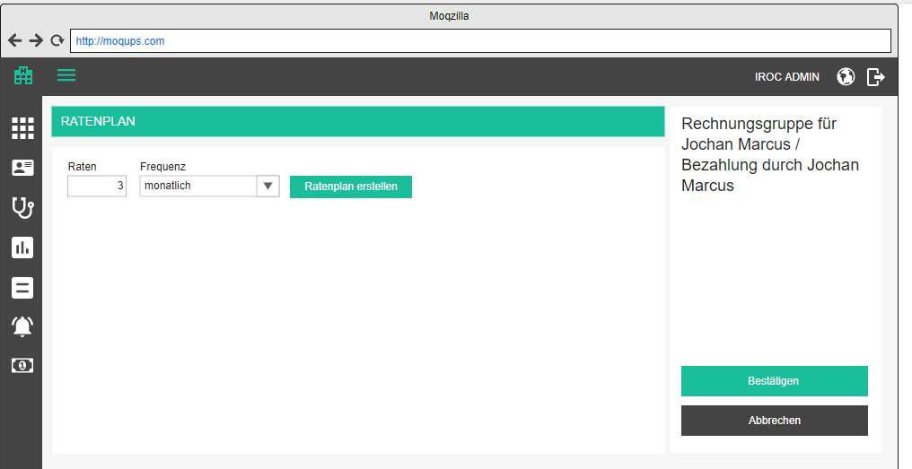

When the user starts with the installment plan, we will offer them an installment generator, so that they do not have to create installments one by one. The user will specify number of installments they wish to generate and the frequency. For example: 3 monthly installments will generate 3 installments, first with the deadline which is one month after the bill date, second which is one month after the first installment deadline, third with deadline one month after the second. Each installment will have the amount which is bill total divided by 3.
- Installments / Raten
- Frequency / Frequenz
- Generate installment plan / Ratenplan erstellen

After an installment plan is generated, the generator is hidden and the user can manually change the installment plan until the bill is signed off on. If the user deletes all the installments, the generator appears again. With the generated installments the user can do the following:

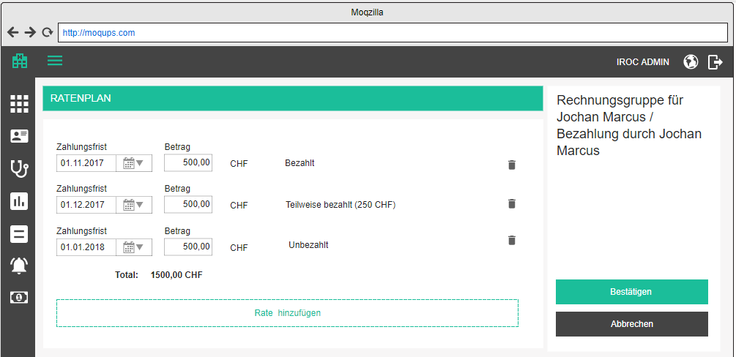

Add / edit installment

For each installment, the user can specify the deadline and the amount. The currency is taken from the bill catalog.
- Add installment / Rate hinzufügen
- Payment deadline / Zahlungsfrist - mandatory, must be a valid date, each next installment date must be greater than the previous!
- Amount / Betrag - mandatory, must be a positive number, aligned right with two decimal spaces
- Status (available only when the bill has been signed off on):
- Paid / Bezahlt - if there is a payment assigned to this installment in the full amount
- Partially paid / Teilweise bezahlt (amount + currency) - if there is a payment assigned to this installment which does not fully cover the price
- Unpaid / Unbezahlt - if there is no payment assigned to this installment
- Total / Total (currency) - sum of all installment amounts, two decimal points, must be equal to the bill total
- Installments total does not equal bill total (<bill total> <currency>) / Ratenzahlungtotal entspricht nicht der Rechnungstotal (<bill total> <currency>) - validation message

Delete installment

Upon clicking on the delete icon, the user will be prompted by a standard confirmation popup.
- Delete installment / Rate löschen
- Are you sure you want to delete this installment? / Sind Sie sicher, dass Sie diese Rate löschen möchten?

View installment plan

View installment plan / Ratenplan anzeigen

Once a bill is signed off, the installment plan goes into view-only mode, meaning, no changes can be applied. The title in the upper right corner is formulated as

Bill <bill number> for <patient> / Rechnung <bill number> für <patient>

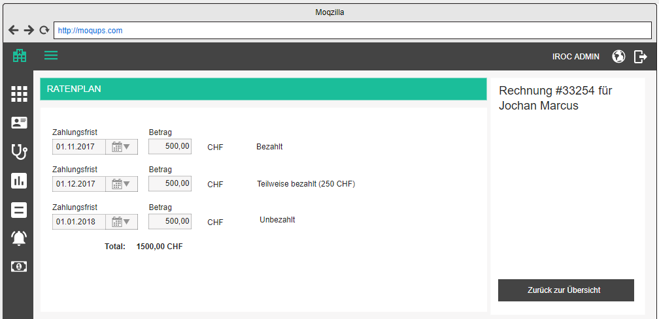

Print installment plan payment instructions

Payments

Payments is a completely new menu point underneath the bills menu point. It is a central place where the user (typically a financial manager) can see all the payments, upload payments from bank statements, assign payments to bills, etc.

Payments overview

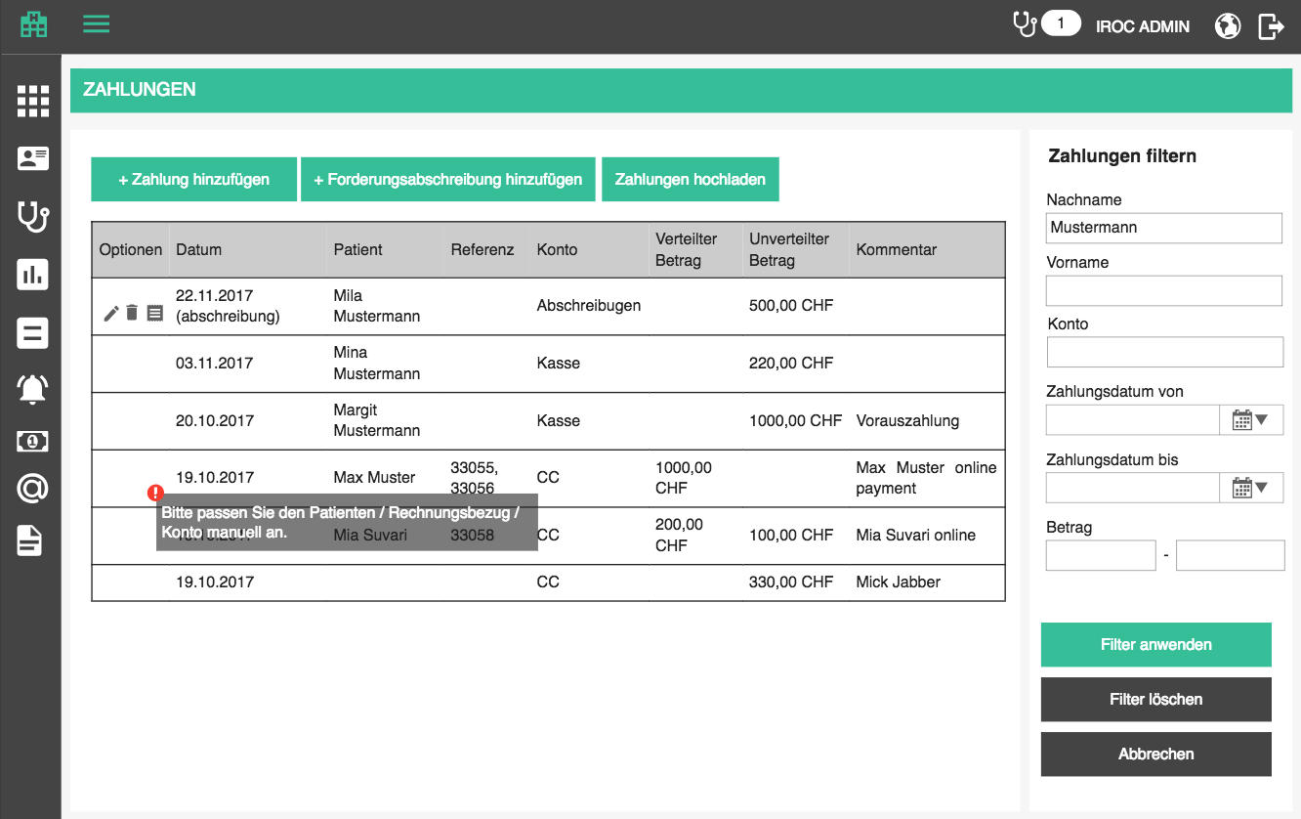

Overview is a table which contains all payments which are added to the tenant database.

The overview table contains the following columns:
- Payments / Zahlungen - page and menu point title
- Options / Optionen (edit, delete)
- Payment date / Zahlungsdatum - date when the payment was made
- Patient / Patient - patient name in form <last name>, <first name>, link to patient history
- Reference / Referenz
- this column will display comma separated list of bill / dunning numbers which this payment / write-off / refund has been distributed to
- Account / Konto - booking account to which the payment was attached
- Distributed amount / Verteilter Betrag - portion of the payment amount which was already assigned to bills or dunnings; aligned right, two decimal points, currency appended;
- Undistributed amount / Unverteilter Betrag - portion of the payment amount which has not been assigned to bills or dunnings; aligned right, two decimal points, currency appended
- Comment / Kommentar - specified comment

The list should be sortable by all columns (except options, of course). Default sorting is by payment date, descending.
The list should be search-able by patient, account and comment. Search starts as soon as you type, but with a small debounce. Check the rest of the app for guidance.

When the searched list is empty, display the following text instead of the first row:
- There are no matching payments for this search criteria. / Es gibt keine passenden Zahlungen für diese Suchkriterien.

When the list is empty in general, display the following text instead of the first row:
- There are no payments entered. / Es sind keine Zahlungen eingegeben.

Advanced filters are not needed for now.

Upload payments

After the bills have been forwarded the practice waits for the money to land on their account. When the money lands on bank account, the practice will get a file from their bank and import it into the system to mark the paid bills as paid. This file format may differ from bank to bank, so we need to construct a flexible solution to easily switch the file parsing.

For now, we will be using BESR file which looks something like the example at the bottom.
- Upload payments / Zahlungen hochladen
- Available in the payments overview

Marked portion of every row except for last one, is the reference number (bill number or debtor (patient) number), and underlined portion is the amount paid. (New line, spaces and hyphens are added for easier reading. The actual file does not have them, see example). Upon processing the upload, amounts from the file need to be booked against referenced bills and/or patients. All of this should be done the same way and using the same methods as when the user is doing it manually. Pay attention to installments if there are any, and whenever an amount larger than what the bill actually states, that amount is booked without reference (and can be later used to compensate for another treatment).

For example, bill was 500 CHF, and patient accidentally wires 600 CHF. The patient has gotten payment instructions where the bill reference is stated, so we will end up with an entry in BESR file which is 600 CHF for that bill. When we process the file, we will book 500 CHF against the bill and the leftover 100 CHF unreferenced, and the patient will have an extra 100 CHF on their booking account.

Based on the bill reference number, we will be able to deduce the patient and connect the payment to them. If there is no bill with the specified reference number, try to match the reference to a patient with that number. This will occur in cases hen, for example, a patient needs to pay a deposit so we have no bill to reference. In this case, the payment will not reference any bill, naturally.

Relevant data:

- Account BESR-ID [digits 13-19]: Based on the bold portion of the row (BESR-ID) we will be able to deduce the bank account th which the payment should be booked.
- Bill number / Patient number [digits 20-38]: Based on yellow marked portion (20 digits) we will deduce to which bill (and corresponding patient) or just patient this payment should be connected
- Amount [digits 40-49]: Based on underlined 10 digits we will deduce the payment amount. Last two digits are decimals (cents) and the entire number is padded with zeros
- Payment date [digits 72-77]: Based on orange marked portion (6 digits) we will deduce the payment date. The format is YYMMDD
- Rejection [digit 87]: This is the rejection code. If 1, the payment was rejected -> we skip this line, if 0 payment should be created

002 010045710 923338-000461510000298040027 0000230000 0000000000 171026 171027 171027 000000000 0 000000000 0000
002 010045710 923338-000464110000298150010 0000025370 0000000000 171027 171027 171027 000000000 0 000000000 0000
002 010045710 923338-000565410000090490684 0000031900 0000000000 171026 171027 171027 000000000 0 000000000 0000
002 010045710 923338-000580810000289790035 0000013350 0000000000 171026 171027 171027 000000000 0 000000000 0000
002 010045710 923338-005198510000295790026 0000600000 0000000000 171027 171027 171027 000000000 0 000000000 0000
002 010045710 923338-005246510000057360071 0000035645 0000000000 171027 171027 171027 000000000 0 000000000 0000

999 010045710 999999999999999999999999999 000000936265 000000000006 171030 000000000 000000000

If a payment could not be imported for one of the following reasons:
- No file was uploaded / Es wurde keine Datei hochgeladen
- Incorrect file format / Falsches Dateiformat
- Row <row number> format incorrect / Zeile <row number> Format ist falsch
- Row <row number> could not be assigned to a patient / Zeile <row numbe>konnte keinem Patienten zugewiesen werden
- Row <row number> could not be assigned to an account / Zeile <row number> konnte keinem Konto zugewiesen werden
A file which contains any of the issues will not be processed and the user will get an error feedback in a popup, so that they can overview and correct the file
- Payment upload failed / - title of the popup
If the file has been uploaded successfully, display success bubble
- Payments successfully processed / Zahlungen erfolgreich verarbeitet
Download example 03195169.V11
More info available here.

Note:
BESR file will be replaced by an XML format in 2018, probably in the second half, so this part will have to be adjusted later.

Add payment

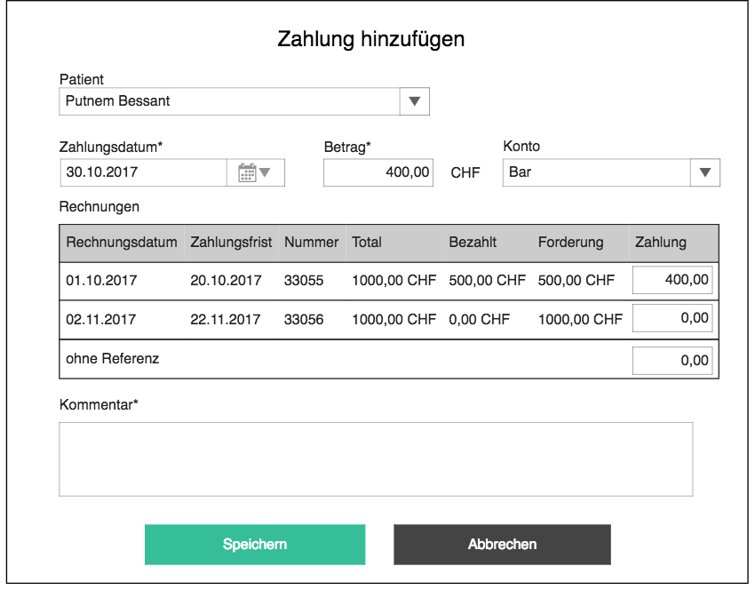

If the patient or patient’s health insurance makes a payment, we will want to document it and mark which bills it covers. Have in mind that the patient may make partial payments for one bill, so we will be taking in payments until the bill is covered completely. As long as it is not overdue, everything is fine. Another exceptional scenario is when the patient has a couple of open bills and decides to pay them all up in one go - in this case we will need to document which bills have been covered with that one payment. Generally, we will have one payment for one bill, but it is important to keep other options open.

Similarly to bills, payments can also be associated to dunnings. This is used to document that dunning fees are paid (although paying just the dunning fee will not settle the dunning if the bill is still unpaid).

Clicking on the ”add payment” button opens up a popup where the user can specify how much money was received and distribute it to one or more open bills or dunning documents, or leave it undistributed.
- Add payment / Zahlung hinzufügen - button for adding payment / popup title
- Patient / Patient - autocomplete with patients, same as the one on add new appointment
- Payment date / Zahlungsdatum - date of payment; date box, mandatory, default today
- Amount / Betrag <currency> - amount paid; mandatory, must be a number (negatives are allowed to enable the user to put into the system when they paid back to the patient), currency at the end is default tenant currency (later we will be able to choose this)
- Account / Konto - dropdown with accounts from Cash and Cash equivalent group (Note: if the list of these accounts grows, we will need a way to easy for the user to select, but it should not happen at the beginning.)
- Bills / Rechnungen - list of all open bills and dunnings for this patient, the user can choose multiple and specify how much is distributed to which; if a bill has dunnings, all dunning fees are summed up and displayed under the corresponding bill
- user can also leave a portion undistributed (bottom row) “Without reference / Ohne Referenz"
- distribute here / hier verteilen - an icon, when clicked, the unpaid amount of this bill is distributed to it, if the payment amount allows it
- Bill date / Rechnungsdatum - bill date / dunning date
- Payment deadline / Zahlungsfrist - sort by this row descending
- Bill number / Rechnungsnummer - empty if dunning
- Total / Total - bill amount / sum of all dunning fees for this bill
- Paid /Bezahlt - sum of all payments for this bill / dunning fees
- Debt / Forderung - rest to be paid for bill / dunnings
- Payment / Zahlung - amount to be distributed, must be a positive number, not larger than the remainder to be paid, sum of all distributed values must be equal to the payment amount
- Comment / Kommentar - text area, optional
- Save / Spreichern
- Cancel / Abbrechen

If one of the bills to which a portion of the payment has been distributed has an installment plan, book the distributed amount to the next installment which is not yet paid in total. If the amount to be distributed is more than one installment, book it against the next installment, and so on…

Every entered payment adds a payment transaction to the patient’s debitor account, thus enabling us to see the current balance. If the debitor account does not exist at the time of first payment, create it, because every patient needs a debitor account.

Edit payment

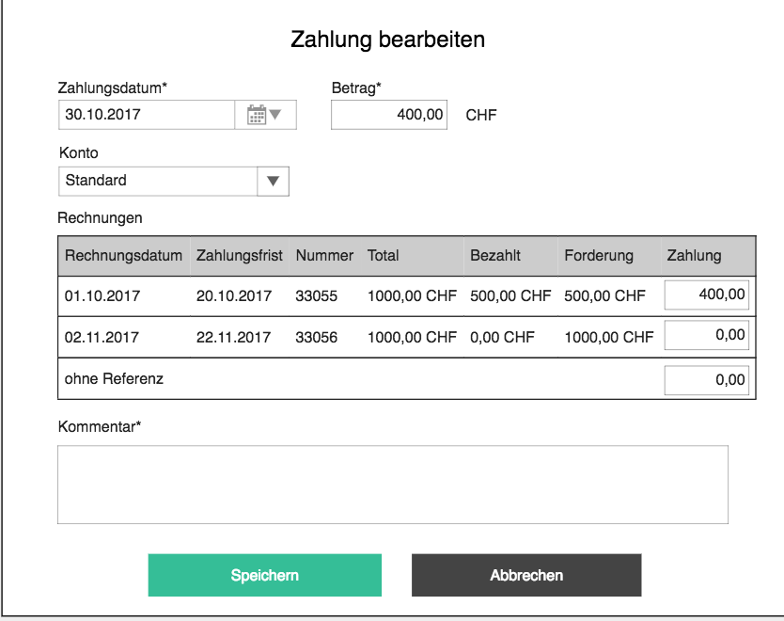

Editing a payment starts by clicking on the corresponding row’s edit button
- Edit payment / Zahlung bearbeiten

The popup is the same as the one for adding a payment, with the exception that:
- comment will be mandatory because we want to track why a payment has been changed; we also have to capture the timestamp when the change was made and by whom
- the bills table will have open bills AND the bills to which the current payment has already been distributed, because the user might want to distribute to current bills differently, or distribute the payment to other bills

Note: Before the serious bookkeeping functionality is implemented, there is no need for the mandatory comment and user capturing.

Delete payment

See Patient billing account

Add / edit / delete write-off

See Patient billing account

Add / edit / delete refund

See Patient billing account

E-Billing

Sending bill to an HIP electronically

Billing to HIPs is normally done electronically, by sending or uploading a file in certain format to the HIP's billing service. The format may vary from country to country, from HIP to HIP. For example, we implemented exporting bills into format called EDIFACT in the frame of MediosConnect project. They use this file to upload it to HIPs website.

In Switzerland, there are many HIPs, with which it is possible to communicate via standardized XML files, discussed later on. The ‘only’ limitation is the fact that entities which want to send bills to HIPs electronically, have to have a signed contract with those HIPs. B-op product portfolio does not yet have this direct communication on their roadmap, which does not mean it will not eventually do just that. But, for the time being, PM will rely on existing settlement processors which act as gateways to HIPs. There is a number of those, for example, MediPort (MediData) and ÄrzteKasse.

In the first stage, we will concentrate on MediData Network which is the most common.

Connection to payment gateways are administered in the tenant settings.

The user will have a separate page for e-billing where they can pick out all the documents that they want to forward to MediData. This list includes all open bills which have not yet entered the e-billing process (do not have transmission statuses) and all bills which are already in the e-billing process. By default, TG bills are not displayed in e-billing, but if this option is enabled in tenant settings, both TP and TG bills will be on this page.
- E-billing / E-Abrechnung - title
- Table with all eligible documents
  - Checkbox for multi-actions; checkbox in the header marks all items which match the current search criteria
  - Type / Type
    - Bill / Rechnung
    - Bill Copy / Rechnung Kopie
    - Dunning / Mahnung
    - Dunning Copy / Mahnung Kopie
    - Bill Storno / Rechnung Storno
    - Dunning Storno / Mahnung Storno
  - Status / Status + info icon for messages
    - Open / offen
    - Transmitted / übermittelt - show messages in history popup*
    - Accepted / Akzeptiert - show messages in history popup
    - Pending / Anstehend - show messages in history popup
    - Rejected / Abgelehnt - show errors in history popup
    - Processed / Erledigt
  - Patient / Patient - patient name in form <last name> <first name> , link to patient history
  - Issuer / Aussteller - the doctor who issued the bill
  - Number / Nummer - bill number or dunning number; this is a link to the bill / dunning document
  - Payment deadline / Zahlungsfrist
  - Transmission date / Übermittlungsdatum - date when the bill was last transmitted to MediData (or other settlement processor); this is a link to downloading the XML file which was sent to processor
  - Answer date / Antwortdatum - date when the bill received answer from MediData (or other settlement processor); this is a link to answer HTML file which the processor sent back
  - Amount / Betrag - aligned to the right, two decimal points, currency
  - Unpaid / Unbezahlt - open amount; aligned to the right, two decimal points, currency
  - Recipient / Empfänger - display name of the recipient (HIP)

History popup
Displays the transmission history entries of a bill in ascending order. For each history entry display
- Date and time / Datum und Zeit:
- Status / Status:
- Details / Details:
  - <explanation>
  - #<error record_id> [<error code>] <error text> (display in multiple lines if multiple error codes supplied)
- Company / Firma: <company name>
  - Phone / Telefon: <phone>
  - Email / Email: <email>
- Employee / Angestellter: <last name, first name>
  - Phone / Telefon: <phone>
  - Email / Email: <email>

OK / OK - closes popup

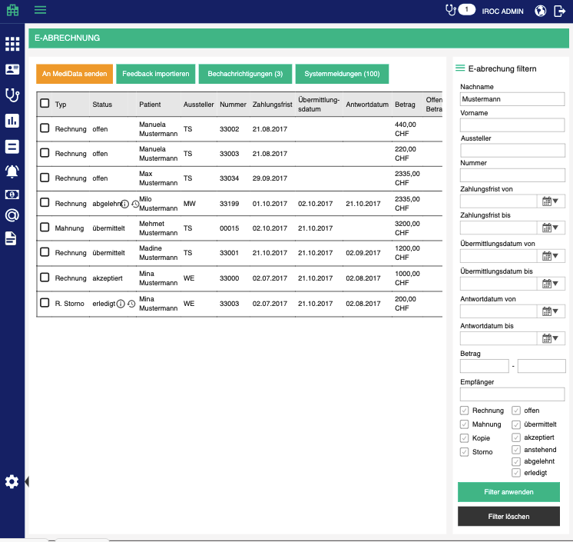

Table should be sortable by all columns (default: by payment deadline ascending).

Advanced filters appear on the right side of the screen and offer the following behavior:

Filters should be applied as AND operation, meaning, only items which meet all the criteria are shown.
- Filter e-billing / E-abrechnung filtern - subtitle
- Last name / Nachname - of the patient
- First name / Vorname - of the patient
- Issuer / Aussteller - doctor
- Number / Nummer
- Payment deadline from / Zahlungsfrist von - including specified date
- Payment deadline to / Zahlungsfrist bis - including specified date
- Transmission date from / Übermittlungsdatum von - including specified date
- Transmission date to / Übermittlungsdatum bis - including specified date
- Answer date from / Antwortdatum von - including specified date
- Answer date to / Antwortdatum bis - including specified date
- Amount / Betrag - two text boxes for lower and higher amount boundary for search
- Recipient / Empfänger - HIP
- Bill / Rechnung - return bills
- Dunning / Mahnung - return dunnings
- Copy / Kopie - return copies of bills / dunnings, depending on what is selected; if neither bill / dunning filter is selected, select both of those checkboxes and return results
- Storno / Storno - return cancellations of bills / dunnings, depending on what is selected; if neither bill / dunning filter is selected, select both of those checkboxes and return results
- Open / offen - return open bills / dunnings
- Transmitted / übermittelt - return transmitted bills / dunnings
- Accepted / Akzeptiert- return answered bills / dunnings which were accepted
- Pending / Anstehend - return answered bills / dunnings which are pending
- Rejected / Abgelehnt - return answered bills / dunnings which were rejected
- Processed / Erledigt - return bills / dunnings marked as processed
- Apply filters / Filter anwenden - filter bills based on specified criteria
- Clear filters / Filter löschen - clear filters and show all items

This view offers only group actions because it seems highly unlikely that documents will ever be sent one by one. The following actions are available…

Send to payment processor

There can be many payment processors which the user can use for sending the bills to, especially if PM is used in different countries. For that reason, we will, eventually have many implementations of sending data to a processor. We are starting with just one, but have to keep in mind that this functionality will soon have to be expanded.

For example, we now have “Send to MediData” button, but if the PM tenant is configured to be able to send to multiple, we might have “Send to X” and ”Send to Y” buttons next to it. Or we will select a preferred payment processor for each item and then just click “Send”

When the user checks a couple of bills, the send button becomes enabled and if the user presses it, each selected document will be sent to MediData.
- Send to <payment processor> / An <payment processor> senden
- Are you sure you want to transfer the selected documents for e-billing? This action cannot be reversed. / Sind Sie sicher, dass Sie die ausgewählten Dokumente für die E-Rechnung einsenden möchten? Diese Aktion kann nicht rückgängig gemacht werden.

Only eligible open items can be transmitted, items of other statuses will be skipped. Bubble message will display how many of the selected ones were sent successfully
- If all items sent successfully, show a green bubble: All documents were successfully transmitted. / Alle Dokumente wurden erfolgreich übermittelt.
- If some of them were not eligible for sending, show an orange bubble: <number> documents were successfully transmitted. / <number> Dokumente wurden erfolgreich übermittelt.
- If an error occurred and no items could be sent, show the standard error bubble

Note:
XMLs need to be encrypted because of the sensitive patient data according to official documentation. We will have to communicate with MediData to get the details about encryption and how the upload can be automated, so that the user does not have to upload the files to their online portal manually.

Note:
Guarantor entry in the XML is either the patient himself, or, in case the patient is under 18 year of age, their alternative contact.

Detailed explanations are provided on the official website and can be downloaded here.

Note:
Basic MediData document transmission is free of charge, but we have to check if some additional fees may apply and inform IROC.

Note:
Before sending each bill, check if there is a generated XML in the patient document archive (see details in Billing implications section). If not, generate one, put it in the archive before sending.

Import feedback from payment processor

MediData provides feedback documents which can be uploaded to PM.
- Import feedback / Feedback importieren

Based on the invoice reference we will connect the feedback document to the original bill / dunning document and add it to patient document archive where it can be viewed. A link to feedback document should be present in the e-billing section as well, from where it can be opened in a new tab.
- View / Anzeigen

The rest of the process is manual. Financial officer will act based on the received feedback, cancel bills if needed, create an transmit new ones, etc.

Positive feedback is not sent at all (what a lousy attitude :) ). The money will eventually arrive to the bank account, the customer will upload payments and paid bill / dunning will not be displayed in e-billing.

Check with MediData in which format the feedback can be provided, i.e. if we can get PDFs which can be directly displayed without having to create reports.

Mark as processed

If (negative) feedback arrives and the user acts on it, e.g. creates a new bill and sends it out again, the old one needs to be hidden from the screen to not bother the user any more. This is done by selecting items and marking them as processed, thus changing their status.
- Mark as processed / Als erledigt markieren
- Are you sure you want to mark these items as processed / Möchten Sie diese Elemente wirklich als erledigt markieren?

Applying this action on already processed elements will return them to the previous state.

Messages from e-billing gateway

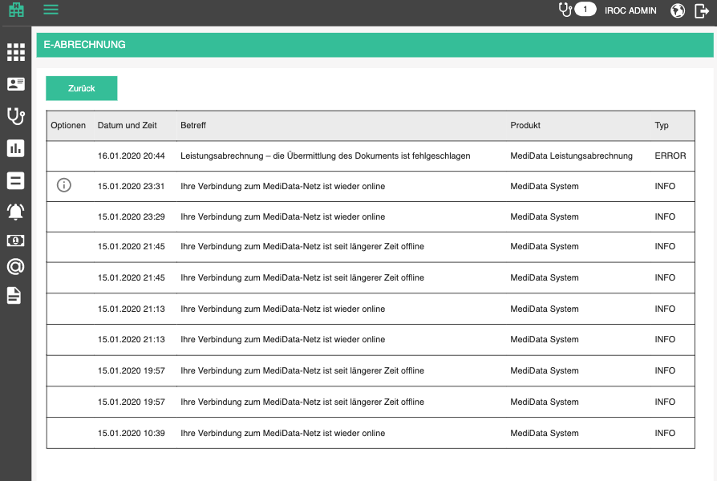

Messages are a way for e-billing gateways to communicate with end users - doctors and financial officers. If the customer uses multiple gateways, the messages are aggregated into this table. It is reachable by clicking on the Messages button above e-billing table. Messages can be billing messages and system messages
- Messages (<number of unread messages>) / Benachrichtigungen (<number of unread messages>)
- System messages (<number of unread messages>) / Systemmeldungen (<number of unread messages>)

Table is a standard “infinite scroll” table, sortable by all columns, except for options. By default, messages are sorted by date and time, descending.

The table offers the following columns:
- Options / Optionen
- Show details / Details anzeigen: into icon when clicked opens the details popup
- Confirm / Bestätigen - marks a message as confirmed and it disappears from the list
- Date and time / Datum und Zeit: <created>
- Subject / Betreff: <subject (isoCode)>
- Product / Produkt:
- (if system message) MediData System / MediData System
- (if billing message ) MediData Leistungsabrechnung / MediData e-billing
- Type / Typ: <severity>

When there are no messages to diplay:
- There are no messages available. / Es sind keine Nachrichten verfügbar.

Details popup:

Details / Details
- Date and time / Datum und Zeit: <created>
- Product / Produkt: System / Leistungsabrechnung
- Type / Typ: <severity>

<message (isoCode*)>

*If the isoCode of the current language of the application is not available in the message, take "de" as default

E-billing request
Detailed instructions are included here. This section is just an overview of the elements which we will use for now, because the schema is much more complex than initially needed.

Notes:
- pay attention to rounding of prices. It is explained in the provided documentation (page 25)
- Some elements like Company and Person are reused in many places, pay attention to them

Invoice payload body most important elements:

Balance

- Currency = CHF
- Amount - bill total
- Amount_obligations - total of all the services marked as obligation
- Amount_reminder - dunning fee if this is a dunning
- Amount_prepaid - amount paid in advance
- Amount_due = amount + amount_reminder- anount_prepaid

Esr9

- Type = 16or27
- Participant_number - ESR number of the billing office
- Reference_number - reference number on the bill, formatted in the same way as on the PDF
- Coding_line - ESR code, the same way as it appears on the bill
- Bank - Company element with bank data

Tiers_payant if the bill recipient is an HIP / tiers_garant otherwise

- Biller - Company element with billing office data
- Provider - Company element with billing office data or Person element with assigned doctor data (depending on the need; if every doctor is a company of his own, like in IROC, biller and provider will be the same; if the doctor is an employee, the biller will be the office and the provider will be the employee)
- Insurance - Company element with data of the HIP to which we are billing
- Patient - Person element with patient data
- Guarantor - Person element with legal representative of the patient or the patient himself
- Insured - on rare occasions where the patient is an infant where the billing is done over parent’s insurance
- Balance - all payment relevant data; VAT is not used yet

Kvg / uvg / ivg / vvg - depending on the applicable law
- Isured_id - patient’s insurance contract number
- Case_id
- Case_date
- Ssn - patient’s social security number, AHV number

Treatment
- Date_begin - date of first service on the bill
- Date_end - date of last service on the bill
- Canton - code of the canton in which the treatment took place (canton of the billing office)
- Reason - illness / accident / etc
- Apid - patient ID from our software
- Acid - case ID from our software
- Diagnosis - Diagnosis element with type (cantonal, freetext, ICD10, etc) and the code of the diagnosis
- Xtra_hospital -

Services
- Service_ex (for TARMED)
- Service (for drugs and other services)

PM error codes
ProblemWhenValidatingTheMessageOverSchema = 80005
Message does not conform to the official schema. / Die Nachricht entspricht nicht dem offiziellen Schema.

RecipientEanNumberIsMissing = 80007
Recipient does not have EAN defined. / Die EAN des Empfängers ist nicht definiert.

BillRecipientCityInformationHasToBeDefined = 80021,
Recipient does not have city defined. / Der Ort des Empfängers ist nicht definiert.

BillRecipientZipInformationHasToBeDefined = 80022,
Recipient does not have ZIP defined. / Die Postleitzahl des Empfängers ist nicht definiert.

ResponsiblePersonIsNotADoctorWithGLN = 80002,
Issuer is not a doctor with valid GLN. / Der Aussteller ist kein Arzt mit gültiger GLN.

DoctorDoesNotHaveEanNumberDefined = 80006
Issuer does not have EAN defined. / Der Aussteller hat keine EAN definiert.

IssuingOfficeCityInformationHasToBeDefined = 80019,
Issuer does not have city defined. / Der Aussteller hat keinen Ort definiert.

IssuingOfficeZipInformationHasToBeDefined = 80020,
Issuer does not have ZIP defined. / Der Aussteller hat keine Postleitzahl definiert.

IssuingOfficeZsrNotDefined = 80008
Issuer does not have EAN defined. / Der Aussteller hat keine EAN definiert.

ZsrIsNotInAValidFormat = 80018
Issuer ZSR format is not valid. / Das ZSR-Format des Ausstellers ist nicht gültig.

EsrParticipantNumberMissinng = 80010
ESR participant number is missing. / Die ESR-Teilnehmernummer fehlt.

EsrReferenceNumberMissing = 80011
Bill ESR reference number is missing. / Die ESR-Referenznummer der Rechnung fehlt.

EsrCodingLineMissing = 80012
Bill ESR code is missing. / Der ESR-Code der Rechnung fehlt.

BillHasNoDeliveredServices = 80001,
Bill contains no positions. / Die Rechnung enthält keine Position.

BillPositionTypeHasToBeCatalogOrGoods = 80004,
Bill contains positions which are neither services nor products. / Die Rechnung enthält Positionen, die weder Dienstleistungen noch Produkte sind.

ServiceTarrifTypeHasToBeDefined = 80013
Bill contains positions without defined tariff. / Die Rechnung enthält Positionen ohne definierten Tarif.

ServiceCodeHasToBeDefined = 80014
Bill contains positions without defined code. / Die Rechnung enthält Positionen ohne definierten Code.

ServiceNameHasToBeDefined = 80016
Bill contains positions without defined title. / Die Rechnung enthält Positionen ohne definierten Titel.

PatientGenderCanOnlyBeMaleOrFemale = 80015
Patient gender is neither male or female. / Das Geschlecht des Patienten ist weder männlich noch weiblich.

PatientDoesNotHavePatientNumber = 80017
Patient number is not defined. / Die Patientennummer ist nicht definiert.

PatientBirthdayNotDefined = 80009
Patient does not have a date of birth defined. / Der Patient hat kein Geburtsdatum definiert.

PatientCityInformationHasToBeDefined = 80023
Patient does not have city defined. / Der Patient hat keinen Ort definiert.

PatientZipInformationHasToBeDefined = 80024
Patient does not have ZIP defined. / Der Patient hat keine Postleitzahl definiert.

UploadingToMediDataClientFailed = 80025
Transfer to MediData Client failed. / Die Übermittlung an den MediData Client war nicht erfolgreich.

RecipientEanNotInMediDataNetworkParticipantList = 80026
Recipient EAN is not in MediData Network participant list. / Die EAN des Empfängers befindet sich nicht in der Teilnehmerliste von MediData Network.

AssignedBusinessParticipantIsNotADoctor = 80027
Issuer is not a doctor. / Der Aussteller ist kein Arzt.

DocumentUploadedToMediDataClientOccurredAnError = 80028
Transfer to MediData Client succeeded, but with error. / Die Übermittlung an den MediData Client war nicht erfolgreich, aber mit Fehler.

E-billing response
Detailed instructions are included here. This section is just an overview of the elements which we will use for now, because the schema is much more complex than initially needed.

Most of the required information will be contained in the following 3 elements:

Pending
This element is returned if the request is “stuck” and cannot be fully processed. Additional information is supplied as:
- Explanation
- Messages (code + text)

Accepted
This element is returned if the request was accepted. Additional information is supplied as:
- Explanation

Rejected
This element is returned if the request was rejected. Additional information is supplied as:
- Explanation
- Errors (code + text)

Integration with ÄrzteKasse

ÄrzteKasse is an institution which takes care of bill sending in a physical way. This means that they will literally print out and send invoices instead of you for a small fee. In addition to that, they take care that the recipient really gets the bill, so if the bill comes back with "recipient unknown" reason, they will make sure they find the correct address and resend it, to minimize the practices' loss because of incorrect addresses.

MediData also offers the printing and mailing of the bills, but they have higher fees. For that reason, IROC will most likely cooperate with ÄrzteKasse from year 2018. They offer a software for billing medical services, but also offer an interface to other softwares, where data is exchanged in XML format.

See with ÄrzteKasse what the XML looks like, is it the Datenaustausch specification
See how the communication is done, is there an API or someone needs to upload the documents somewhere
Is there a response from them, or do we just wait for the money to arrive
How is dunning perform through their interface

TG Printing
This is a section of billing made for mass printing of the bills which are handed or mailed directly to patients or their alternative contacts. The list includes all open TG bills which have not yet been sent (do not have transmission statuses) and all bills which have already been printed and sent.
TG Printing / TG Drucken - title
- Table with all eligible documents
  - Checkbox for multi-actions; checkbox in the header marks all items which match the current search criteria
  - Type / Type
    - Bill / Rechnung
    - Bill Copy / Rechnung Kopie
    - Dunning / Mahnung
    - Dunning Copy / Mahnung Kopie
    - Bill Storno / Rechnung Storno
    - Dunning Storno / Mahnung Storno
  - Status / Status + info icon for messages
    - Open / offen
    - Transmitted / übermittelt - show messages in history popup*
    - Accepted / Akzeptiert - show messages in history popup
    - Pending / Anstehend - show messages in history popup
    - Rejected / Abgelehnt - show errors in history popup
    - Processed / Erledigt
  - Patient / Patient - patient name in form <last name> <first name> , link to patient history
  - Issuer / Aussteller - the doctor who issued the bill
  - Number / Nummer - bill number or dunning number; this is a link to the bill / dunning document
  - Payment deadline / Zahlungsfrist
  - Sending date / Versanddatum - last date on which the document has been marked as sent
  - Amount / Betrag - aligned to the right, two decimal points, currency
  - Unpaid / Unbezahlt - open amount; aligned to the right, two decimal points, currency
  - Recipient / Empfänger - display name of the recipient (patient)

History popup
Displays the transmission history entries of a bill in ascending order. For each history entry display
- Date and time / Datum und Zeit:
- Status / Status:
OK / OK - closes popup

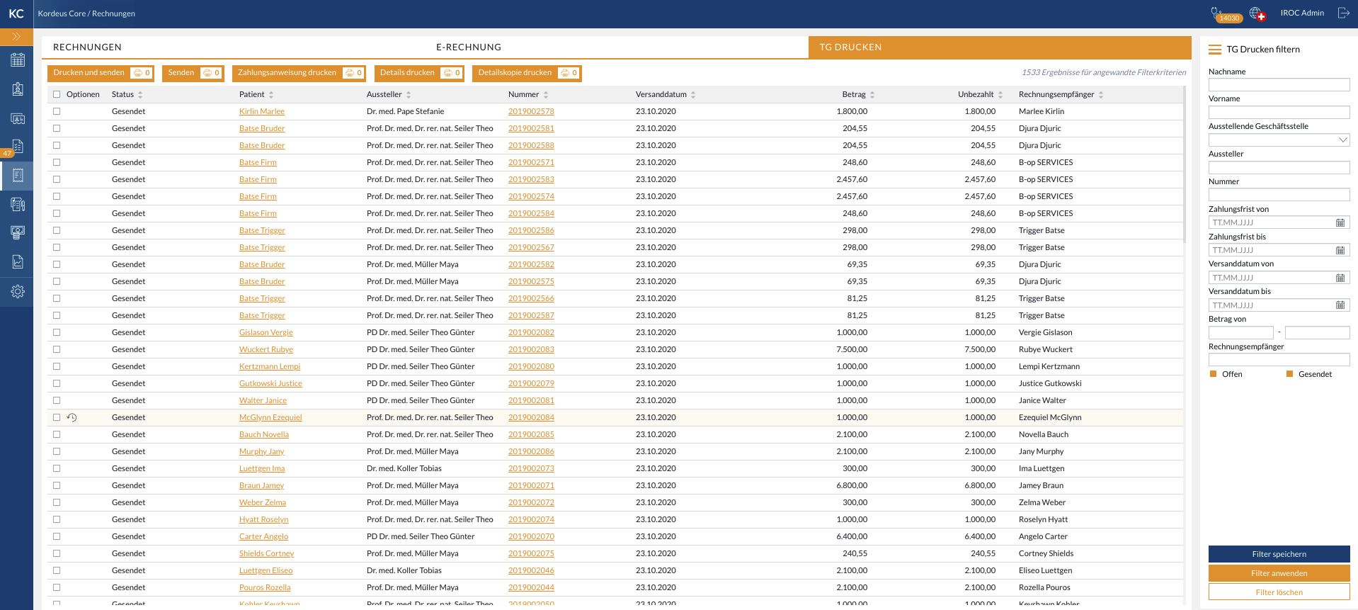

Table should be sortable by all columns (default: by payment deadline ascending).

Advanced filters appear on the right side of the screen and offer the following behavior:

Filters should be applied as AND operation, meaning, only items which meet all the criteria are shown.
- Filter e-billing / E-abrechnung filtern - subtitle
- Last name / Nachname - of the patient
- First name / Vorname - of the patient
- Issuer / Aussteller - doctor
- Number / Nummer
- Payment deadline from / Zahlungsfrist von - including specified date
- Payment deadline to / Zahlungsfrist bis - including specified date
- Sending date from / Versanddatum von
- Sending date from / Versanddatum bis
- Amount / Betrag - two text boxes for lower and higher amount boundary for search
- Recipient / Empfänger - patient
- Open / offen - return open bills / dunnings
- Sent / Gesendet - return transmitted bills / dunnings
- Apply filters / Filter anwenden - filter bills based on specified criteria
- Clear filters / Filter löschen - clear filters and show all items

This view offers only group actions because it seems highly unlikely that documents will ever be sent one by one. The following actions are available…

Print and send / Drucken und senden
Opens printing popup where the user selects which printer will be used for printing payment instructions and which for details.
Creates a transmission entry for each selected bill and put it into Sent / Gesendet status.
Uploads PDFs to patient archive.
Downloads zip archive with all printed documents.

Send / Senden
Creates a transmission entry for each selected bill and put it into Sent / Gesendet status.

Print payment instruction / Zahlungsanweisung drucken
Opens printing popup where the user selects which printer will be used for printing payment instructions.
Uploads PDFs to patient archive.
Downloads zip archive with all printed documents.

Print details / Details drucken
Opens printing popup where the user selects which printer will be used for printing bill details
Uploads PDFs to patient archive
Downloads zip archive with all printed documents

Print details copy / Detailskopie drucken
Opens printing popup where the user selects which printer will be used for printing bill details.
Uploads PDFs to patient archive.
Downloads zip archive with all printed documents.

Dunning

The word stems from the 17th century verb dun, meaning to demand payment of a debt. Dunning is a process which comes into play when the bills become severely overdue. It can have multiple levels, from mere reminders, over dunning which introduces additional fees and unpleasant phone calls and ultimately to legal actions. Laws in each country regulate the form that dunning can take. It is generally unlawful to harass or threaten consumers. It is acceptable to issue firm reminders and to take all allowable collection options.

Dunning overview

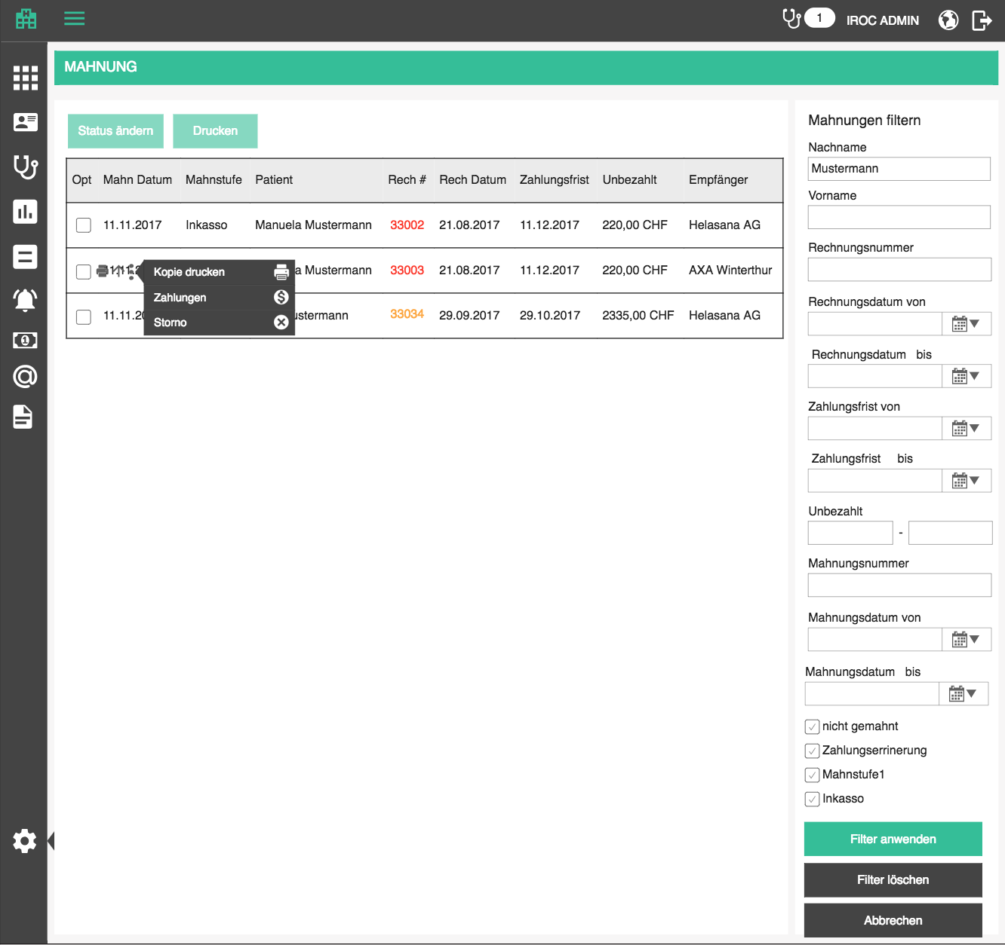

Dunning overview displays 1) all overdue bills so that the user can start the dunning process, 2) latest dunning document for every bill which is in dunning. This is because a single bill may be dunned multiple times: if the patient does not pay, we issue a reminder (1st dunning level); if they still do not pay, we issue dunning (2nd dunning level); and so on. It is not too interesting to display all the dunning levels, but the last one. Cancelled bills are not shown,. Because it makes no sense to start dunning on a cancelled bill.

A dunning remains in the overview until the patient has paid the full amount of the original bill and all dunning fees of all dunning levels.

The following data is displayed in the table:

- Options / Optionen
- checkbox for mass-manipulation (see below)
- Print / Drucken - prints the document (See E-billing and reports section)
- Change level / Stufe ändern (see below)
- more options:
- Print copy / Kopie drucken - same as for bill
- Payments - redirection to billing account of the corresponding patient
- Cancel / Stornieren (see below)
- Mark as done / Als fertig markieren (see below)
- Dunning date / Mahndatum - date when the latest dunning document was created, empty if the bill hasn't entered the dunning process, or if dunning process is done
- color code: regular font color if not overdue; critical if overdue
- comment icon is visible if there is a comment supplied, otherwise, visible only on hover; clicking on this icon opens a small popup for editing the comment, which behaves the same as for position comments on the bill edit page and billable block positions on medical services page (see Medical services section for details)
- Start dunning process / Mahnprocess starten - if this is an overdue bill which is not yet in the dunning process, we will display the start dunning link button which creates the dunning document of the first level (see Add dunning below)
- Dunning level / Mahnstufe (or "done / fertig" if done, otherwise a link which downloads the dunning document)
- Patient / Patient - patient name in form <last name>, <first name>, a link to patient history
- Bill number / Rechnungsnummer - number of the dunned bill which behaves as a link to open the bill PDF in a new tab; see Bills section for color codes
- Bill date / Rechnungsdatum
- Payment deadline / Zahlungsfrist - payment deadline of the dunning document, or bill deadline if bill hasn't entered the dunning process
- Unpaid / Unbezahlt - unpaid portion of the bill + dunning fees of all existing dunning documents for that bill
- Recipient / Empfänger - recipient

The list should be sortable by all columns (except options, of course). Default sorting is by dunning date, descending.
The list should be search-able by patient, dunning number and bill number. Search starts as soon as you type, but with a small debounce. Check the rest of the app for guidance.

Advanced filters should appear on the right side of the screen at all times. If the advanced filters are implemented, the standard search bar is not needed.

Filters should be applied as AND operation, meaning, only dunning documents which meet all the criteria are shown.
- Filter dunning/ Mahnungen filtern - subtitle
- Last name / Nachname - of the patient
- First name / Vorname - of the patient
- Issuing office / Ausstellende Geschäftsstelle - issuing office, dropdown which represents the tree structure
- Bill number / Rechnungsnummer
- Bill date from / Rechnungsdatum von - including specified date
- Bill date to / Rechnungsdatum bis - including specified date
- Payment deadline from / Zahlungsfrist von - payment deadline of dunning document or bill (if not yet in dunning) including specified date
- Payment deadline to / Zahlungsfrist bis - payment deadline of dunning document or bill (if not yet in dunning) including specified date
- Unpaid / Unbezahlt - two text boxes for lower and higher amount boundary for search
- Dunning level / Mahnstufe - dropdown with all available dunning levels
- Dunning date from / Mahndatum von - including specified date
- Dunning date to / Mahndatum bis - including specified date
- Dunning levels: list of all dunning levels + "not in dunning / nicht gemahnt" + "done / fertig"- this section is applied as OR operation, because one dunning document can only be in one dunning level
- Apply filters / Filter anwenden - filter dunning documents based on specified criteria
- Clear filters / Filter löschen - clear filters and show all data

When the searched list is empty, display the following text instead of the first row:
- There are no matching dunning documents for this search criteria. / Es gibt keine passenden Mahnungen für diese Suchkriterien.

When the list is empty in general, display the following text instead of the first row:
- There are no dunning documents. / Es gibt keine Mahnungen.

Download CSV / CSV herunterladen - download a csv file with all the dunning documents which are currently displayed in the list.

Add dunning

Bills which are eligible to enter the dunning process, i.e. the ones are overdue, appear in the dunning list automatically, only without dunning level. To start the dunning process on a bill, the user will press the start dunning link and create a dunning document of the first level (see details in the next section).

Increase dunning level

The user can change dunning level by clicking on the increase level action icon
- Increase dunning level / Mahnstufe erhöhen

Before we actually change the level, i.e. create a new dunning document, the user must confirm the action
- Are you sure you want to increase the dunning? This will create an additional debit of <dunning fee + currency>. / Sind Sie sicher, dass Sie den Mahnstufe erhöhen möchten? Dadurch wird eine zusätzliche Debit von <dunning fee + currency> erstellt.

After confirmation a new dunning document is created for that patient. It will contain the following data:
- default comment for the chosen dunning level
- same recipient as the bill
- a position for fee with details specified by the chosen level
- name, amount and tariff are taken from the level
- if there is an interest rate defined for the dunning level, it is calculated as:
Interest = open amount * interest rate * (days overdue at the time of dunning / 365)
- deadline calculated from dunning level property "days until next level" (current date + days until next level)
- reference to the previous dunning level, or the bill itself, if this is the first level

This dunning document will be added to the patient billing account.

Inkasso : is done by an external party. Once the bill gets to that dunning stage, the external service will charge the patient all the unpaid positions, dunning fees and interests, plus an inkasso fee which stays with the inkasso entity. Inkasso fee should be charged to the practice (because they are using the inkasso services), but the common practice is to charge this to the patient (although this is not possible in all countries, and would not stand in court of law).

Commonly, the user will define one, final, dunning level which is of inkasso type and that would be the last dunning level in which a bill can come.

Dunning documents with highest dunning level do not have this option.

Note:
After creating a dunning or increasing the level, generate a PDF and put it in the patient document archive (see details in Billing implications section).
- Dunning PDF / Mahnung PDF - document type, GID entry
- Billing data / Abrechnungsdaten - document category, GID entry

Switzerland specific dunning levels

We can precreate these dunning levels for swiss customers:
1. Dunning level 1 / Mahnstufe 1 - 30 days after bill deadline
2. Dunning level 2 / Mahnstufe 2 - 14 days after 1st level
3. Dunning level 3 / Mahnstufe 3 - 14 days after 2nd level
4. Inkasso / Inkasso - 14 days after 3rd level

Cancel dunning

When the user clicks on cancel icon, a popup with a mandatory comment area will appear.
- Cancel dunning / Mahnung stornieren
- Cancellation reason / Stornogrund
- Comment / Kommentar

When the user confirms dunning cancellation, we will cancel the last (visible) dunning level and change its level to
- Canceled / Storniert

We will also capture the user who cancelled the bills, and the timestamp when they were canceled.

If the bill had previous dunning documents, the one with the highest level is now displayed in the overview. This option is, naturally, not visible for bills which don’t have dunning documents attached to them.

Note:
After cancelling a dunning level, generate a PDF and put it in the patient document archive (see details in Billing implications section).
- Dunning Cancellation PDF / Mahnung Storno PDF - document type, GID entry
- Billing data / Abrechnungsdaten - document category, GID entry

Mark dunning as done
When the user marks dunning as done, it will display done instead of the status. If the user tries to mark dunning as done, even though there is an unpaid amount, we will display a message:
- Are you sure you want to mark this dunning document as done? It has not been paid in full. / Sind Sie sicher, dass Sie dieses Mahnung als fertig markieren möchten? Sie wurde nicht vollständig bezahlt.

Print dunning

See Reports section. The dunning PDF will look exactly the same as bill PDF, except it will have a different title and will include a dunning date and dunning fees.

Mass manipulation

Mass manipulation represents performing actions on multiple dunning documents at the same time, to enable a user to do more things together, like, start dunning multiple overdue bills. We will start with mass status change.

Every row in the dunning list should have a check box. When the user checks one of the boxes, the view changes a little: 1) single row actions disappear and 2) mass manipulation buttons above the table become enabled. A check all / uncheck all box should be in the header row. When the user unchecks all rows, the view goes back into its original state.

When the user clicks on "increase dunning level" button above the table
- Increase dunning level / Mahnstufe erhöhen

When the user confirms, dunning level of each selected document increases as described in the Increase level section above (documents with the highest available dunning level are skipped). Before proceeding to do so, we must ask the user to confirm:
- Are you sure you want to increase the dunning level all of <number of> documents? / Sind Sie sicher, dass Sie den Mahnstufe für alle <number of> Mahnungen erhöhen möchten?

When the user clicks on "cancel dunning" button above the table
- Cancel dunning / Mahnung stornieren

When the user confirms, dunning documents are cancelled as described in the Increase level section above (bills which are not in dunning are skipped). Before proceeding to do so, we must ask the user to confirm:
- Are you sure you want to cancel all <number of> dunning documents? / Sind Sie sicher, dass Sie alle <number of> Mahnungen stornieren möchten?

When the user clicks on "start dunning process" button above the table
- Start dunning process / Mahnprocess starten

When the user confirms, all selected bills will get a dunning document as explained above (bills which are already in dunning are skipped). Before proceeding to do so, we must ask the user to confirm:
- Are you sure you want to start dunning process on <number of> bills? /Sind Sie sicher, dass Sie den Mahnprozess für <number of> Rechnungen starten möchten?

Since some selectable items are not eligible for all actions, some of them will be skipped. Bubble message will display how many of the selected ones were processed successfully
- If all items processed successfully, show a green bubble: All documents were successfully processed. / Alle Dokumente wurden erfolgreich verarbeitet.
- If some of them were not eligible for processing, show an orange bubble: <number> documents were successfully processed. / <number> Dokumente wurden erfolgreich verarbeitet.
- If an error occurred and no items could be processed, show the standard error bubble

When the user clicks on "marked as done" button above the table
- Mark as done / Als fertig markieren

When the user clicks, all selected bills will get marked as done as explained above. Before proceeding to do so, we must ask the user to confirm:
- Are you sure you want to mark dunning document as done? / Sind Sie sicher, dass Sie Mahnung als fertig markieren möchten?

Since some selectable items are not eligible for all actions, some of them will be skipped. Bubble message will display how many of the selected ones were processed successfully
- If all items processed successfully, show a green bubble: All documents were successfully marked as done. / Alle Dokumente wurden erfolgreich als fertig markiert.
- If some of them were not eligible for processing, show an orange bubble: <number> documents were successfully processed. / <number> Dokumente wurden erfolgreich verarbeitet.
- If an error occurred and no items could be processed, show the standard error bubble

Patient extensions

Billing will have implications on multiple aspects of the application, such as: highlighting patients which have overdue unpaid bills, warning the user not to book an appointment for a patient which has unpaid critical bills, etc.

Patient balance shortcut
A convenient way to display patient account balance is a shortcut which we will use in various places within the app. It is essentially a link which leads to the patient billing account page and displays the current balance, together with the currency. If the value is negative, the link will be red. If zero black and green if positive.
We will introduce the shortcut in appointment making screen, just above the patient dropdown.
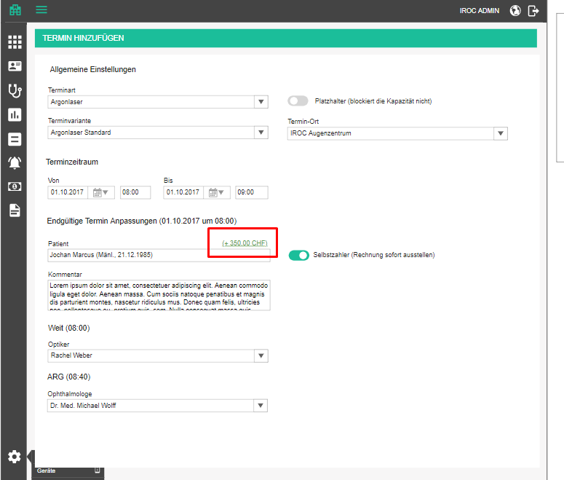

Also, we will display the patient account balance on patient list in the last column.

Patient overview

Patient name

Instead of displaying patient first name and last name column in the patient overview, display both in one column to save on space in format <last name>, <first name>.

Patients with non-billed services

To help the financial manager of the practice in creating bills, we are going to introduce a filter in the patient section which will display all the patients who have unbilled services. See advanced filters above.

Note: Before advanced filter can be implemented, we can extract the “Show patients with unbilled services” above the patients table. Checking this shows just the patients with services which have been provided (delivered) but not yet billed.

For these patients, we will display a create bill icon
- Bill services / Lesitungen abrechnen

From there, they can click on the make bill icon icon which will
-> open a new bill group form
-> select the patient
-> select current date as bill date
-> set the deadline to default deadline which should be defined in tenant settings
-> open new bill popup where the user can pick which encounters to bill
(see Bills section for details)

Note: user can add a bill even for a patient who has no unbilled services, but they will have to specify bill positions manually.

Patients with unapproved HIPs
In the patient list, introduce a button which goes through each patient’s HIPs and checks if any of them have no stamps of approval.
- Verify HIPs / Krankenkassen überprüfen

For every patient who has such HIPs, display a warning icon with tooltip:
- The following HIPs may have erroneous data: / Die folgenden Krankenkassen haben möglicherweise fehlerhafte Daten:
- <list of HIPs which have no stamps of approval>

Patient actions

Since we are expanding an already large number of actions available for each row in the patient table, we need to introduce a new UI concept for this. We will eventually apply this concept to all tables which provide more than 3 actions.

The goal is to display 2 of the most commonly used actions directly in every row, and the rest of them in a context menu which appears after clicking on a "burger" icon (three dots or lines). The actions in the context menu will have appropriate icons and labels. If no more than 3 icons exist, show all 3 of them.

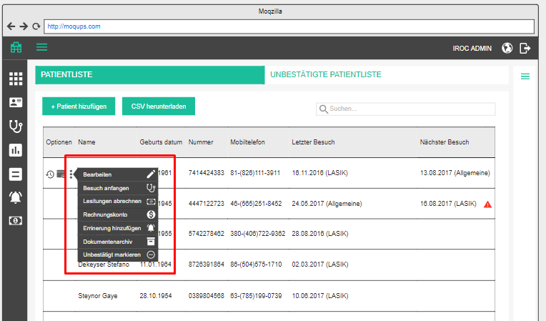

Advanced filters

Since open bills will have the most implications in the patients section, we will have to alter the list a little bit and introduce advanced filters. Advanced filters should appear on the right side of the screen and be "retractable", i.e. user can hide them if they don't need them, so that it doesn't take up space when not needed. If the design team thinks this should be present at all times, we can discuss it.

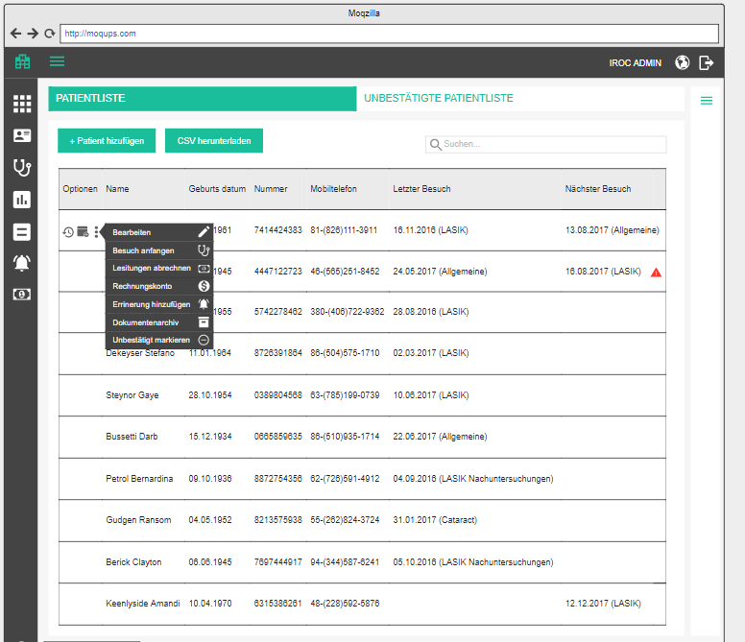

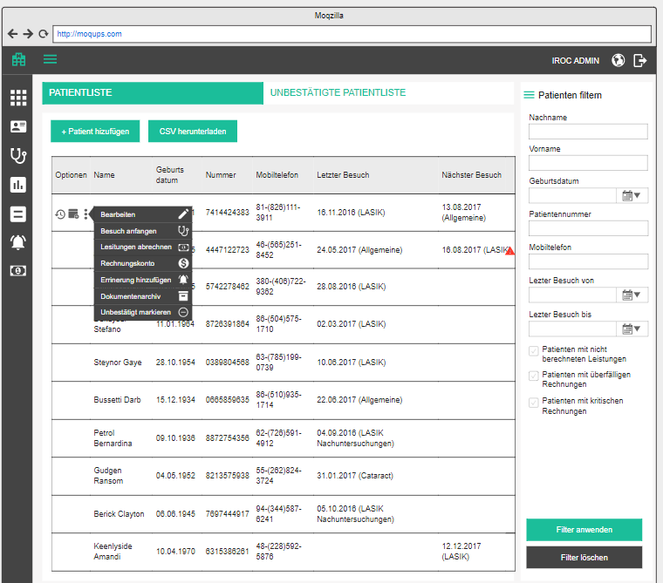

If the advanced filters are displayed, the standard search bar is not shown.

Filters should be applied as AND operation, meaning, only patients which meet all the criteria are shown.
- Filter patients / Patienten filtern - subtitle
- Last name / Nachname
- First name / Vorname
- Birth date / Geburtsdatum
- Patient number / Patientennummer
- Mobile phone / Mobiltelefon
- Encounters from / Untersuchungen von - including each specified date
- Encounters to / Untersuchungen bis - including each specified date
- Documentation form / Dokumentationsform – type of documentation; works in sync with encounter dates
- Patients with non billed services/ Patienten mit nicht berechneten Leistungen - display patients who have encounters which are not associated with any bills
- Patients with overdue bills / Patienten mit überfälligen Rechnungen - display patients who are not fully paid and are past due (or any of the installments are past due)
- Patients with critical bills / Patienten mit kritischen Rechnungen - display patients who have bills marked as critical
- Apply filters / Filter anwenden - filter patients based on specified criteria
- Clear filters / Filter löschen - clear filters and show all patients

Download CSV / CSV herunterladen - download a csv file with all the patients who are currently displayed in the list

Standard search

Standard search offers 4 search boxes above the patients table. Search is performed after the user starts typing, as on other pages, except we have multiple search parameters in different search boxes which are applied as AND function.
- Last name / Nachname
- First name / Vorname
- Birth date / Geburtsdatum
- Patient number / Patientennummer

Delete unconfirmed patient

Currently, we can only confirm an unconfirmed patient, or merge them into another patient. But we are missing an option to delete them, which can happen if, for example, a patient registered online but never went through with booking an appointment. In that case, we end up with a phantom patient record which has to be deleted.

Introduce an icon for deleting an unconfirmed patient, which will, after confirmation, delete the unconfirmed patient and all their appointments.
- Delete unconfirmed patient / Unbestätigten Patienten löschen - tooltip on the icon
- Are you sure you want to delete unconfirmed patient <patient name> and all their appointments? / Sind Sie sicher, dass Sie den unbestätigten Patienten <patient name> und alle ihre Termine löschen möchten?
- Successfully deleted unconfirmed patient. / Unbestätigter Patient wurde erfolgreich gelöscht.

Patient details sidebar

Sidebar details are going to be exactly the same on every patient page (history, billing, document archive). It contains the following data:
- <Last name>, <First name> (<gender icon>)
- <DOB> (Age: / Alter: <age>)
- #<patient number>
- <address>
- E: / E: <email>
- M: / M: <mobile phone>
- W: / A: <work phone>
- P: / T: <phone>
- F: / F: <fax>
- For each alternative contact, if data available, display
  - <Contact type>: <display name> - <address>; <phone>
- For each selected health insurance display
  - <insurance type>: <HIP name> (<insurance number>) until / bis <insurance end date>
- Open bills / Offene Rechnungen + icon-link which leads the user to the patient account page “Patient billing / Patientenabrechnung"
  - for each open bill or dunning document display
  - #<bill number>: <amount + currency> + <dunning fees connected to this bill + currency>
  - exclamation icon if the bill was marked as critical, with tooltip “critical / kritisch”
- Account balance / Kontostand
  - sum of all payments (excluding deleted ones) - sum of all bills (excluding cancelled ones)
  - if less than zero, color it red
- Notes / Notizen - notes with option to add, edit and delete

Patient notes

Regular notes (to be implemented)
Notes is a container of patient notes of general type, without flag important. Each note looks like a little post-it note. The notes section can be collapsed and expended. If there are any important notes to display, this section is expanded by default.
- <number> notes for this patient. / <number> Notizen für diesen Patienten.
- Notes are sorted by date and time of creation, descending

Patient notes are displayed in
- Side panel of patient history
- Side panel of patient archive
- (Do not display on patient edit page)
To add a note to patient record, the user can click on add button, which opens a new post-it where the user can enter the note. The note automatically gets type: general patient note, with important flag off. A note is saved on focus-out of the text area. Every note is constantly editable, the user just needs to start typing in the text area inside of the post-it.
- Add / Hinzufügen – adds a new note at the beginning of the list
- Note saved. / Notiz wurde gespeichert.
- Note not saved. / Notiz wurde nicht gespeichert.

To delete a note, the user will need to confirm their action.
- Delete / Löschen
- Are you sure you want to delete this patient note? / Sind Sie sicher, dass Sie diese Patientennotiz löschen möchten?
- Note deleted. / Notiz wurde gelöscht.

Important notes
Important notes is a container of patient notes of general type, with flag important. Each note looks like a little post-it note. The important notes section can be collapsed and expended. If there are any important notes to display, this section is expanded by default.
- <number> important notes for this patient. / <number> wichtige Notizen für diesen Patienten.
- Notes are sorted by date and time of creation, descending

Important patient notes are displayed in
- Every documentation form, above the middle panel
To add an important note to patient record, the user can click on add button, which opens a new post-it where the user can enter the note. The note automatically gets type: general patient note, with important flag on. A note is saved on focus-out of the text area. Every note is constantly editable, the user just needs to start typing in the text area inside of the post-it.
- Add / Hinzufügen – adds a new note at the beginning of the list
- Note saved. / Notiz wurde gespeichert.
- Note not saved. / Notiz wurde nicht gespeichert.

To delete a note, the user will need to confirm their action.
- Delete / Löschen
- Are you sure you want to delete this patient note? / Sind Sie sicher, dass Sie diese Patientennotiz löschen möchten?
- Note deleted. / Notiz wurde gelöscht.

Billing notes
Billing notes is a container of patient notes of billing type, regardless of the important flag. Each note looks like a little post-it note. The billing notes section can be collapsed and expended. If there are any billing notes to display, this section is expanded by default.
- <number> billing notes for this patient. / <number> Abrechnungsnotizen für diesen Patienten.
- Notes are sorted by date and time of creation, descending

Billin notes are displayed in
- Bill preparation page of an encounter
- Patient billing section
- Add/edit bill page - as soon as a patient is selected

To add a billing note to patient record, the user can click on add button, which opens a new post-it where the user can enter the note. The note automatically gets type: billing patient note, with important flag off. A note is saved on focus-out of the text area. Every note is constantly editable, the user just needs to start typing in the text area inside of the post-it.
- Add / Hinzufügen – adds a new note at the beginning of the list
- Note saved. / Notiz wurde gespeichert.
- Note not saved. / Notiz wurde nicht gespeichert.

To delete a note, the user will need to confirm their action.
- Delete / Löschen
- Are you sure you want to delete this patient note? / Sind Sie sicher, dass Sie diese Patientennotiz löschen möchten?
- Note deleted. / Notiz wurde gelöscht.

Patient history

Patient history is a chronological overview of all patient visits and open appointments.

Patient history / Patientengeschichte

The main part of the page contains a table with the encounters and appointments. Appointments which are connected to an encounter are not shown, the encounter is more informative.
Appointments are toggled when the user checks the corresponding radio buttons above the table:
- Appointments / Termine - radio button which, if checked, shows appointments in the table, unchecked by default
- Encounters / Untersuchungen - radio button which, if checked, shows encounters in the table, checked by default
- All / Alles - radio button which, if checked, shows appointments and encounters in the table, unchecked by default

The table contains the following information:
- Options / Optionen
  - if appointment -> edit (pen) opens re-book appointment
  - If appointment (open) -> cancel (cross) cancels the entire appointment after confirmation, just like on agenda
  - If appointment -> history, which opens a popup with appointment history like here
  - if encounter (open) -> edit (pen) opens the encounter form for editing
  - if encounter (open) -> delete (can) deletes encounter after user confirmation
  - if encounter (finished) -> view (eye) opens the encounter in view only mode
- Date / Datum
  - if displaying appointment, show start time too;
  - if cancelled or no-show display that in brackets
- Title / Name - title of appointment / encounter
- Staff / Personal - comma separated list of required persons (appointment) / participants (encounter)
- Devices / Geräte - comma separated list of required devices (appointment) / used devices (encounter)
- Open tasks / Offene Aufgaben - number of open tasks connected to this encounter; empty if 0 (because we want to attract the attention to the ones which actually have open tasks)
  - On hover, a tooltip with a list of open task titles appears
- Type / Typ
  - Appointment / Termin
  - Encounter / Behandlung
- Free of charge / Kostenlos – label which appears next to encounters, finished as free-of-charge

Table is sortable by all columns, default sorting is by date, descending.

Table is searchable by all columns.

A new encounter can be started by clicking on add encounter button which leads to screen with all the available forms for user to choose from
- Add encounter / Behandlung hinzufügen

A new appointment can be created by clicking on book appointment button which leads to the book appointment page, with the current patient preselected
- Book appointment / Termin buchen

Deletion of encounters behaves the same as in the general encounter history (see here).

Cases
Above the history table, display all cases connected to this patient as buttons, together with the “Full history / Vollständige Geschichte” button in the first place. Clicking on a case filters the list to show only encounters of that case. Clicking on full history resets the table.

Patient billing account

Patient billing account will be the place where a financial officer can find all open and paid bills of a patient. This is important because in a medical practice, all bills are connected to a patient and everything revolves around a patient. Like we stated in the Bills section, it can happen that part of the patient treatment is covered by the health insurance and part by patient himself, but the both bills are essentially connected to the patient and the practice will hold the patient liable for an unpaid bill. That’s why we want to give the user an option to see a patient’s balance at any time.

We will introduce another page to which the user can navigate from the patient list.
- Patient billing / Patientenabrechnung

The page will have the following sections...

Bills

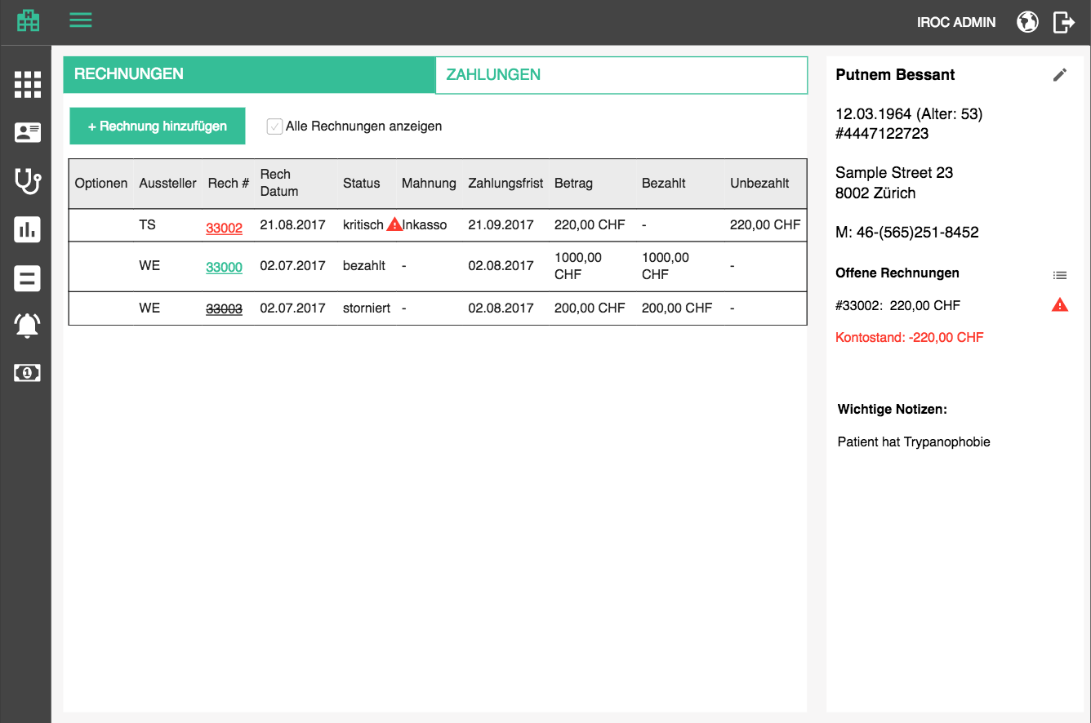

This table will contain open bills issued for this patient. If the user selects the “show all” option, then paid and cancelled and basically all bills for this patient will be displayed.
- Show all bills / Alle Rechnungen anzeigen

The table has the same functionalities and columns as the general bills table, except for Patient column, which is redundant since we are displaying only bills for one patient.

The table should be sortable by all columns, default by date descending.

Payments

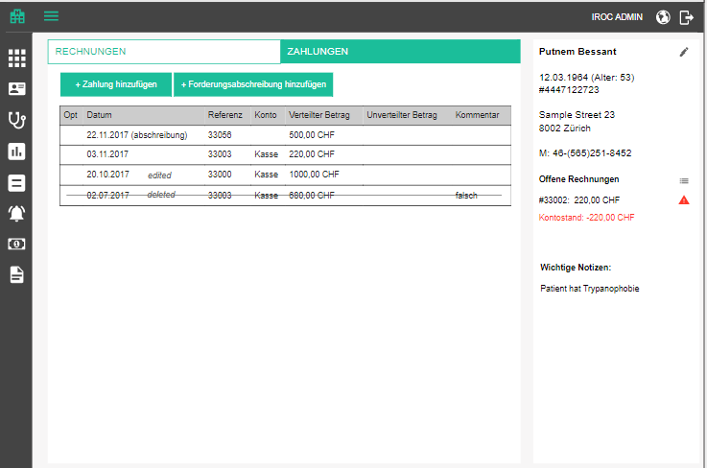

This table will contain all the payments made by this patient (or by their health insurance, in their name), refunds and bill write-offs. The table will contain the following columns:
- Options (edit and delete)
- Date / Datum - date of payment / write-off / refund
- Reference / Referenz
- this column will display comma separated list of bill / dunning numbers which this payment / write-off / refund has been distributed to
- each reference is a link to opening the corresponding document's PDF in a new browser tab
- if the payment / refund was edited, show label “edited / bearbeitet” and on hover show tooltip with information

<name of the user who edited>, <date of editing>, "<comment>"

- if the payment / refund was deleted, show label “deleted / gelöscht” and on hover show tooltip with information

<name of the user who deleted>, <date of deleting>, "<comment>"

- Account / Konto - account to which this payment was attributed
- Distributed amount / Verteilter Betrag - portion of the payment amount which was already assigned to bills or dunnings; aligned right, two decimal points, currency appended;
- Undistributed amount / Unverteilter Betrag - portion of the payment amount which has not been assigned to bills or dunnings; aligned right, two decimal points, currency appended
- Comment / Kommentar - specified comment

The table should be sortable by all columns, default by date descending.

Add bill

See Bills and bill groups section.

Add payment
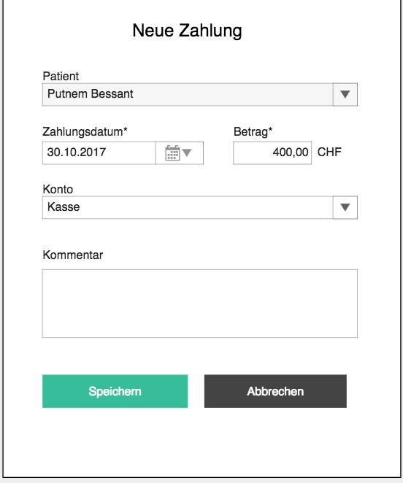

If a patient makes a payment, we will want to document it. This screen will mostly be used for cash payments at the front desk, so we will not care about payment-to-bill mapping at this point, we will later have a separate page for that.

Clicking on the ”add payment” button opens up a popup where the user can specify how much money was received and print receipt.
- Add payment / Zahlung hinzufügen - button for adding payment / popup title
- Patient / Patient - this popup will be used in other pages where patient is not known upfront, so we need a dropdown / autocomplete box with patients. It will be prefilled and disabled on this page because we are coming from a specific patient’s account.
- Payment date / Zahlungsdatum - date of payment; date box, mandatory, default today
- Amount / Betrag <currency> - amount paid; mandatory, must be a positive number, currency at the end is default tenant currency (later we will be able to choose this)
- Account / Konto - dropdown with accounts from Cash and Cash equivalent group (Note: if the list of these accounts grows, we will need a way to easy for the user to select, but it should not happen at the beginning.)
- Comment / Kommentar - text area, optional
- Save / Spreichern
- Cancel / Abbrechen

Every entered payment adds a payment transaction to the patient’s debitor account, thus enabling us to see the current balance. If the debitor account does not exist at the time of first payment, create it, because every patient needs a debitor account.

After saving, prompt the user to print the receipt (see details in Reports section) by choosing the printer in a popup
- Print receipt / Quittung drucken

Edit payment
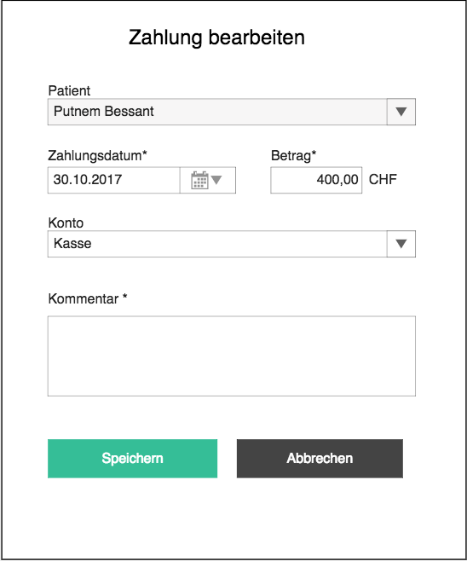

Editing a payment starts by clicking on the corresponding row’s edit button
- Edit payment / Zahlung bearbeiten

Edit button is visible only if the user has sufficient rights.

The popup is the same as the one for adding a payment, with the exception that:
- comment will be mandatory because we want to track why a payment has been changed; we also have to capture the timestamp when the change was made and by whom

Note: Before the serious bookkeeping functionality is implemented, there is no need for the mandatory comment and user capturing.

Delete payment

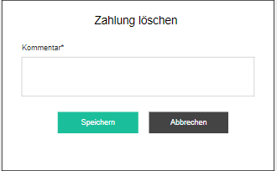

Deleting a payment works a little bit different than the usual deletion, because we are dealing with sensitive info here (money). For that reason we will display a popup with a mandatory comment field. Like on edit, we will capture the user who deleted the payment.
- Delete payment / Zahlung löschen
- Reason for deletion / Löschgrund

Delete button is visible only if the user has sufficient rights.

Note: Before the serious bookkeeping functionality is implemented, there is no need for the mandatory comment and user capturing.

Add / edit / delete write-off

In cases when the customer goes bankrupt, refuses to pay because they are unhappy with the services, or just cannot pay for any reason, the debt needs to be written off. An accounting method to achieve this is to annul the debt by adding a "payment" to a special account for "bad debt" or "un-collectables".

Adding this write-off credit is done exactly the same as a payment, except it will be a different booking account in the database and we will see differences in the UI:

- Add bad debt write-off / Forderungsabschreibung hinzufügen - button above the table
- New write-off / Neue Forderungsabschreibung - popup title in the add popup
- Edit write-off / Forderungsabschreibung bearbeiten - popup title in the edit popup
- Delete write-off / Forderungsabschreibung löschen - popup title in the delete popup
- the entry in the table will have a label which signifies that it is a write-off
- write-off / abschreibung

Edit and delete icons are visible only if the user has sufficient rights. Comment is mandatory when editing and deleting write-offs.

Write-offs can reference bills or dunning documents.

Add / edit / delete refund

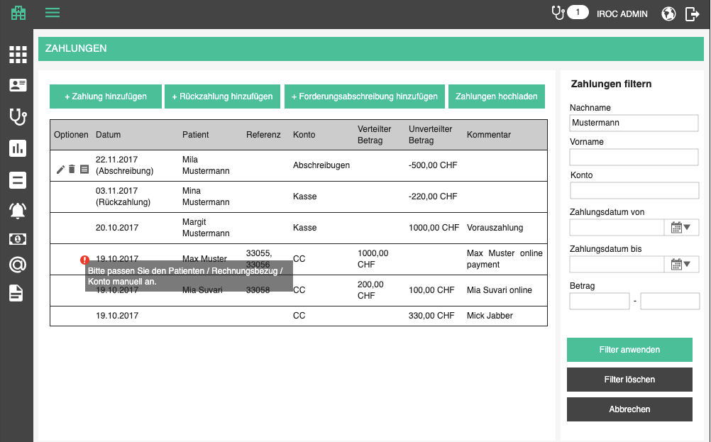

In cases when the customer, e.g. accidentally pays too much, the clinic will need to refund them. For example : bill was 1590 CHF and patient accidentally wired 1600 CHF. The payment was 1600 CHF, but the clinic wired (or paid out in cash) the outstanding 10 CHF and that needs to be documented somehow. This can be done by adding a 10 CHF refund to the bill. In the background, this will be a negative payment.

The result will be visible when calculating unpaid amount of a bill. The negative value of a refund will be summed with the positive payments, and will eventually be subtracted. In our example, unpaid amount on the bill will be X = 1590 CHF - (1600 CHF - 10 CHF) = 1590 CHF - 1590 CHF = 0 CHF

Adding a refund is done exactly the same as a payment, except it will be a negative balance change in the database and we will see differences in the UI:

- Add refund / Rückzahlung hinzufügen - button above the table
- New refund / Neue Rückzahlung - popup title in the add popup
- Edit refund / Rückzahlung bearbeiten - popup title in the edit popup
- Delete refund / Rückzahlung löschen - popup title in the delete popup
- the entry in the table will have a label which signifies that it is a refund
- refund / Rückzahlung

Edit and delete icons are visible only if the user has sufficient rights. Comment is mandatory when editing and deleting refunds.

Refunds can reference bills or dunning documents. Offered bills and dunning documents are the ones which have anything paid for them. Maximum amount per bill / dunning is the amount which was already paid (you can't refund more than has been paid).

Note: Both payment and refund can only be specified as positive numbers in the UI, but the refund is added as a negative payment in the back, and is marked as refund in the UI.

Cancel bill

See functionality in bill section and apply the same here.

Cancel dunning

The cancellation functionality in this section is based on cancellation of dunning documents from the dunning section, except for the fact that all dunning documents will be displayed separately in this page, not just the one with the highest level. Therefore, clicking cancel on a row will just invoke the cancellation process on that one dunning document. Capturing the comment and user and timestamp is done the same way as explained in the dunning section.

Warn before making an appointment for a patient which has critical bills

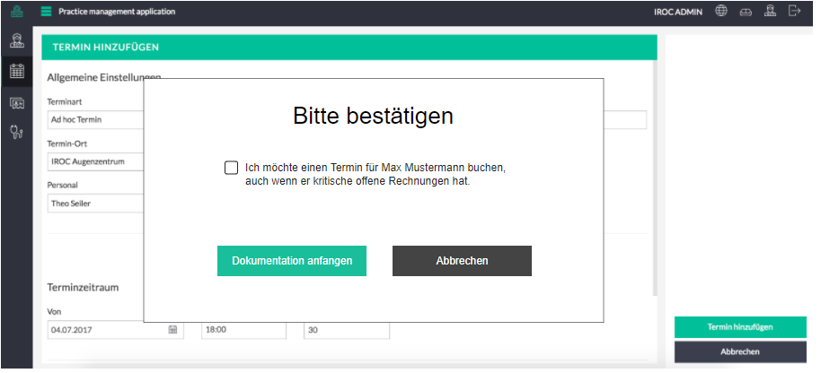

It happens quite often that the people who make appointments are not the ones who take care of the bills. So, it happens just as often that they keep making appointments for patients who have a large debt, and it is most likely that doctors will invest time into an appointment they will never be compensated for. I've actually seen people in IROC get really upset over this. That's why we want to warn the front desk not to make appointments if the patient has critical open bills.

When booking an appointment for a patient with critical bills, before the appointment is booked, a popup will appear and the user will have to explicitly check the checkbox in order to proceed.
- Please confirm / Bitte bestätigen
- I want to book an appointment for <patient name>, even though they have critical open bills. / Ich möchte einen Termin für <patient name> buchen, auch wenn sie kritische offene Rechnungen hat.
- Confirm / Bestätigen
- Cancel / Abbrechen

Patient document archive

Patient document archive will hold all uploaded documents relevant to a patient. Those will be financial documents like bills or medical documents like medical scans, lab results, etc. They are accumulated through various parts of the the application, such as encounter documentation forms or billing, or dunning. We will first need to introduce this feature when we start sending bills to e-billing.
- Document archive / Dokumentenarchiv - action in the patient list and title of the page

This page is reached through the action in the patient list. User can choose between table or tree mode:
- Table / Tabelle
- Tree / Verzeichnisbaum

The view table displays all the documents connected to this patient.
- Options - download (see below), delete, download Word file
- Date / Datum - date when the document was uploaded
- Title / Name - document name; link which opens the document in a new tab
- Comment on hover
- Reference / Referenz - Number of the entity to which it was attached, e.g. bill number, date and type of encounter
- Type / Typ - type of document like "Billing XML" or "Billing PDF". These will be catalog entries defined at the point of creation (see Bills section for now)
- Category / Kategorie - category such as "Billing data" or "Health data". These will be catalog entries defined at the point of creation (see Bills section for now)

Table should be sortable by all columns.

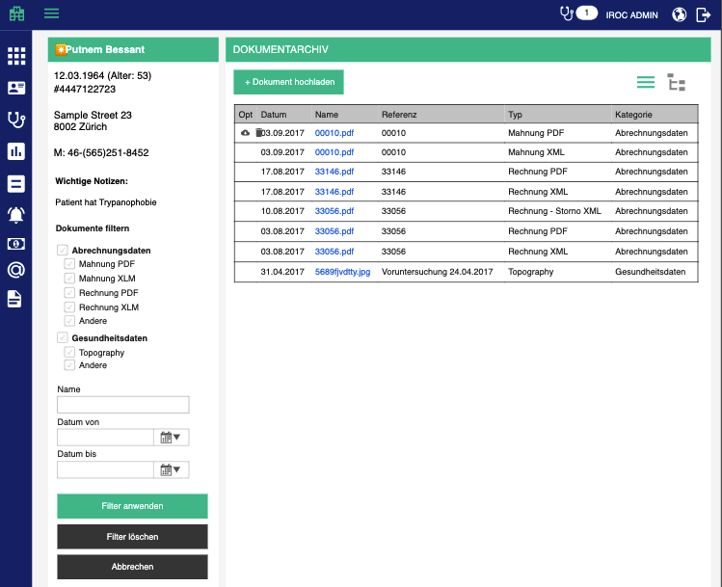

Tree view also displays all documents connected to the patient, but in a different structure:

Category 1
- Type 1
  - Doc 1 (document comment) action icons
- Type 2
  - Doc 2 (document comment) action icons
  - Doc 3 (document comment) action icons
- Type 3
  - Doc 4 (document comment) action icons
Category 2
- Type 4
  - Doc 5 (document comment) action icon
- Type 5
  - Doc 6 (document comment) action icons

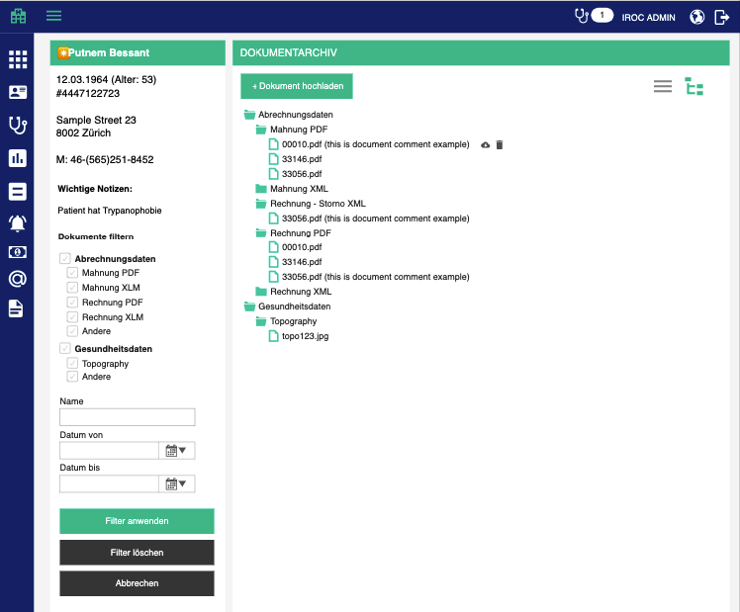

Advanced search

A filter pane is needed on this page because the number of filters will grow as more and more types of documents are introduced. We will filter documents by type, category, name and date. Filters operate with AND logic, but checkboxes inside one section operate with OR logic. For example, if we have multiple types selected and a name search query defined, the result will be all documents which match the name AND have any of the selected types. By default, all checkboxes are ticked and displayed. Since there can be many types of documents, we will display them by category, so that until a category is checked no types for that category are displayed. Above the filters we will display standard patient highlights, similar to the patient balance account.
- Apply filters / Filter anwenden - filter documents based on specified criteria
- Clear filters / Filter löschen - tick all filters and show all documents
- Cancel / Abbrechen - go back to patients

When the searched list is empty, display the following text instead of the first row:
- There are no matching documents for this search criteria. / Es gibt keine passende Dokumente für diese Suchkriterien.

When the list is empty in general, display the following text instead of the first row:
- There are no uploaded documents. / Es sind keine hochgeladenen Dokumente vorhanden.

Download

Every document can be downloaded by pressing the download button in corresponding row. A download is prompted with the file name constructed as <category>_<type>_<date of upload> and after the document has been downloaded, the user remains on the same page.
- Download / Herunterladen

If the document is a Microsoft Word file, this action will download a Kordeus file (see Kordeus File Helper section for details). For such files, another option which downloads the plain Word file
- Download Word file / Word-Datei herunterladen

Delete

Deletion is initiated by clicking on the delete button in a suitable row. The user will have to confirm the action before the document is actually deleted.
- Are you sure you want to delete <document name>? / Sind Sie sicher, dass Sie <document name> löschen möchten?
- Delete / Löschen - tooltip on the delete button

Upload
Uploading is done either in the background, on other pages like bills or encounter documentation, or directly on the archive page by clicking the upload button.
- Upload documents / Dokumente hochladen

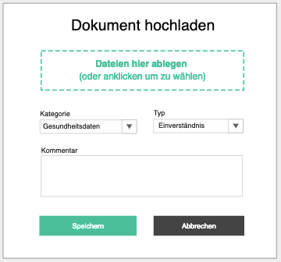

The button opens a popup where the use can either drag documents onto an upload area or click on it to chose a document from the standard upload dialog.
- Drop documents here (or click to choose manually) / Dateien hier ablegen (oder anklicken um zu wählen)
- Type / Typ - catalog values
- Category / Kategorie - catalog values
- Comment / Kommentar
- Save / Speichern
- Cancel / Abbrechen

If the user chooses more than one documents, they will all be uploaded with the same type and category. The selected documents will appear beneath the “upload” button. The user can click on upload several times and the more documents they select, the more will appear beneath the upload button. Have in mind that the user can add a lot of files and that the list might have to be scrollable, to keep the whole popup visible.

On successful upload display bubble
- Document(s) successfully uploaded. / Dokument(e) erfolgreich hochgeladen.
On unsuccessful upload display standard error bubble

After each successful upload, we will save, in user settings, which category and type was selected, as well as the location on local disc from which the files were chosen. On each new upload we will preselect the last used category and type of document, as well as location on local disk from which the files were last uploaded, if anything was saved in the user settings. The reason for this is the fact that users will usually upload from the same folder and under same category and type, and this will save them a lot of time.

Likewise, once a file is uploaded (image or PDF) it should be opened for preview in a new tab. Other file types should not be opened because no preview is possible within a web browser.

Edit metadata

Uploaded documents are edited by clicking on the edit icon of the corresponding row. The user can edit
- Edit document / Dokument bearbeiten - popup title
- Title / Name
- Category / Kategorie
- Type / Typ
- Comment / Kommentar

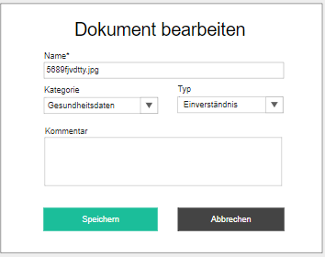

Kordeus File Helper
Users need an option to edit uploaded documents. This is challenging because Kordeus runs in a browser and all files are uploaded to the B-Op DMS. To give the users a feeling that they editing an uploaded document, Kordeus needs an auxiliary desktop app for Windows OS (Kordeus File Helper), which will automatically upload changed files.

Whenever the user downloads a .doc or .docx file from the patient archive, what is actually downloaded is a .kordeus meta file, which contains ID of the file and its location on the DMS.

Upon installation, Kordeus File Helper makes itself the default application for opening .kordeus files and lets the user enter B-Op credentials which will be used for downloading and uploading files.

Main functionality of Kordeus File Helper
- It downloads the actual file into its Data folder, based on metadata in the .kordeus file
- It opens the downloaded file with Microsoft Word
- It attaches a Watcher which will be triggered when the user saves their changes on the file in MS Word
- When triggered, the Watcher will automatically upload the changed version of the file to the original DMS location

File revisions
To make sure that no data is lost or corrupt, DMS and patient archive should both support document revisions. Downloading a file through .kordeus metadata file should always download the latest revision and automatically uploaded file should create a new revision. Patient archive may or may not offer revision history in the UI.

Patient edit

Base data

VIP patient
In patient base data:
- VIP / VIP - switch that indicates that the patient is a very important person;
- if switched on, a badge will appear next to the patients name in all aspects of the app (patient list, patient history, billing, etc, masks, agenda) letting the user know that this patient receives a special treatment (what that special treatment is defined “offline” by the customer)

Patient gender

Since health insurances do not care for gender fluidity or anything similar, we will only offer male and female as gender options for patients.

If the user chooses “male” as gender, title should be preselected to “Mr / Herr”. Likewise, when “female” is selected, title should be preselected to “Mrs / Frau”.

Patient address

When supplying the address, when ZIP code is selected, city, canton and country should be preselected, at least in Switzerland.

Patient's treating doctor
In patient base data, a dropdown is available for selecting the patient's treating doctor, which will speed up the process of appointment booking
- Treating doctor / Behandelnder Arzt
- Offer doctors with valid working contract for choice

EHIC number

In patient base data, add a field for health insurance card number
- EHIC number / VeKa Nummer
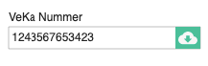

Although this is usually a number, some health insurance cards can have letters in them, so we will not perform any validations. If the user clicks on the import button, they will be taken to the Data Import page, where the patient data will be requested from EHIC service and where the user can select which data to import (see Import patient data from EHIC service section).

Health insurance

Referrers
- Referrers / Zuweiser - tab title, page title
- Add referer / Zuweiser hinzufügen - add partner title
- Edit referer / Zuweiser bearbeiten - edit partner title

All referrer types should be extended by a comment field, where the user can add details about the referral. The comment field should be added to the popup and the details panel which displays them.

Above all referrers, a section where the user can specify where the patient has heard about the clinic:
- Optician / Optiker
- Family physician / Hausarzt
- Clinic / Klinik
- Ophthalmologist / Augenarzt
- Acquaintance / Bekannte
- Internet / Internet
- Advertisement / Werbung
- Other / Sonstiges

Since some documentation forms can offer this kind of functionality (like refraction screening), we will offer this information to the user, to make things easier for them. Get all the patient data items from RCNL patient data set (avoid duplicates) and display them as the hint/info text below
- Sources found in encounters: <comma separated list of sources> / Quellen, die in Behandlungen gefunden wurden: <comma separated list of sources>
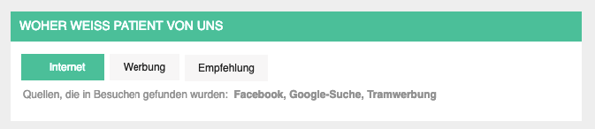

Technical info: Since we have a possibility to save different types of notes, we can use a special note type for this referral information, and display it only here and not among other notes. We can save it as comma separated list in such a note…

Alternative contact

Other data

Default recipient
In billing data section, "Default recipient" dropdown enables the user to specify the default recipient used in bill preparation (see Encounters section) and bill creation (see Bills section).

The user can select one of the following options (if defined for the patient):

  - Patient: <patient name> / Patient: <patient name>
  - Alternative contacts (1...n), represented by their type (e.g. Emergency, Legal representative)
  - Employer: <employer name> / Arbeitgeber: <employer name>
  - Main health insurance: <HIP title> / Gesetzliche Krankenversicherung: <HIP title>
  - Main accident insurance: <HIP title> / Gesetzliche Unfallversicherung: <HIP title>
  - Disability insurance: <HIP title> / Invaliditätsversicherung: <HIP title>
  - Other insurance: <HIP title> / Sonstige Krankenversicherung: <HIP title>
  - Private health insurance: <HIP title> / Private Krankenversicherung: <HIP title>
  - Private accident insurance: <HIP title> / Private Unfallversicherung: <HIP title>

When a new patient is created, default recipient depends on billing profile:
- TG
  - patient is over 18 years of age -> patient
  - patient is less than 18 -> first alternative contact (if available, otherwise patient)
- TP + copy / TP
  - main health insurance if it exists

Importing patient data from EHIC service

To take some manual work off the user's hands, we will enable importing data from various health insurance services which offer such an option. The import starts on patient base data page, when the user enters EHIC number and presses import.

We will support different services as time progresses,starting from Swiss SASIS VeKa Service. Since there will be different services (in other countries), the import functionality should be pluggable, in a simple way, meaning it is not too complex to introduce a new service.

SASIS VeKa service

Certain data needs to be pre configured in order to send requests to the data provider.

For SASIS VeKa service, we will need to supply the following parameters on every request:
- Requesting service name / Abfragedienst-Name - name of the querying software, PM
- User / Benutzer - provided by Sasis
- Password / Kennwort - provided by Sasis
- Language / Sprache - D (Germain), I (Italian), F (French)
- ZSR / ZSR - a valid ZSR which is registered for this service
- Certificate / Zertifikat - user for signing the request
These settings, therefore should be configurable in tenant settings UI, or in a settings file.

To get the data from VeKa service, we will have to provide all the static parameters mentioned above and certain parameters which vary from request to request:

- EHIC number - patient's EHIC number
- Treatment date - actually the request date

The request structure and endpoints are provided in SASIS VeKa service documentation (section 1.2, 1.3.1 and 1.3.3.1).

The response structure and error codes are provided in SASIS VeKa service documentation (1.3.2, 1.3.3.2 and 1.4).

Mapping of PM patient data to VeKa return data is the following:

Insured person / Versicherte Person
First name / Vorname | patient / basicData / givenname
Last name / Nachname | patient / basicData / familyname
Date of birth / Geburtsdatum | patient / basicData / birthdate | Returned in format yyyy-MM-ddTHH:mm:ss.zzz;
Gender / Geschlecht | patient / basicData / gender | female / male
Language / Sprache | patient / language | D / I / F
Street name / Straße | patient / basicData / address / street | Portion without house number
House number / Hausnr. | patient / basicData / address / street | Number at the end
ZIP / PLZ | patient / basicData / address / zip
City / Ort | patient / basicData / address / city
Country / Land | patient / basicData / address / countrycode | match by ISO code
Canton / Kanton | - | Try to fetch based on ZIP
EHIC # / VeKa-Nr. | patient / basicData / card_id
AHV # / AHV-Nr. | patient / basicData / unique_id
Contract # / Mitgliedsnr. | patient / basicData / assured_id | Health insurance contract number
Valid from / Gültig ab | patient / validFrom
Valid to / Gültig bis | patient / validTo
Health insurance / Krankenkasse
Name / Name | patient / insurance / name
Org. unit / Organisationseinheit | patient / insurance / description | Just displayed to the user, not mapped to anything in PM
Street name / Straße | patient / insurance / address / street | Portion without house number
House number / Hausnr. | patient / insurance / address / street | Number at the end
ZIP / PLZ | patient / insurance / address / zip
City / Ort | patient / insurance / address / city
GLN / GLN-Nr. | patient / insurance / ean_party
BAG / BAG-Nr. | patient / insurance / BAG_insurance_id | Just displayed to the user, not mapped to anything in PM
Phone number / Tel-Nr. | patient / insurance / phone
Email / Email | patient / insurance / e-mail
Health insurance coverage / KVG Deckung
Base / Basis | patient / KVG / basic_insurance / Text | Just displayed to the user, not mapped to anything in PM
Accident / Unfall | patient / KVG / basic_insurance_accident / Text | Just displayed to the user, not mapped to anything in PM
Model / Modell | patient / KVG / basic_insurance_model / Text | Just displayed to the user, not mapped to anything in PM

When the data is fetched from EHIC service, we want to display it to the user next to the current values, so that they see the difference. The data shall be displayed in a table on a popup. Each row where current value is different from the imported value shall be highlighted.
- Data import / Datenimport
- Confirm / Bestätigen
- Cancel / Abbrechen

Items which do not exist on PM side, but are available from the EHIC service (and vice versa) shall be displayed as information for the user, highlighted gray.

When the user clicks confirm, the data is applied to the open edit form, but is not saved until the user saves it.

Important: If the GLN number of the patient's HIP matches any HIP in the system, picked changes are applied to the HIP, and that HIP is connected to the patient. If the GLN is not found in the tenant database, it is created and attached to the patient as the main health insurance. After updating or creating a HIP in tenant database, an email is sent to the "catalog administrator" email, which is set up in tenant settings. This is a notification to the person maintaining the catalogs that maybe a change should be applied to the catalog too.

Email subject: PM HIP catalog extension
Email body:

The following HIP has been <added / updated> in the database of <tenant name> (<tenant ID>):

Title: | Company name (old) -> Company name (new)
Street name: | Street name (old) -> Street name (new)
House number: | House number (old) -> House number (new)
ZIP: | ZIP (old) -> ZIP (new)
City: | City (old) -> City (new)
GLN: | GLN (old) -> GLN (new)
Phone: | Phone (old) -> Phone (new)
Email: | Email (old) -> Email (new)

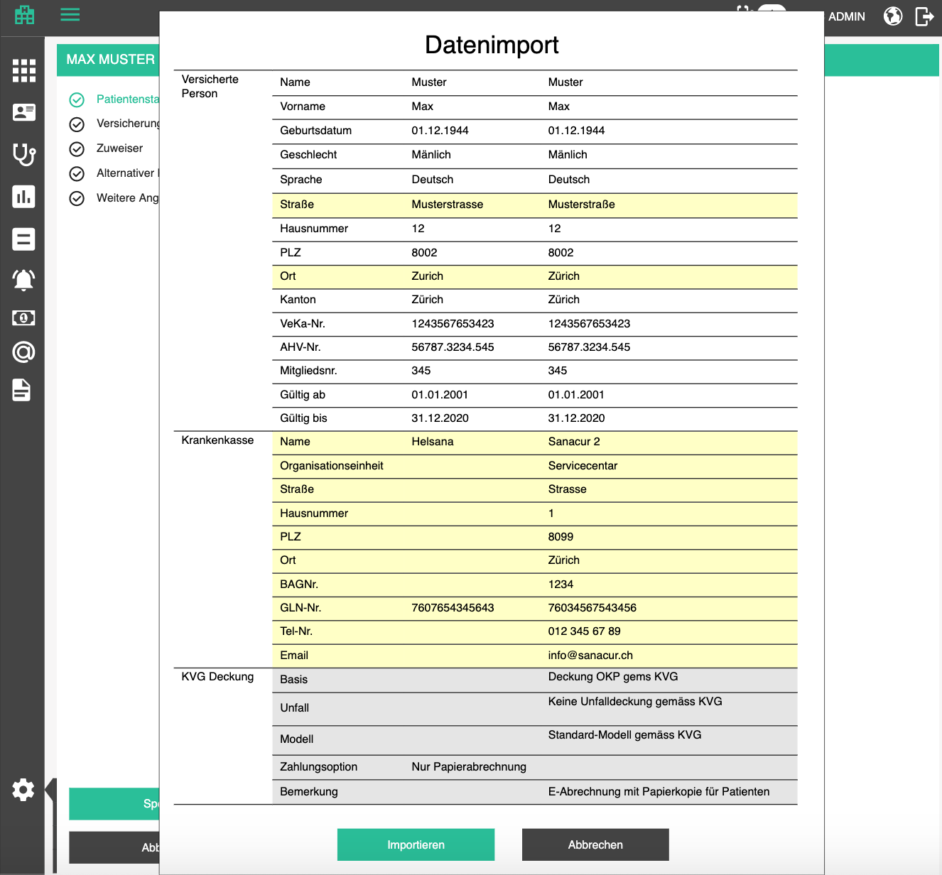

Reports and printing

The layout of the printable bill and the content of e-billing XML in Switzerland are standardized and bare the same data, so the data retrieval can be conveniently shared. Explanations can be found here. Have in mind that e-billing and reporting depends on the country or even specific tenant settings, so the generation of the e-billing files should depend on that setting (keep an open end for future development).

Explanations about the format are available in German, in a Microsoft CHM format here and here. Since the updates to Windows make it impossible to open CHM and the workaround is more complex than one for disarming an explosive device, use this Chrome app to upload and open them.

Note:
Currently used version of XML files is 4.4 but version 4.5 is already available and will be used from 2019. Consult with MediData (e-payment processor) which format to use initially.

Reports and printing

Print bill

Depending on bill recipient and patient billing profile, different bill templates will be printed:
Recipient | Patient /  Alternative contact /  Employer | Health insurance
Billing instructions
Bill details
Bill details copy for patient |  | (if TP + copy selected)

Bill printing will require a bill template made using the WRB. First, we will need a document type "Patient Bill / Patientenrechnung" and placeholders for each field displayed in the UI for bill and its positions. With those placeholders, we will be able to construct the template. These are the fields:

# | Group | Label | DE | EN | Comment
#1 | 0 | Document_ID | Dokument ID | Document ID | Human readable ID of the PDF from the document server
#2 | 0 | Document_Timestamp | Dokument Zeitstempel | Document Timestamp | Local date and time at the moment of printing
#3 | 0 | BillerOffice_Title | Rechnungsstelle Titel | Biller Office Title
#4 | 0 | BillerOffice_BillingSpecialization | Rechnungsstelle Abrechnungs Spezialisierung | Biller Office Billing Specialization | Comes right after the billing office name
#5 | 0 | BillerOffice_BillingAddress_Street | Rechnungsstelle Abrechnungs Straße | Biller Office Billing Address Street
#6 | 0 | BillerOffice_BillingAddress_Number | Rechnungsstelle Abrechnungs Nummer | Biller Office Billing Address Number
#7 | 0 | BillerOffice_BillingAddress_ZIP | Rechnungsstelle Abrechnungs PLZ | Biller Office Billing Address ZIP
#8 | 0 | BillerOffice_BillingAddress_City | Rechnungsstelle Abrechnungs Stadt | Biller Office Billing Address City
#9 | 0 | BillerOffice_BillingAddress_Phone | Rechnungsstelle Abrechnungs Telefon | Biller Office Billing Address Phone
#10 | 0 | BillerOffice_BillingAddress_Fax | Rechnungsstelle Abrechnungs Fax | Biller Office Billing Address Fax
#11 | 0 | BillerOffice_ZSR | Rechnungsstelle ZSR | Biller Office ZSR
#12 | 0 | BillerOffice_GLN | Rechnungsstelle  GLN | Biller Office GLN
#13 | 0 | Patient_Number | Patientennummer | Patient Number
#14 | 0 | Patient_DOB | Patient Geburtsdatum | Patient Date of Birth
#15 | 3 | Patient_Employer | Patient Arbeitgeber | Patient Employer | Employer VAT, title, position, street, number, ZIP, City, Country
#16 | 0 | Patient_Gender_Abbreviation | Patient Geschlecht Abkürzung | Patient Gender Abbreviation
#17 | 0 | Patient_Title | Patient Titel | Patient Title
#18 | 0 | Patient_FirstName | Patient Vorname | Patient First Name
#19 | 0 | Patient_LastName | Patient Nachname | Patient Last Name
#20 | 0 | Patient_Address_Street | Patientenadresse Straße | Patient Address Street
#21 | 0 | Patient_Address_Number | Patientenadressen Nummer | Patient Address Number
#22 | 0 | Patient_Address_ZIP | Patientenadresse PLZ | Patient Address ZIP
#23 | 0 | Patient_Address_City | Patientenadresse Stadt | Patient Address City
#24 | 0 | Patient_Address_Canton | Patientenadresse Kanton | Patient Address Canton
#25 | 0 | Patient_AHV | Patient AHV | Patient AHV
#26 | 0 | HealthInsurance_ContractNumber | Krankenversicherungsvertragsnummer | Health Insurance Contract Number | Contract number of the health insurancecontract the selected patient has with the selected recipient HIP; if no HIP was selected as the recipient, this will be empty
#27 | 0 | Bill_Number | Rechnungsnummer | Bill Number
#28 | 0 | Bill_Date | Rechnungsdatum | Bill Date
#29 | 0 | Bill_Deadline_Date | Fälligkeitsdatum der Rechnung | Bill Deadline Date
#30 | 0 | Bill_Deadline | Fälligkeit der Rechnung | Bill Deadline
#31 | 0 | Bill_FirstEncounterDate | Rechnung erster Behandlung Datum | Bill First Encounter Date | Date of the first encounter which has a service charged by this bill.
#32 | 0 | Bill_LastEncounterDate | Rechnung letzter Behandlung Datum | Bill Last Encounter Date | Date of the last encounter which has a service charged by this bill.
#33 | 2 | Bill_TotalMedicalServices | Rechnung medizinische Dienstleistungen Total | Bill Total Medical Services | Total amount of positions with tariffs 001, 003
#34 | 2 | Bill_TotalParamedicalServices | Rechnung Paramedizinische Dienstleistungen Total | Bill Total Paramedical Services | Will be empty for now
#35 | 2 | Bill_TotalMedicines | Rechnung Medikamente Total | Bill Total Medicines | Total amount of positions with tariffs: 400, 401, 402, 403, 450, 451, 452
#36 | 2 | Bill_TotalMiGel | Rechnung MiGel Total | Bill Total MiGel | Will be empty for now
#37 | 2 | Bill_TotalOther | Rechnung Sonstiges Total | Bill Total Other | Total amount of positions with tariffs: 406 and 999
#38 | 2 | Bill_Total | Rechnung Total | Bill Total | If this is printed as a dunning document, the total will have the value of all bill positions and all dunning fees from all levels below and including the one which is being printed.
#39 | 2 | Bill_Total_ReimbursmentMandatory | Rechnung Total für Erstattung durch HIP | Bill Total for Reimbursement by HIP | Total amount of positions which have a tariff which dictates reimbursement
#40 | 0 | Bill_Deposit | Rechnung Anzahlung | Bill Deposit | If there is a payment connected to this bill already (partial payment by HIP or patient themselves) it goes to this field.
#41 | 2 | Bill_TotalWithoutDeposit | Rechnung Total ohne Anzahlung | Bill Total Without Deposit | Bill total minus the deposit.
#42 | 0 | Bill_PaymentReference | Rechnungszahlungsreferenz | Bill Payment Reference | Part of the ESR code which represents the payment reference
#43 | 0 | Bill_ESRCode | Rechnung ESR-Code | Bill ESR Code
#44 | 0 | Bill_Comment | Rechnung Kommentar | Bill Comment
#45 | 0 | Bill_IsCopy | Rechnung Kopie | Bill Is Copy | If the bill is being printed as a copy, this is "ja", otherwise "nein"
#46 | 0 | Bill_RemunerationType | Rechnung Vergütungsart | Bill Remuneration Type | "TP" if patient or alternative contact is the recipient "TG" if a health insurance is the recipient;
#47 | 0 | Bill_ApplicableLaw | Rechnung Gesetz | Bill Applicable Law
#48 | 0 | Bill_Stationing | Rechnung Stationierung | Bill Stationing
#49 | 0 | Bill_Locality | Rechnung Lokalität | Bill Locality
#50 | 0 | Bill_TreatmentReason | Rechnung Behandlungsgrund | Bill Treatment Reason
#51 | 0 | Bill_DiagnoseType | Rechnung Diagnosetyp | Bill Diagnose Type | Cantonal (if free text like we have now), ICD10 if ICD10, etc
#52 | 3 | Bill_Diagnoses | Rechnung Diagnosen | Bill Diagnoses | Comma separated list of diagnoses
#53 | 0 | Bill_Currency | Rechnung Währung | Bill Currency
#54 | 0 | KoGu_Date | KoGu Datum | KoGu Date
#55 | 0 | KoGu_Number | KoGu Nummer | KoGu Number
#56 | 0 | Dunning_Date | Mahndatum | Dunning Date | This will be empty for bills, has value only for dunning documents
#57 | 0 | Dunning_Number | Mahnnummer | Dunning Number | This will be empty for bills, has value only for dunning documents
#58 | 0 | VAT_Percentage | MwSt-Prozentsatz | VAT Percentage
#59 | 2 | VAT_Total_CHF | MwSt. Total CHF | VAT Total CHF
#60 | 0 | Account_BankTitle | Konto Bank Titel | Account Bank Title
#61 | 0 | Account_BankAddress_ZIP | Konto Bank Adresse PLZ | Account Bank Address ZIP
#62 | 0 | Account_BESR_ID | Konto BESR-ID | Account BESR-ID | BESR ID of the merchant
#63 | 0 | Bank_BESR_ID | Bank BESR-ID | Bank BESR-ID | BESR ID of the bank which processes the payments.
#64 | 1 | BillPosition_Date | Rechnungsposition Datum | Bill Position Date
#65 | 1 | BillPosition_Tariff | Rechnungsposition Tarif | Bill Position Tariff
#66 | 1 | BillPosition_Code | Rechnungsposition Code | Bill Position Code | Tarifziffer in the report
#91 | 1 | BillPosition_Localization | Rechnungsposition Seite | Bill Position Side | Localization abbreviation (L/R)
#67 | 1 | BillPosition_ReferenceCode | Rechnungsposition Bezugscode | Bill position Reference Code | Bezugsziffer in the report; if this position is mandatorily billed with another position, here will be the code of that other position
#68 | 1 | BillPosition_Title | Rechnungsposition Name | Bill Position Title
#69 | 4 | BillPosition_Comment | Rechnungsposition Kommentar | Bill Position Comment | If comment is supplied
#70 | 1 | BillPosition_Quantity | Rechnungsposition Menge | Bill Position Quantity
#71 | 1 | BillPosition_DoctoralServices_Value | Rechnungsposition AL Wert | Bill Position Doctoral Services Value
#72 | 1 | BillPosition_DoctoralServices_TPV | Rechnungsposition AL TPW | Bill Position Doctoral Services TPV
#73 | 1 | BillPosition_DoctoralServices_ScaleFactor | Rechnungsposition ALx | Bill Position Doctoral Services Scale Factor
#74 | 1 | BillPosition_TechnicalServices_Value | Rechnungsposition TL | Bill Position Technical Services Value
#75 | 1 | BillPosition_TechnicalServices_TPV | Rechnungsposition TL TPW | Bill Position Technical Services TPV
#76 | 1 | BillPosition_TechnicalServices_ScaleFactor | Rechnungsposition TLx | Bill Position Technical Services Scale Factor
#76 | 1 | BillPosition_ReimbursmentMandatory | Rechnungsposition Erstattungspflicht | Bill Position Is Reimbursement Mandatory
#78 | 1 | BillPosition_Total | Rechnungsposition Total | Bill Position Total
#79 | 0 | Bill_Recipient_Title | Rechnungsempfänger Titel | Bill Recipient Title | if recipient is a person (patient himself or his alternative contact)
#80 | 0 | Bill_Recipient_FirstName | Rechnungsempfänger Vorname | Bill Recipient First Name | if recipient is a person (patient himself or his alternative contact)
#81 | 0 | Bill_Recipient_LastName | Rechnungsempfänger Nachname | Bill Recipient Last Name | if recipient is a person (patient himself or his alternative contact)
#82 | 0 | Bill_Recipient_CompanyName | Rechnungsempfänger Firma | Bill Recipient Company Name | if recipient is a company (HIP)
#83 | 0 | Bill_Recipient_Address_Street | Rechnungsempfängeradresse Straße | Bill Recipient Address Street
#84 | 0 | Bill_Recipient_Address_Number | Rechnungsempfängeradresse Nummer | Bill Recipient Address Number
#85 | 0 | Bill_Recipient_Address_ZIP | Rechnungsempfängeradresse PLZ | Bill Recipient Address ZIP
#86 | 0 | Bill_Recipient_Address_City | Rechnungsempfängeradresse Ort | Bill Recipient Address City
#87 | 0 | Bill_Total_Whole | Bill Gesamt ganzes Teil | Bill Total Whole Part | whole part of the bill total
#88 | 0 | Bill_Total_Decimals | Bill Gesamter dezimaler Teil | Bill Total Decimal Part | decimals part of the bill total
#89 | 0 | Bill_ReferenceNumber_Part1 | Rechnungszahlungsreferenz Teil 1 | Bill Reference Number Part 1
#90 | 0 | Bill_ReferenceNumber_Part2 | Rechnungszahlungsreferenz Teil 2 | Bill Reference Number Part 2
#91 | 0 | Document_Title | Dokument Titel | Document title | If printing is revoked through bill printing, the title should be Bill / Rechnung and if dunning it will be the name of the dunning level. Similar approach will be added for bill copy, bill cancellation, etc. This is forwarded by the application depending on the context of invocation.
#92 | 0 | ProviderOffice_Title | Leistungserbringerstelle Titel | Provider Office Title
#93 | 0 | ProviderOffice_BillingSpecialization | Leistungserbringerstelle Abrechnungs Spezialisierung | Provider Office Billing Specialization | Comes right after the provider office name
#94 | 0 | ProviderOffice_BillingAddress_Street | Leistungserbringerstelle Abrechnungs Straße | Provider Office Billing Address Street
#95 | 0 | ProviderOffice_BillingAddress_Number | Leistungserbringerstelle Abrechnungs Nummer | Provider Office Billing Address Number
#96 | 0 | ProviderOffice_BillingAddress_ZIP | Leistungserbringerstelle Abrechnungs PLZ | Provider Office Billing Address ZIP
#97 | 0 | ProviderOffice_BillingAddress_City | Leistungserbringerstelle Abrechnungs Stadt | Provider Office Billing Address City
#98 | 0 | ProviderOffice_BillingAddress_Phone | Leistungserbringerstelle Abrechnungs Telefon | Provider Office Billing Address Phone
#99 | 0 | ProviderOffice_BillingAddress_Fax | Leistungserbringerstelle Abrechnungs Fax | Provider Office Billing Address Fax
#100 | 0 | ProviderOffice_ZSR | Leistungserbringerstelle ZSR | Provider Office ZSR
#101 | 0 | ProviderOffice_GLN | Leistungserbringerstelle GLN | Provider Office GLN
#102 | 0 | Dunning_Message | Mahnmitteilung | Dunning message
#103 | 0 | Case number | Fallnummer | Case number | Mostly used for accident billing
#104 | 0 | Case date | Falldatum | Case date | Mostly used for accident billing
#105 | 0 | TreatingDoctor_GLN_List | Behandelnder Arzt GLN Liste | Treating Doctor GLN List | contains responsible persons from all encounters in the bill as 1/ <GLN1> 2/ <GLN2> etc.;  if the Issuing office GLN is not in that list it will be appended to the end as n/ <GLNn>
#106 | 0 | Bill_Recipient_GLN | Rechnungsempfänger GLN | Bill Recipient GLN | currently possible only of HIP is the recipient, this will actually be the EBillingGLN of the HIP
#107 | 1 | ResponsibleDoctor_Number | Verantwortlicher Arzt Nummer | Responsible Doctor Number | ordinal number of the issuing office GLN in the TreatingDoctor_GLN_List
#108 | 1 | TreatingDoctor_Number | Behandelnder Arzt Nummer | Treating Doctor Number | ordinal number of the responsible person GLN in the TreatingDoctor_GLN_List
#109 | 1 | Session_Number_For_Date | Session Number for Date | Sitzungsnummer für Datum | ordinal number of the encounter from which it has originated for that date, i.e. if there are multiple encounters for different dates on a bill, all positions will have the ordinal number 1, but if there were 2 encounters on the same date, the positions from the 1st one will have ordinal number 1 and positions from the second one will have ordinal number 2.

The printing itself should be implemented the same way as appointment slip: when the user clicks on print bill button, the popup with available printers appears, user selects one, data from the bill and the default bill template are merged and sent for printing.
- Print bill / Rechnung drucken

ESR Reference number
Reference number is printed on the ESR (Organge Payment slip) to indicate the biller ID (BESR-ID of the bank) and debtor ID or bill ID.

Content of the reference number:

- 6-digit Merchant (biller) account -> BESR-ID
- 20-digit Reference - either bill number or debtor (patient) number; padded with zeros
- 1-digit checksum for the first two points

The number which is created from the points above is reorganized in the following structure into 2 parts.

Part 1: First 2 digits [whitespace] second 5 digits [whitespace] third 5 digits
Part 2: Fourth 5 digits [whitespace] fifth 5 digits

ESR code

The ESR code contains all required data to process a payment via ESR (Organge Payment slip) which is the standard in Switzerland. Since the orange slip is scanned and processed automatically by the patment system, this code must be printed in OCR-B font.

Example of an ESR code:

0100000479209>923338000565710000226510038+ 010045710>
(details and more details)

Its structure is the following:

- [2 digits] Type -> "01" for codes which contain amount (we will always use this), "04" for codes without amount
- [10 digits] Amount -> last two digits are decimal points, decimal delimiter is not visible, pad with zeros at the begining
- [1 digit] Checksum for 1 and 2 -> see Checksum section below
- [1 character ] Control character, always ">"
- [6 digits] Merchant account -> BESR-ID
- [20 digits] Reference -> Reference to a bill so that the billing software can match payments with bills, or reference to a debtor (patient) so that the billing software can add payment to debtor’s account; pad with zeros if necessary
- [1 digit] Checksum for 5 and 6 -> see Checksum section below
- [2 characters] Control character, always "+ "
- [9 characters] Merchant bank ID -> ID of the bank of the recipient; this number is specified as 12-234-6 and must be restructured for this code so that the hyphens are stripped and the middle section is padded with zeros until it reaches 6 digits
- [1 character ] Control character, always ">"

Note:
Checksums were included to prevent errors which are made when humans type in the numbers, or when the payment slips get smudged and one digit starts looking like another…

Checksum
Checksum is, allegedly, calculated according to Luhn’s algorithm, but according to all sources (example) and online calculators, that’s not entirely true. Swiss payment system uses a customized solution, which is available in the code example below (tested with available bill examples).

static int calculateChecksum(string number)
{
var arrTable = new int[] { 0, 9, 4, 6, 8, 2, 7, 1, 3, 5 };
var carryOver = 0;
for (var i = 0; i < number.Length; i++)
{
carryOver = arrTable[((carryOver + Int32.Parse(number.Substring(i, 1))) % 10)];
}
return (10 - carryOver) % 10;
}

Note: Bill template for contact lenses fitting will be a little different than the standard bill. For that reason, we will want to specify the different bill template for the contact lenses office. When the final corporate design is defined, so will be the bill, but the list of placeholders is the same as for the standard bills. The only difference is that we need to pay attention to the applied tax, because it has to be displayed on the bill, below the total.

Print patient details label

Patient details label is a label printed on a self adhesive paper 10.35 cm x 3.8 cm size. In IROC, it is used for surgery books, but can find multiple applications. The functionality is similar to appointment slip.

The label should contain the following patient data:

# | Group | Label | DE | EN | Comment
#1 | 0 | Patient_Number | Patientennummer | Patient Number
#2 | 0 | Patient_DOB | Patient Geburtsdatum | Patient Date of Birth
#3 | 0 | Patient_Gender_Abbreviation | Patient Geschlecht Abkürzung | Patient Gender Abbreviation
#4 | 0 | Patient_Title | Patient Titel | Patient Title
#5 | 0 | Patient_FirstName | Patient Vorname | Patient First Name
#6 | 0 | Patient_LastName | Patient Nachname | Patient Last Name
#7 | 0 | Patient_Address_Street | Patientenadresse Straße | Patient Address Street
#8 | 0 | Patient_Address_Number | Patientenadressen Nummer | Patient Address Number
#9 | 0 | Patient_Address_ZIP | Patientenadresse PLZ | Patient Address ZIP
#10 | 0 | Patient_Address_City | Patientenadresse Stadt | Patient Address City
#11 | 0 | Patient_Address_Canton | Patientenadresse Kanton | Patient Address Canton
#12 | 0 | Patient_AHV | Patient AHV | Patient AHV
#13 | 0 | Patient_Mobile_Phone | Patienten-Handynummer | Patient mobile phone number
#14 | 0 | Patient_Landline | Patienten-Festnetznummer | Patient landline number
#15 | 0 | Patient_Main_Health_Insurance | Patient Hauptkrankenkasse | Patient Main Health Insurance

Printing will be invoked from the calendar, the same way as appointment slip, by clicking on the Print patient information / Patienteninformationen drucken option, which will display a popup where the user can choose a printer.

￼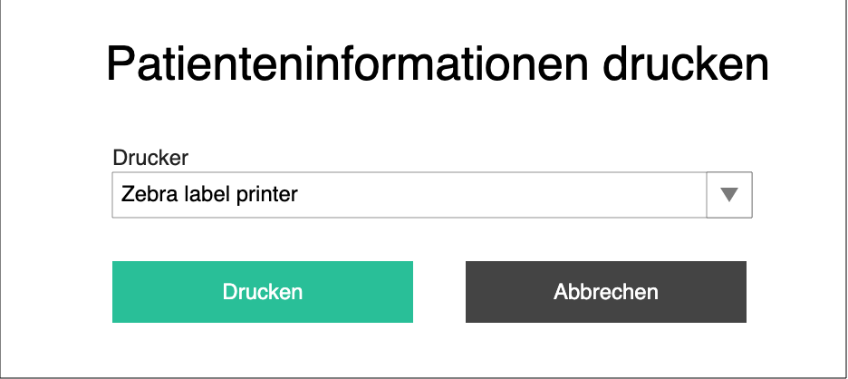

The template should look like the one in the following picture:
￼
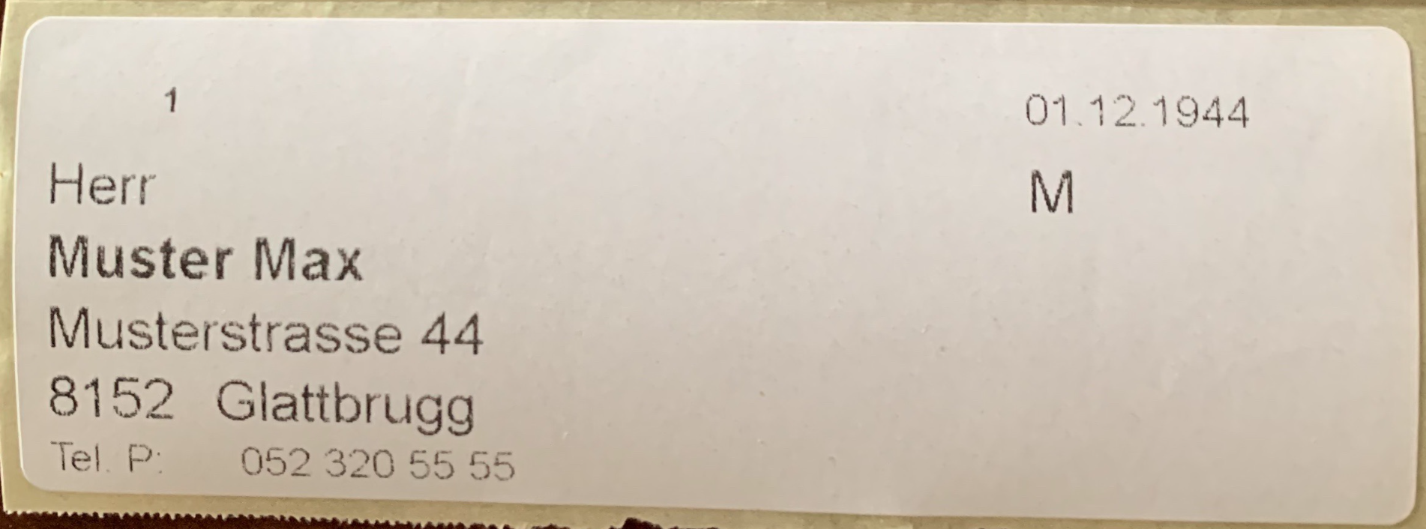

Print deposit request
Deposit request is a document which contains payment instructions for a service which has not yet been performed. In clinics which work on a pre-paid basis, the patients will have to pay for treatment before they come for a treatment.

The deposit request will look like the first page of the bill with biller and patient info and payment instructions at the bottom. We will need a new document type with the placeholders depicted below.

In the middle, instead of the bill info (because we don’t really have a bill) will be a text explaining to the patient why and until when they need to wire the money.

Usage:
Deposit request will be printed from the appointment popover in the calendar. Find a suitable icon for this action
- Print deposit request / Anzahlungsanfrage drucken

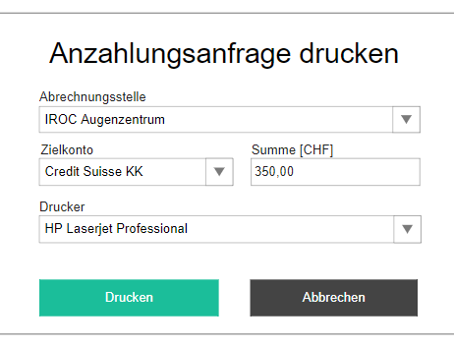

The action opens a popup where the user must select:

- Billing office / Abrechnungsstelle - dropdown with offices (display them indented to show hierarchy structure); mandatory
- Target bank account / Zielkonto - a dropdown with bank accounts; mandatory (needed for payment instruction printing)
- Amount [CHF] / Summe [CHF] - price which will be encoded into the document
- Printer / Drucker - dropdown with all the printers (with station name in the brackets); mandatory
- Print / Drucken - starts printing

# | Group | Label | DE | EN | Comment
#1 | 0 | Document_ID | Dokument ID | Document ID | Human readable ID of the PDF from the document server
#2 | 0 | Document_Timestamp | Dokument Zeitstempel | Document Timestamp | Local date and time at the moment of printing
#3 | 0 | BillerOffice_Title | Rechnungsstelle Titel | Biller Office Title
#4 | 0 | BillerOffice_BillingSpecialization | Rechnungsstelle Abrechnungs Spezialisierung | Biller Office Billing Specialization | Comes right after the billing office name
#5 | 0 | BillerOffice_BillingAddress_Street | Rechnungsstelle Abrechnungs Straße | Biller Office Billing Address Street
#6 | 0 | BillerOffice_BillingAddress_Number | Rechnungsstelle Abrechnungs Nummer | Biller Office Billing Address Number
#7 | 0 | BillerOffice_BillingAddress_ZIP | Rechnungsstelle Abrechnungs PLZ | Biller Office Billing Address ZIP
#8 | 0 | BillerOffice_BillingAddress_City | Rechnungsstelle Abrechnungs Stadt | Biller Office Billing Address City
#9 | 0 | BillerOffice_BillingAddress_Phone | Rechnungsstelle Abrechnungs Telefon | Biller Office Billing Address Phone
#10 | 0 | BillerOffice_BillingAddress_Fax | Rechnungsstelle Abrechnungs Fax | Biller Office Billing Address Fax
#11 | 0 | BillerOffice_ZSR | Rechnungsstelle ZSR | Biller Office ZSR
#13 | 0 | Patient_Number | Patientennummer | Patient Number
#14 | 0 | Patient_DOB | Patient Geburtsdatum | Patient Date of Birth
#16 | 0 | Patient_Gender_Abbreviation | Patient Geschlecht Abkürzung | Patient Gender Abbreviation
#17 | 0 | Patient_Title | Patient Titel | Patient Title
#18 | 0 | Patient_FirstName | Patient Vorname | Patient First Name
#19 | 0 | Patient_LastName | Patient Nachname | Patient Last Name
#20 | 0 | Patient_Address_Street | Patientenadresse Straße | Patient Address Street
#21 | 0 | Patient_Address_Number | Patientenadressen Nummer | Patient Address Number
#22 | 0 | Patient_Address_ZIP | Patientenadresse PLZ | Patient Address ZIP
#23 | 0 | Patient_Address_City | Patientenadresse Stadt | Patient Address City
#24 | 0 | Patient_Address_Canton | Patientenadresse Kanton | Patient Address Canton
#25 | 0 | Patient_AHV | Patient AHV | Patient AHV
#26 | 0 | Bill_ESRCode | Rechnung ESR-Code | Bill ESR Code
#27 | 0 | Account_BESR_ID | Konto BESR-ID | Account BESR-ID | BESR ID of the merchant
#28 | 0 | Bank_BESR_ID | Bank BESR-ID | Bank BESR-ID | BESR ID of the bank which processes the payments.
#29 | 0 | Appointment_Title | Termin | Appointment | Appointment display name
#30 | 0 | Appointment_Date | Termindatum | Appointment date | Date of the appointment
#31 | 0 | Appointment_Time | Terminzeit | Appointment time | Time of the appointment
#32 | 0 | Amount | Summe | Amount | Amount to be paid
#33 | 0 | Amount_Whole | Summe ganzes Teil | Amount whole part | Whole part of amount to be paid
#34 | 0 | Amount_Decimals | Summe dezimaler Teil | Amount decimal part | Decimal part of amount to be paid
#35 | 0 | ReferenceNumber_Part1 | Rechnungszahlungsreferenz Teil 1 | Bill Reference Number Part 1
#36 | 0 | ReferenceNumber_Part2 | Rechnungszahlungsreferenz Teil 2 | Bill Reference Number Part 2
#37 | 0 | Account_BankTitle | Konto Bank Titel | Account Bank Title
#38 | 0 | Account_BankAddress_ZIP | Konto Bank Adresse PLZ | Account Bank Address ZIP

Print bill copy

Bill copy is printed when the patient asks for it. It will look exactly the same, except one field "Kopie" which will have the value "ja" instead of "nein" set.
- Print bill copy / Rechnungskopie drucken

Print payment reminder (dunning)

Although, generally, different dunning steps can have different layout, for the needs of the IROC billing project, we will have one layout for all steps and the layout will be basically the same as for the bill, only with dunning-specific data, all positions of the original bill + all dunning fees (see bellow). We will support only that layout for now.

Dunning fees

All flat rate dunning fees of all dunning levels are summed up in one item called
- Dunning fees / Mahnspesen
All interests of all dunning levels are summed up in another item called
- Late payment interest / Verzugszinsen

A V P M codes for dunning fees are, for now, static -> 2 2 0 0

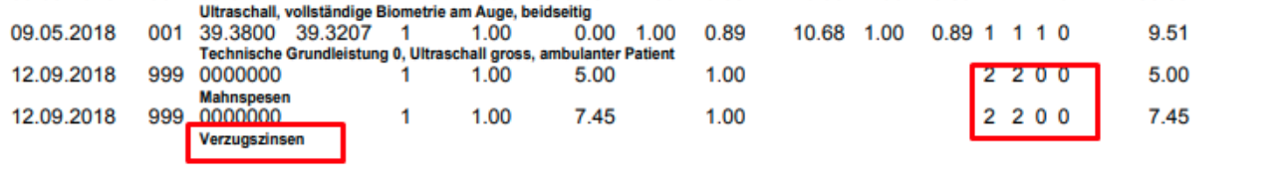

The number 2 refers to the GLN specified in the GLN-Liste section of the report. There, we have the billing doctor GLN specified as 1/ <GLN>. When we are printing the dunning document, we will add 2/2099999999999 which is a hardcoded GLN for dunning. These numbers are used for official tracking in Switzerland where amounts billed are tied to a doctor’s GLN. Since the dunning is not a service provided by a doctor, we will tie it to this special GLN.

Print bill cancellation

Same format as for the bill, only with cancellation specific data and negative position values. See official documentation.

Print receipt
A receipt is a two-pager with patient's name, date of the transaction, amount and a place for the signature. This document is printed out and given to the patient if they pay on the spot. First page is the original and second page is the copy. Patient receives the copy.

Usage:
Receipt printing will be prompted after a payment has been added on the patient billing account or payments, or retroactively by clicking on the print receipt icon in payments table (both on general payment table and patient billing account payments). Find a suitable icon for this action
- Print receipt / Quittung drucken

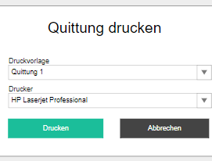

The action opens a popup where the user must select:

- Printing template / Druckvorlage - a dropdown with all the templates of Receipt document type; mandatory
- Printer / Drucker - dropdown with all the printers (with station name in the brackets); mandatory
- Print / Drucken - starts printing

# | Group | Label | DE | EN | Comment
#1 | 0 | Document_Timestamp | Dokument Zeitstempel | Document Timestamp | Local date and time at the moment of printing
#2 | 0 | Patient_Title | Patient Titel | Patient Title
#3 | 0 | Patient_FirstName | Patient Vorname | Patient First Name
#4 | 0 | Patient_LastName | Patient Nachname | Patient Last Name
#5 | 0 | Patient_Address_Street | Patientenadresse Straße | Patient Address Street
#6 | 0 | Patient_Address_Number | Patientenadressen Nummer | Patient Address Number
#7 | 0 | Patient_Address_ZIP | Patientenadresse PLZ | Patient Address ZIP
#8 | 0 | Patient_Address_City | Patientenadresse Stadt | Patient Address City
#9 | 0 | Patient_Address_Canton | Patientenadresse Kanton | Patient Address Canton
#10 | 0 | Payment_Amount | Zahlungsbetrag | Payment Amount
#11 | 0 | Payment_Currency | Währung | Currency
#12 | 0 | Payment_Comment | Kommentar | Comment
#13 | 0 | Payment_Bills | Rechnungen | Bills | Comma separated list of bill numbers

Note:
After printing, generate a PDF and put it in the patient document archive.
- Payment receipt PDF / Quittung PDF - document type, GID entry
- Billing data / Abrechnungsdaten - document category, GID entry

Example

Print prescription
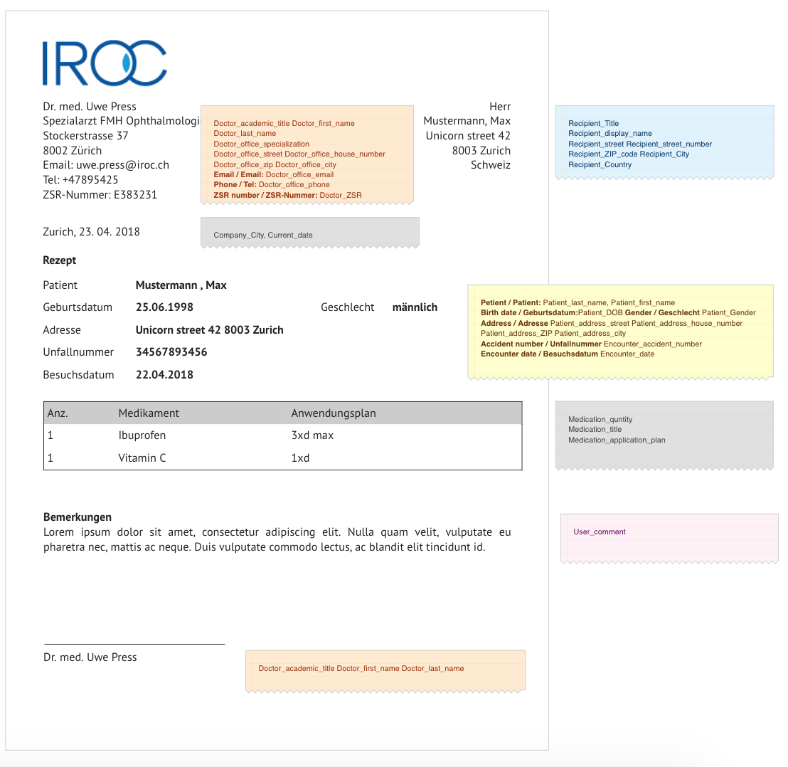

Note: If the prescription has no elements, printing it makes no sense. In this case, disable the print button and show a tooltip:
- Prescription must have at least one item in order to print it. / Das Rezept muss mindestens einen Artikel enthalten, um es drucken zu können.

This printout is given to a patient to get prescribed medication from a local or another pharmacy. It is invoked from suitable encounter masks, i.e. prescription section/tab.

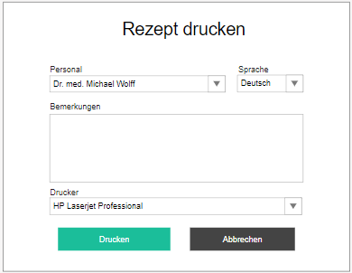
The user is required to specify:
- Staff / Personal - doctor who is signing the prescription; dropdown with doctors; mandatory
  - Preselect currently logged in user, if they are on the Staff list
- Language / Sprache - dropdown with all tenant languages; mandatory
- Comment / Bemerkungen - text area; optional
- Printer / Drucker - dropdown with all available printers
- Print / Drucken - confirm button
- Cancel / Abbrechen - cancel button
- Print prescription / Rezept drucken - title
In case the current encounter has multiple prescriptions, the user will be able to check and uncheck which ones to print. All are checked by default.
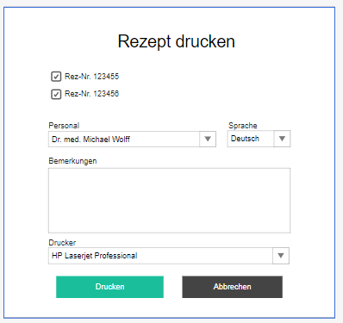
When a PDF is created, whether it is printed or not, place it in the patient’s archive under the name
- Prescription <date> / Rezept <date>
- PDF / PDF - document type, GID entry
- Other / Sonstige - document category, GID entry

# | Group | Label | DE | EN | Comment
#1 | 0 | Doctor_academic_title | Doktortitel | Doctor’s academic title
#2 | 0 | Doctor_first_name | Arzt Vorname | Doctor’s first name
#3 | 0 | Doctor_last_name | Arzt Nachname | Doctor’s last name
#4 | 0 | Doctor_office_name | Arzt-Büro | Doctor’s office name
#5 | 0 | Doctor_office_specialization | Spezialisierung | Doctor’s office specialization
#6 | 0 | Doctor_office_street | Arzt-Büro-Straße | Doctor’s office street
#7 | 0 | Doctor_office_house_number | Arzt Büro Hausnummer | Doctor’s office house number
#8 | 0 | Doctor_office_ZIP | Arzt Büro PLZ | Doctor’s office ZIP code
#9 | 0 | Doctor_office_city | Arzt Büro Stadt | Doctor’s office city
#10 | 0 | Doctor_office_country | Arzt Büro Land | Doctor’s office country | Not used for now
#11 | 0 | Doctor_office_email | Arzt Büro Hauptemail | Doctor’s office main email
#12 | 0 | Doctor_office_phone | Arzt Büro Haupttelefonnummer | Doctor’s office main phone number
#13 | 0 | Doctor_ZSR | ZSR-Nummer des Arztes | Doctor’s ZSR number
#14 | 0 | Recipient_Title | Empfängertitel | Recipient’s title | Recipient will be the patient by default (if not specified in the calling popup)
#15 | 0 | Recipient_display_name | Name des Empfängers | Recipient’s name | First name + last name, or company name
#16 | 0 | Recipient_address_street | Straße des Empfängers | Recipient’s street
#17 | 0 | Recipient_address_house_number | Hausnummer des Empfängers | Recipient’s house number
#18 | 0 | Recipient_address_ZIP | PLZ des Empfängers | Recipient’s ZIP code
#19 | 0 | Recipient_address_city | Stadt des Empfängers | Recipient’s city
#20 | 0 | Recipient_address_country | Land des Empfängers | Recipient’s country | Not used for now
#21 | 0 | Company_city | Firmenstadt | Tenant company’s city
#22 | 0 | Patient_last_name | Nachname des Patienten | Patient’s first name
#23 | 0 | Patient_first_name | Vorname des Patienten | Patient’s last name
#24 | 0 | Patient_DOB | Geburtsdatum des Patienten | Patient’s date of birth
#25 | 0 | Patient_gender | Geschlecht des Patienten | Patient’s gender
#26 | 0 | Patient_address_street | Patientenadresse Straßenname | Patient’s street
#27 | 0 | Patient_address_house_number | Patientenadresse Hausnummer | Patient’s house number
#28 | 0 | Patient_address_ZIP | Patientenadresse PLZ | Patient’s ZIP code
#29 | 0 | Patient_address_city | Patientenadresse Stadt | Patient’s city
#30 | 0 | Patient_address_country | Patientenadresse Land | Patient’s country | Not used for now
#31 | 0 | Encounter_accident_number | Unfallnummer | Accident number | Patient’s accident number for the current encounter, not used for now
#32 | 1 | Medication_quantity | Medikamentenmenge | Medication quantity
#33 | 1 | Medication_title | Medikamententitel | Medication title
#34 | 1 | Medication_application_plan | Medikamente Anwendungsplan | Medication application plan
#35 | 0 | User_comment | Benutzerkommentar | User comment | Supplied in the calling popup
#36 | 0 | Current_date | Aktuelles Datum | Current date | If not automatically provided by WRB
#37 | 0 | Encounter_date | Behandlungsdatum | Encounter date | Date of the encounter from which we are printing
#38 | 0 | Doctor_office_fax | Arzt Büro Faxnummer | Doctor’s office fax number
#39 | 1 | Medication_permanent_prescription | Dauerrezept | Permanent prescription | Filled if medication is not limited
#40 | 1 | Medication_comment | Comment | Kommentar
#41 | 1 | Medication_localization | Localization | Seite | OS -> Left eye / Linkes Auge  OD -> Right eye / Rechtes Auge  OU -> Both eyes / Beide Augen
#42 | 1 | Medication_StartDate | Start date | Startdatum
#43 | 1 | Medication_Duration | Duration | Dauer

Print glasses prescription
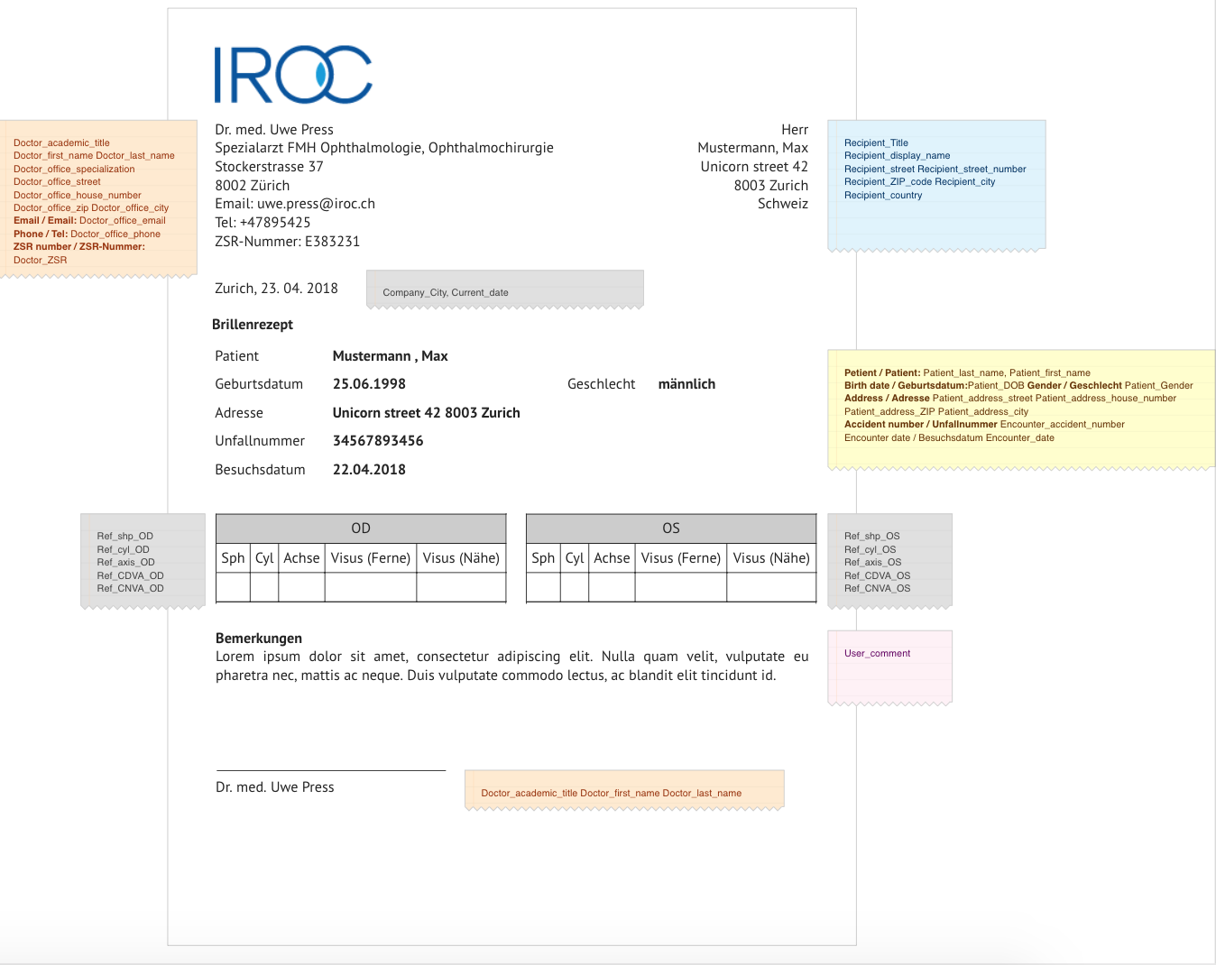

This printout is given to a patient to get prescribed glasses. It is invoked from suitable encounter masks, i.e. refraction section/tab. Printed values are the subjective refraction values of the current encounter.

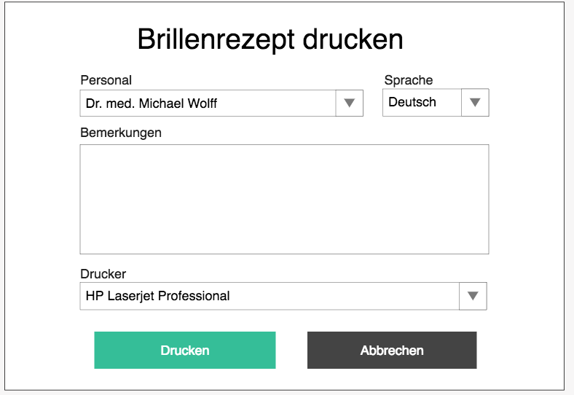
The user is required to specify:
- Staff / Personal - doctor who is signing the prescription; dropdown with doctors; mandatory
  - Preselect currently logged in user, if they are on the Staff list
- Language / Sprache - dropdown with all tenant languages; mandatory
- Comment / Bemerkungen - text area; optional
- Printer / Drucker - dropdown with all available printers
- Print / Drucken - confirm button
- Cancel / Abbrechen - cancel button
- Print glasses prescription / Brillenrezept drucken - title
When a PDF is created, whether it is printed or not, place it in the patient’s archive under the name
- Glasses prescription <date> / Brillenrezept <date>
- PDF / PDF - document type, GID entry
- Other / Sonstige - document category, GID entry

# | Group | Label | DE | EN | Comment
#1 | 0 | Doctor_academic_title | Doktortitel | Doctor’s academic title
#2 | 0 | Doctor_first_name | Arzt Vorname | Doctor’s first name
#3 | 0 | Doctor_last_name | Arzt Nachname | Doctor’s last name
#4 | 0 | Doctor_office_name | Arzt-Büro | Doctor’s office name
#5 | 0 | Doctor_office_specialization | Spezialisierung | Doctor’s office specialization
#6 | 0 | Doctor_office_street | Arzt-Büro-Straße | Doctor’s office street
#7 | 0 | Doctor_office_house_number | Arzt Büro Hausnummer | Doctor’s office house number
#8 | 0 | Doctor_office_ZIP | Arzt Büro PLZ | Doctor’s office ZIP code
#9 | 0 | Doctor_office_city | Arzt Büro Stadt | Doctor’s office city
#10 | 0 | Doctor_office_country | Arzt Büro Land | Doctor’s office country | Not used for now
#11 | 0 | Doctor_office_email | Arzt Büro Hauptemail | Doctor’s office main email
#12 | 0 | Doctor_office_phone | Arzt Büro Haupttelefonnummer | Doctor’s office main phone number
#13 | 0 | Doctor_ZSR | ZSR-Nummer des Arztes | Doctor’s ZSR number
#14 | 0 | Recipient_Title | Empfängertitel | Recipient’s title | Recipient will be the patient by default (if not specified in the calling popup)
#15 | 0 | Recipient_display_name | Name des Empfängers | Recipient’s name | First name + last name, or company name
#16 | 0 | Recipient_address_street | Straße des Empfängers | Recipient’s street
#17 | 0 | Recipient_address_house_number | Hausnummer des Empfängers | Recipient’s house number
#18 | 0 | Recipient_address_ZIP | PLZ des Empfängers | Recipient’s ZIP code
#19 | 0 | Recipient_address_city | Stadt des Empfängers | Recipient’s city
#20 | 0 | Recipient_address_country | Land des Empfängers | Recipient’s country
#21 | 0 | Company_city | Firmenstadt | Tenant company’s city
#22 | 0 | Patient_last_name | Nachname des Patienten | Patient’s first name
#23 | 0 | Patient_first_name | Vorname des Patienten | Patient’s last name
#24 | 0 | Patient_DOB | Geburtsdatum des Patienten | Patient’s date of birth
#25 | 0 | Patient_gender | Geschlecht des Patienten | Patient’s gender
#26 | 0 | Patient_address_street | Patientenadresse Straßenname | Patient’s street
#27 | 0 | Patient_address_house_number | Patientenadresse Hausnummer | Patient’s house number
#28 | 0 | Patient_address_ZIP | Patientenadresse PLZ | Patient’s ZIP code
#29 | 0 | Patient_address_city | Patientenadresse Stadt | Patient’s city
#30 | 0 | Patient_address_country | Patientenadresse Land | Patient’s country | Not used for now
#31 | 0 | Encounter_accident_number | Unfallnummer | Accident number | Patient’s accident number for the current encounter, not used for now
#32 | 0 | Ref_shp_OD | Sphärische Aberration des rechten Auges | Right eye spherical aberration
#33 | 0 | Ref_cyl_OD | Zylindrisch Aberration des rechten Auges | Right eye cylindrical aberration
#34 | 0 | Ref_axis_OD | Astigmatismusachse des rechten Auges | Right eye astigmatism axis
#35 | 0 | Ref_CDVA_OD | Korrigiertes Fernvisus des rechten Auges | Right eye corrected distance visual acuity
#36 | 0 | Ref_CNVA_OD | Korrigiertes Nahvisus des rechten Auges | Right eye corrected near visual acuity
#37 | 0 | Ref_UDVA_OD | Unkorrigiertes Fernvisus des rechten Auges | Right eye uncorrected distance visual acuity
#38 | 0 | Ref_UNVA_OD | Unkorrigiertes Nahvisus des rechten Auges | Right eye uncorrected near visual acuity
#39 | 0 | Ref_shp_OS | Sphärische Aberration des linken Auges | Left eye spherical aberration
#40 | 0 | Ref_cyl_OS | Zylindrisch Aberration des linken Auges | Left eye cylindrical aberration
#41 | 0 | Ref_axis_OS | Astigmatismusachse des linken Auges | Left eye astigmatism axis
#42 | 0 | Ref_CDVA_OS | Korrigiertes Fernvisus des linken Auges | Left eye corrected distance visual acuity
#43 | 0 | Ref_CNVA_OS | Korrigiertes Nahvisus des linken Auges | Left eye corrected near visual acuity
#44 | 0 | Ref_UDVA_OS | Unkorrigiertes Fernvisus des linken Auges | Left eye uncorrected distance visual acuity
#45 | 0 | Ref_UNVA_OS | Unkorrigiertes Nahvisus des rechlinken Auges | Left eye uncorrected near visual acuity
#46 | 0 | User_comment | Benutzerkommentar | User comment | Supplied in the calling popup
#47 | 0 | Current_date | Aktuelles Datum | Current date | If not automatically provided by WRB
#48 | 0 | Encounter_date | Behandlungsdatum | Encounter date | Date of the encounter from which we are printing
#49 | 0 | Ref_PrisHor_OD | Horizontales Prisma des rechten Auges | Right eye horizontal prism
#50 | 0 | Ref_PrisHor_Axis_OD | Horizontale Prismenachse des rechten Auges | Right eye horizontal prism axis
#51 | 0 | Ref_PrisVer_OD | Vertikales Prisma des rechten Auges | Right eye vertical prism
#52 | 0 | Ref_PrisVer_Axis_OD | Vertikale Prismenachse des rechten Auges | Right eye vertical prism axis
#53 | 0 | Ref_PrisHor_OS | Horizontales Prisma des linken Auges | Left eye horizontal prism
#54 | 0 | Ref_PrisHor_Axis_OS | Horizontale Prismenachse des linken Auges | Left eye horizontal prism axis
#55 | 0 | Ref_PrisVer_OS | Vertikales Prisma des linken Auges | Left eye vertical prism
#56 | 0 | Ref_PrisVer_Axis_OS | Vertikale Prismenachse des linken Auges | Left eye vertical prism axis
#57 | 0 | Ref_PD | Pupil distance | Hornhautscheitelabstand | PD / HSA
#58 | 0 | Doctor_office_fax | Arzt Büro Faxnummer | Doctor’s office fax number
#59 | 0 | Ref_Add_OS | Linkes Auge Presbyopie induzierte sphärische Aberration | Left eye Presbyopia induced spherical aberration
#60 | 0 | Ref_Add_OD | Rechtes Auge Presbyopie induzierte sphärische Aberration | Right eye presbyopia induced spherical aberration

Note: All Sph, Cyl, K1, K2, Ast and similar diopter values must be printed the same way as on UI - with the minimum of 2 decimal places. So if Sph = 1, the glasses prescription must display 1.00.

Print contact lenses prescription

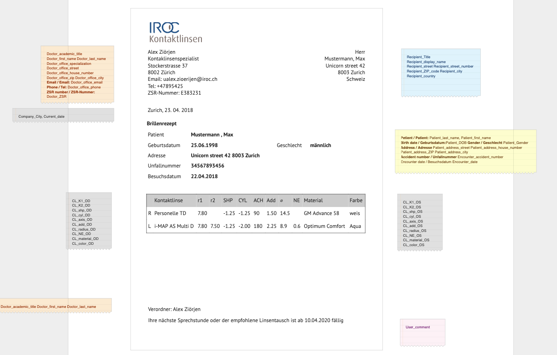

This printout is given to a patient to get prescribed contacts, or to have the details of their contact lenses, if they need it for health insurance reimbursement, or any other reason. It is invoked from suitable encounter masks, i.e. contact lenses fitting section/tab. The button is available for every lens in the fitting protocol.

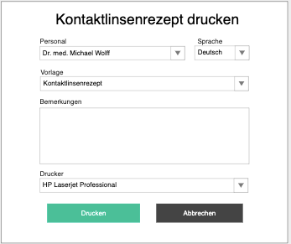

The user is required to specify:
- Staff / Personal - doctor who is signing the prescription; dropdown with doctors; mandatory
  - Preselect currently logged in user, if they are on the Staff list
- Language / Sprache - dropdown with all tenant languages; mandatory
- Template / Vorlage - dropdown with all templates of contact lenses prescription type
  - Prefilled with default template for this user, if exists, otherwise with tenant default
- Comment / Bemerkungen - text area; optional
  - Prefilled with date of the next appointment task (done or not) of the current encounter
  - If there are multiple appointment tasks connected to this encounter, take the one with the appointment date which comes first
  - Your next consultation for the recommended lens exchange is due from <appointment target date>. / Ihre nächste Sprechstunde oder der empfohlene Linsentausch ist ab <appointment target date> fällig.
- Printer / Drucker - dropdown with all available printers
- Print / Drucken - confirm button
- Cancel / Abbrechen - cancel button
- Print lenses prescription / Kontaktlinsesrezept drucken - title
When a PDF is created, whether it is printed or not, place it in the patient’s archive under the name
- Contact lenses prescription <date> / Kontaktlinsenrezept <date>
- PDF / PDF - document type, GID entry
- Other / Sonstige - document category, GID entry

# | Group | Label | DE | EN | Comment
#1 | 0 | Doctor_academic_title | Doktortitel | Doctor’s academic title
#2 | 0 | Doctor_first_name | Arzt Vorname | Doctor’s first name
#3 | 0 | Doctor_last_name | Arzt Nachname | Doctor’s last name
#4 | 0 | Doctor_office_name | Arzt-Büro | Doctor’s office name
#5 | 0 | Doctor_office_specialization | Spezialisierung | Doctor’s office specialization
#6 | 0 | Doctor_office_street | Arzt-Büro-Straße | Doctor’s office street
#7 | 0 | Doctor_office_house_number | Arzt Büro Hausnummer | Doctor’s office house number
#8 | 0 | Doctor_office_ZIP | Arzt Büro PLZ | Doctor’s office ZIP code
#9 | 0 | Doctor_office_city | Arzt Büro Stadt | Doctor’s office city
#10 | 0 | Doctor_office_country | Arzt Büro Land | Doctor’s office country | Not used for now
#11 | 0 | Doctor_office_email | Arzt Büro Hauptemail | Doctor’s office main email
#12 | 0 | Doctor_office_phone | Arzt Büro Haupttelefonnummer | Doctor’s office main phone number
#13 | 0 | Doctor_ZSR | ZSR-Nummer des Arztes | Doctor’s ZSR number
#14 | 0 | Recipient_Title | Empfängertitel | Recipient’s title | Recipient will be the patient by default (if not specified in the calling popup)
#15 | 0 | Recipient_display_name | Name des Empfängers | Recipient’s name | First name + last name, or company name
#16 | 0 | Recipient_address_street | Straße des Empfängers | Recipient’s street
#17 | 0 | Recipient_address_house_number | Hausnummer des Empfängers | Recipient’s house number
#18 | 0 | Recipient_address_ZIP | PLZ des Empfängers | Recipient’s ZIP code
#19 | 0 | Recipient_address_city | Stadt des Empfängers | Recipient’s city
#20 | 0 | Recipient_address_country | Land des Empfängers | Recipient’s country
#21 | 0 | Company_city | Firmenstadt | Tenant company’s city
#22 | 0 | Patient_last_name | Nachname des Patienten | Patient’s first name
#23 | 0 | Patient_first_name | Vorname des Patienten | Patient’s last name
#24 | 0 | Patient_DOB | Geburtsdatum des Patienten | Patient’s date of birth
#25 | 0 | Patient_gender | Geschlecht des Patienten | Patient’s gender
#26 | 0 | Patient_address_street | Patientenadresse Straßenname | Patient’s street
#27 | 0 | Patient_address_house_number | Patientenadresse Hausnummer | Patient’s house number
#28 | 0 | Patient_address_ZIP | Patientenadresse PLZ | Patient’s ZIP code
#29 | 0 | Patient_address_city | Patientenadresse Stadt | Patient’s city
#30 | 0 | Patient_address_country | Patientenadresse Land | Patient’s country | Not used for now
#31 | 0 | Encounter_accident_number | Unfallnummer | Accident number | Patient’s accident number for the current encounter, not used for now
#32 | 0 | CL_K1_OD | r1 der rechten Kontaktlinse | Right contact lens r1
#33 | 0 | CL_K2_OD | r2 der rechten Kontaktlinse | Right contact lens r2
#34 | 0 | CL_Shp_OD | Sphärische Korrektur der rechten Kontaktlinse | Right contact lens spherical correction
#35 | 0 | CL_Cyl_OD | Zylindrische Korrektur der rechten Kontaktlinse | Right contact lens cylindrical correction
#36 | 0 | CL_Axis_OD | Zylindrische Korrekturachse der rechten Kontaktlinse | Right contact lens cylindrical correction axis
#37 | 0 | CL_Add_OD | Korrektur der Presbyopie der rechten Kontaktlinse | Right contact lens presbyopia correction
#38 | 0 | CL_Radius_OD | Durchmesser der rechten Kontaktlinse | Right contact lens radius
#39 | 0 | CL_NE_OD | NE der rechten Kontaktlinse | Right contact lens NE
#40 | 0 | CL_Material_OD | Material der rechten Kontaktlinse | Right contact lens material
#41 | 0 | CL_Color_OD | Farbe der rechten Kontaktlinse | Right contact lens color
#42 | 0 | CL_Title_OD | Name der rechten Kontaktlinse | Right contact lens title
#43 | 0 | CL_K1_OS | r1 der linken Kontaktlinse | Left contact lens r1
#44 | 0 | CL_K2_OS | r2 der linken Kontaktlinse | Left contact lens r2
#45 | 0 | CL_Shp_OS | Sphärische Korrektur der linken Kontaktlinse | Left contact lens spherical correction
#46 | 0 | CL_Cyl_OS | Zylindrische Korrektur der linken Kontaktlinse | Left contact lens cylindrical correction
#47 | 0 | CL_Axis_OS | Zylindrische Korrekturachse der linken Kontaktlinse | Left contact lens cylindrical correction axis
#48 | 0 | CL_Add_OS | Korrektur der Presbyopie der linken Kontaktlinse | Left contact lens presbyopia correction
#49 | 0 | CL_Radius_OS | Durchmesser der linken Kontaktlinse | Left contact lens radius
#50 | 0 | CL_NE_OS | NE der linken Kontaktlinse | Left contact lens NE
#51 | 0 | CL_Material_OS | Material der linken Kontaktlinse | Left contact lens material
#52 | 0 | CL_Color_OS | Farbe der linken Kontaktlinse | Left contact lens color
#53 | 0 | CL_Title_OS | Name der linken Kontaktlinse | Left contact lens title
#54 | 0 | User_comment | Benutzerkommentar | User comment | Supplied in the calling popup
#55 | 0 | Current_date | Aktuelles Datum | Current date | If not automatically provided by WRB
#56 | 0 | Encounter_date | Behandlungsdatum | Encounter date | Date of the encounter from which we are printing
#57 | 0 | Doctor_office_fax | Arzt Büro Faxnummer | Doctor’s office fax number

Note: All Sph, Cyl, K1, K2, Ast and similar diopter values must be printed the same way as on UI - with the minimum of 2 decimal places. So if Sph = 1, the glasses prescription must display 1.00.

Print driver’s licence confirmation

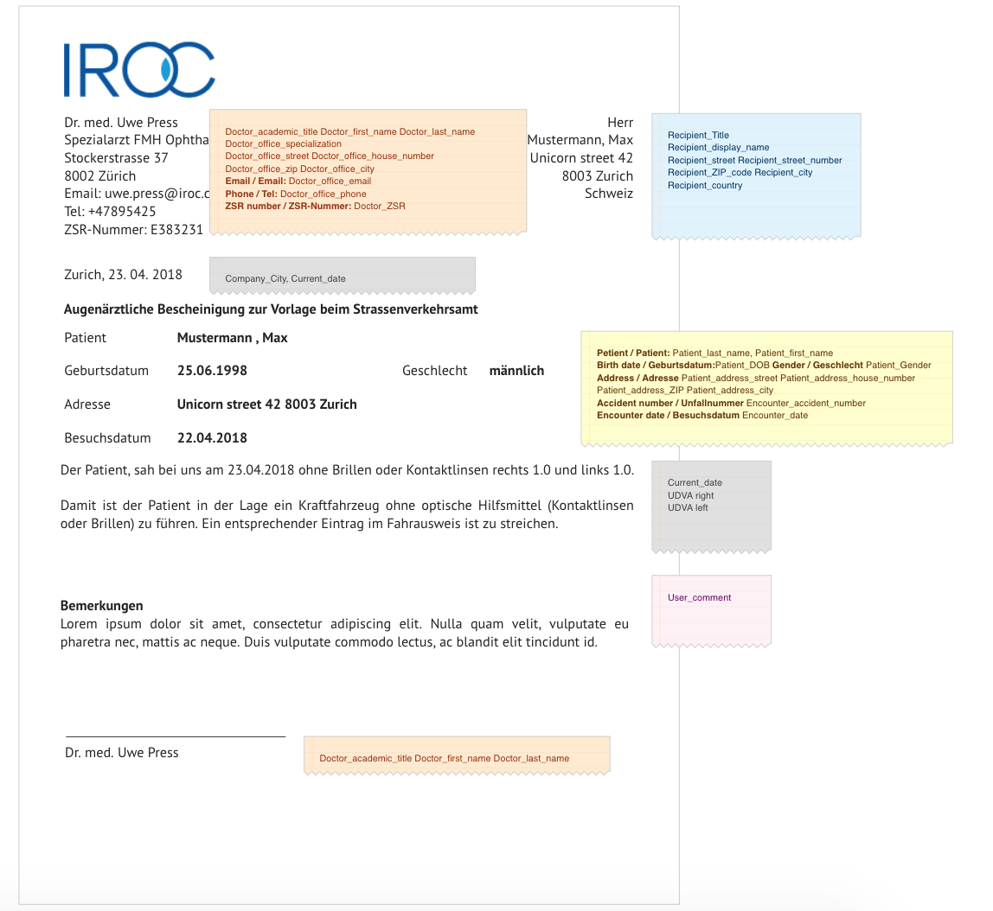
This printout is given to a patient to get their driver’s licence updated that they no longer need glasses or contacts after LASIK. It is invoked from suitable encounter masks, i.e. refraction section/tab. Printed values are the subjective refraction values of the current encounter.

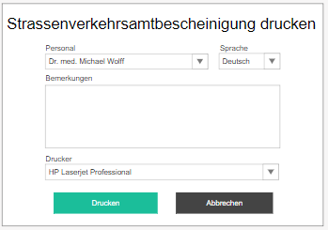
The user is required to specify:
- Staff / Personal - doctor who is signing the prescription; dropdown with doctors; mandatory
  - Preselect currently logged in user, if they are on the Staff list
- Language / Sprache - dropdown with all tenant languages; mandatory
- Comment / Bemerkungen - text area; optional
- Printer / Drucker - dropdown with all available printers
- Print / Drucken - confirm button
- Cancel / Abbrechen - cancel button
- Print drivers’ licence confirmation / Strassenverkehrsamtbescheinigung ducken- title
When a PDF is created, whether it is printed or not, place it in the patient’s archive under the name
- Traffic office <date> / Strassenverkehrsamt <date>
- PDF / PDF - document type, GID entry
- Other / Sonstige - document category, GID entry
Note: Required placeholders are the same as for Glasses prescription printout.

Print work excuse
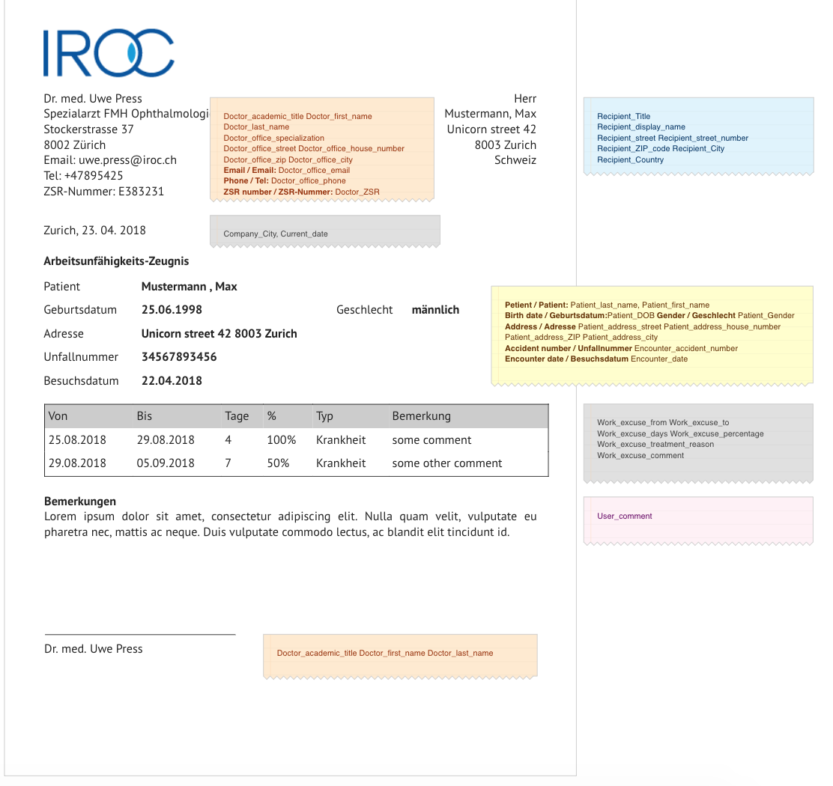
This printout is given to a patient to justify an absence from work. It is invoked from suitable encounter masks, i.e. work excuses section/tab.
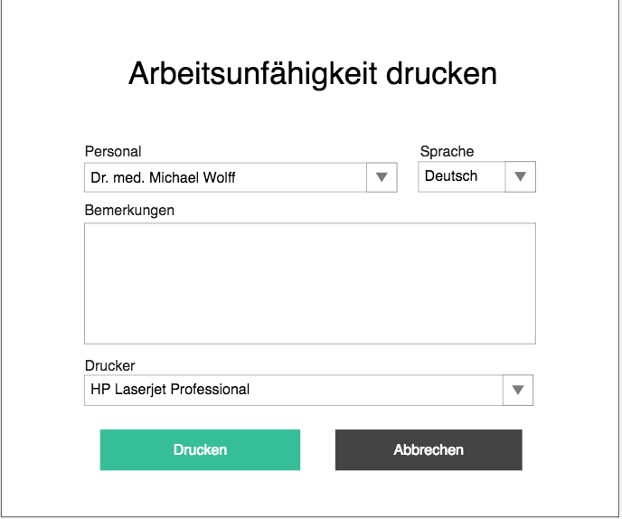
The user is required to specify:
- Staff / Personal - doctor who is signing the prescription; dropdown with doctors; mandatory
  - Preselect currently logged in user, if they are on the Staff list
- Language / Sprache - dropdown with all tenant languages; mandatory
- Comment / Bemerkungen - text area; optional
- Printer / Drucker - dropdown with all available printers
- Print / Drucken - confirm button
- Cancel / Abbrechen - cancel button
- Print work excuse / Arbeitsunfähigkeit drucken - title
When a PDF is created, whether it is printed or not, place it in the patient’s archive under the name
- Work excuse <date> / Arbeitsunfähigkeit <date>
- PDF / PDF - document type, GID entry
- Other / Sonstige - document category, GID entry

# | Group | Label | DE | EN | Comment
#1 | 0 | Doctor_academic_title | Doktortitel | Doctor’s academic title
#2 | 0 | Doctor_first_name | Arzt Vorname | Doctor’s first name
#3 | 0 | Doctor_last_name | Arzt Nachname | Doctor’s last name
#4 | 0 | Doctor_office_name | Arzt-Büro | Doctor’s office name
#5 | 0 | Doctor_office_specialization | Spezialisierung | Doctor’s office specialization
#6 | 0 | Doctor_office_street | Arzt-Büro-Straße | Doctor’s office street
#7 | 0 | Doctor_office_house_number | Arzt Büro Hausnummer | Doctor’s office house number
#8 | 0 | Doctor_office_ZIP | Arzt Büro PLZ | Doctor’s office ZIP code
#9 | 0 | Doctor_office_city | Arzt Büro Stadt | Doctor’s office city
#10 | 0 | Doctor_office_country | Arzt Büro Land | Doctor’s office country | Not used for now
#11 | 0 | Doctor_office_email | Arzt Büro Hauptemail | Doctor’s office main email
#12 | 0 | Doctor_office_phone | Arzt Büro Haupttelefonnummer | Doctor’s office main phone number
#13 | 0 | Doctor_ZSR | ZSR-Nummer des Arztes | Doctor’s ZSR number
#14 | 0 | Recipient_Title | Empfängertitel | Recipient’s title | Recipient will be the patient by default (if not specified in the calling popup)
#15 | 0 | Recipient_display_name | Name des Empfängers | Recipient’s name | First name + last name, or company name
#16 | 0 | Recipient_address_street | Straße des Empfängers | Recipient’s street
#17 | 0 | Recipient_address_house_number | Hausnummer des Empfängers | Recipient’s house number
#18 | 0 | Recipient_address_ZIP | PLZ des Empfängers | Recipient’s ZIP code
#19 | 0 | Recipient_address_city | Stadt des Empfängers | Recipient’s city
#20 | 0 | Recipient_address_country | Land des Empfängers | Recipient’s country | Not used for now
#21 | 0 | Company_city | Firmenstadt | Tenant company’s city
#22 | 0 | Patient_last_name | Nachname des Patienten | Patient’s first name
#23 | 0 | Patient_first_name | Vorname des Patienten | Patient’s last name
#24 | 0 | Patient_DOB | Geburtsdatum des Patienten | Patient’s date of birth
#25 | 0 | Patient_gender | Geschlecht des Patienten | Patient’s gender
#26 | 0 | Patient_address_street | Patientenadresse Straßenname | Patient’s street
#27 | 0 | Patient_address_house_number | Patientenadresse Hausnummer | Patient’s house number
#28 | 0 | Patient_address_ZIP | Patientenadresse PLZ | Patient’s ZIP code
#29 | 0 | Patient_address_city | Patientenadresse Stadt | Patient’s city
#30 | 0 | Patient_address_country | Patientenadresse Land | Patient’s country | Not used for now
#31 | 0 | Encounter_accident_number | Unfallnummer | Accident number | Patient’s accident number for the current encounter, not used for now
#32 | 1 | Work_excuse_from | Arbeitsunfähigkeit Startdatum | Excuse start date
#33 | 1 | Work_excuse_to | Arbeitsunfähigkeit Enddatum | Excuse end date
#34 | 1 | Work_excuse_days | Arbeitsunfähigkeitsdauer in Tagen | Excuse duration in days
#35 | 1 | Work_excuse_percentage | Prozentsatz der Arbeitsunfähigkeit | Excuse disability percentage
#36 | 1 | Work_excuse_treatment_reason | Arbeitsunfähigkeit Behandlungsgrund | Excuse treatment reason
#37 | 1 | Work_excuse_comment | Arbeitsunfähigkeit Kommentar | Excuse comment
#38 | 0 | User_comment | Benutzerkommentar | User comment | Supplied in the calling popup
#39 | 0 | Current_date | Aktuelles Datum | Current date | If not automatically provided by WRB
#40 | 0 | Encounter_date | Behandlungsdatum | Encounter date | Date of the encounter from which we are printing
#41 | 0 | Doctor_office_fax | Arzt Büro Faxnummer | Doctor’s office fax number

Excel reports

Reports choice page

Some of the reports we have addressed so far are parts of business processes, which are printed “along the way”, like receipt report. But there are other types of reports, which are used mainly for controlling, and should, therefore, be available from a central place inside the app.

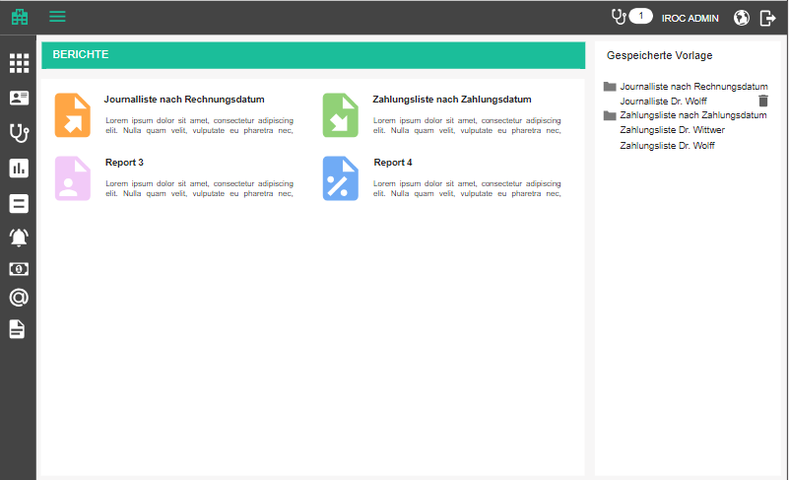

At some point, it might make sense to have a controlling module which holds all the reports available, but for the time being, we can start with a "Reports & Controlling” page. This page will contain, for each report, an icon, name and a short description. We will start with 2 reports: bills and payments report.
- Reports and controlling / Berichte und Controlling - Page title
- Bill list for date range / Journalliste nach Rechnungsdatum - title of the report; include a placeholder text for descriptions so that we can establish how long the description should optimally be
- Payment list for date range / Zahlungsliste nach Zahlungsdatum - title of the report; include a placeholder text for descriptions so that we can establish how long the description should optimally be

On the right hand side of the reports section, we will always have a scrollable list of saved templates, grouped by report type (saved criteria for a certain report, see more details below). After selecting a template, the screen will show report criteria page for the chosen report type, plus the saved criteria. A template can be deleted by clicking on the delete icon and confirming.
- Are you sure you want to delete <template name>? / Sind Sie sicher, dass Sie <template name> löschen möchten?
- Delete template / Vorlage löschen - tooltip on the button

A new template can be created by clicking on the add template button, beneath the section of corresponding report type. It opens an empty form.
New template / Neue Vorlage

Every criteria page will have a section for saving the criteria as a template
- Title / Name - texbox where the user specifies the title of template; mandatory
- Save template / Vorlage speichern - updates the currently selected template, if there is a selected template, or creates a new one
- Template name must be unique. / Der Vorlagenname muss eindeutig sein.

Note: the list of reports will grow over time and at some point there will be no space for large icons and tiles. At that point we will have to introduce a table view for this page.

Bills report

For bookkeeping reasons, the financial manager needs a way to export all reports made for a chosen employee and cost center and a specified timeframe.

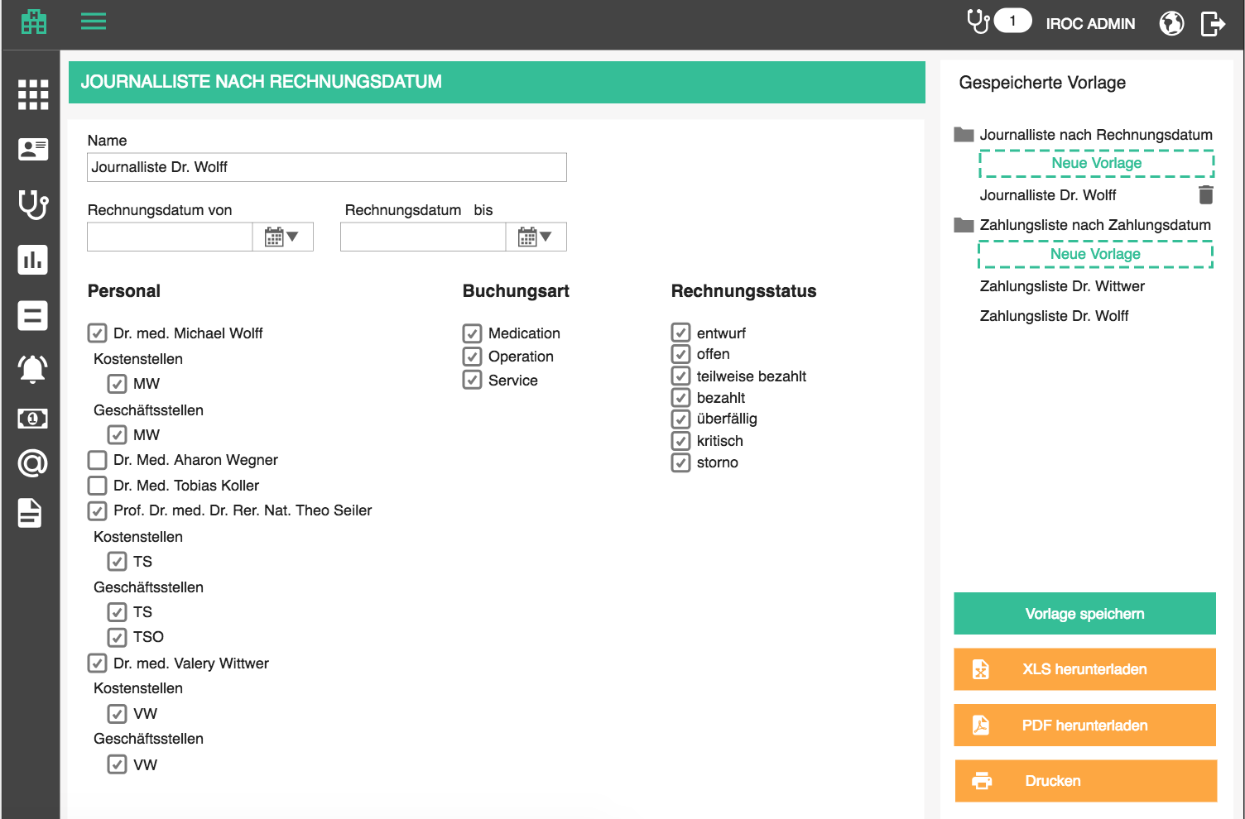

After selecting the appropriate report type, the user is taken to the report criteria page, where they select
- Bill date from / Rechnungsdatum von - date picker; we will display all relevant bills which have bill date greater or equal to this one; mandatory
- Bill date to / Rechnungsdatum bis- date picker; we will display all relevant bills which have bill date less or equal to this one; mandatory
- Include draft bills / Rechnungsentwürfe einschließen – checkbox; unchecked by default; when checked includes data from unsigned bills
- Staff / Personal - a list of checkboxes with staff (only the ones who have cost centers and billing offices defined); user can select multiple
- for each checked staff, display the list of cost centers connected through bills (Cost centers / Kostenstellen), and preselect the default one, if available
- for each checked staff, display the list of offices connected through bills ( Offices / Geschäftsstellen), and preselect the default one, if available
- Booking types / Buchungsarten - a list of checkboxes with booking types;user can select multiple
- Bills status / Rechnungsstatus - a list of checkboxes with all bill statuses; user can select multiple and this is an additional filter for the bills which we fetch
- draft / Entwurf - not yet signed off (this is a link to bill edit page)
- open / offen - signed off but nothing has been paid
- partially paid / teilweise bezahlt - payments associated with this bill do not amount to the bill total; bill gets in this status whenever the first payment is added but full sum is not reached
- paid / bezahlt - payments associated with this bill amount to the bill total; bill gets in this status whenever a payment is added to this bill which reaches the bill total
- overdue / überfällig - any open or partially paid bill which has due date before current date is considered overdue
- critical / kritisch - user can mark overdue bills as critical, which will have an impact on the patient (more details in Billing implications section)
- canceled / storno

The report will contain all the bills of the selected staff + cost center, grouped by date and type. This means that all bookings of the same type on a day should be accumulated into one row. All bookings for one day will have a subtotal

Criteria page offers 3 standard buttons:
- Download XLS / XLS herunterladen - downloads the XLS
- Save / Speichern - saves the filter
- Cancel / Abbrechen - returns the user to the report choice page

The Excel looks like the following example and has a tab for every selected doctor. Columns are:
- Date / Datum
- Cost center / Kostenstelle
- Office / Geschäftsstelle
- Booking type / Buchungsart
- Amount [CHF] / Umfang [CHF]

Bills report

Bills by patient report

For bookkeeping reasons, the financial manager needs a way to export all bills made for a chosen employee and cost center and a specified timeframe, and get the revenue per patient. This report is very similar to the general bills report.

After selecting the appropriate report type, the user is taken to the report criteria page, where they select
- Bill date from / Rechnungsdatum von - date picker; we will display all relevant bills which have bill date greater or equal to this one; mandatory
- Bill date to / Rechnungsdatum bis- date picker; we will display all relevant bills which have bill date less or equal to this one; mandatory
- Include draft bills / Rechnungsentwürfe einschließen – checkbox; unchecked by default; when checked includes data from unsigned bills
- Staff / Personal - a list of checkboxes with staff (only the ones who have cost centers and billing offices defined); user can select multiple
- for each checked staff, display the list of cost centers connected through bills (Cost centers / Kostenstellen), and preselect the default one, if available
- for each checked staff, display the list of offices connected through bills ( Offices / Geschäftsstellen), and preselect the default one, if available

The report will contain all the bills of the selected staff + cost center, grouped by date and patient. This means that all bookings for the same patient on a day should be accumulated into one row. All bookings for one day will have a subtotal.

Criteria page offers 3 standard buttons:
- Download XLS / XLS herunterladen - downloads the XLS
- Save / Speichern - saves the filter
- Cancel / Abbrechen - returns the user to the report choice page

The Excel looks like the following example and has a tab for every selected doctor. Columns are:
- Date / Datum
- Cost center / Kostenstelle
- Office / Geschäftsstelle
- Patient / Petient
- Amount [CHF] / Umfang [CHF]

Bills with patients report

Payments report

For bookkeeping reasons, the financial manager needs a way to export all payments made for bills of a chosen doctor, cost center and a specified timeframe.

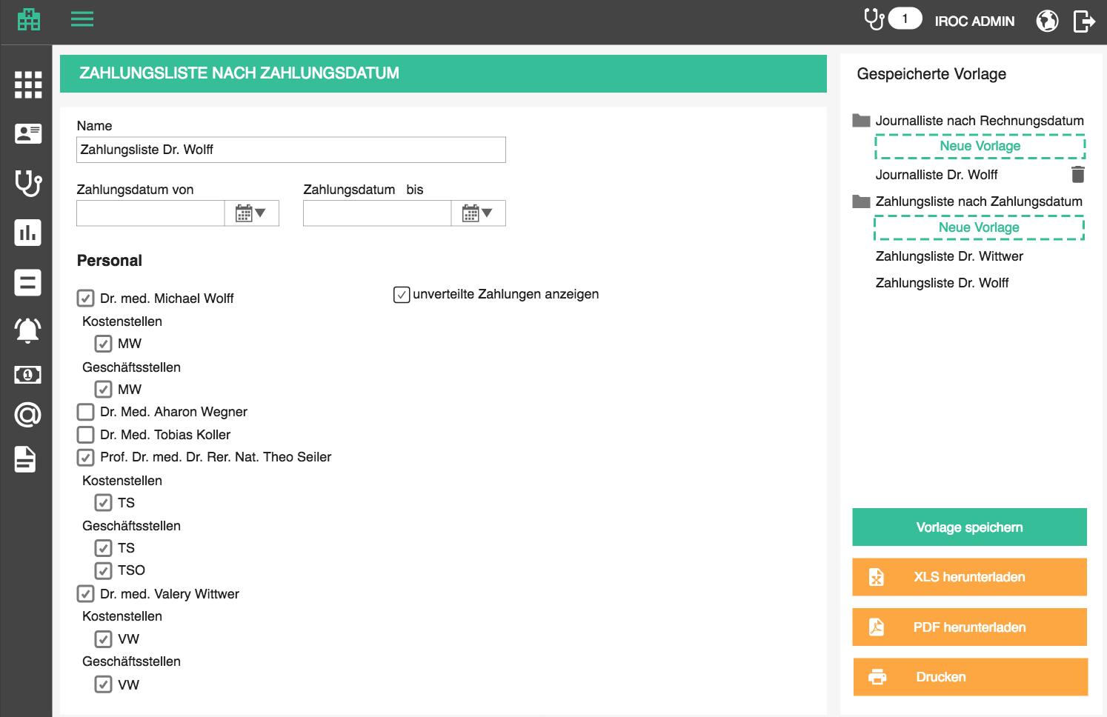

After selecting the appropriate report type, the user is taken to the report criteria page, where they select
- Payment date from / Zahlungsdatum von - date picker; we will display all relevant payments which have payment date greater or equal to this one; mandatory
- Payment date to / Zahlungsdatum bis- date picker; we will display all relevant payments which have payment date less or equal to this one; mandatory
- Staff / Personal - a list of checkboxes with staff (only the ones who have cost centers and billing offices defined); user can select multiple
- for each checked staff, display the list of cost centers connected through bills (Cost centers / Kostenstellen), and preselect the default one, if available
- for each checked staff, display the list of offices connected through bills ( Offices / Geschäftsstellen), and preselect the default one, if available
- show undistributed payments / unverteilte Zahlungen anzeigen - checkbox which, if checked, will add a tab to the report called “Undistributed payments / Unverteilte Zahlungen”, which lists undistributed amounts of various payments (total payment amount - sum of amounts distributed to bills). Office and cost center will be empty, but we display the account to which the payment was made.

The report will contain all the payments of the selected doctor + cost center, grouped by date and booking account. This means that all payments to the same account on a day should be accumulated into one row. All payments for one day will have a subtotal. For tracking purposes, display deleted payments with [deleted/gelöscht] in front of the comment.

Criteria page offers 3 standard buttons:
- Download XLS / XLS herunterladen - downloads the XLS
- Save / Speichern - saves the filter
- Cancel / Abbrechen - returns the user to the report choice page

The Excel looks like the following example and has a tab for every selected doctor. Columns are:
- Date / Datum
- Cost center / Kostenstelle
- Office / Geschäftsstelle
- Konto / Account - number and name
- Amount [CHF] / Umfang [CHF]

Payments report

Appointment plan report

For organizational reasons, planning staff needs a way to export an appointment plan (predominantly surgery appointment plan) to stick it to a wall so that everyone knows what they need to work on.

This report type is added to the reports and controlling page as
- Appointment plan / Terminplan

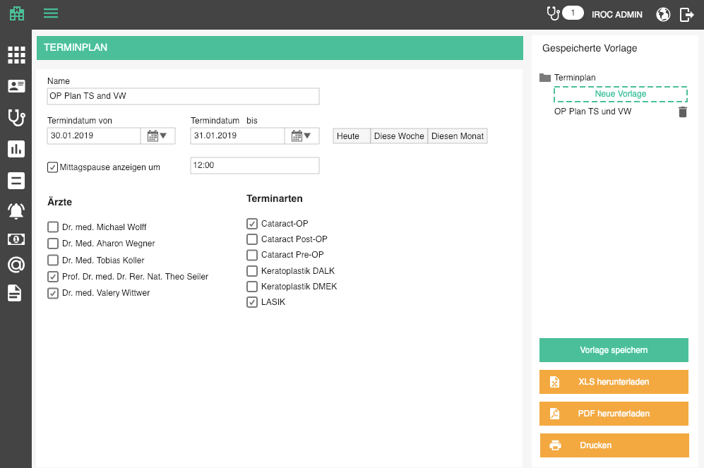

On the report criteria page, the user will select:

- Title / Name - title of the report and template, if saved
- Appointment date from / Termindatum von - date picker; mandatory
- Appointment date to / Termindatum bis - date picker; mandatory
- Shortcuts for dates
  - Today / Heute - sets start and end date to current date
  - This week / Diese Woche - sets start date to Monday of this week and end date to Sunday of this week
  - This month / Diesen Monat - sets start date to first date of the current month and end date to the last date of the current month
- Show lunch break at / Mittagspause anzeigen um - checkbox which indicates whether to include a lunch break or not
- lunch break start - enabled only if lunchbreak checked; 12:00 by default; if enabled must be a valid time
- Staff / Personal - staff to include if they are key resources
  - Choose all / Alle wählen
- Appointment types / Terminarten - appointment types to include
  - Choose all / Alle wählen
The report will contain appointments which:
- have specified doctors as key resources, or named resources if key resources do not exist
- are of specified appointment types
- are booked for any date between start and end date, including those dates

Appointments are separated by date, with date in a heading row, and sorted by start time.
On every day, if option checked, insert the lunch break before the time point specified in report criteria.

Criteria page offers 3 standard buttons:
- Download XLS / XLS herunterladen - downloads the XLS
- Save / Speichern - saves the filter
- Cancel / Abbrechen - returns the user to the report choice page

Downloaded excel looks like the following example. Columns are:

- Entry / Eintritt - date of the appointment + start time in new line
- Start / Start - start of the step which has a key resource, or named resource if no key resource present
- Eye / Auge - currently empty, added manually
- Operation reason / Operationsgrund - appointment title
- Person / Person - <patient last name> <patient first name> (<patient number>)
- Surgeon / Operateur - initials of the key resources, or named resources, if there are no key resources
- B. year / Jahrg - patient’s birth year
- Comment / Bemerkung - appointment comment
- nameless empty column for manually added details

Appointment plan

Appointment statistics report

For statistical reasons, users will want to download a report which counts different appointment types for a timeframe.

This report type is added to the reports and controlling page as
- Appointment statistic / Terminstatistik

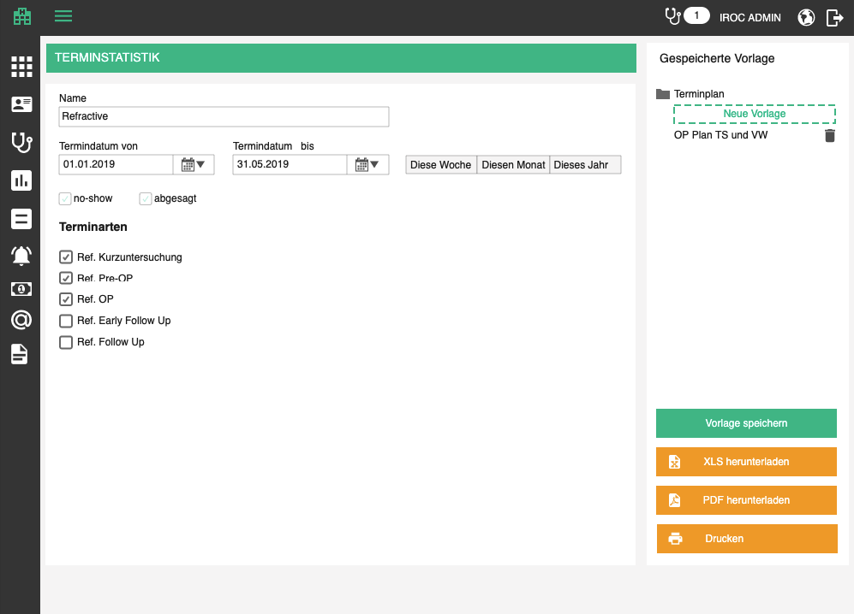

On the report criteria page, the user will select:

- Title / Name - title of the report and template, if saved
- Appointment date from / Termindatum von - date picker; mandatory
- Appointment date to / Termindatum bis - date picker; mandatory
- Shortcuts for dates
  - This week / Diese Woche - sets start date to Monday of this week and end date to Sunday of this week
  - This month / Diesen Monat - sets start date to first date of the current month and end date to the last date of the current month
  - This year / Dieses Jahr - sets start date to first date of the current uear and end date to the last date of the current year
- No-show / No-show - include appointments which are marked as no-show
- Cancelled / Abgesagt - include appointments which are cancelled
- Appointment types / Terminarten - appointment types to include
  - Choose all / Alle wählen
The report will contain appointments which:
- are of specified appointment types
- are booked for any date between start and end date, including those dates
- Are no-shows or cancelled, if it has been specified so; these are counted separately from other regular appointments
Criteria page offers 3 standard buttons:
- Download XLS / XLS herunterladen - downloads the XLS
- Save / Speichern - saves the filter
- Cancel / Abbrechen - returns the user to the report choice page

Downloaded excel looks like the following example.

Tab 1: Weeks / Wochen - displays counted appointments per calendar week, for the selected time range. Every selected appointment type will be a header in the first row. If no-shows and cancellations are included, there will be 3 columns for each appointment type.
- Regular / Regulär
- No-show / No-show
- Cancelled / Abgesagt

Each row will represent the week number and year, as in W01 2019, W02 2019, and so on. Cells contain the count of corresponding appointments.

Last line contains totals.

Tab 2: Months / Monate - displays counted appointments per calendar month, for the selected time range. Every selected appointment type will be a header in the first row. If no-shows and cancellations are included, there will be 3 columns for each appointment type.
- Regular / Regulär
- No-show / No-show
- Cancelled / Abgesagt

Each row will represent the month and year, as in January 2019, February 2019, and so on. Cells contain the count of corresponding appointments.

Last line contains totals.

Appointment statistics

Appointment chains report

For statistical reasons, users will want to download a report which counts instances of a certain appointment type which meet certain criteria. These criteria are the chains, e.g. “All refractive pre-OPs which were followed by a surgery" or “All screenings which resulted in pre-OPs".

This report type is added to the reports and controlling page as
- Appointment chains / Terminketten

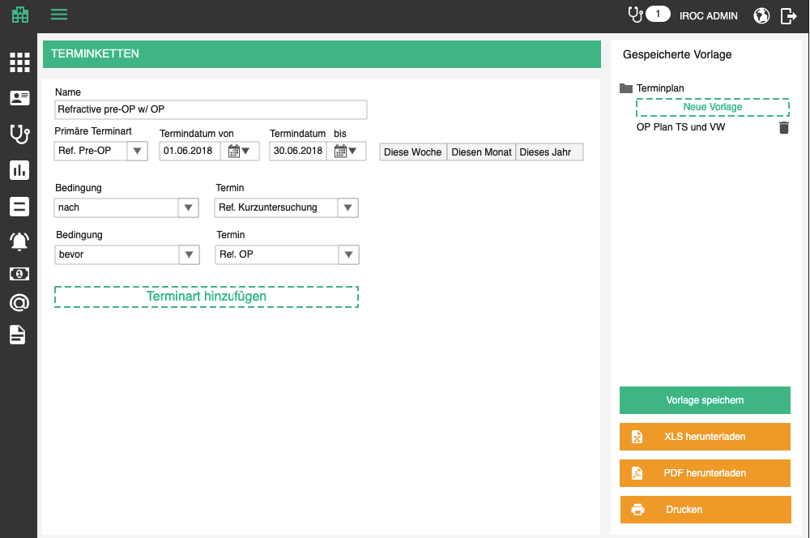

On the report criteria page, the user will select:

- Title / Name - title of the report and template, if saved
- Primary appointment type / Primäre Terminart - appointment type for which we are making the statistic
- Appointment date from / Termindatum von - date picker; mandatory
- Appointment date to / Termindatum bis - date picker; mandatory
- Shortcuts for dates
  - This week / Diese Woche - sets start date to Monday of this week and end date to Sunday of this week
  - This month / Diesen Monat - sets start date to first date of the current month and end date to the last date of the current month
  - This year / Dieses Jahr - sets start date to first date of the current uear and end date to the last date of the current year
- List of relations with other appointment types
  - Condition / Bedingung - relation to another appointment type
    - Before / bevor - primary appointment happened before an appointment of the following type
    - After / nach - primary appointment happened before an appointment of the following type
  - Appointment type / Terminart - type of the related appointment
  - Add appointment type / Terminart hinzufügen - button which adds a new pair of condition - type
The report will contain appointments which:
- are of specified appointment type
- are booked for any date between start and end date, including those dates
- Have an appointment of specified types before / after them
  - Non-primary appointments do not have to fit the time frame
Criteria page offers 3 standard buttons:
- Download XLS / XLS herunterladen - downloads the XLS
- Save / Speichern - saves the filter
- Cancel / Abbrechen - returns the user to the report choice page

Downloaded excel looks like the following example.

Summary row which displays
- Primary appointment type
- Time frame start
- Time frame end
- Conditions met / Bedingungen erfüllt: <number of primary appointments which meet the criteria> / <total number of primary appointments for timeframe>

Detail rows which display:
- Primary appointment date
- Other appointment type names, each has its column
- Patient / Patient

Appointment chains

Patient statistics report

For statistical reasons, users will want to download patient related statistics.

This report type is added to the reports and controlling page as
- Patient statistic / Patientenstatistik

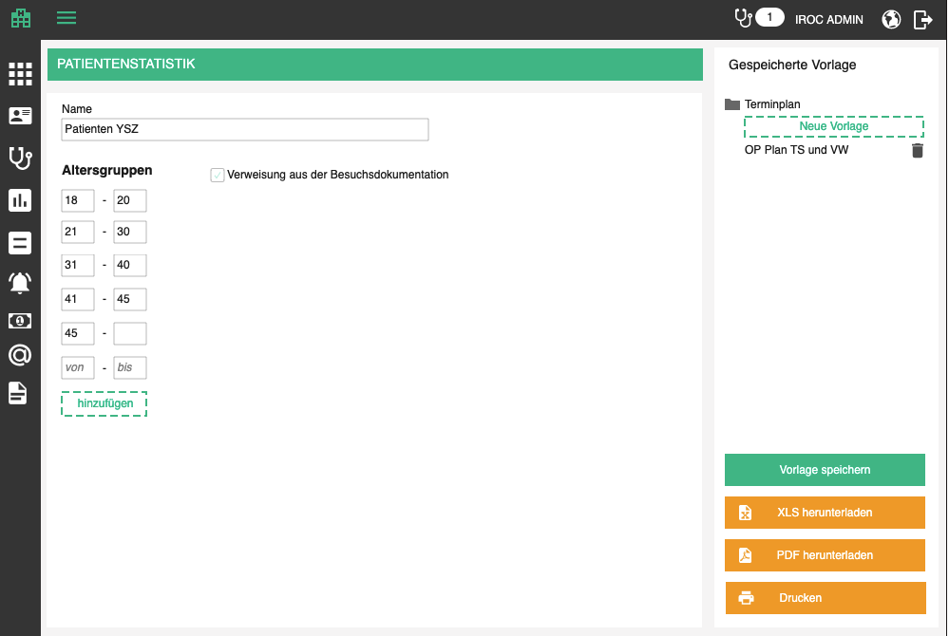

On the report criteria page, the user will select:

- Title / Name - title of the report and template, if saved
- Age groups / Altersgruppen - a list of from-to pairs which represent age groups
  - Each box needs to contain a positive integer
  - From / von - can be empty - such an age group starts from 0
  - To / bis - can be empty - such an age group ends with a very large positive number
  - Add / hinzufügen - adds a new from-to pair
  - All empty from to pairs are purged on save
- Referrals from encounter documentation / Verweisung aus der Behandlungsdokumentation - whether or not to include patient referral sources from documentation forms [Set: RCNL]

The report will contain patients which:
- Are within any of the age groups
Criteria page offers 3 standard buttons:
- Download XLS / XLS herunterladen - downloads the XLS
- Save / Speichern - saves the filter
- Cancel / Abbrechen - returns the user to the report choice page

Downloaded excel looks like the following example.

Tab 1: Age / Alter - shows the number of patients for each of the selected groups
- Men / Männer - number of male patients for age group
- Women / Frauen - number of female patients for age group
- Total / Total - number of patients for age group, regardless of gender

Last row shows summed up totals.

Tab 2: Referral / Verweisung - shows the number of patients which have a certain referral source added to their base data, or any of their encounters, if marked so on the criteria page.

Last row shows summed up totals.

Tab 3: City of residence / Wohnort - shows the number of patients of each city / region / country.
- City / Ort
- Region / Region
- Country / Land
- Men / Männer - number of male patients for city / region / country
- Women / Frauen - number of female patients for city / region / country
- Total / Total - number of patients for city / region / country, regardless of gender

Last row shows summed up totals.

Patient statistics

Refractive values report
This report provides detailed overview of refractive error values and target refraction values from various encounter types, in order to calculate the success of corrective procedures.

This report type is added to the reports and controlling page as
- Refractive values / Refraktionswerte

On the report criteria page, the user will select:

- Title / Name - title of the report and template, if saved
- Encounter date from / Behandlungsdatum von - date picker; mandatory
- Encounter date to / Behandlungsdatum bis - date picker; mandatory
- Documentation form / Dokumentationsmaske
  - Choose all / Alle wählen
The report contains encounters which are documented through selected forms. They are grouped by patient and sorted by patient name. For each patient, the report offers a row for each encounter of selected types, sorted by date (ascending).
Downloaded excel looks like the following example. Columns are:
- Patient / Patient - first name last name
- Date / Datum - date of the encounter
- Documentation form / Dokumentationsmaske
- Subjective / Subjektiv
  - Right / Rechts
    - SHP / SPH
    - CYL / ZYL
    - Axis / Achse
    - Add / Add
    - Sc / Sc
    - Cc / Cc
    - Nv sc / Nv sc
    - Nv cc / Nv cc
    - Pinhole / Lochblende
    - PD / HSA
  - Left / Links
    - SHP / SPH
    - CYL / ZYL
    - Axis / Achse
    - Add / Add
    - Sc / Sc
    - Cc / Cc
    - Nv sc / Nv sc
    - Nv cc / Nv cc
    - Pinhole / Lochblende
    - PD / HSA
- Target refraction / Zielrefraktion
  - Right / Rechts
    - SHP / SPH
    - CYL / ZYL
    - Axis / Achse
  - Left / Links
    - SHP / SPH
    - CYL / ZYL
    - Axis / Achse
- Planned / performed Procedure / Geplantes / durchgeführtes Verfahren -
  - Right / Rechts
  - Left / Links

Criteria page offers 3 standard buttons:
- Download XLS / XLS herunterladen - downloads the XLS
- Save / Speichern - saves the filter
- Cancel / Abbrechen - returns the user to the report choice page

Refraction values

Service billing report
This report provides a list of services with billing details. This helps the administrator detect if there any opportunity costs in the organization.

This report type is added to the reports and controlling page as
- Service billing / Abrechnung von Dienstleistungen

On the report criteria page, the user will select:

- Title / Name - title of the report and template, if saved
- Encounter date from / Behandlungsdatum von - date picker; mandatory
- Encounter date to / Behandlungsdatum bis - date picker; mandatory

The report contains services which are documented in the specified time frame. They are sorted by date of encounters, ascending.

Downloaded excel looks like the following example. It contains two tabs.

Services / Dienstleistungen
- Encounter date / Untersuchungsdatum
- Encounter type / Untersuchungstyp
- Treating doctor / Behandelnder Arzt
- Patient number / Patientennummer
- Patient name / Patientenname
- Patient DOB / Geburtsdatum des Patienten
- Free of charge / Kostenlos
- Documented service / Dokumentierte Dienstleistung
- Billed service / Abgerechnete Dienstleistung
- Non-billed service / Nicht abgerechnete Dienstleistung
- Over-billed service / Überrechnete Dienstleistung
- Bill draft number / Entwurfsnummer

Bills / Rechnungen - contains all bills which have bill draft number which appears on the services tab
- Bill draft number / Entwurfsnummer
- Draft / Entwurf
- Bill number / Rechnungsnummer
- Total [CHF] / Total [CHF]
- Encounter types / Untersuchungstypen
- Treating doctor / Behandelnder Arzt
- Billing office / Rechnungsstelle
- Sent / Übermittelt
- Paid [CHF] / Bezahlt [CHF]
- Fully paid / Vollbezahlt

Criteria page offers 3 standard buttons:
- Download XLS / XLS herunterladen - downloads the XLS
- Save / Speichern - saves the filter
- Cancel / Abbrechen - returns the user to the report choice page

Service billing excel

[Deprecated] Encounter billing report
This report provides a list of encounters with billing details. This helps the administrator detect if there any opportunity costs in the organization.

This report type is added to the reports and controlling page as
- Encounter billing / Abrechnung von Untersuchungen

On the report criteria page, the user will select:

- Title / Name - title of the report and template, if saved
- Encounter date from / Behandlungsdatum von - date picker; mandatory
- Encounter date to / Behandlungsdatum bis - date picker; mandatory
- Documentation forms / Dokumentationsmasken - documentation forms to include
  - Choose all / Alle wählen
- Staff / Personal - staff to include if they are responsible person
  - Choose all / Alle wählen
- Include draft bills / Rechnungsentwürfe einschließen – checkbox, if checked, draft bills are taken into consideration when checking which services have been billed

The report contains encounters which are documented through selected forms, by selected responsible people in the specified time frame. They are sorted by date of encounters, ascending.

Important: If a medical service was performed but not billed, check if all its billable positions are on the bill (through other services) and if yes list it under billed services.

Downloaded excel looks like the following example. Columns are:
- Date / Datum - date of the encounter
- Responsible staff / Verantwortliches Personal
- Documentation form / Dokumentationsmaske
- Appointment variant / Terminvariante
- Patient / Patient
- Birth date / Geburtsdatum
- Status / Status
  - finished / fertig
  - open / offen
- Free of charge / Kostenlos - yes / ja / no / nein
- Unbilled services / Nicht abgerechnete Dienstleistungen - comma separated list of not billed delivered services
- Billed services / Abgerechnete Dienstleistungen - comma separated list of billed delivered services
- Total CHF / Total CHF - sum of all the bills for this encounter

Criteria page offers 3 standard buttons:
- Download XLS / XLS herunterladen - downloads the XLS
- Save / Speichern - saves the filter
- Cancel / Abbrechen - returns the user to the report choice page

[Deprecated] Not billed encounters report
This report provides a list of finished encounters with unbilled services. This helps the administrator detect if there any opportunity costs in the organization.

This report type is added to the reports and controlling page as
- Not billed encounters / Nicht abgerechnete Untersuchungen

On the report criteria page, the user will select:

- Title / Name - title of the report and template, if saved
- Encounter date from / Behandlungsdatum von - date picker; mandatory
- Encounter date to / Behandlungsdatum bis - date picker; mandatory
- Documentation forms / Dokumentationsmasken - documentation forms to include
  - Choose all / Alle wählen
- Staff / Personal - staff to include if they are responsible person
  - Choose all / Alle wählen
- Include draft bills / Rechnungsentwürfe einschließen – checkbox, if checked, draft bills are taken into consideration when checking which services have been billed

The report contains finished encounters which are documented through selected forms, by selected responsible people in the specified time frame, which have at least one not billed service. They are sorted by date of encounters, ascending.

Downloaded excel looks like the following example. Columns are:
- Date / Datum - date of the encounter
- Responsible staff / Verantwortliches Personal
- Documentation form / Dokumentationsmaske
- Appointment variant / Terminvariante
- Patient / Patient
- Birth date / Geburtsdatum
- Free of charge / Kostenlos - yes / ja / no / nein
- Unbilled services / Nicht abgerechnete Dienstleistungen - comma separated list of not billed delivered services
- Billed services / Abgerechnete Dienstleistungen - comma separated list of billed delivered services

Criteria page offers 3 standard buttons:
- Download XLS / XLS herunterladen - downloads the XLS
- Save / Speichern - saves the filter
- Cancel / Abbrechen - returns the user to the report choice page

Unbilled encounters

[Deprecated] Open encounters report
This report provides a list of open encounters. This helps the administrator detect if there any open encounters.

This report type is added to the reports and controlling page as
- Open encounters / Offene Untersuchungen

On the report criteria page, the user will select:

- Title / Name - title of the report and template, if saved
- Encounter date from / Behandlungsdatum von - date picker; mandatory
- Encounter date to / Behandlungsdatum bis - date picker; mandatory
- Documentation forms / Dokumentationsmasken - documentation forms to include
- Staff / Personal - staff to include if they are responsible person
The report contains open (not finished) encounters which are documented through selected forms, by selected responsible people in the specified time frame. They are sorted by date of encounters, ascending.

Downloaded excel looks like the following example. Columns are:
- Date / Datum - date of the encounter
- Responsible staff / Verantwortliches Personal
  - Choose all / Alle wählen
- Documentation form / Dokumentationsmaske
  - Choose all / Alle wählen
- Appointment variant / Terminvariante
  - Choose all / Alle wählen
- Patient / Patient
- Birth date / Geburtsdatum

Criteria page offers 3 standard buttons:
- Download XLS / XLS herunterladen - downloads the XLS
- Download PDF / PDF herunterladen - downloads the data from the XLS as a PDF
- Print / Drucken - button shows the choose printer popup, which sends the PDF to printing

Open encounters

Template documents generation
Template documents are word documents (see document templates) with placeholders which get replaced by real data by the document management service. Depending on the type of document, different placeholders will be available for replacement and different input parameters will be asked from the user before generation.

For example, appointment based templates will be generated from a chosen appointment. As such, they will have all the important appointment and patient data to replace the placeholders. However, the procedure consent form requires doctor and office data which is not necessarily part of the appointment, and this data needs to be specified by the user explicitly.

When the user initiates the document generation process, a popup will appear
- Staff / Personal - doctor who is signing the prescription; dropdown with doctors; mandatory
  - Preselect currently logged in user, if they are on the Staff list
- Recipient / Recipient - the business participant who is the recipient of the document, displayed as <display name> (<type>); types can be
  - Patient / Patient
  - Referrer / Zuweiser
  - Referring doctor / Zuweisender Arzt
  - Specialist / Spezialarzt
  - Family doctor / Hausarzt
  - Therapy/Care / Therapie/Pflege
  - Alternative contacts (1...n), represented by their type (e.g. Emergency, Legal representative)
  - Employer / Arbeitgeber
  - Main health insurance / Gesetzliche Krankenversicherung
  - Main accident insurance / Gesetzliche Unfallversicherung
  - Disability insurance / Invaliditätsversicherung
  - Other insurance / Sonstige Krankenversicherung
  - Private health insurance / Private Krankenversicherung
  - Private accident insurance / Private Unfallversicherung
- Language / Sprache - dropdown with all tenant languages; mandatory
- Template / Vorlage - dropdown with all suitable document templates
- Download / Herunterladen - confirm button
- Cancel / Abbrechen - cancel button
- Download document / Dokument herunterladen - title

User clicks on “download” button, and a document is created based on template data and patient and appointment data.
If during the compilation of the message (replacing placeholders with actual data) some data is not available, the placeholder will be replaced by nothing (will remain empty).

Every template needs to have the desired language selected. The default is the current language of the application, but the user can select any of the available languages of the tenant. However, if there is no template document uploaded for the selected language, the app will display an error bubble and nothing will be generated.
- No template available for <language name>. / Für <language name> ist keine Schablone verfügbar.

Created Word document is uploaded to corresponding patient’s archive (if patient present). In these cases, the app will offer the user an option to download the Kordeus file (see Kordeus File Helper section for details), so that the changes are uploaded to the patient archive automatically.

Still, some users don’t have or want the Kordeus File Helper, so they need an option to download the plain Word file. This decision will be made via popup which appears just before the file is downloaded.

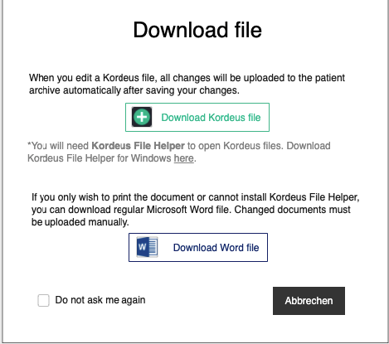

Download file / Datei herunterladen

When you edit a Kordeus file, all changes will be uploaded to the patient archive automatically after saving your changes. / Wenn Sie eine Kordeus-Datei bearbeiten, werden alle Änderungen nach dem Speichern automatisch in Ihr Patientenarchiv hochgeladen.

Download Kordeus file / Kordeus-Datei herunterladen

You will need *Kordeus File Helper tool to open Kordeus files. Download Kordeus File Helper for Windows here. / * Zum Öffnen von Kordeus-Dateien benötigen Sie den Kordeus File Helper. Den Kordeus File Helper für Windows können Sie hier herunterladen.

If you only wish to print the document or cannot install Kordeus File Helper tool, you can download regular Microsoft Word file. Changed documents must be uploaded manually. / Wenn Sie das Dokument nur ausdrucken möchten oder den Kordeus File Helper nicht installieren können, können Sie die normale Microsoft Word-Datei herunterladen. Geänderte Dokumente müssen in diesem Fall manuell hochgeladen werden.

Download Word file / Word-Datei herunterladen

[ ] Do not ask me again / [ ] Nicht noch mal fragen

Cancel / Abbrechen

Kordeus and Word icons will slowly teach the user the difference between these files and they will associate Kordeus icon with automatic upload.

Kordeus File Helper link goes to a html page where they can download instructions and installation zip.

Appointment documents are generated from calendar or patient history, i.e. wherever there is an appointment available. When the user gets available actions for an appointment in the calendar, one of those actions will be “Documents / Dokumente”.

Patient documents are generated from patient history “Documents / Dokumente” button.

Encounter documents are generated from masks “Documents / Dokumente” button, located on the navigation panel. This button shall be available as an option in patient history and general history, for every encounter.

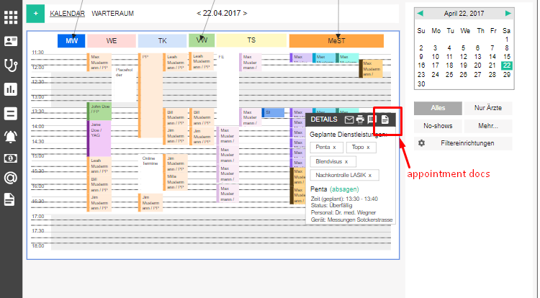

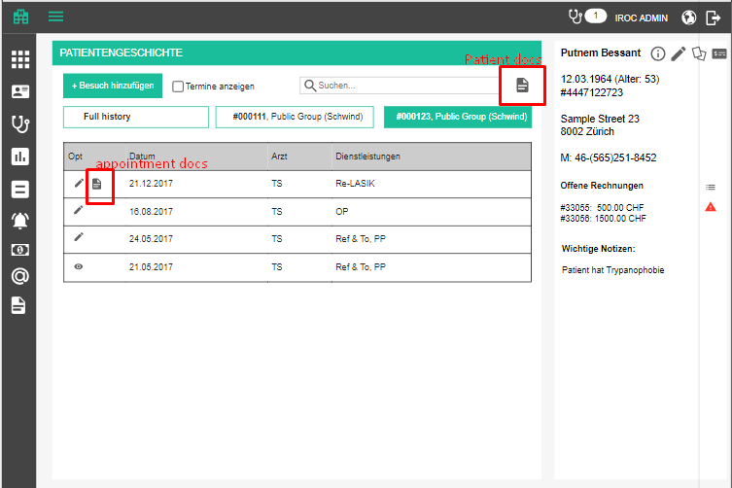

Clicking on this option will display a popup with the following options to select:
- Create document / Dokument erstellen - title
- Staff / Personal - dropdown with all available doctors who have an office defined (similar as in when we choose a doctor for bills)
  - Preselect currently logged in user, if they are on the Staff list
- Language / Sprache - language in which the document will be printed
- Document template / Dokumentschablone - list of document templates of type “Appointment documents” for appointments and “Patient documents” for patient
- Download / Herunterladen - confirmation button, generates the document and starts download
- Cancel / Abbrechen - cancel button

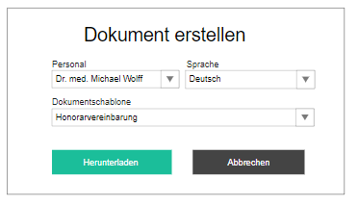

Tasks (old Reminders)
We detected a need to lift the appointment reminders to a more generic level and enable the users to create tasks for their colleagues and themselves. These tasks can be to make an appointment for a patient (like we had so far), or to call the patient back, or anything and everything else.

Tasks overview

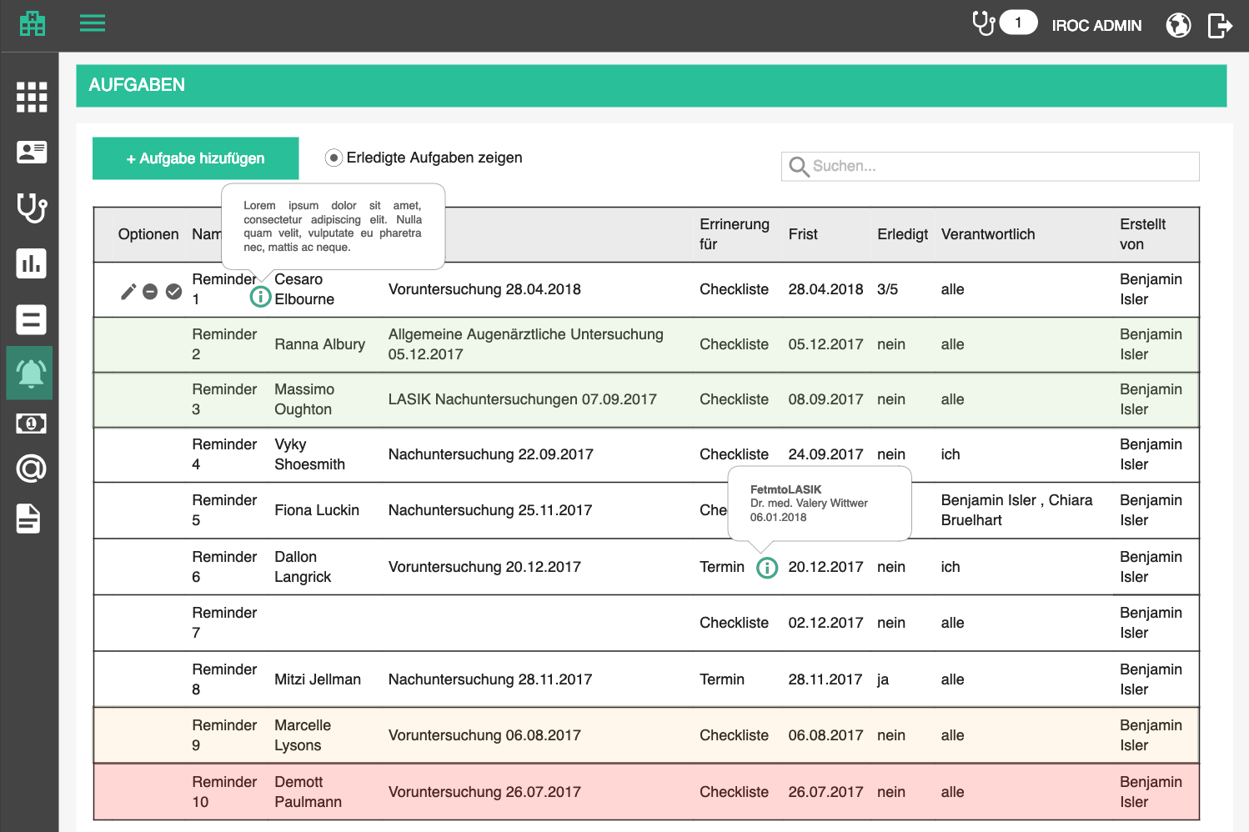

Overview is a table which contains all tasks made by the currently logged in person, tasks for currently logged in person, and public tasks. It contains the following columns:
- Tasks / Aufgaben - page title
- Options / Optionen
  - Edit
  - Mark as done
  - Delete
  - Send email / Email schicken – opens the send email form; disabled if patient has no email address defined
  - Book appointment / Termin buchen
    - Available only for appointment reminder tasks
    - After an appointment is booked over task, the task is automatically marked as done
    - Opens appointment booking screen and prefills the following data
      - Target date -> slot calculation start timeframe
      - Preferred staff -> Any matching key resource
      - Appointment type -> Appointment type
      - Appointment variant -> Appointment variant
      - Appointment steps -> Appointment steps
      - Comment -> Appointment comment
  - Document template / Dokumentvorlage - does exactly the same as on patient history page, plus adds an entry to task protocol
    - Type: other
    - Comment: Created document <document name> / Dokument <document name> wurde erstellt
  - Activity log / Protokoll - Go to activity log
- Task title / Aufgabentitel
  - Info icon if description is specified, description appears in a tooltip on hover
- Patient / Patient
  - Link to patient history
- Encounter / Behandlung
  - Link to encounter
- Type / Typ
- Details / Details
  - If appointment reminder
    - Book appointment link
    - <Appointment type + variant> with <doctor> on <date>
  - If checklist
    - list of checklist items, with indicator which ones are done
  - If email reminder
    - Send email link
- Due date / Frist
  - Also display time if not 00:00
- Done / Erledigt
- Last action / Letzte Aktivität - title and date of last action in the action log
- Responsible / Verantwortlich - all / alle, me / ich, <comma separated list of assignees>
- Created by / Erstellt von - name of creator

If there are any private tasks, show a label under the table:
- +<number> private tasks by <comma separated list of creators, sorted alphabetically>
- a private task is a task assigned to people other than the current user, which is why they do not see it

The list is sortable by all columns (except options, of course). Default sorting is by title, alphabetically.
The list should be search-able by all columns, except for “Done”. Search starts as soon as you type, but with a small debounce. Check the rest of the app for guidance.

When the searched list is empty, the following text is displayed instead of the first row:
- There are no matching tasks for this search criteria. / Es gibt keine passenden Aufgaben für diese Suchkriterien.

When the list is empty in general, the following text is displayed instead of the first row:
- There are no tasks defined. / Es gibt keine definierten Aufgaben.

Border color of a row depends on the due date:
- Due date up to today (including today) and not done = error color as a thick left border on the row
- Due date in next two weeks (starting tomorrow) and not done = warning color as a thick left border on the row
- Due date in two to four weeks and not done = neutral color as a thick left border on the row
- Due date in more that four weeks or done = no color

Menu item icon has a notification bubble which displays the number of tasks which are marked with critical color.

The table displays only open tasks by default, but the user can see the done ones by checking the checkbox
- Show done tasks / Erledigte Aufgaben zeigen

Add / edit task - Base data

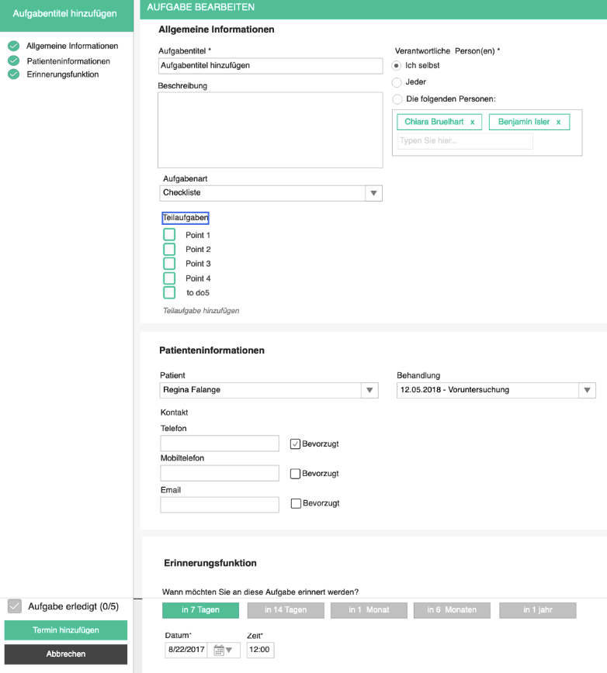

Adding and editing relies on the same form, only in case of editing, the data will be prifilled with existing data. In the top right corner, the title of the currently added / edited task is displayed and changes whenever the user changes title.

Adding a task is started by clicking on the add button above the table
- Add task / Aufgabe hinzufügen

Editing is started by clicking on the edit button in the corresponding row in the table
- Edit task / Aufgabe bearbeiten

Base data is opened by default and there the user can specify the following attributes
- Base data / Stammdaten - page title
- Title / Name - mandatory
- Description / Beschreibung - text area, optional
- Responsible Person / Verantwortliche Person(en) (radiobuttons)
  - Myself / Ich selbst - assigns the task to currently logged in user
  - Everyone / Jeder - sets as public for everyone to see, default
  - The following persons / Die folgenden Personen - tag-like component for adding people via autocomplete
- Notification / Erinnerungsfunktion - checkbox which indicates whether or not users will be reminded about the approaching due date and time, unchecked by default
- When would you like to be reminded of this task? / Wann möchten Sie an diese Aufgabe erinnert werden?
- Due date / Frist - date until when the task must be done, optional
  - Time / Zeit - also optional, default is 00:00
- Patient / Patient - autocomplete with patients same as on appointment booking, optional
- Contact / Kontakt (contact data taken from the patient and if changed saved into patient)
  - Phone / Telefon (Preferred / Bevorzugt checkbox )
  - Mobile phone / Mobiltelefon (Preferred / Bevorzugt checkbox )
  - Email / Email (Preferred / Bevorzugt checkbox )
- Encounter / Behandlung - autocomplete with all the encounters for the selected patient, optional
  - Keep the encounter open until done / Hält die Behandlung offen bis Aufgaben erledigt sind - if checked the task will disable the Finish button on the encounter form

- Task type / Aufgabenart
- Checklist / Checkliste + x/y (x done of y items)
  - Default task type
  - User can specify, check and uncheck sub-tasks
    - When all checkboxes are checked, the task goes into “done” status
  - Add sub task / Teilaufgaben hinzufügen - becomes a text field where the user specifies the text and clicks enter to save
- Appointment reminder / Terminerinnerung + booked / gebucht checkbox
  - User can check the checkbox and change the status to “done”
  - Staff / Personal - optional
  - Appointment type / Terminart – mandatory
  - Appointment type variant / Terminvariante – mandatory
  - Appointment steps - mandatory
  - When should the appointment take place? / Wann soll der Termin stattfinden? - mandatory, by default same as task deadline
- Email reminder / Email Erinnerung + sent / geschickt checkbox
  - User can check the checkbox and change the status to “done”
  - Email template / Email Schablone - autocomplete box in which the user selects the template which will be used
  - Send / Schicken - icon which opens the send email screen with email constructed of template and placeholder data; enabled only if patient is connected to task and patient has email
  - When an email is sent by this action, an email action is automatically logged, with email body in the comment
- Finished task / Aufgabe erledigt

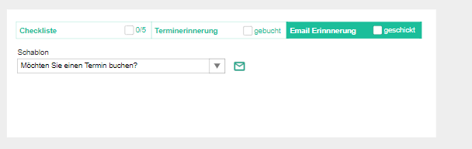

The page offers 3 standard buttons:

- Save / Speichern - executes all the validations and displays errors if necessary, otherwise saves the changes and displays the success message
- (if adding new) Task has been successfully created. / Aufgabe wurde erfolgreich erstellt.
- (if editing) Task has been successfully updated. / Aufgabe wurde erfolgreich aktualisiert.

- Cancel / Abbrechen - go back to overview withought saving changes
- Back to overview / Zurück zur Übersicht - go back to overview withought saving changes

If the user tries to leave the page after some changes have been made but not yet saved, the app will warn them with the standard "Are you sure you want to leave this page..." popup. This functionality should be applied to all pages, always.

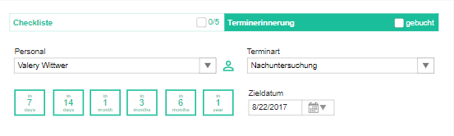

When the user tries to switch between checklist / appointment task type, we will ask for confirmation because the data will be lost.
- Are you sure you want to change the task type? <Checklist / Appointment> data will be lost. / Möchten Sie den Aufgabentyp wirklich ändern? <Checkliste / Termin> Daten gehen verloren.

When a task is created or edited, an automatic action log item with the current date is created (see Action log).
- Comment: Task created / Aufgabe erstellt OR Task edited / Aufgabe bearbeitet
- Action: Data change
- Date: current date

Delete task

Upon clicking on the delete icon, the user will be prompted by a standard confirmation popup.
- Delete task / Aufgabe löschen
- Are you sure you want to delete <task name>? / Sind Sie sicher, dass Sie <task name> löschen möchten?

When a task is deleted, an automatic action log item with the current date is created (see Action log).
- Comment: Task deleted / Aufgabe gelöscht
- Action: Deletion
- Date: current date

Mark task as done

Upon clicking on the done icon, the task will be set to done, and if it has any sub-tasks (checklist), they will all be marked as done.
- Mark task as done / Aufgabe als erledigt markieren

When a task, or one of its checklist items is marked as done or not done, an automatic action log item with the current date is created (see Action log).
- Comment: “<checkbox title>”/Task marked as done / “<checkbox title>”/Aufgabe beendet OR “<checkbox title>”/Task opened / “<checkbox title>”/Aufgabe geöffnet
- Action: status change
- Date: current date

Tasks on encounter forms

Since some tasks can be connected to encounters, and, additionally, prevent an encounter from being finished, we will have to show them on a suitable form.

In the navigation panel of a form, display the list of open tasks connected to the patient, sorted by due date, ascending. Tasks which are connected to the encounter are marked to be distinguishable from other tasks connected to the current patient. Tasks which block the encounter from being finished should be highlighted in warning color. Until they are done, the Finish button is disabled and shows a message
- This encounter has unfinished blocking tasks / Diese Behandlung hat nicht erledigte Blockierungsaufgaben

Each tasks is displayed as an expandable and collapsible panel. When collapsed, it shows
- Due date
- Title
- x/y done for checklist
- Checkbox for appointment reminder, email reminder or task without checklist
When expanded, it also shows
- Description
- Checklist with an option to change status, if checklist
- Appointment type, target date and preferred staff, if appointment reminder
- Email template and send email icon, if email reminder

Changing status on encounter form creates an action in action log. (see Action Log)

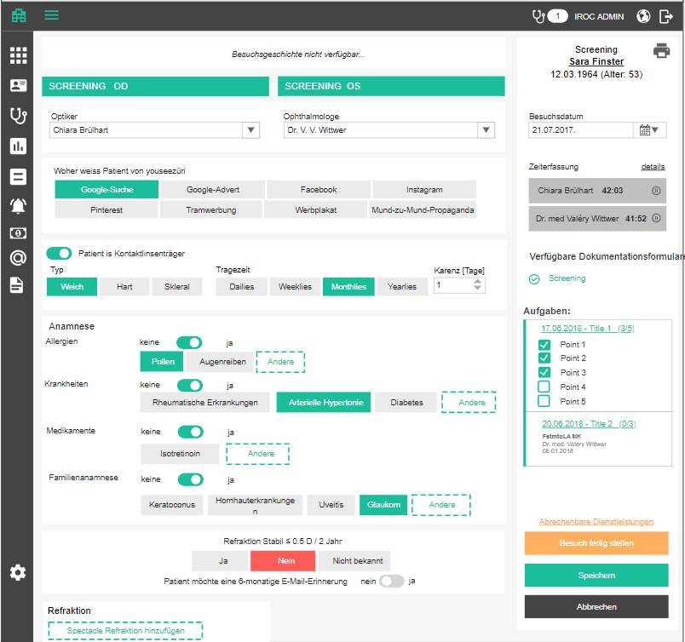

Task Action Log

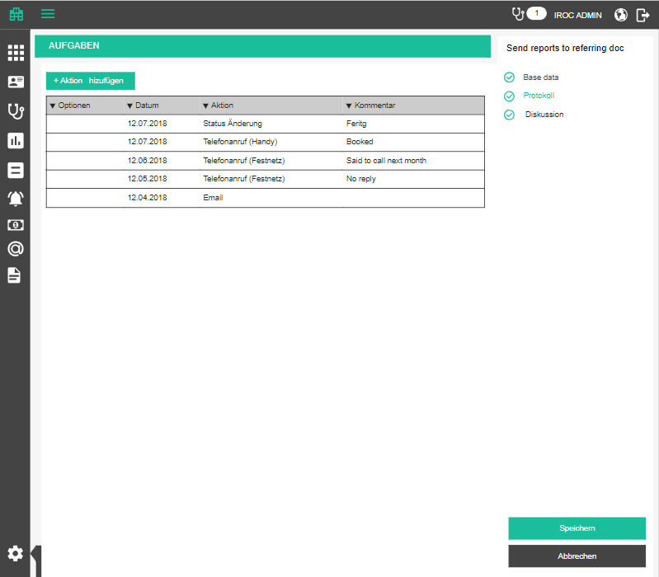

Log / Protokoll - tab title

Action log tab contains all the actions which were taken on one task. Some of these actions are added manually, by the user, and some are created automatically. An example of automatically created action items is marking a task or a checklist item as done.

The tab contains a table with all the action items, sorted by date, descending.

- Options / Optionen (edit, delete)
- Date / Datum - date when the action was captured
- Action / Aktion
- Comment / Kommentar

User can sort by all columns, except for options, of course.

Adding and editing relies on the same popup, only in case of editing, the data will be prifilled with existing data.

Adding an action is started by clicking on the add button above the table
- Add action / Aktion hinzufügen

Editing is started by clicking on the edit button in the corresponding row in the table
- Edit action / Aktion bearbeiten

Popup has the following data:
- New action / Neue Aktion OR Edit action / Aktion bearbeiten - title
- Date / Datum - date and time when the action was captured- mandatory, current date default
- Action / Aktion - a dropdown with catalog data
  - Email / Email
  - Phone call (mobile) / Telefonanruf (Mobil)
  - Phone call (landline) /Telefonanruf (Festnetz)
  - Status change / Status Änderung
  - Data change / Daten Änderung
  - Deletion / Löschung
  - Other / Sonstige [default]
- Comment / Kommentar - optional

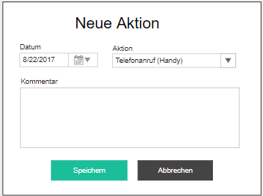

Delete action

Upon clicking on the delete icon, the user will be prompted by a standard confirmation popup.
- Delete action / Aktion löschen
- Are you sure you want to delete this action? / Sind Sie sicher, dass Sie diese Aktion löschen möchten?

Task discussion
To be defined

Statistics

Doctor service performance

With billing functionalities, we are introducing another statistic: Doctor service performance. The goal of this statistic is to give a financial manager or controller an insight in how often each of the medical services is billed. This is important because clinics lose money by forgetting or neglecting billing of certain services they perform, especially if the bills are created days after an encounter was done. A lot of things go unnoticed or forgotten, and a simple service (e.g. a test performed on a patient) which lasts 3 minutes, is done on almost every patient and never gets billed, creates an opportunity cost, i.e. the practice could have been reimbursed by the HIP and was not because they did not the medical service on the bill!

Each encounter has a set of planned medical services which can all theoretically be billed. Sometimes not all of them will be performed, and that’s ok, but more often we will have the situation that the ones which are performed are not getting billed.

This statistic will display, for a chosen appointment type, how many times (on average) does each selected doctor bill each planned medical service. This way, a controller can clearly see if someone is forgetting to bill some services regularly and remind them not to forget to bill them in the future.

To clarify to the users what this statistic actually means, display the explanation on hover over an info icon next to the statistic title:
- This statistic shows the average number of times each of the selected doctors has billed a medical service planned within the selected appointment type. The average indicator shows an overall average number of billings for each of the services. / Diese Statistik gibt an, wie oft durchschnittlich jeder der ausgewählten Ärzte jede medizinische Dienst in der ausgewählten Terminart abgerechnet hat. Der Durchschnittsindikator zeigt eine durchschnittliche Zahl von Abrechnungen für jeden der Dienste an.

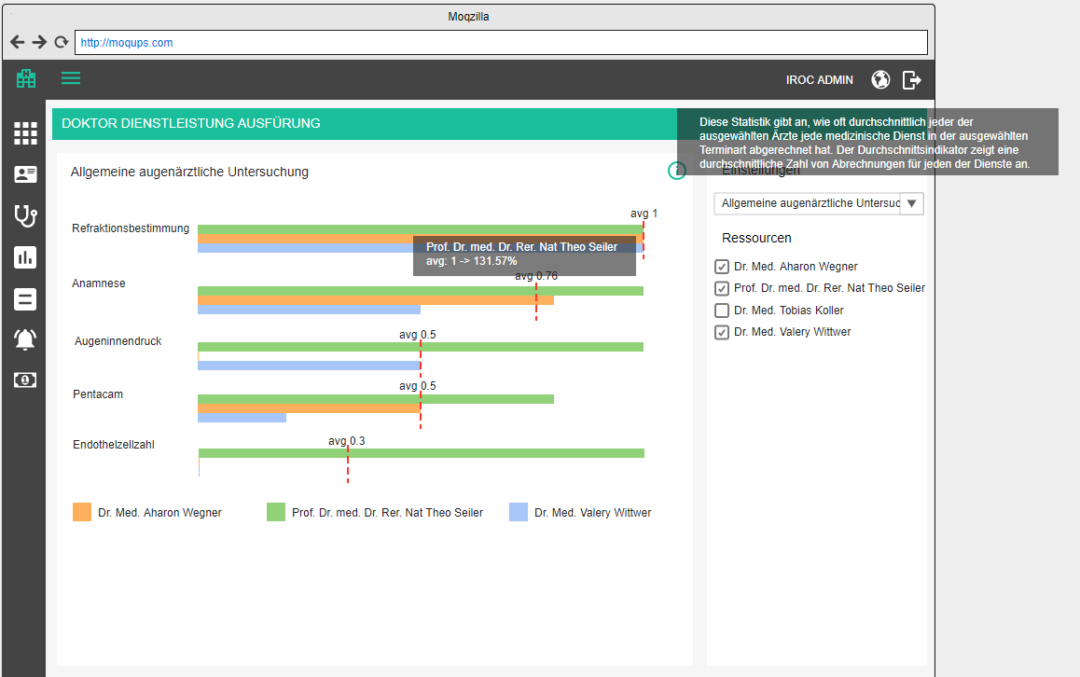

The user will first select an appointment type and the doctors they wish to compare. The Y axis will list all the medical services ever scheduled for appointments of that type. They will be sorted by the mean number of billings, descending (more about mean number of billings later).

The X axis displays, for each selected doctor, the average number of times (value from 0 to 1, rounded up to 2 decimal points) each doctor has billed that service in an encounter instantiated from that appointment type. In addition to that, for each medical service, we will have an overall average billing frequency for that service displayed as a dashed vertical red line with the average value on top of it. The average value is the number of all the times this service has been billed, divided by the number of times the service has been planned (rounded to 2 decimal points). This information will give us an insight in how the selected doctors are performing compared to the overall average.

At one point, the users might want to also display the results for a time frame, so please take that into consideration when creating the methods to fetch the data. By default, the time frame is from forever to forever.

Details about the UI

The user can select an appointment type and pick one or more doctors
- Settings / Einstellungen - subtitle in the top right corner
- Appointment type / Terminart - dropdown with all appointment types, sorted alphabetically, the first one is selected by default
- Resources / Ressourcen - a checkbox list with all the staff who are doctors, user can select multiple, select the first two by default

For every medical service, display the name on the left side of the graph and average on the right side. The width of each graph corresponds to the maximum average number of billings for the current selection. Technically, a medical service can be billed more than once per encounter, so that is the reason. The line for each of the selected doctors will be the fraction of that maximum average frequency.

When the user hovers over a doctor's line, the details will be displayed on a tooltip
<academic title> <First name> <Last name>
avg: <doctor's billing frequency> -> <percentage of that frequency compared to the total average>

Doctor's lines are assigned colors (consult a designer about the pool of colors which we may use) and below the graph display the legend as
<square in doctor's color> <academic title> <First name> <Last name>

Capacity statistic adaptations

Make a menu item group for the existing 2 statistics, because we will have more of those eventually.

Add the info icon to capacity statistics, to explain to the user what the page is good for.
- This statistic shows the ratio between planned working hours and hours booked for appointments, for a selected resource in the selected timeframe. If the ratio is below 50%, the bar is purple. For ratio between 50% and 120%, the bar is green. For ratio between 100% and 120% the bar is orange. For ratio over 120% the bar is red, to indicate that the resource is significantly overbooked. / Diese Statistik zeigt das Verhältnis zwischen geplanter und geleisteter Arbeitszeit für eine ausgewählte Ressource im ausgewählten Zeitraum. Wenn das Verhältnis unter 50% liegt, ist der Balken violett. Für ein Verhältnis zwischen 50% und 120% ist der Balken grün. Für ein Verhältnis zwischen 100% und 120% ist der Balken orange. Bei einem Verhältnis über 120% ist der Balken rot, um anzuzeigen, dass die Ressource erheblich überbucht ist.

Documentation API (technical documentation)

Delivered services detection
Although we will let the user (doctor) check which services they delivered and want to bill, we will also like to make their life easier and pre-select the services which were documented.

We can set up formulas which indicate, based on documented patient data and performed procedures on a certain form, if a medical service has been delivered. E.g. If we have a value for SPH (spherical refraction value) that means that Refraction medical service has been delivered.
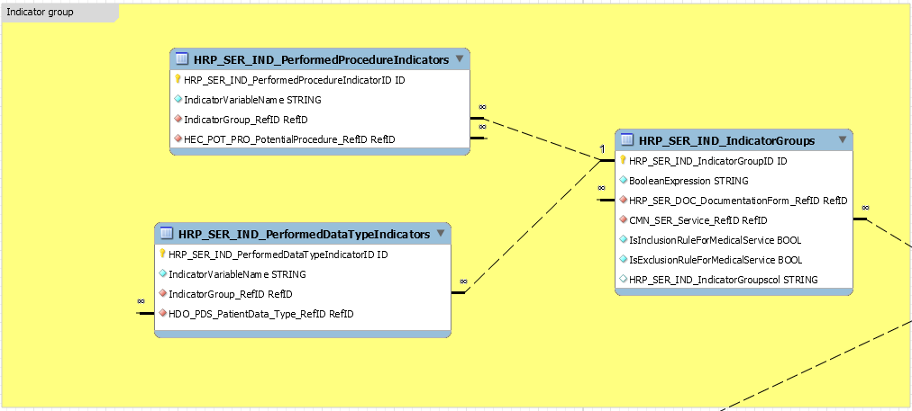

These formulas will eventually be administered from a UI, but for now they will be imported into the database.

Documentation API should provide a list of potential medical services for each documentation form, together with their indicator groups.

Parameters:
- List of Documentation Form IDs
Return:
- List of potential medical services with
  - ID
  - Name
  - Description
  - List of Indicator Groups with formulas

Delivered services statuses
Every time a delivered services is checked or unchecked on delivered and billable page, we have to change its status and capture which user changed it. The available statuses:
- Ready for billing / Bereit für Abrechnung - when the service is checked
- Not ready for billing / Nicht bereit für Abrechnung - when service is unchecked
- Billed / Abgerechnet - when services has been included in a bill; when in this status, the checkbox in UI is disabled for editing

Note: PM team and Mathias should share the GIDs which will be used for these statuses, as they are catalog entries

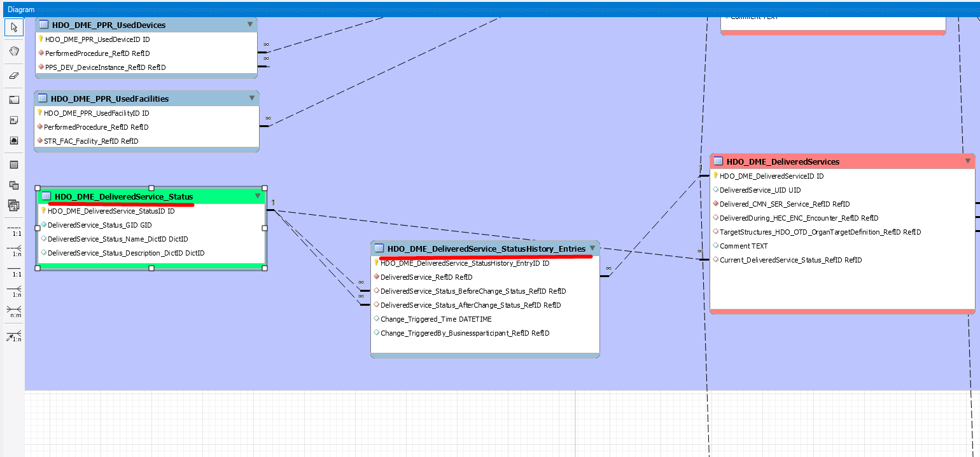

Basically, the API should do the following:
- Create a new entry in the status history table with new status GID and link it to the previous status GID
- Set the business participant to the new status history entry
- Timestamp the new status history entry

Parameters:
- Delivered service ID
- Business participant ID
- New status GID
Return:
- Success status

Consumed materials adaptation
Consumed materials currently take only product ID, but we need to specify GID, similar to used devices, for example.

In addition to that, the consumed materials should be adapted to use IfApplied_TargetStructures_HDO_OTD_OrganTargetDefinition_RefID
Instead of IfApplied_Location_HEC_OST_OSE_OrganStructureElement_RefID because this will enable us to specify multiple organ structure elements for the same consumed materials.

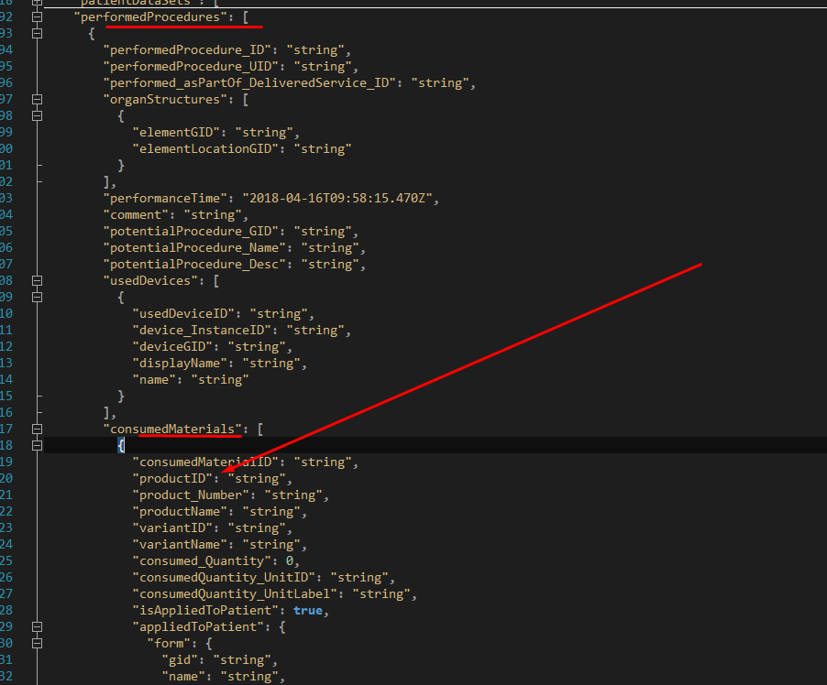

Handed out materials

Similar to consumed materials, we will have handed out materials. These are usually products which are handed out to the patient during an encounter, e.g. pain relief medication or antibiotics.

The structure is similar to consumed materials, except for the fact that all handed out materials will be handled as positions on one handed out materials header which is connected directly to the encounter.

The user will also be able to prescribe start and end date of the medication as well as textual representation of application plan, e.g. 3x/d = three times a day.

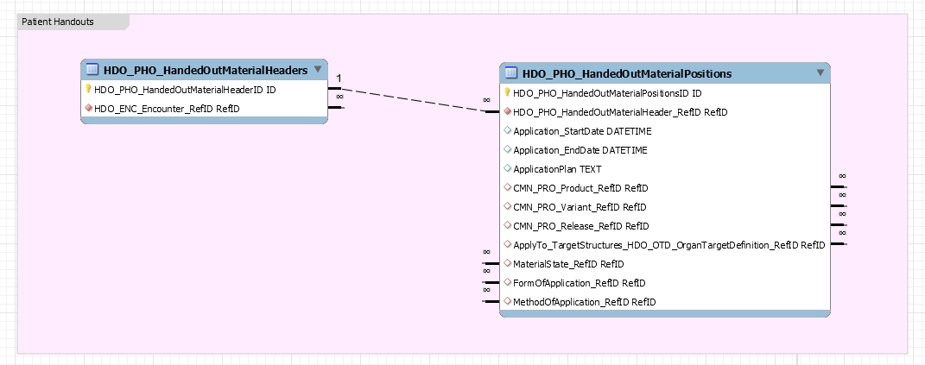

Open encounter
Just like closing an encounter, we need a way to re-open it and capture the user who did it.

Encounter history
While working on one encounter, the user will need data from other encounters, such as: refraction history, allergies and a timeline of all encounters. Documentation for developers need to get access to this data.

Depending on the complexity and performances, we could go with either of these approaches:
- Fetch all encounters for a patient
  - This might be a lot of data if the patient has a long history
  - On the other hand the approach is pretty straight forward
- Fetch an “overview” of encounters, such as ID, date and title, and the developers get details from any encounter by fetching its data

Patient data item comment

More and more often we have the need to store a user’s comment connected to a certain data type. Currently the only possible option is to create another patient data type which is of type string. This will bring us to the point of having a lot of redundant patient data types.

For that reason, we want to add an optional, free text comment to patient data item. DocAPI needs to be extended to save this comment field.

Encounter billing comment

The doctor who selects the delivered services to be billed at the end of an encounter can enter a free text comment which might be important to the person who creates bills based on this encounter. This field is now a part of Encounter entity and should be saved by DocAPI.

Case upload and PMC changes

Since case upload relies on medical services, which can be user defined, we can soon end up with a plethora of GIDs which are related to pretty similar things which need to be taken into consideration.

For example: From Schwind’s perspective, a case consists of one refractive surgery pre-op, one refractive surgery and one or more refractive surgery post-ops.

Some practices will have three medical services: pre-op, po and post-op. Some will call them differently. Some (like YOUSEEZUERI) will have two different medical services for op: LASIK and FemtoLASIK because they bill them differently (femto is more expensive) and two different services for post-op: early and late follow up (because early follow up is free of charge and later ones are charged). This leads us to a situation where case upload and PMC will have to check for LASIK, FemtoLASIK and RefOP GIDs when it comes to what a refractive surgery service is, and so on.

To solve this issue, we introduced meta-services, which are virtually service types. They come from catalog only (users cannot define their own, but rely on what is offered) and the user can connect their services to offered meta-services, which will signify that, e.g. both LASIK and FemtoLASIK are refractive surgery.

Case detection mechanism has to look at each service in an encounter and check if it is of suitable meta-service.

PMC graphs have to also look at meta-service of each service to detect if it is a pre-op, op or post-op.

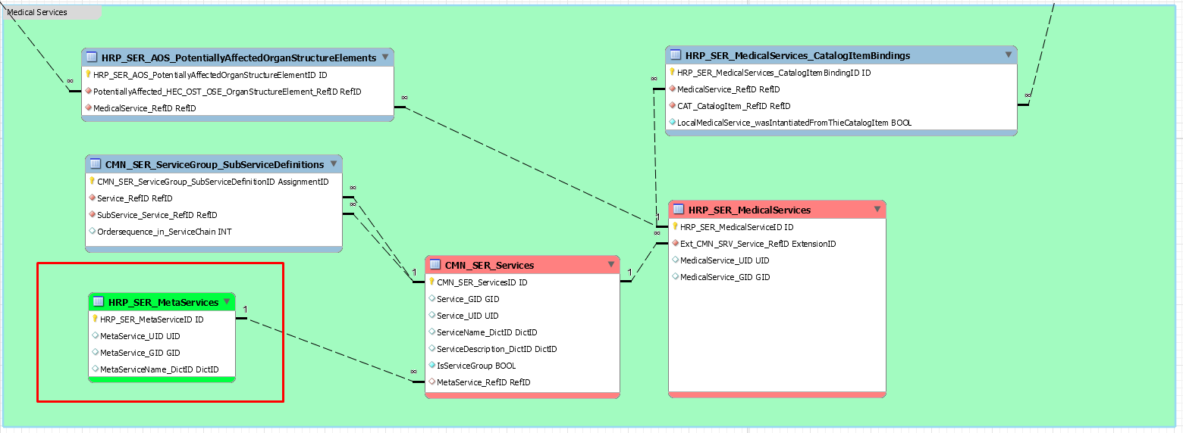

Documentation Context and PMC changes

Out of the need to specify the same entity for more than one purposes within one encounter, we introduced documentation contexts. Namely, we have situations where, e.g. the same device can be used for two different purposes, and we need to know what those purposes are.

In case of patient data items, we have sets to group them together. But devices, handed out materials and consumed materials could not be contextualized before. This is why Documentation Context was introduced.

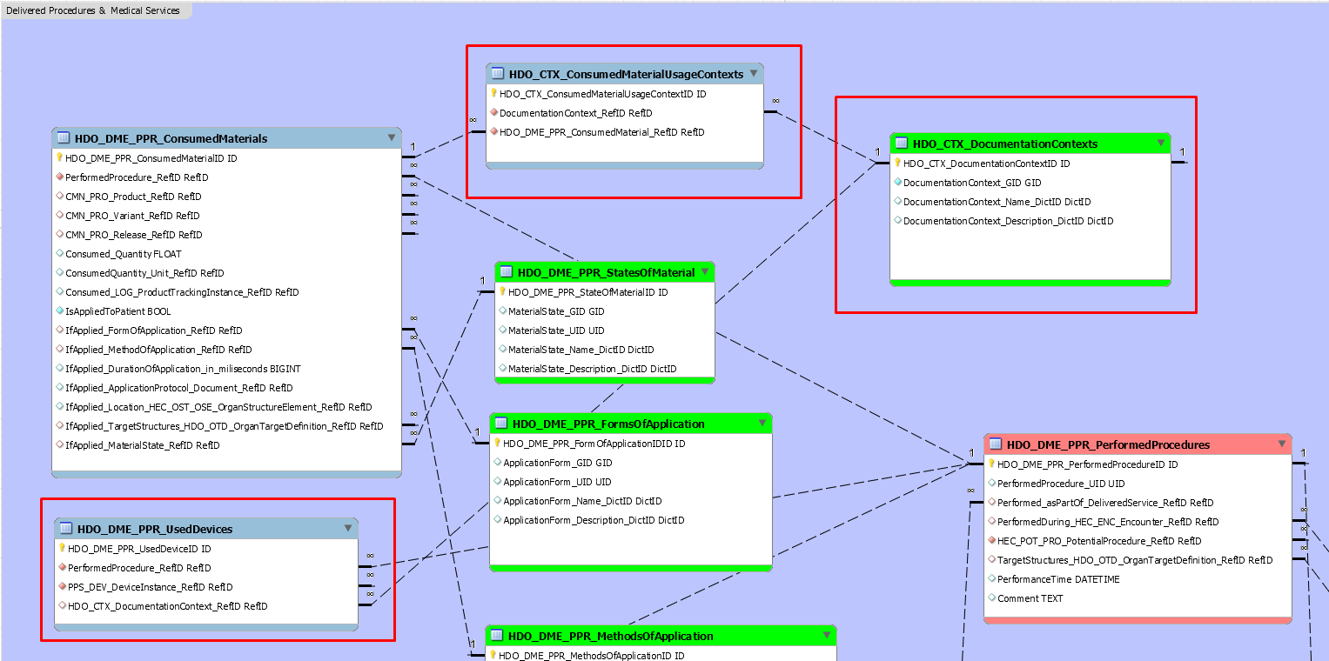
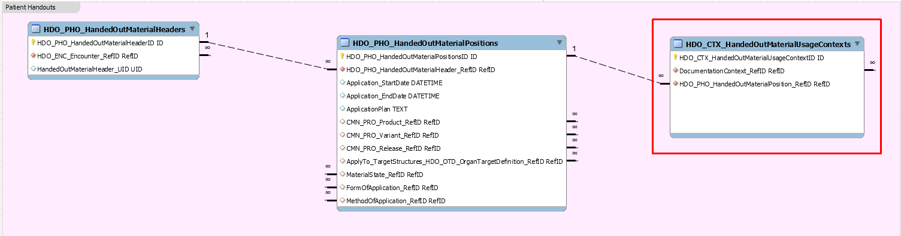

Examples:

1) Handed out material "Floxal" can be found twice in the encounter.
Context "Historic": The patient is telling the doctor what antibiotic he was using (historically).
Context "Prevention": The doctor is handing out the same antibiotic for prevention of new infection.

2) A Device of Device-Type "Refractive Laser" can be used twice within the same (Femtolaser) procedure.
Contect "Flapmaking": There the Laser is used to cut the flap
Context "Vision Correction": There the (another) laser is used to do the refraction correction

Additional Info:
1. This table should NEVER be used for patient data as the context must be already defined in the Patient Data Type Definition. Otherwise the Definition is imperfect.

DocAPI must be adapted to support Documentation Context save and load.

PMC must become aware of the contexts whenever devices, consumed materials and handed out materials are used for statistics calculation.

Device integration

Device data collection and upload technical concept is in this document.
Device data retrieval to PM technical concept is in this document.

When fetching data from the FTP, the consuming application must send tenant ID, as the measurements will be separated into folders with tenant IDs as names, so that each tenant can only see their own data. The uploading applications must know to which tenant folder to upload.

Device data should be archived after 24 hours, to not clutter the popup.

Autorefractors
An autorefractor or automated refractor is a computer-controlled machine used during an eye examination to provide an objective measurement of a person's refractive error and prescription for glasses or contact lenses. This is achieved by measuring how light is changed as it enters a person's eye.

All of these devices, even the old ones, can export measurement data in some form which will be used in the documentation form, or objective refraction.

When the user invokes objective refraction import, we want to show them a list of all unprocessed items captured by the devices. The popup will look something like this:

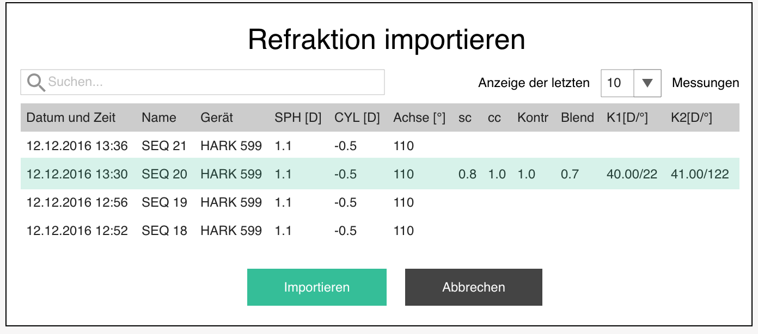

- Import refraction / Refraktion importieren
- Search… / Suchen… - filters results by patient name
- Display latest <number> measurements / Anzeige der letzten <number> Messungen
  - 5 (default) / 10 / 50 / 100 / all
- Table in which one row can be selected for import, with the following data:
  - Date and Time / Datum und Zeit - date and time of the measurement
  - Title / Name - name of the patient or sequence number or whatever data the device supplied as a name
  - Device / Gerät - device which provided the values
  - SPH [D] / SPH [D] - spherical aberration if available
  - CYL [D] / CYL [D] - cylindrical aberration if available
  - Axis [°] / Achse [°] - axis if available
  - sc / sc - visual acuity without correction, if available
  - cc / cc - visual acuity with correction, if available
  - Kontr / Contr - visual acuity with high contrast, if available
  - Blend / Glare - visual acuity with glare, if available
  - K1 [D/°] / K1 [D/°] - K1 value (diopter and axis)
  - K2 [D/°] / K2 [D/°] - K2 value (diopter and axis)
Have in mind that the popup for each eye displays values for that eye only.

Zeiss Humphrey Autorefraktometer and Keratometer (HARK 599)

Exported data

File will be uploaded in the following format: deviceName-datetime-device GID.txt

The exported data is a bit different depending on the measurement settings. With automatic measurement, we only have refraction measurements, and in manual, we have objective measurements, Uncorrected visual acuity, Contrast visual acuity and Glare visual acuity, so the parsing will have to be adapted.

In any case, the relevant data for one measurement is always between SOH and ETX characters.Inside one such segment, we can have measurement for left and for right eye.

The labels in exported data depend on device settings, so, although we will just have German (DE) values at the beginning, we should have these in separate resource files.

Left eye measurements start with LINKES AUGE (DE) and right eye measurements with RECHTES AUGE (DE). Check for both, but have in mind that one might not be present.

For each eye, try to extract the following data, if available:

Uncorrected visual acuity
Unkorrigiert (DE) with a couple of blank spaces and a value as the last thing in that line

Objective refraction
Obj (De) with values in the next line, defined as
SPH sign [+/-] (whitespace) SPH value (whitespace) CYL sign [+/-] (whitespace) CYL value (whitespace) A value (whitespace) Corrected visual acuity

Contrast visual acuity
Ger. Kontrast (DE) with a couple of blank spaces and a value as the last thing in that line

Glare visual acuity
Blend Test (DE) with a couple of blank spaces and a value as the last thing in that line

K1

Dim1 (diopters): Ker (DE) values -> the first R or L line below it -> value number one (43.50 (R) and 44.00 (L) in the example below)
Dim2 (axis): Ker (DE) values -> the first R or L line below it -> value number three (14 (R) and 175 (L) in the example below)

K2

Dim1 (diopters): Ker (DE) values -> line below R or L line below it -> value number one (45.25 (R) and 45.25 (L) in the example below)
Dim2 (axis): Ker (DE) values -> line below R or L line below it-> value number three (104 (R) and 85 (L) in the example below)

Note: K measurements are not in the LINKES AUGE and RECHTES AUGE sections like the refraction values. The are separated into L and R section under Ker section.

The other measurement results are ignored for now.

Automatic refraction measurement and keratometry

HARK SEQ 18
Sph Zyl. Achse Visus
RECHTES AUGEObj
- 0.25 - 0.50 25
Reflex: 20
LINKES AUGEObj
+ 0.25 - 0.25 175
Reflex: 14
Vertex: 13.5
PD: 61
Ker dpt mm Achse
R 43.50 7.74 14
45.25 7.46 104
MITTLERES 44.50 7.60
K - 1.75 DK x 14
L 44.00 7.67 175
45.25 7.46 85
MITTLERES 44.75 7.57
K - 1.25 DK x175

Manual refraction measurement and keratometry

HARK SEQ 33
Sph Zyl. Achse Visus
RECHTES AUGEUnkorrigiert 0.5
Obj
+ 0.25 - 1.00 103 0.5
Ger. Kontrast 0.33
Blend Test 0.13
Reflex: 11
LINKES AUGEUnkorrigiert 0.33
Obj
- 0.00 - 0.75 60 0.5
Ger. Kontrast 0.33
Blend Test 0.13
Reflex: 27
Vertex: 13.5
PD: 68
Ker dpt mm Achse
R 40.00 8.45 22
39.25 8.61 112
MITTLERES 39.75 8.53
K - 0.75 DK x112
L 40.00 8.43 18
41.25 8.20 108
MITTLERES 40.75 8.32
K - 1.25 DK x 18

NIDEK AR-1s

Exported data

NIDEK’s AR-a autorefractor is a bit more modern than Zeiss HARK599 and as such, offers a LAN connection, in addition to COM port. LAN connection provides a simply set up way to send data to a computer in an XML file, which is very straightforward for parsing. For this reason, we will integrate over LAN. The exported files will be uploaded to common FTP location, from which they can be parsed and imported into the application.

File will be uploaded in the following format: deviceName-datetime-device GID.xml

We will extract the following values from the file:

Patient name

<Data> // <Patient> // <No.>

Device

<Data> // <ModelName> + <ROMVersion>

Timestamp

<Data> // <Date> (Y/M/D) + <Time> (H/M/S)

Left eye measurements are in the <L> tag and right eye measurements are in the <R> tag. Check for both, but have in mind that one might not be present.

For each eye, try to extract the following data, if available:

Uncorrected visual acuity

<VA> // <UCVA> = sc

Corrected visual acuity

<VA> // <BCVA> = cc

Objective refraction

<AR> // <ARMedian> tag will contain the average objective refraction values if the device was set to capture 3 or more measurements. However, this tag may be missing. If that is the case, look for the last occurrence of
<AR> // <ARList> tag

When we have located the suitable objective refraction tag, we will take the values from the following child elements:

<Sphere> = SPH
<Cylinder> = CYL
<Axis> = A

Contrast visual acuity

<VA> // <LVA> = Kontr

Glare visual acuity

<VA> // <GVA> = Blend

K1

<KM> // <KMMedian> tag will contain the average keratometry values if the device was set to capture 3 or more measurements. However, this tag may be missing. If that is the case, look for the last occurrence of
<KM> // <KMList> tag

When we have located the suitable keratometry value tag, we will take the values from the following child elements:

Dim1 (diopters): <R1>//<Power>
Dim2 (axis): <R1>//<Axis>

K2

<KM> // <KMMedian> tag will contain the average keratometry values if the device was set to capture 3 or more measurements. However, this tag may be missing. If that is the case, look for the last occurrence of
<KM> // <KMList> tag

When we have located the suitable keratometry value tag, we will take the values from the following child elements:

Dim1 (diopters): <R2>//<Power>
Dim2 (axis): <R2>//<Axis>

The other measurement results are ignored for now. Example file can be found here.

Lensmeters

A lensmeter or lensometer, also known as a focimeter or vertometer, is an ophthalmic instrument. It is mainly used by optometrists and opticians to verify the correct prescription in a pair of eyeglasses, to properly orient and mark uncut lenses, and to confirm the correct mounting of lenses in spectacle frames. Lensmeters can also verify the power of contact lenses, if a special lens support is used.

When the user invokes glasses refraction import, we want to show them a list of all unprocessed items captured by the devices. The popup will look something like this:

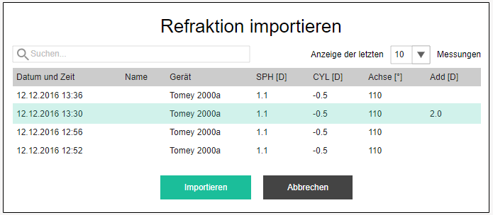

- Import refraction / Refraktion importieren
- Search… / Suchen… - filters results by patient name
- Display latest <number> measurements / Anzeige der letzten <number> Messungen
  - 5 (default) / 10 / 50 / 100 / all
- Table in which one row can be selected for import, with the following data:
  - Date and Time / Datum und Zeit - date and time of the measurement
  - Title / Name - name of the patient or sequence number or whatever data the device supplied as a name
  - Device / Gerät - device which provided the values
  - SPH [D] / SPH [D] - spherical aberration if available
  - CYL [D] / CYL [D] - cylindrical aberration if available
  - Axis [°] / Achse [°] - axis if available
  - Add [D] / Add [D] - Additional presbyopic aberration

Have in mind that the popup for each eye displays values for that eye only.

Tomey 2000a

File will be uploaded in the following format: deviceName-ddMMyyyyHHmmss-device GID.txt

Data can be found between SOH and EOT characters, in the following pattern:

LM
LR+ 0.75- 0.25154
AR2.00
PR+ 0.00- 1.50
LL+ 0.50- 0.25 25
AL2.00
PL+ 0.00- 1.50

Right lens

LR<+ or ->blankspace<sph><+ or ->blankspace<cyl><a> (delimited by AR tag)
AR<add> (delimited by PR tag)

Left lens

LL<+ or ->blankspace<sph><+ or ->blankspace<cyl><a> (delimited by AL tag)
AL<add> delimited by (PL tag)

The other measurement results are ignored for now. Example file can be found here.

Tomey TL 6000/7000

File will be uploaded in the following format: deviceName-ddMMyyyyHHmmss-device GID.csv

Data is distributed in rows of the csv file, where the first column represents the tag, and subsequent columns contain values.

Device

[MC_NM], <device>

Timestamp

[ST_DT], <MM/dd/yyyy>
[ST_TM], <hh:mm:ss AM/PM>

Right lens

[POWER_R], <sph>, <cyl>, <a>
[ADD_R], <add>

Left lens

[POWER_L], <sph>, <cyl>, <a>
[ADD_L], <add>

The other measurement results are ignored for now. Example file can be found here.

Corneal Tomography

Corneal topography devices measure different properties of the cornea. These are called Scheimpflug devices, after the inventor of this approach.

Data exported from these devices can be used to pre-populate some of the values in encounter documentation which will save the user time and errors.

When the user invokes pentacam import, we want to show them a list of all unprocessed items captured by the scheimpflug devices. The popup will look something like this:

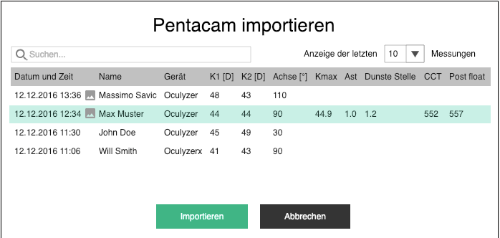

- Import Pentacam values / Pentacam importieren
- Search… / Suchen… - filters results by patient name; prefill with name of the current patient
- Display latest <number> measurements / Anzeige der letzten <number> Messungen
  - 5 (default) / 10 / 50 / 100 / all
- Table in which one row can be selected for import, with the following data:
  - Date and Time / Datum und Zeit - date and time of the measurement
  - Image icon if there are images for this measurement
  - Title / Name - name of the patient or sequence number or whatever data the device supplied as a name
  - Device / Gerät - device which provided the values
  - K1 [D] / K1 [D] - dim 1 of K1
  - K2 [D] / K2 [D] - dim1 of K2
  - Axis [°] / Achse [°] - dim 2 of K1
  - Kmax [D] / Kmax [D] -
  - Ast / Ast - corneal astigmatism
  - Thinnest location [µm] / Dünnste Stelle [µm]
  - CCT [µm] / CCT [µm] - central corneal thickness

Have in mind that the popup for each eye displays values for that eye only.

Wavelight Oculyzer

Exported data

Oculyzer can export various formats of data, including jpg image of the corneal maps. However, we will use the .csv file from which we can extract all the values easily. Note that the files will be semicolon-separated values.

File will be uploaded in the following format: deviceName-datetime-device GID.csv

We will extract the following values from the file:

Patient name

Section [PATIENT] // Last name, First name

Localization

Section [PATIENT] // Eye

Device

Section [SYSTEM] // Name

Timestamp

Section [EXAMINATION] // Date, Time

K1

Dim1 (diopters): Section [GENERAL DATA] // Cornea Front Rh (converted from mm to dpt: Diopters = 337.5 / millimeters)
Dim2 (axis): Section [GENERAL DATA] // Cornea Front Axis

K2

Dim1 (diopters): Section [GENERAL DATA] // Cornea Front Rv (converted from mm to dpt: Diopters = 337.5 / millimeters)
Dim2 (axis): empty

CAST (Corneal astigmatism)

Section [GENERAL DATA] // Cornea Front Astig

Kmax

Section [GENERAL DATA] // K Max (Front)

Thinnest location

Section [GENERAL DATA] // Pachy Min

Posterior float

not imported, users will specify manually

Central Corneal Thickness

Section [GENERAL DATA] // Pachy Apex

The other measurement results are ignored for now. Example file can be found here.

Oculus Pentacam

Exported data

Pentacam can export various formats of data, including jpg image of the corneal maps. However, we will use the .csv file from which we can extract all the values easily. Note that the files will be semicolon-separated values.

File will be uploaded in the following format: deviceName-datetime-device GID.csv

We will extract the following values from the file:

Patient name

Section [PATIENT] // Last name, First name

Localization

Section [PATIENT] // Eye

Device

Section [SYSTEM] // Name

Timestamp

Section [EXAMINATION] // Date, Time

K1

Dim1 (diopters): Section [GENERAL DATA] // Cornea Front Rh (converted from mm to dpt: Diopters = 337.5 / millimeters)
Dim2 (axis): Section [GENERAL DATA] // Cornea Front Axis

K2

Dim1 (diopters): Section [GENERAL DATA] // Cornea Front Rv (converted from mm to dpt: Diopters = 337.5 / millimeters)
Dim2 (axis): empty

CAST (Corneal astigmatism)

Section [GENERAL DATA] // Cornea Front Astig

Kmax

Section [GENERAL DATA] // K Max (Front)

Thinnest location

Section [GENERAL DATA] // Pachy Min

Posterior float

not imported, users will specify manually

Central Corneal Thickness

Section [GENERAL DATA] // Pachy Apex

Images:

Pentacam users can export JPG images to specific folder. The images have all needed measurement data encoded in the name as:

Meier_Jeremy_OD_20092018_112320_4 Maps Refr -> PatientLastName_PatientFirstName_Localization_Date_Time_ImageType

We can use first 5 elements in the name to connect and image to a measurement. All images that match will be uploaded together with the measurement as:
DeviceGID_PatientFirstName_PatientLastName_Localization_DateTime_ImageOrdinalNumber.JPG

The other measurement results are ignored for now. Example file can be found here.

Optical Biometry

Optical biometry is the current standard for intraocular lens (IOL) power calculations in clinical practice. Optical biometry is a highly accurate non-invasive automated method for measuring the anatomical characteristics of the eye. Accurate measurements are critical for determining the correct power of an IOL before it is implanted during cataract surgery.

When the user invokes IOL import, we want to show them a list of all unprocessed items captured by the optical biometry (BIO) devices. The popup will look something like this:

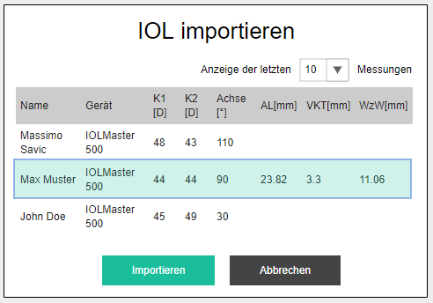

- Import IOL values / IOL importieren
- Search… / Suchen… - filters results by patient name; prefill with name of the current patient
- Display latest <number> measurements / Anzeige der letzten <number> Messungen
  - 5 (default) / 10 / 50 / 100 / all
- Table in which one row can be selected for import, with the following data:
  - Date and Time / Datum und Zeit - date and time of the measurement
  - Title / Name - name of the patient or sequence number or whatever data the device supplied as a name
  - Device / Gerät - device which provided the values
  - K1 [D] / K1 [D] - dim 1 of K1
  - K2 [D] / K2 [D] - dim1 of K2
  - Axis [°] / Achse [°] - dim 2 of K1
  - AL [mm] / AL [mm] - axial length
  - ACD [mm] / VKT [mm] - anterior chamber depth
  - WtW [mm] / WzW [mm] - width of the iris

Have in mind that the popup for each eye displays values for that eye only.

Zeiss IOL Master 500

IOL Master can communicate with a PC via serial port. Serial communication is explained in this document, and the digest will be laid out here. Basically, the IOL Master sends data in blocks, marked B1 to BF, each of which contains different set of data. When the device is done sending block B1, for example, PC has to answer with b1\r\n and the IOL Master starts sending the next block.

The data within one block is separated by “0x0”, so in this specification, we will reference each piece of data by it’s ordinal number within the block. When the block is split by “0x0”, the first token is always the block name itself (e.g. B2), we will call it the 0th token.

To avoid potentially wrong imports, we will indicate to the user which measurement is most likely the one they are looking for. If the patient first name and last name match the patient of the current encounter by 80% and encounter date matches the measurement date, the row will be highlighted in an obvious way.

If the user selects a measurement where patient and date do not match, we will display a warning message before importing the measurement.
- Warning / Warnung
- Patient name from the device does not match the current patient name. / Der Patientenname aus dem Gerät stimmt nicht mit dem aktuellen Patientennamen überein. - if patient name does not match
- Measurement date does not match the encounter date. / Der Messdatum ist nicht identisch mit dem Untersuchungsdatum. - of date does not match
- Are you sure you want to import this measurement? It may be incorrect. / Sind Sie sicher, dass Sie diese Messung importieren möchten? Es könnte falsch sein.
- Yes / Ja
- No / Nein

Patient name

Block: B1
Last name: Token 1
First name: Token 2

Localization

Localization is not really black and white with this device, so it will be covered separately for every imported field, where localization matters.

Device

“Zeiss_IOLMaster500”

Timestamp

Although the date of the examination is part of block B4, we will ignore it because the is no time component included. Instead, we will look for the timestamp in the file name, which will be formatted as:

Zeiss_IOLMaster500-ddMMyyyyHHmmss-c74801c8-689d-084e-8027-095d1c23d182.txt

K1

Block: B7 and B5

Dim1 R: B7 / token 6 (converted from mm to dpt: Diopters = 332 / millimeters)
Dim 2 R: B5 / token R1
Dim2 R: round down (average (B5 / token 5, B5 / token 13, B5 / token 21))

Dim1 L: B7 / token 13 (converted from mm to dpt: Diopters = 332 / millimeters)
Dim2 L: B5 / token L1
Dim2 L: round down (average (B5 / token 8, B5 / token 16, B5 / token 24))

Token R1: ((B5 / token 25) - 1) * 8 + 5
Token L1: ((B5 / token 26) - 1) * 8 + 8

K2

Block: B7

Dim1 R: B7 / token 7 (converted from mm to dpt: Diopters = 332 / millimeters)
Dim 2 R: (K1+90) mod 180

Dim1 L: B7 / token 14 (converted from mm to dpt: Diopters = 332 / millimeters)
Dim2 L: (K1+90) mod 180

Objective refraction

When refraction is not measured, IOL Master will return “gibberish” for these values. To prevent that, we will rely on validations:

Sph: must be a float value between -25 and +20
Cyl: must be a float value between -10 and +10
A: must be an integer value between 0 and 179
If the acquired value is not valid, it should be ignored.

Block: B2

Sph R: Token 3
Cyl R: Token 4
A R: Token 5
VA R: Token 6

Block: B3

Sph L: Token 1
Cyl L: Token 2
A L: Token 3
VA L: Token 4

AL

Block: B7

AL R: Token 4
AL L: Token 11

ACD

Block: B7

ACD R: Token 9
ACD L: Token 16

WtW

Block: BF

IOL Master can send up to 3 white-to-white values, where only one is active, and we want to import that one. To determine which one is active, we will look for active index in:
Token: 46 (indexR)
Token: 47 (indexL)

WtW R = (2 * WR) / FR
WR Token: indexR*15+6
FR Token: indexR*15+3

WtW L = (2 * WL) / FL
WL Token: indexL*15+12
FL Token: indexL*15+3

Note: Round result to 1 decimal digit.

Status

Block: B3
Status R: Token 5
Status L: Token 6

Acquired value should be decoded using this legend:

0 = phakic
1 = aphakic
2 = silicone filled eye
3 = pseudophakic Silicone1
4 = pseudophakic Silicone2
5 = pseudophakic Silicone3
6 = pseudophakic Memory
7 = pseudophakic PMMA
8 = pseudophakic Acryl
9 = silicone filled eye; aphakic

Target refraction

Block: B8
Target ref: Token 6

Lenses

Lenses and constants

Block: BD

BD contains four types of lenses (Token1, Token3, Token5, Token7):

0: Physiol H65
1: FineVision Multi
2: KOWA Avansee gelb
3: Ankoris Toric Physiol

Or some other ones

and their constants for different formulas (Token2, Token4, Token6, Token8):

0: Haigis formula -> A0:0.653 A1:0.4 A2:0.1
1: HofferQ -> pACD:4.34
2: Holladay -> SF:0.66
3: SRK II -> A(SRK II):117
4: SRK/T -> A(SRK/T):117

These constants are separated by “;” in Token2, Token4, Token6, Token8.

IOL powers and target refractions

Block: BE

We do not need to calculate anything, as the calculated data comes from IOL Master in block BE, but we need to know which data is for which formula.

There will be as many instances of BE block as there are formulas. In every one of those instances, the ordinal number is encoded in Token 1 (0 = Haigis, 1 = HofferQ….). And the indicator if the data was calculated will be in Token 2 (if 0, skip this block, if 1 gather the values).

IOL power R: Token3, Token4...Token39
Target refaction R: Token76, Token77… Token111

IOL power L: Token39, Token40...Token75
Target refaction L: Token112, Token 113… Token147

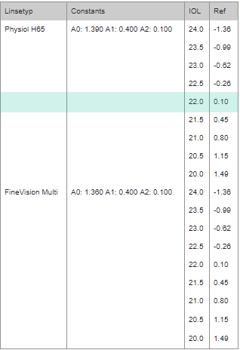

Automatic device data upload
The concept of uploading device data to a server and then importing it into Kordeus via popups gives flexibility to browse and use device data when the user is not sitting directly at the device. However, it has certain limitations. One of these limitations is the fact that the user can pick the wrong measurement from the popup if more measurements are done sequentially.

To bypass this limitation, and to speed up the process, Kordeus shall offer a desktop application which displays the data collected from a device as soon as it is captured, which the user can upload to the correct encounter documentation in just a click or two.

Kordeus Device Integration Desktop
Each medical device has its way of sending data to the computer to which it is attached. Some use a serial port, some use an ethernet cable, or a USB connection. But regardless of the implementation, the data will be stored in a predefined folder on the attached computer in a predefined format. It can be parsed in exactly the same way as it is parsed in order to show it in the device integration popups within Kordeus. It is just important to pair the corresponding parsing method with the corresponding folder in which the file lands when the data is sent from the devices.

This is done via textual settings file, or a settings UI in which the user will specify:
- Email / Email – a valid Kordeus user account
- Password / Passwort – non-plaintext password box
- Server / Server – a URL or IP of the server on which DevIntAPI and DocAPI resides
- Measurement viability [hrs] / Viabilität der Messungen [Std.] – number of hours after which the measurements are no longer viable and are purged from app memory
- Devices / Geräte
  - Type / Typ – dropdown with all supported device types
  - Path / Pfad – absolute path to the folder in which the assigned device stores data
  - Add device configuration / Gerätekonfiguration hinzufügen – a button which opens another device configuration block

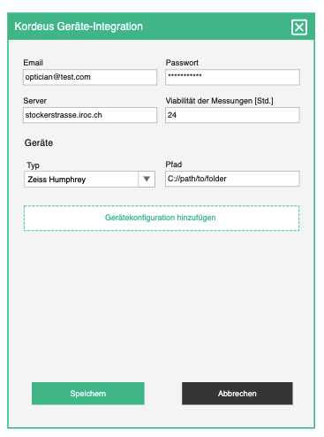

Processing incoming data
The app monitors configured folders for incoming data and when there is a new file, depending on the folder and type of device, it parses it with the correct parsing method and stores it into app’s memory.

On startup, the app goes through configured folders and parses all data for the current day and stores in the memory.

The app’s memory is purged periodically of all measurements older than configured viability period (if current time is less than measurement timestamp + viability).

Displaying incoming data
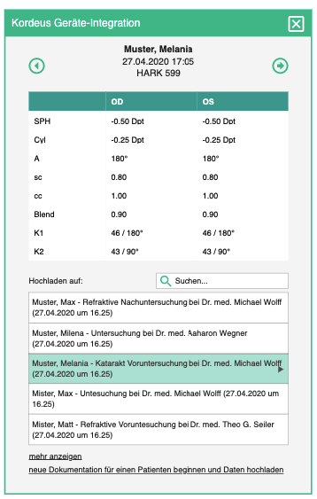

When a data file arrives to a predefined folder, it is parsed and displayed in the UI immediately. If the application was not in focus at the time when data arrives, it is put into focus to attract the user’s attention. This way the user will know which measurement they are sending to Kordeus Device Integration API.

The user will see:
- Patient name – if sent by device
- Date and time of the measurement
- Device name
- Next / Nächste – visible only if there is a newer measurement than this one, displays the next measurement in the values table
- Previous / Vorhergehende - visible only if there is an older measurement than this one, displays the previous measurement in the values table
- Values table for OS and OD, which depends on the device type
  - This table will display the same data as the device integration popups, only for both localizations at the same time
  - See chapters above for different devices
    - Zeiss Humphrey
    - NIDEK AR-1s
    - Tomey 2000a
    - Wavelight Oculizer
    - Oculus Pentacam
    - Zeiss IOL Master 500

Uploading chosen data
The user can upload data currently shown in the values table, by choosing one of the encounters listed below the values table.

The list shows all open encounters for the current day and appointments which are in queue or running but do not have an encounter connected to them. Each list item contains the following data
- Patient last name, first name
- Documentation form title or appointment type
- with / bei
- Responsible person or key person in an appointment
- Date of the encounter / appointment
- If appointment
  - at / um
  - Time

The list can be expended by clicking on the show more button which loads a number of past encounters / appointments.
- show more / mehr anzeigen

The list is sorted by date and time descending (it's logical you want to upload to the latest encounter).

The user can filter the list by patient name, documentation form title / appointment type and responsible person / key person.

To help the user find the correct encounter, if the measurement contains patient name, the app highlights the latest encounter for that patient.

If the user picks an appointment, an encounter will be created first. Then the data is added to the encounter and saved.

If the user has not found a suitable encounter, they can start a new one by clicking on the link
- Start new documentation for a patient and upload data / Neue Dokumentation für einen Patienten beginnen und Daten hochladen

This will replace the encounters list with a form in which the user can select a patient and a documentation form type, create it and upload to it.
- Patient / Patient - patient serach box
- Documentation form / Dokumentationsform - dropdown with available doc forms
- Save / Speichern - creates encounter and uploads data
- Cancel / Abbrechen - shows the encounters list again

In any case, the user needs to confirm they wish to upload data:
- Are you sure you want to upload data to <doc form title> for <patient name>? / Sind Sie sicher, dass Sie Daten in <doc form title> für <patient name> hochladen möchten?

If the documentation form to which we are attempting to save data has been opened for editing by another user in the meantime, the upload will not be successful and the message will appear:
- <user> is currently working on this encounter. It is not possible to upload data until they are finished with work. / - <user> arbeitet derzeit an dieser Untersuchung. Es ist nicht möglich, Daten hochzuladen, bevor sie mit der Arbeit fertig sind.

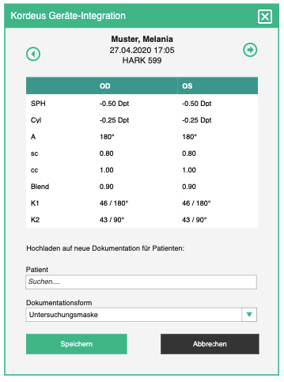

ProMed Community connection

Sharing cases with ProMed communities

ProMedi communities are a platform where doctors can share their (anonymized) cases with other interested parties and thus contribute to research studies and education.

At the start, we have one community organized around Schwind, a company which produces refractive surgery and diagnostics equipment. Their aim is to collect case data from doctors around the world in order to analyze the data from pre-ops, operations and post-ops and use the results to improve their devices.

Other companies and institutions will eventually come onboard and start collecting data. Each of these entities will have their own tenant, which means that inter-tenant communication will have to happen.

Handshake
In order to enable inter-tenant data sending, the two tenants have to know each other. A PM tenant has to know about Community tenant to which its users can connect. Tenant introduction is a process which will be implemented in later stages of development, but for the time being, every PM tenant which wants to connect with a community, will have the community information inserted into its database.

After “tenant introduction”, administrator can connect user accounts to their corresponding community accounts on the user page, accounts tab, by specifying email and password of the account. After successful handshake, PM user and PMC user are connected and PM user can upload cases to PMC.

Case detection
During handshake PMC sends PM tenant information about all relevant groups for the connected user. One of the information which PM should receive are case detection rules. These rules represent formulae which specify what qualifies as a case for the said community. E.g. A case is a series of encounters which delivered a pre-op, surgery, post-op respectively. Any other combination of encounters is not interesting for the case type in question.

Note: A case is a series of encounters (one or more) and has a type.

For time being, case detection criteria have to be inserted into the tenant database. Once they are in the tenant’s database (by manual insertion or handshake process), the case detection service, provided by DocAPI, can be invoked after a finished encounter. Result of this operation is the case to which the encounter can be uploaded (a new one will be created if it doesn’t exist for the patient).

Case upload
After the case detection service finds a suitable case for the finished encounter, PM should offer the user a possibility to chose to which community groups they want to upload case to (multiple are possible). All user’s PMC groups should be offered. In addition to that, user can select the “auto-upload” option, which will automatically upload eligible encounters to this case, without prompting the user.

Note: In the current implementation for Schwind, one user sees all the participants of all the encounters in a case and has the right to upload to their groups on PMC. This looks like a violation of privacy so we should stick to every user being able to upload case to their own groups on PMC, as a part of the core product.

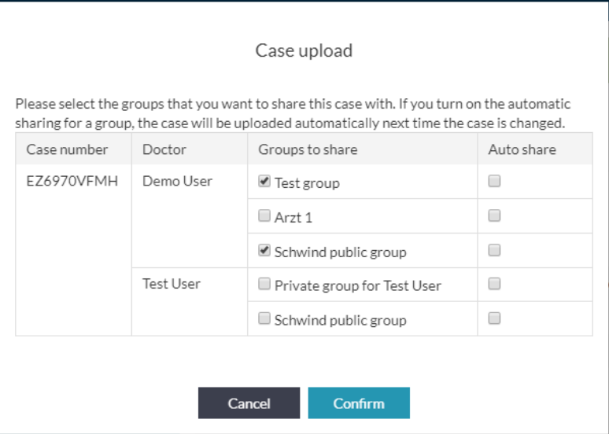

Popup shows the following data
- Case upload / Fall hochladen - title
- Please select the groups that you want to share this case with. If you turn on automatic sharing for a group, the case will be uploaded automatically next time the case is changed. / Bitte wählen Sie die Gruppen aus, mit denen Sie diesen Fall teilen möchten. Wenn Sie die automatische Freigabe für eine Gruppe aktivieren, wird der Fall beim nächsten Ändern des Falls automatisch hochgeladen. - explanation
- Case number / Fallnummer
- Participant / Teilnehmer
- Groups / Gruppen
- Auto share / Automatische Freigabe

On confirm, the case is saved in the tenant database with corresponding status which will make it eligible for uploading by CHEC connector.

If action was successful, show the following success bubble:
- Case was successfully saved and awaits upload. / Der Fall wurde erfolgreich gespeichert und wartet auf den Upload.
Otherwise
- Case could not be saved. / Der Fall konnte nicht gespeichert werden.

Zugseil integration

PM tenant working in Zugseil
Tenants created primarily for working in PM have a set of required entities, such as company, one user account etc. But in order to make them work with Zugseil (i.e. to open the Zugseil app with credentials of a PM user), we must make sure the tenant has minimum required entities. These are:

- To be defined

Products defined and imported in Zugseil
Since Zugseil offers extensive product management options, it is likely that products which originate from the Zugseil application will come with complex logistics settings. PM will deal with products in the most simple way and will not be able to handle these complex settings. For that reason we must disallow PM users to change anything on these products in order not to override or delete these settings. Products from Zugseil (or products made in PM, either option works) must be clearly marked so that PM knows for which ones to offer editing.

Products vs Articles
In complex product centered solution, such as Zugseil, every product offered to customers has one or more articles “in the background”. The logic behind this is that a company may offer “Syringe 10mL” as a product to their customers for a certain price, even though they get 10 ml syringes from different suppliers and different manufacturers for different prices, but want to keep it simple on the customer side. Thus, one product is connected to a couple of articles in the background.

Since all products have variants (even the ones which officially don’t, have at least one default variant) this dictates that all product variants have one or more article variants in the background.

Since products are customer-facing entities, products and product variants go to customer orders and bills. Articles are physical, logistic entities - the ones which can actually be found on stock, it is articles and article variants that go to stock when they are delivered by suppliers and which are taken from stock and shipped to customers.

Customer order, Shipment and Bills
Zugseil offers detailed logistics processes, which have minimal requirements in order to be displayed within the app. For example: to be able to create a bill, from Zugseil’s perspective (and the legal perspective, in most countries) the goods (tangible products and services) have to be shipped. Even though service cannot be physically shipped, there has to be an evidence that it was delivered to a customer, before it is billed.

But before we put anything onto a shipment, we need to have a customer order first. We don’t ship anything without the customer’s explicit request (order). After we have an order, a shipment which is billable (shipped or picked up) we can create a bill, and that is the whole process.

So, everything starts with a customer order. When we are dealing with products sold, e.g. online, it is clear that the customer will put things into their shopping basket, confirm the order, and we have a customer order. In the healthcare domain, we need to be a little more creative, because the patient doesn’t really tell the doctor what to do, but the doctor makes a decision what is the right course of action, i.e. which services to deliver or medications and disposables to use. Maybe, in aesthetic surgery, the patient will order, up front, what they want done, but even then, the doctor might need to do something while the patient is under general anesthesia.

Let’s say a patient comes to the doctor (encounter). The fact that they came is like a blanco customer order - the patient asks the doctor to treat them. Which items will end up on that order depends on the flow of the encounter - the doctor might do some tests or apply some medications, etc. So, when an encounter is made, so is a customer order, with one placeholder item. The placeholder item is needed because Zugseil will not know what to do with customer orders without items - it makes no sense. This placeholder item will be replaced by real items as the encounter is getting documented. The order must be linked to the encounter from which it has originated.

As the encounter goes on, we will add items to the customer order. When a medial service is delivered we add the corresponding service products to the order. The doctor may have added services to the list of delivered services manually - those service products are added to the order also. As materials are consumed and marked “for billing”, their products are added to the order too. Handed out materials marked “for billing” (such as eye drops which the doctor gave to the patient to take home) also. All prescription items marked “for billing” (taken from to practice’s internal pharmacy) also. We need to take care that when a service is removed from the list of delivered services, the corresponding product needs to be taken off the order. Same goes for consumed materials, handed out materials and executed prescriptions. We can adjust this on every encounter update, for example.

Tables and fields to populate:
- To be defined

When a customer order is created, a shipment is created as well. For each item added to the customer order, a shipment item is created. In a normal scenario, shipment items need to be packed and marked as shipped, but in our case, everything was already given when it was documented, so the shipment items are automatically marked as shipped and ready for billing. Also have in mind that when an item is removed from the customer order, the corresponding item is removed from the shipment.

If a product is marked for logistics handling (see logistics), we need to create a reservation of stock quantity, mark it as executed automatically, and create a shelf content adjustment.

Tables and fields to populate:
- To be defined

Once we have a customer order and a shipment marked as ready for billing, we can create a bill. Bill creation behaves the same as defined in Billing section.

Fields to populate:
- To be defined

Note: Have in mind that we can have multiple bills for one customer order, because some services and product can be billed to the patient’s health insurance, some to the patient themselves, some to their employer, etc. When the user creates multiple bills, we have to split the shipment header to as many bills as they are and reconnect the shipment positions accordingly.

Logistics
Even simple products, created or imported in PM, will offer a simple logistics (inventory) functionality. All products which are marked for logistics handling, will have to be tracked when added to, or removed from storage. This means that, whenever a product is put on a shipping order and marked as shipped, we will have to create a shelf content adjustment which reduces the shelf content of the corresponding product. Likewise, when the quantity on stock is adjusted (up or down) in the inventory process, we will create a shelf content adjustment. Products which are not marked for logistics handling will not have shelf content adjustments.

Note: Shelf content is a batch of items of one product out on a shelf (lowest level storage unit). It is a common occurrence that there are multiple shelf contents of the same product on the same shelf. They are not treated as one, because they were put on the shelf at different times, they may have different expiration dates, batch numbers, etc.

Catalogs
In Zugseil, product catalogs are a way for companies to offer their products to their customers, and if needed, their employees for internal ordering. Pretty much, they pack a couple (of thousands) of products into a catalog, send the catalog code to the customer, the customer imports catalog and every catalog item ends up as an article in the customer's database (see above what articles are). Those articles can be turned into products for internal usage or further publication to others, in the form of product catalogs.

A product can have various prices defined through various price schema, e.g. Discounted price for long term customers, Wholesale price, Retail price, etc. One catalog, however, will be connected to only one price list. It is also important to have in mind that catalogs have revisions, which have validity periods, and that the correct price of a product, is the price which was attached to the catalog revision valid at the time of billing.

OP supplies
Surgical equipment catalog
Nylon Suture, 13mm, 45cm black
ETHILON Nylon Suture, 45 cm, black
UNIFY Surgical Nylon Suture, 13mm, ⅜ C, 45 cm, black
Supplier
Practice
Nylon Suture, 13mm, 45cm black
Suture
Manually made
imported
copied
Article
Legend:
Product
Catalog
Latex gloves, blue
Scalpel
Scalpel
Safeyear Latex Gloves

PM status quo:
PM uses catalogs to instantiate products which are used on documentation masks. This covers the second part of the process explained above. The catalogs which PM uses are created manually. Product sections of various documentation forms have hard coded catalog UIDs, in which they let users search for products.

PM goal:
Handle catalogs by using Zugseil API, or integrate these two applications, so that the PM admin can use Zugseil to:

1. Import catalogs from their suppliers thus creating articles
2. Create products out of imported articles
3. Pack products into catalogs which are used internally

In addition, the administrator should be able to select which product catalogs are available for which documentation masks or their sections. E.g. refractive surgery masks have two distinct sections for selecting consumed products:
- Anesthetics (lidocaine, drops)
- Post op materials (monocle, bandage lens)
Every tenant administrator should be able to define these two catalogs and connect them to appropriate form sections.

This integration is vital for the future of PM, because connecting suppliers and practices through b-op software will have tremendous practical and monetary value.

VitoData encounter import

General encounter import
Unlike PM which attaches all measurements to one encounter, most measurements in VD are scattered across the system and attached only to a patient. In order to import this data into PM, we will have to bundle them into encounters in a way that they belong to a single encounter.

This can be achieved by grouping measurements by date. All measurements captured on the same date will be part of one encounter. If there are multiple measurements of the same kind on the same date, only the last ones will be added to corresponding fields. The earlier ones will go into the corresponding comment sections as:

Alle Messungen für <measurement> an diesem Datum:
<time>: <value>

Of course, we will always first fetch all the measurements of one patient and then distribute them into encounters based on date of measurement.

Since the amount of data present in VD is too large to import at once, and we cannot tell which are the most relevant (e.g. If a patient came in for an examination 10 years ago and never came back, that piece of data is not relevant at the present moment, and there must be a lot of similar cases) we have to make a mechanism to import encounter data gradually.

Importer must have an option to import only data for a list of patients, where that list of patients are all patients who have an appointment in the specified time period.

When importing, we must not duplicate data. Once imported patient will not be imported again.

The following measurements are available in VD. The tables also represent which tables and fields are needed for VD queries and in which corresponding PM fields they are supposed to be imported.

Spectacle refraction (Lensmeter)
Link to sheet

Objective refraction (Autoref + Kerato)
Link to sheet

Subjective refraction (Phoropter)
Link to sheet

Anamnesis (KG Wichtig)
Link to sheet

Biometry
Link to sheet

IOP (KG-Eintraege)
Link to sheet

Medications (medi)
Link to sheet

Work excuses (AUF)
Link to sheet

LASIK import
VD features a LASIK mask, which is sometimes used to also document other types of surgeries. We will import data into our Refractive masks. Most of the data will be imported into comment sections because it would be very time consuming to try and map all the values to different masks.

Refractive screening (Questionnaire)
Link to sheet

Refractive pre-OP (Pre-OP)
Link to sheet

Refractive surgery (OP)
Link to sheet

Refractive early follow up (Early Post-OP 1st day and Early Post-OP 3rd day)
Link to sheet 1
Link to sheet 2

Refractive follow up (Post-OP)
Link to sheet

Cataract import
IOL values which we capture in cataract pre-op are kept separately in VD like any other measurement. When importing this kind of measurement, we will create a cataract pre-op encounter.

Catarct Pre-OP
Link to sheet

Operations import
Operations form in VD is used to document all surgeries and we will import the data into our General Surgery form. Since the user can document multiple operations in one “go” in VD, we will treat only the Main Surgery as the procedure which was documented, and all others will be added to the comment.

Link to sheet

VitoPict document import
Documents in VitoPict are spread into 2 different databases, none of which is the same as the VitoData database. These are:
- vitoPictAdm for meta data
- vitoPictImg_1 for data

The files are kept inside of the database, not directly in the file system. The data is in MSSql Image type which should be converted into specified file type and saved on PM’s document management system.

Link to sheet

VitoData report documents import

VitoData offers Word document generation, similar to our document templates. These files are stored on a shared network drive and their metadata is stored in the VD database.

Link to sheet

Appointment Broker connection

This section is under construction

Combining messages for v3 DocBooker and v4 DocBooker

PM will have to keep tenant settings about which message version protocol is used for which broker, so that practices which use the old broker and widget (e.g. IROC) do not stop working when new broker is introduced (YSZ).

Message payload

- Type
- Variant
- Order sequence
- Randomize?
- Time and date
- Human resources
- Facilities
- Devices
- Target facility

Speed optimizations

Access Control Optimization

B-Op's AC component intercepts every request and checks the validity of user's session token. Since PM has a lot of users using the application concurrently, AC needs to be adjusted to facilitate this.

Check what was adjusted with SSeiler and CRekittke.

Documentation Forms Optimization

[ENCOPT.01] Encounter history in RAM

Encounter history is an endpoint which returns all the previous encounters for the needed patient. In some cases which we had this is more than 200 encounters. Even though the method is optimized when we have so much data, the request can take in some cases even more than 2.5 sec. Therefore we will cache relevant data in RAM.

On any given day, RAM should be filled with complete encounter history of (distinct) patients who satisfy the following criteria:
- Patient has had an appointment in the previous 12 weeks
- Patient will have an appointment in the upcoming 2 weeks

On every history load (for the sake of populating masks), the endpoint should check if RAM contains history of the patient in question. If yes, fetch it from RAM. If not, fetch it from the DB like we currently do.

Have in mind that editing any encounter of a patient whose history is currently in RAM should update the cache for that patient.

[ENCOPT.02] Refactor the UI initial load of masks

We should prioritize which requests are needed to be first (from which the rest of the requests are dependent, and based on which the masks are generated). Only requests which are needed for generating the masks should be the blocking ones for the whole UI. Other data can be loaded later. For example the history table does not have to be the blocking we shall put placeholder text "loading... / laden..." instead of the table content until the data are fetched.

[ENCOPT.03] Rarely changed session data in localStorage

We shall put static data which is rarely updated in localStorage, to avoid reloading all static data when switching between Documentation forms and the rest of the PM. This static data are already in server's cache, but with localStorage, we will save 200 – 600ms on every request where we do not even load this data at all.

The mechanism shall be very simple: PM will load static data from the server on every application load and put it in the localStorage. When switching between pages in PM, static data is not re-loaded, so there is no speed issue. When switching between PM app and Documentation forms app, there is a speed issue, because static data is loaded again. The goal is to have Documentation forms application load static data from localStorage every time, unless there is no static data on localStorage. In this case it will be loaded from the server first.

There is no intelligent way of monitoring when the localStorage was updated, because it is updated every time PM application is loaded. A more sophisticated approach will be applied in an additional step. See [ENCOPT.05].

[ENCOPT.04] Lower number of requests

All browsers have a max number of default simultaneous persistent connections per server. For modern Chrome and Firefox is 6. From the time the masks are starting the load to the time they are loaded we have 17 http requests. This means that we must see if we can lower the number of requests by combining the response data in the same requests.

[ENCOPT.05] Monitor static data update through AC

Static data (see [ENCOPT.03]) shall be split into sections, depending on how often they are changed, e.g. ZIP codes and city names, Tenant settings, etc.

AC shall be extended to offer reading and writing last update timestamp of each of the sections of each application (any application can use this mechanism). Whenever a section is updated, AC should get the new update timestamp. In turn, whenever a client makes a request it shall check with AC if the last update timestamp is more recent than the section the client has in localStorage. If yes, localStorage will be updated with each such section data, so that the newest data is changed.

Alternatively, AC can broadcast messages about updated static data to clients and save additional time on check by clients.

Slot calculation optimization

[APPO.01] Settings and slots in RAM + appointment type variant extensions

Pre-requisits

- Move slot "cutting" from PM to AAE
- Limit the number of threads for calculation or make a fail-safe mechanism where a thread "gives up" before the server crashes

Appointment type variant extensions
(the original specification of these changes are in the Administration section)

RAM contents and update rules

1- Resource availabilities
- inhouse and web availabilities for every resource
- updated when an availability has changed for a resource
- updated when an appointment has been made or cancelled or moved for a resource
- loaded for upcoming x weeks, where x is a tenant setting, 21 by default

2- Appointment types and variants
- updated when an appointment type has been changed (variant added or removed)
- updated when an appointment type variant has been changed (step schema only, name and similar attributes are irrelevant)

3- Available slots for all inRAM pre-calculated appointment type variants
- calculated for time frame defined for appointment type variant
- if an appointment was created or moved or cancelled
  - for all appointment type variants
  - where each of the affected resources has potential slots
  - re-calculate slots for +- 12 hours from the new appointment time
- if a resource availability has changed:
  - for all appointment type variants
  - where the affected resource has potential slots
  - re-calculate all slots
  - optionally: take into consideration for which time frames the availability has changed
- if an appointment type variant step schema has changed or a variant was added or deleted:
  - for that appointment type variant
  - re-calculate all slots
- save only unique time slots in RAM, not every slot with every possible resource combination. This will save a lot of space in RAM. When the user selects a slot, the resources should be calculated by running the whole algorithm on the short period of time which is the slot itself. This will be some extra calculation, but the time frame is short.

Slot fetching

- Depending on the appointment type variant, if slots should be taken from RAM take them from RAM, otherwise calculate on the fly
- Extend the endpoint to take offset and limit into consideration
  - offset is the n-th slot from which options should be returned
  - limit is the number of slots which should be resturned
  - additionally, a boolean "more slots available" parameter is returned
- Examples:
  - Offset + limit = 0 + 10 -> take the first 10 slots;
  - Offset + limit = 10 + 10 -> take the second 10 slots;
  - Offset + limit = 20 + 5 -> take the 5 slots starting from the 20th

[APPO.02] Appointment making extensions and patient treating doctor

[APPO.03] Person group extensions and pool resource

